# Objective

To seek a position where I can utilize my skills and abilities that offer professional growth while being resourceful, innovative and flexible and contribute for the growth of the organization and my personality growth.

To enhance my skills on this challenging position and expanding my knowledge.I am adaptive person in a new work environment.I am able to work with multiple task. Self-discipline and high responsibility is my principle.

# Education

e Dr.SMCE

* Bachelor of Engineering

2013 2017

* Electronics and Communication with First class with distinction.

# Work & Experience

* MPL technologies
  + front end developer

2020 2022

* + I worked as front end developer, i was creating web pages and i use to review the developed web pages.

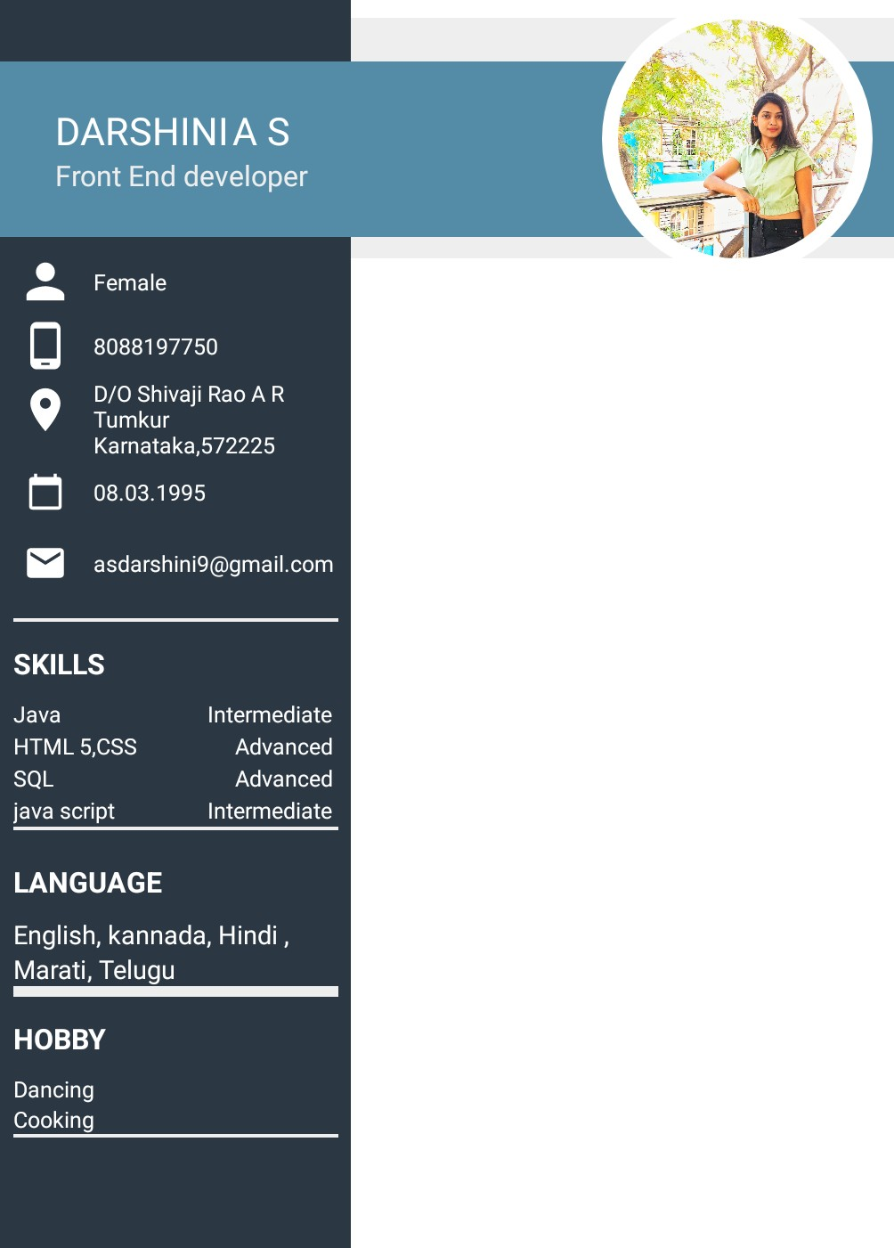

To enhance my skill onfront end development,i am upgrading myself to the new technologies.

# Projects

* - power theft smart management 2017 2017

-Team lead

* + To reduce the power losses due to

hookinCI and bvpassin<1.it was crucial

to build a project ,so we tried to give

our best to reduce the losses using software and hardware which worked out well which was cost effective too.