1.Net search

Nested scroll bar with view pager

http://stackoverflow.com/questions/30580954/viewpager-in-a-nestedscrollview

Copy code as in 2.

2.

Content_home_xml

*<?***xml version="1.0" encoding="utf-8"***?>*<**android.support.design.widget.CoordinatorLayout  
 xmlns:android="http://schemas.android.com/apk/res/android"  
 xmlns:app="http://schemas.android.com/apk/res-auto"  
 xmlns:tools="http://schemas.android.com/tools"  
 tools:context=".Activity.HomeActivity"  
 android:layout_width="match_parent"  
 android:layout_height="match_parent"**>  
  
 <**android.support.design.widget.AppBarLayout  
 android:layout_width="match_parent"  
 android:layout_height="wrap_content"  
 android:theme="@style/ThemeOverlay.AppCompat.Dark.ActionBar"**>  
  
 <**android.support.design.widget.CollapsingToolbarLayout  
 android:layout_width="match_parent"  
 android:layout_height="match_parent"  
 android:fitsSystemWindows="true"  
 app:contentScrim="?attr/colorPrimary"  
 app:expandedTitleMarginEnd="64dp"  
 app:expandedTitleMarginStart="48dp"  
 app:layout_scrollFlags="scroll|exitUntilCollapsed"**>  
 <**LinearLayout  
 android:layout_width="match_parent"  
 android:layout_height="wrap_content"  
 android:orientation="vertical"**>  
  
 <**android.support.v7.widget.Toolbar  
 android:id="@+id/toolbar"  
 android:layout_width="match_parent"  
 android:layout_height="?attr/actionBarSize"  
 android:background="?attr/colorPrimary"  
 app:popupTheme="@style/AppTheme.PopupOverlay"** />  
  
 <**com.android.volley.toolbox.NetworkImageView  
 android:id="@+id/top_network_imageview"  
 android:layout_width="match_parent"  
 android:layout_height="wrap_content"** />  
  
  
 </**LinearLayout**>  
  
  
 </**android.support.design.widget.CollapsingToolbarLayout**>  
 <**android.support.design.widget.TabLayout  
 android:id="@+id/tab_layout"  
 android:layout_width="match_parent"  
 android:layout_height="?attr/actionBarSize"**>  
  
 </**android.support.design.widget.TabLayout**>  
 </**android.support.design.widget.AppBarLayout**>  
  
 <**com.kpf.sujeet.chat.CustomView.MyNestedScrollView  
 android:id="@+id/activity_main_nestedscrollview"  
 android:layout_width="match_parent"  
 android:layout_height="match_parent"  
 android:fillViewport="true"  
 app:layout_behavior="@string/appbar_scrolling_view_behavior"**>  
  
 <**com.kpf.sujeet.chat.CustomView.WrapContentHeightViewPager  
 android:id="@+id/viewpager"  
 android:layout_width="match_parent"  
 android:layout_height="match_parent"**/>  
  
  
 </**com.kpf.sujeet.chat.CustomView.MyNestedScrollView**>  
</**android.support.design.widget.CoordinatorLayout**>

3.

Content_home.xml(above code)

**CoordinatorLayout**

**AppBarLayout**

**CollapsingToolbarLayout**

**LinearLayout**

**Toolbar**

**NetworkImageView**

Outside -> **CollapsingToolbarLayout**

**TabLayout**

Closing of ->**AppBarLayout**

**nestedscrollview**

**WrapContentHeightViewPager**

Closing of -> **MyNestedScrollView**

Closing of->**CoordinatorLayout**

4.

activity_home.xml

has link for activity_home_drawer.xml

5.

activity_home_drawer

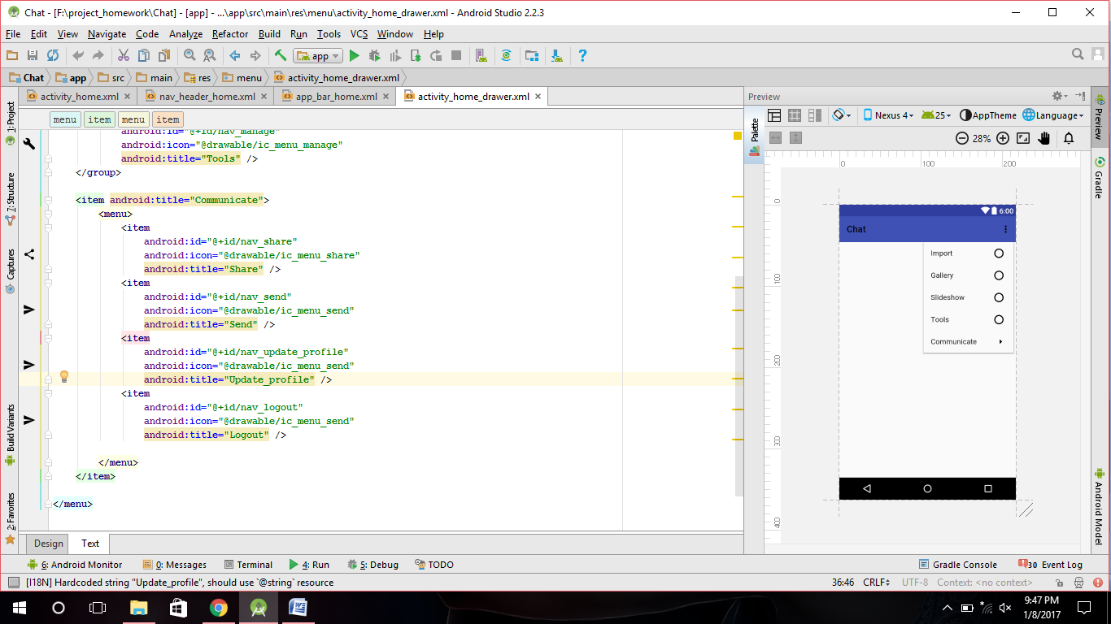

6.

Nav_header_home.xml

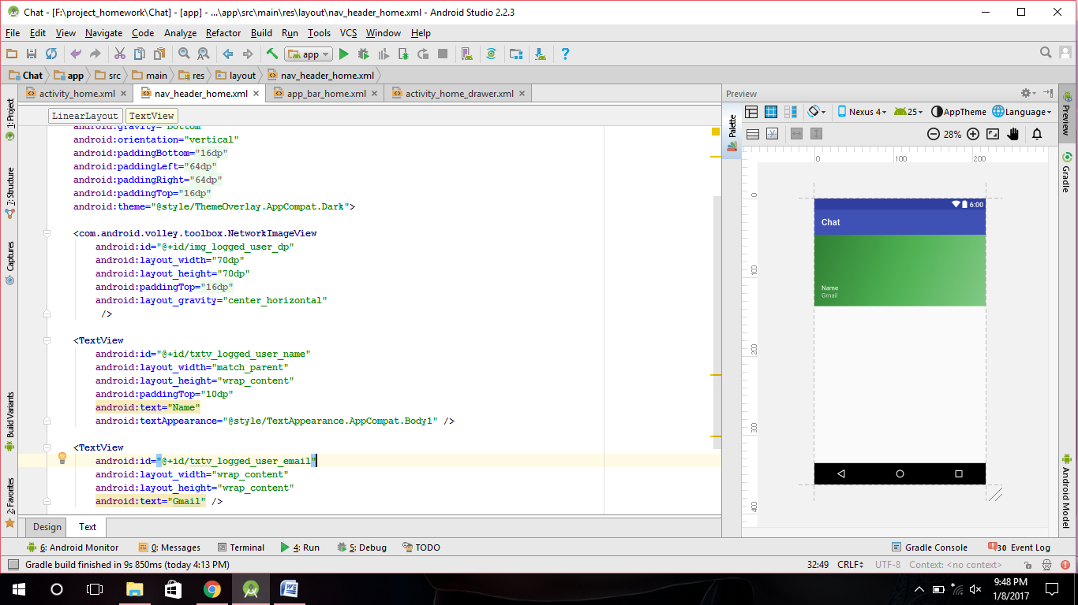

7.

app_bar_home.xml

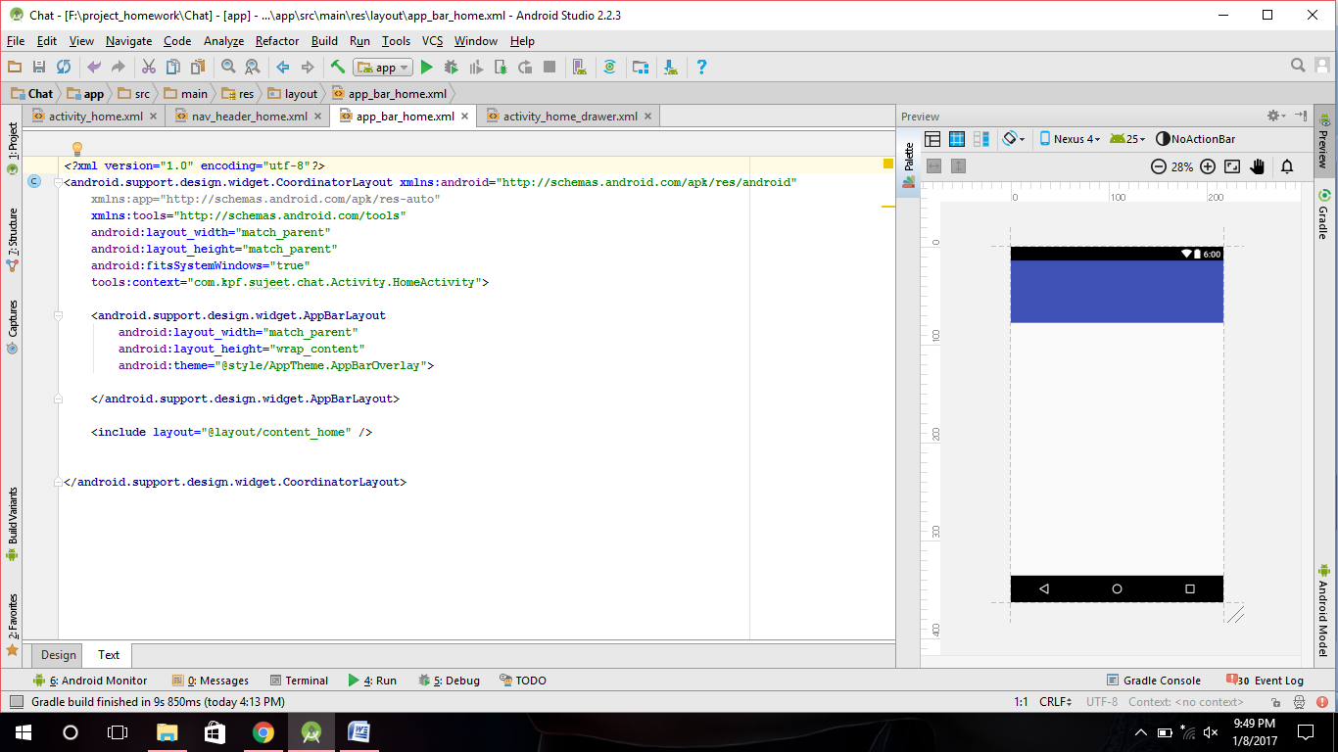

8.Fragments:

a).chat_list_layout.xml

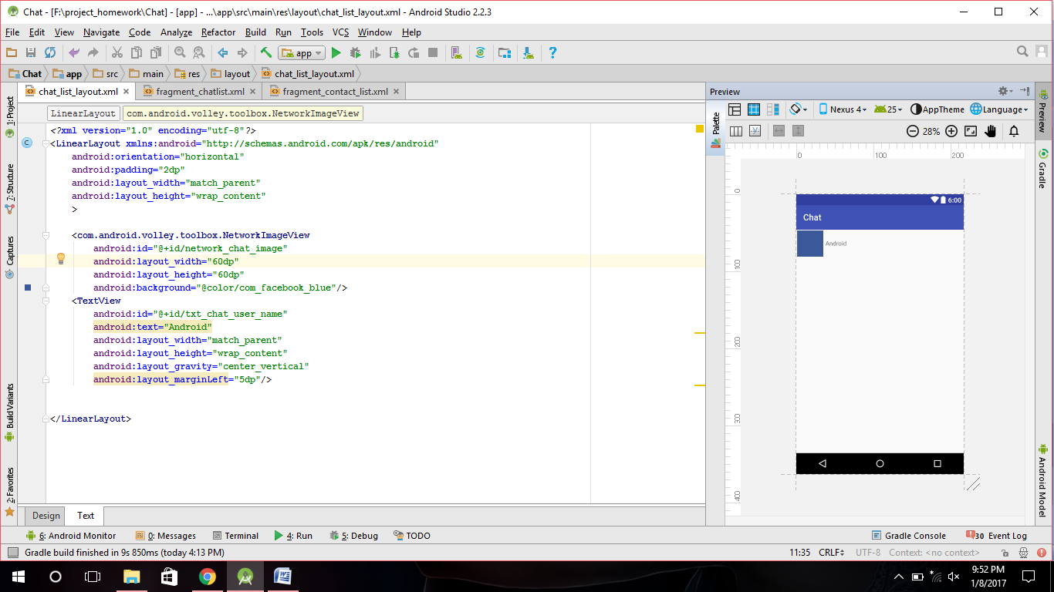

b).fragment_chatlist.xml

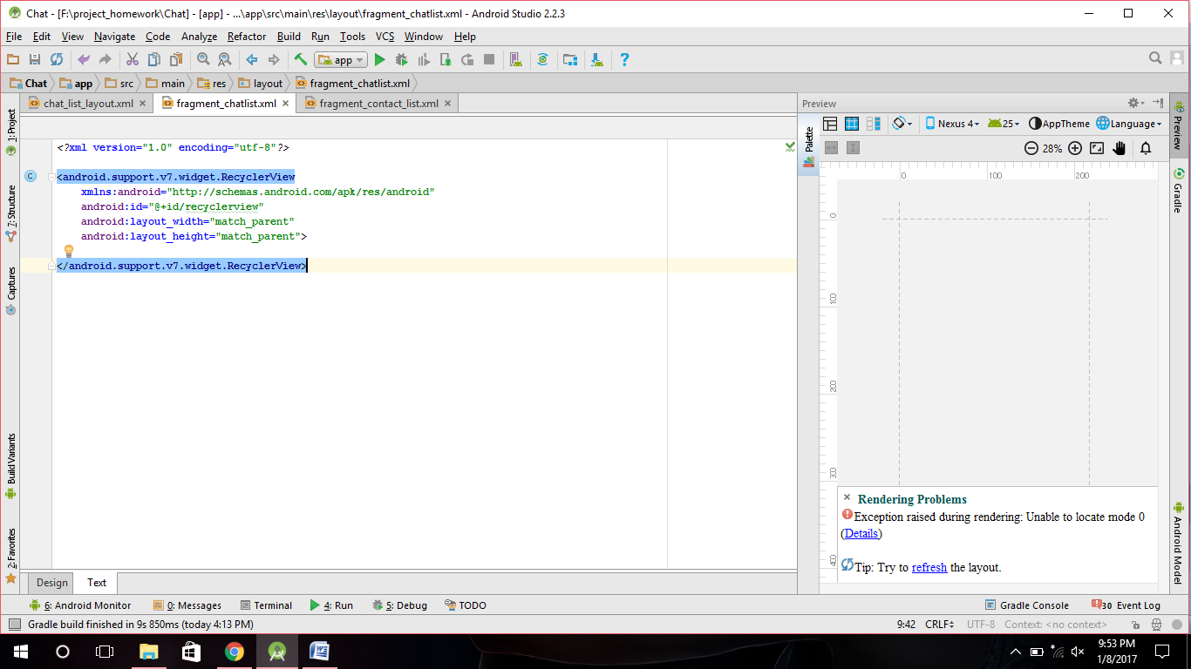

c).fragment_contact_list.xml

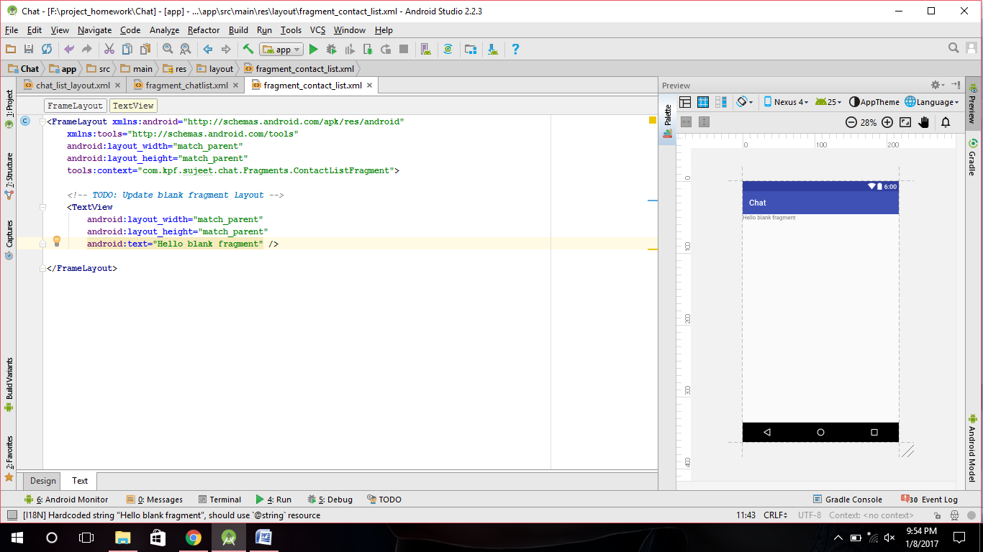

***1)Fragments:

ChatListFragment

ContactListFragment

2)Adapter:

ChatListRecyclerAdapter

PagerAdapter

3)CustomView:

MyNestedScrollView

WrapContentHeightViewPager

4)Models:

User

//for saving photourl to firebase ->database

5)Utils ->NetworkImageView

6)ChatListFragment.java

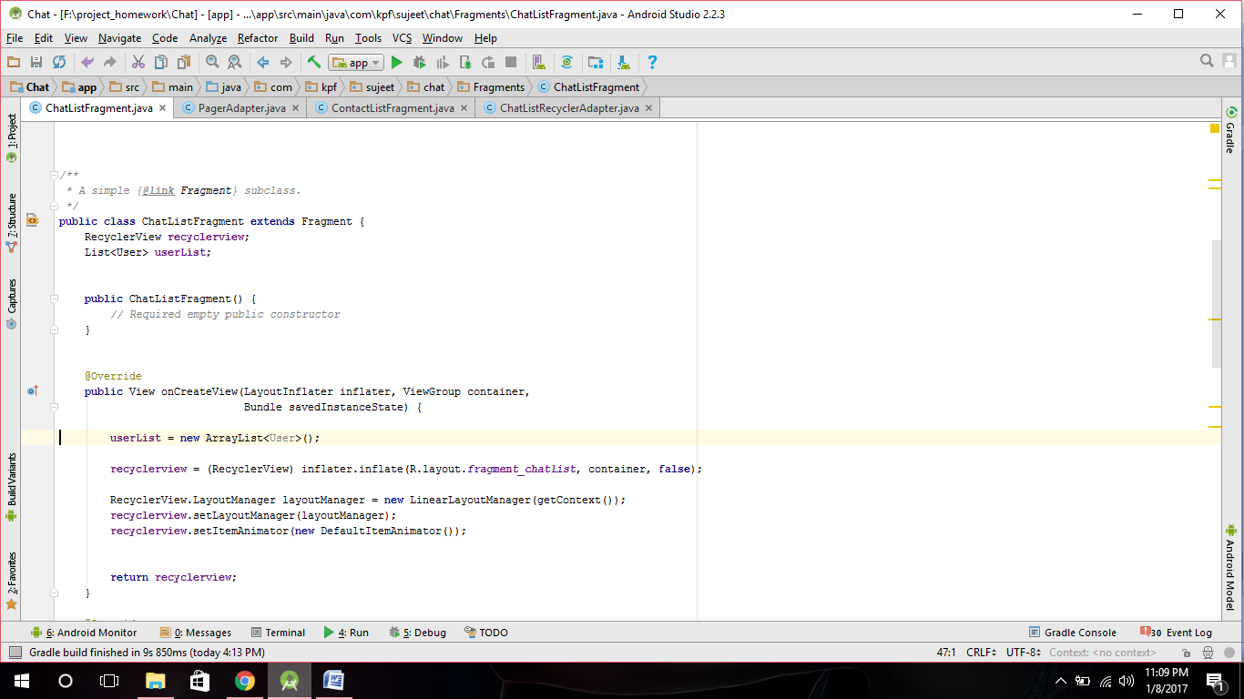

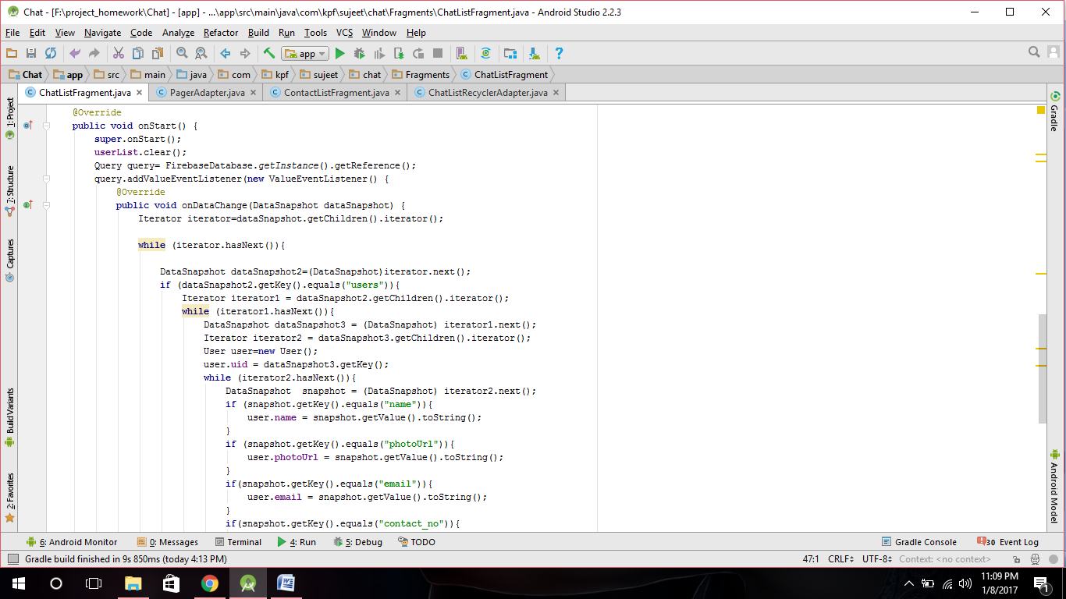

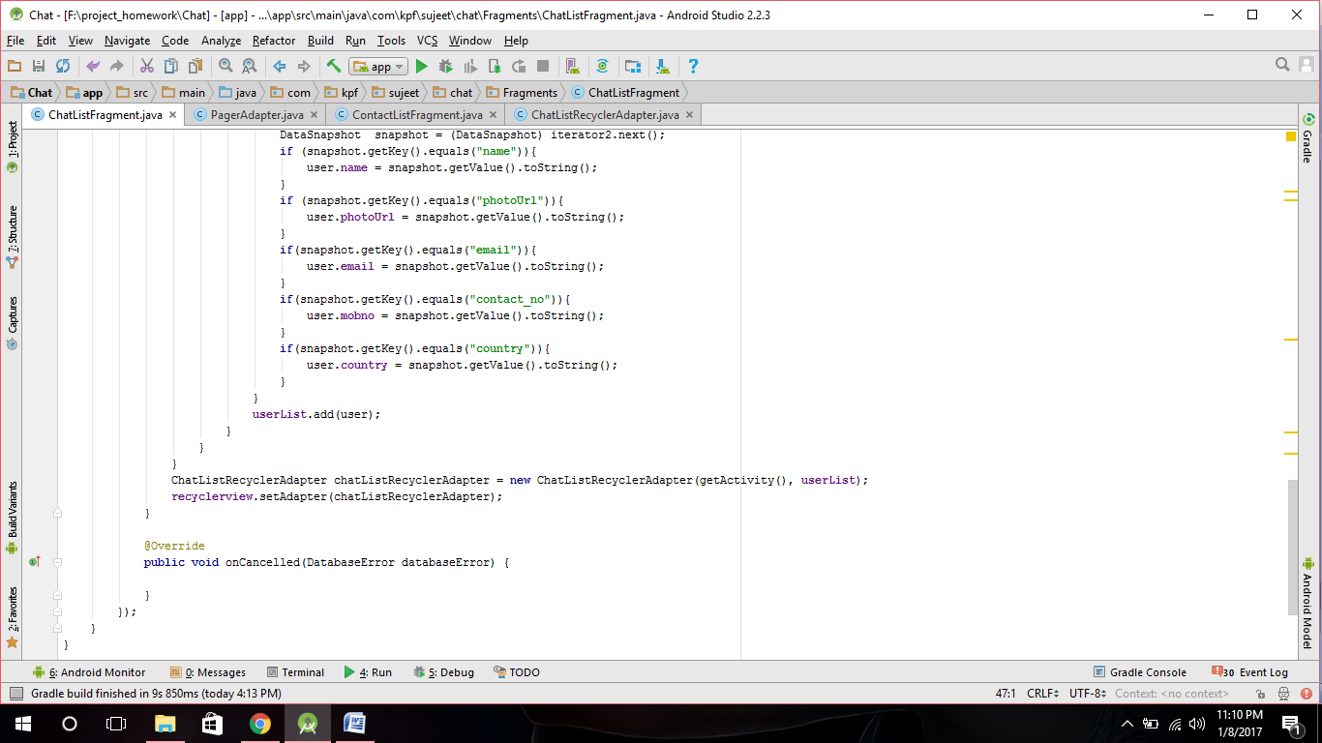

7)ChatListRecyclerAdapter.java

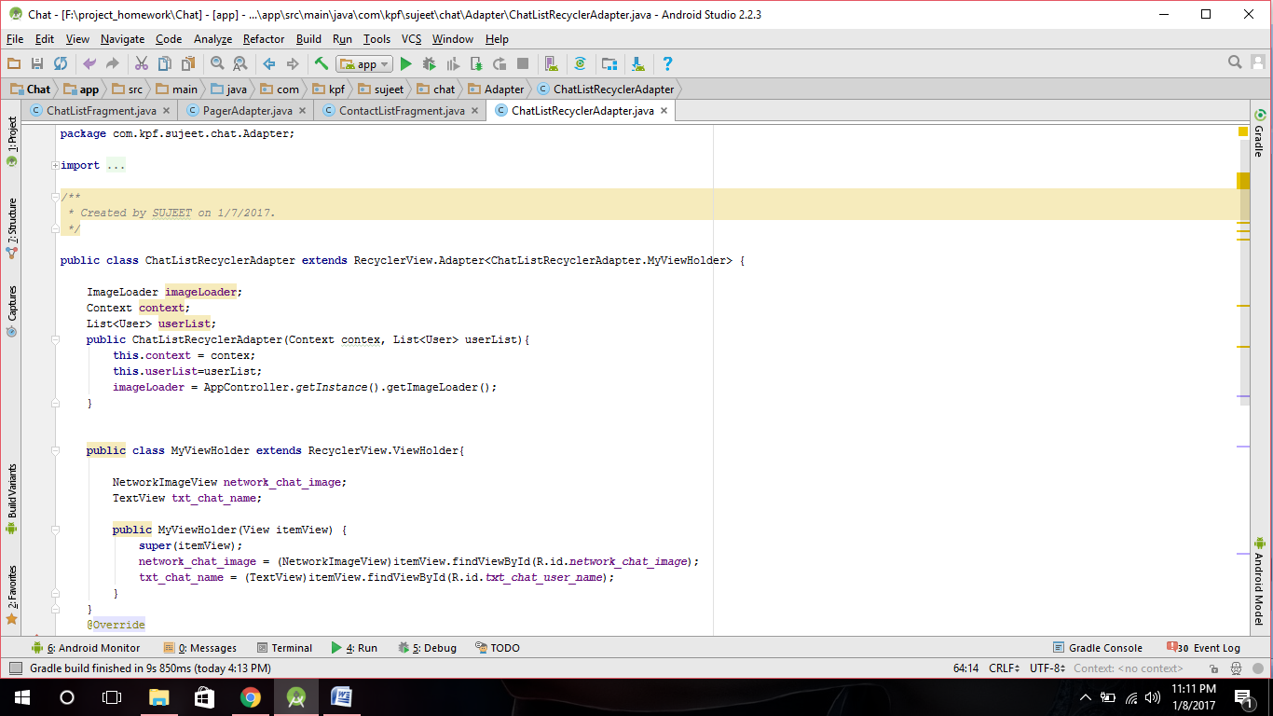

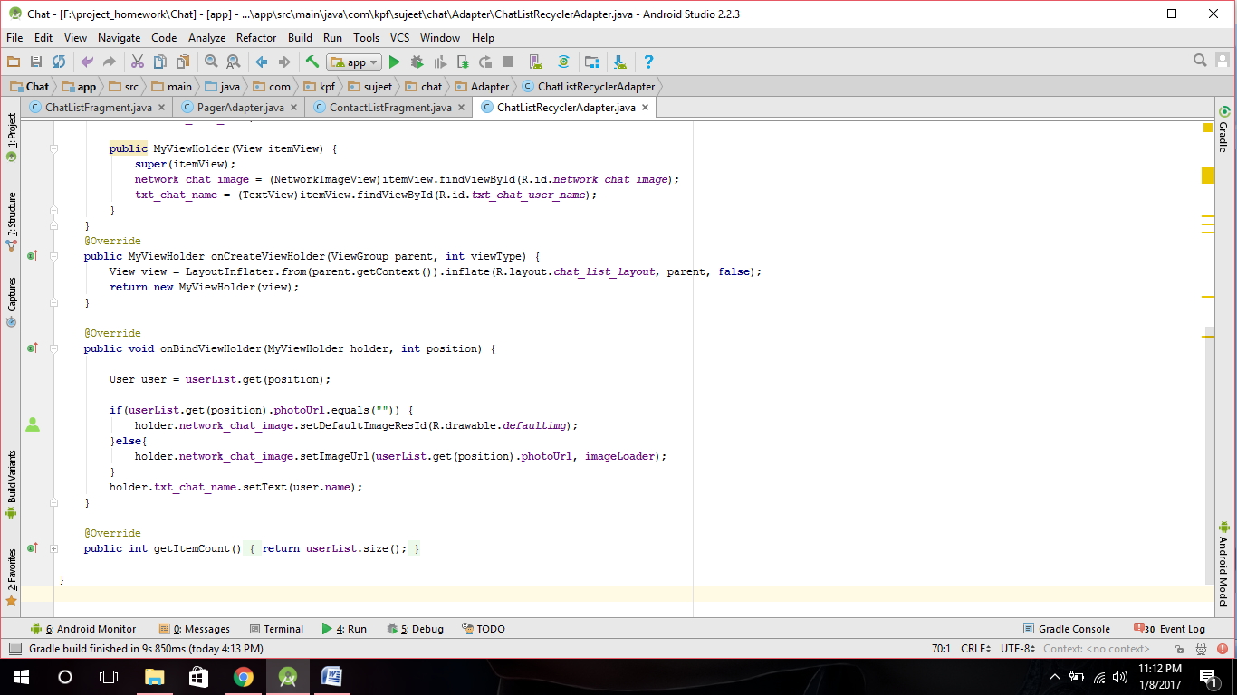

9).PagerAdapter.java

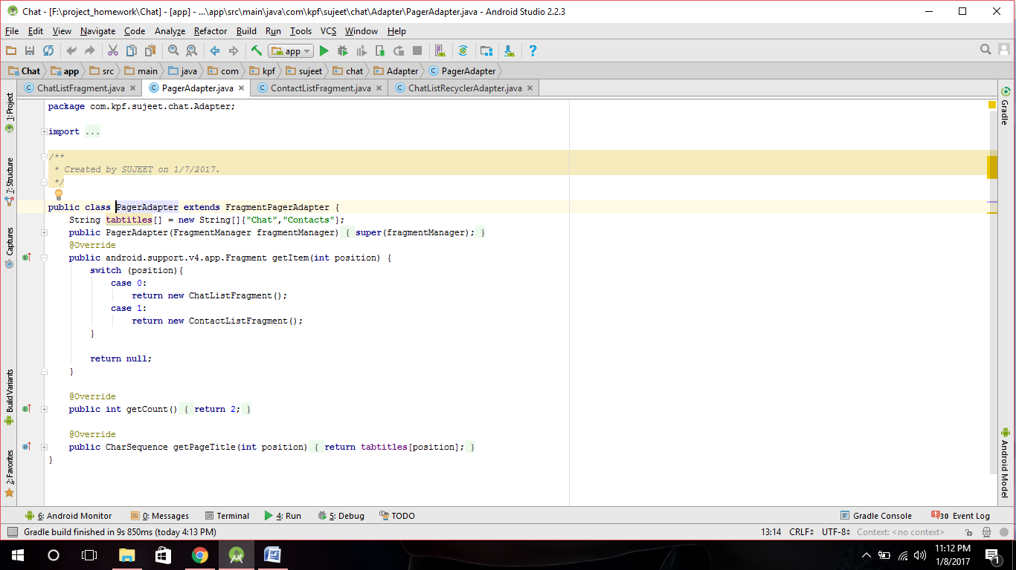

10)ContactListFragment.java

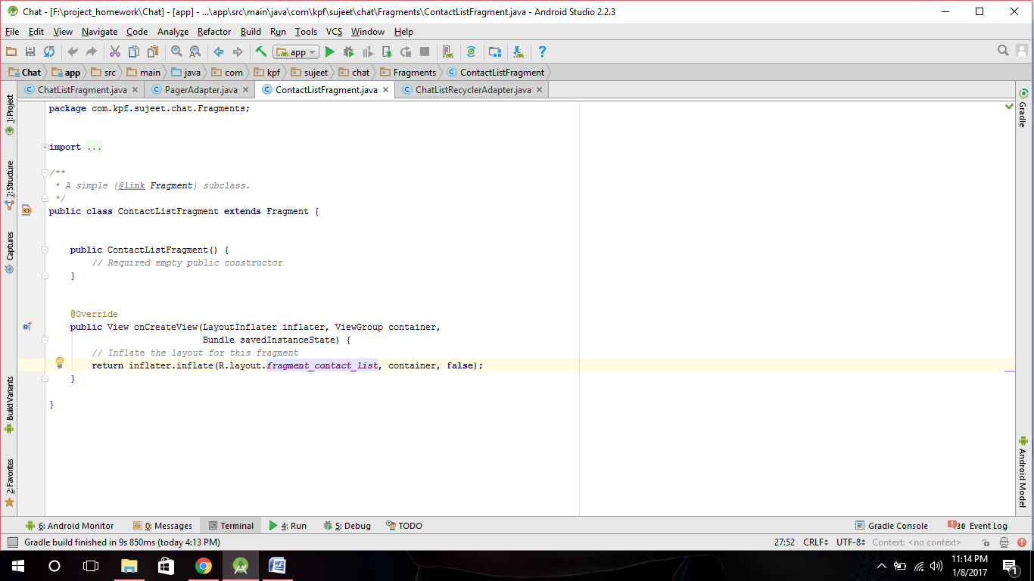

***) Image url saved in firebase database

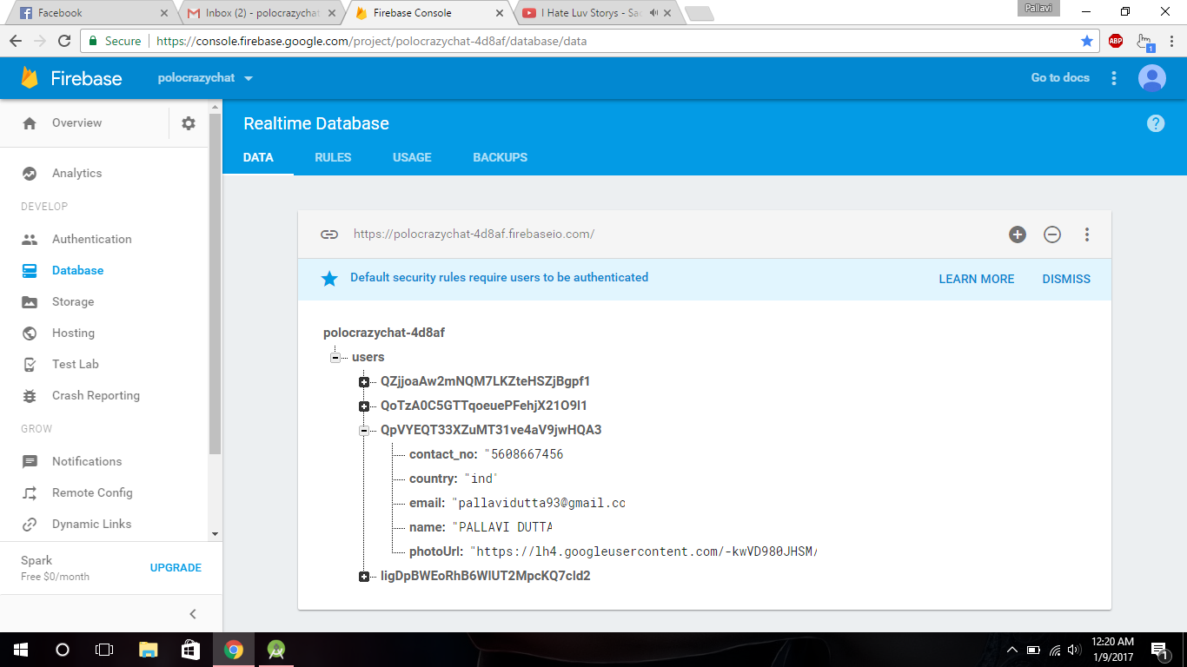

Sequence in view Pager

1)Layout ->

(In content_home.xml)

*<?***xml version="1.0" encoding="utf-8"***?>*<**android.support.design.widget.CoordinatorLayout  
 xmlns:android="http://schemas.android.com/apk/res/android"  
 xmlns:app="http://schemas.android.com/apk/res-auto"  
 xmlns:tools="http://schemas.android.com/tools"  
 tools:context=".Activity.HomeActivity"  
 android:layout_width="match_parent"  
 android:layout_height="match_parent"**>  
  
 <**android.support.design.widget.AppBarLayout  
 android:layout_width="match_parent"  
 android:layout_height="wrap_content"  
 android:theme="@style/ThemeOverlay.AppCompat.Dark.ActionBar"**>  
  
 <**android.support.design.widget.CollapsingToolbarLayout  
 android:layout_width="match_parent"  
 android:layout_height="match_parent"  
 android:fitsSystemWindows="true"  
 app:contentScrim="?attr/colorPrimary"  
 app:expandedTitleMarginEnd="64dp"  
 app:expandedTitleMarginStart="48dp"  
 app:layout_scrollFlags="scroll|exitUntilCollapsed"**>  
 <**LinearLayout  
 android:layout_width="match_parent"  
 android:layout_height="wrap_content"  
 android:orientation="vertical"**>  
  
 <**android.support.v7.widget.Toolbar  
 android:id="@+id/toolbar"  
 android:layout_width="match_parent"  
 android:layout_height="?attr/actionBarSize"  
 android:background="?attr/colorPrimary"  
 app:popupTheme="@style/AppTheme.PopupOverlay"** />  
  
 <**com.android.volley.toolbox.NetworkImageView  
 android:id="@+id/top_network_imageview"  
 android:layout_width="match_parent"  
 android:layout_height="wrap_content"** />  
  
  
 </**LinearLayout**>  
  
  
 </**android.support.design.widget.CollapsingToolbarLayout**>  
 <**android.support.design.widget.TabLayout  
 android:id="@+id/tab_layout"  
 android:layout_width="match_parent"  
 android:layout_height="?attr/actionBarSize"**>  
  
 </**android.support.design.widget.TabLayout**>  
 </**android.support.design.widget.AppBarLayout**>  
  
 <**com.kpf.sujeet.chat.CustomView.MyNestedScrollView  
 android:id="@+id/activity_main_nestedscrollview"  
 android:layout_width="match_parent"  
 android:layout_height="match_parent"  
 android:fillViewport="true"  
 app:layout_behavior="@string/appbar_scrolling_view_behavior"**>  
  
 <**com.kpf.sujeet.chat.CustomView.WrapContentHeightViewPager  
 android:id="@+id/viewpager"  
 android:layout_width="match_parent"  
 android:layout_height="match_parent"**/>  
  
  
 </**com.kpf.sujeet.chat.CustomView.MyNestedScrollView**>  
</**android.support.design.widget.CoordinatorLayout**>

*<Coordinator Layout

*<AppBarLayout

*<Collapsing ToolBar

LinearView ->ToolBar + NetworkImageView

* Collapsing ToolBar>

*<TabLayout>

*AppBarLayout>

*<ScrollView

<ViewPager>

*ScrollView>

2)HomeActivity.java(Inside Activity)

**tab_layout** = (TabLayout)findViewById(R.id.***tab_layout***);  
**viewpager** = (ViewPager)findViewById(R.id.***viewpager***);  
PagerAdapter pagerAdapter = **new** PagerAdapter(**getSupportFragmentManager()**);  
**viewpager**.setAdapter(**pagerAdapter**);  
**tab_layout**.setupWithViewPager(**viewpager**);

*tab_layout

*viewpager

*PagerAdapter: Base class providing the adapter to populate pages inside of a [ViewPager](https://developer.android.com/reference/android/support/v4/view/ViewPager.html).

*viewpager.setAdapter(pagerAdapter)

*tab_layout.setupWithViewPager(viewpager)

3)PagerAdapter(Inside Adapter)

**public class** PagerAdapter **extends** FragmentPagerAdapter {  
 String **tabtitles**[] = **new** String[]{**"Chat"**,**"Contacts"**};  
 **public** PagerAdapter(FragmentManager fragmentManager){  
 **super**(fragmentManager);  
 }  
 @Override  
 **public** android.support.v4.app.Fragment getItem(**int** position) {  
 **switch** (position){  
 **case** 0:  
 **return new ChatListFragment();**  
 **case** 1:  
 **return new** ContactListFragment();  
 }  
  
 **return null**;  
 }  
  
 @Override  
 **public int** getCount() {  
 **return** 2;  
 }  
  
 @Override  
 **public** CharSequence getPageTitle(**int** position) {  
 **return tabtitles**[position];  
 }

*PagerAdapter extends FragmentAdapter

*constructor-> PagerAdapter()

*override->getItem , getCount , getPageTitle

*//tabtitles[]

4)ChatListFragment

**package** com.kpf.sujeet.chat.Adapter;  
  
**import** android.content.Context;  
**import** android.support.v7.widget.RecyclerView;  
**import** android.view.LayoutInflater;  
**import** android.view.View;  
**import** android.view.ViewGroup;  
**import** android.widget.TextView;  
  
**import** com.android.volley.toolbox.ImageLoader;  
**import** com.android.volley.toolbox.NetworkImageView;  
**import** com.kpf.sujeet.chat.Models.User;  
**import** com.kpf.sujeet.chat.R;  
**import** com.kpf.sujeet.chat.Utils.AppController;  
  
**import** java.util.List;  
  
*/**  
 * Created by SUJEET on 1/7/2017.  
 */***public class** ChatListRecyclerAdapter **extends** RecyclerView.Adapter<ChatListRecyclerAdapter.MyViewHolder> {  
  
 ImageLoader **imageLoader**;  
 Context **context**;  
 List<User> **userList**;  
 **public** ChatListRecyclerAdapter(Context contex, List<User> userList){  
 **this**.**context** = contex;  
 **this**.**userList**=userList;  
 **imageLoader** = AppController.*getInstance*().getImageLoader();  
 }  
  
  
 **public class** MyViewHolder **extends** RecyclerView.ViewHolder{  
  
 NetworkImageView **network_chat_image**;  
 TextView **txt_chat_name**;  
  
 **public** MyViewHolder(View itemView) {  
 **super**(itemView);  
 **network_chat_image** = (NetworkImageView)itemView.findViewById(R.id.***network_chat_image***);  
 **txt_chat_name** = (TextView)itemView.findViewById(R.id.***txt_chat_user_name***);  
 }  
 }  
 @Override  
 **public** MyViewHolder onCreateViewHolder(ViewGroup parent, **int** viewType) {  
 View view = LayoutInflater.*from*(parent.getContext()).inflate(R.layout.***chat_list_layout***, parent, **false**);  
 **return new** MyViewHolder(view);  
 }  
  
 @Override  
 **public void** onBindViewHolder(MyViewHolder holder, **int** position) {  
  
 User user = **userList**.get(position);  
  
 **if**(**userList**.get(position).**photoUrl**.equals(**""**)) {  
 holder.**network_chat_image**.setDefaultImageResId(R.drawable.***defaultimg***);  
 }**else**{  
 holder.**network_chat_image**.setImageUrl(**userList**.get(position).**photoUrl**, **imageLoader**);  
 }  
 holder.**txt_chat_name**.setText(user.**name**);  
 }  
  
 @Override  
 **public int** getItemCount() {  
 **return userList**.size();  
 }  
  
}

Again step 4 and then step 5

**package** com.kpf.sujeet.chat.Adapter;  
  
**import** android.content.Context;  
**import** android.support.v7.widget.RecyclerView;  
**import** android.view.LayoutInflater;  
**import** android.view.View;  
**import** android.view.ViewGroup;  
**import** android.widget.TextView;  
  
**import** com.android.volley.toolbox.ImageLoader;  
**import** com.android.volley.toolbox.NetworkImageView;  
**import** com.kpf.sujeet.chat.Models.User;  
**import** com.kpf.sujeet.chat.R;  
**import** com.kpf.sujeet.chat.Utils.AppController;  
  
**import** java.util.List;  
  
*/**  
 * Created by SUJEET on 1/7/2017.  
 */***public class** ChatListRecyclerAdapter **extends 1**.RecyclerView.Adapter<ChatListRecyclerAdapter.**3**MyViewHolder> {  
  
 ImageLoader **imageLoader**;  
 **5** Context **context**;  
 List<User> **userList**;  
 **public** ChatListRecyclerAdapter(Context contex, List<User> userList){  
 **this**.**context** = contex;  
 **this**.**userList**=userList;  
 **imageLoader** = AppController.*getInstance*().getImageLoader();  
 }  
  
  
 **2.** **public class** MyViewHolder **extends** RecyclerView.ViewHolder`{  
  
 NetworkImageView **network_chat_image**;  
 TextView **txt_chat_name**;  
  
 **public** MyViewHolder(View itemView) {  
 **super**(itemView);  
 **network_chat_image** = (NetworkImageView)itemView.findViewById(R.id.***network_chat_image***);  
 **txt_chat_name** = (TextView)itemView.findViewById(R.id.***txt_chat_user_name***);  
 }  
 }  
 @Override  
 **public** MyViewHolder onCreateViewHolder(ViewGroup parent, **int** viewType) {  
 **4.** View view = LayoutInflater.*from*(parent.getContext()).inflate(R.layout.***chat_list_layout***, parent, **false**);  
 **return new** MyViewHolder(view);  
 }  
  
 @Override  
 **6** **public void** onBindViewHolder(MyViewHolder holder, **int** position) {  
  
 User user = **userList**.get(position);  
  
 **if**(**userList**.get(position).**photoUrl**.equals(**""**)) {  
 holder.**network_chat_image**.setDefaultImageResId(R.drawable.***defaultimg***);  
 }**else**{  
 holder.**network_chat_image**.setImageUrl(**userList**.get(position).**photoUrl**, **imageLoader**);  
 }  
 holder.**txt_chat_name**.setText(user.**name**);  
 }  
  
 @Override  
 **7** **public int** getItemCount() {  
 **return userList**.size();  
 }  
  
}

8ChatListFragment

**package** com.kpf.sujeet.chat.Fragments;  
  
  
**import** android.os.Bundle;  
**import** android.support.v4.app.Fragment;  
**import** android.support.v7.widget.DefaultItemAnimator;  
**import** android.support.v7.widget.LinearLayoutManager;  
**import** android.support.v7.widget.RecyclerView;  
**import** android.view.LayoutInflater;  
**import** android.view.View;  
**import** android.view.ViewGroup;  
**import** android.widget.TextView;  
  
**import** com.google.firebase.auth.FirebaseAuth;  
**import** com.google.firebase.database.DataSnapshot;  
**import** com.google.firebase.database.DatabaseError;  
**import** com.google.firebase.database.FirebaseDatabase;  
**import** com.google.firebase.database.Query;  
**import** com.google.firebase.database.ValueEventListener;  
**import** com.kpf.sujeet.chat.Adapter.ChatListRecyclerAdapter;  
**import** com.kpf.sujeet.chat.Models.User;  
**import** com.kpf.sujeet.chat.R;  
  
**import** java.util.ArrayList;  
**import** java.util.Iterator;  
**import** java.util.List;  
  
  
  
*/**  
 * A simple {****@link*** *Fragment} subclass.  
 */***public class** ChatListFragment **extends** Fragment {  
 RecyclerView **recyclerview**;  
 List<User> **userList**;  
  
  
 **public** ChatListFragment() {  
 *// Required empty public constructor* }  
  
  
 @Override  
 **public** View onCreateView(LayoutInflater inflater, ViewGroup container,  
 Bundle savedInstanceState) {  
  
 **userList** = **new** ArrayList<User>();  
  
 **recyclerview** = (RecyclerView) inflater.inflate(R.layout.***fragment_chatlist***, container, **false**);  
  
 RecyclerView.LayoutManager layoutManager = **new** LinearLayoutManager(getContext());  
 **recyclerview**.setLayoutManager(layoutManager);  
 **recyclerview**.setItemAnimator(**new** DefaultItemAnimator());

ContactListFragment

1.code

2.manifest permission

3.gradle dependency

**package** com.kpf.sujeet.chat.Fragments;  
  
  
**import** android.database.Cursor;  
**import** android.os.Bundle;  
**import** android.provider.ContactsContract;  
**import** android.support.v4.app.Fragment;  
**import** android.support.v7.widget.DefaultItemAnimator;  
**import** android.support.v7.widget.LinearLayoutManager;  
**import** android.support.v7.widget.RecyclerView;  
**import** android.view.LayoutInflater;  
**import** android.view.View;  
**import** android.view.ViewGroup;  
  
**import** com.kpf.sujeet.chat.Adapter.ChatListRecyclerAdapter;  
**import** com.kpf.sujeet.chat.Models.User;  
**import** com.kpf.sujeet.chat.R;  
  
**import** java.util.ArrayList;  
**import** java.util.List;  
  
**import static** com.kpf.sujeet.chat.R.id.***recyclerview***;  
  
*/**  
 * A simple {****@link*** *Fragment} subclass.  
 */***public class** ContactListFragment **extends** Fragment {  
  
 List<User> **phoneContactList**;  
 RecyclerView **recyclerview**;  
  
 **public** ContactListFragment() {  
 *// Required empty public constructor* }  
  
  
 @Override  
 **public** View onCreateView(LayoutInflater inflater, ViewGroup container,  
 Bundle savedInstanceState) {  
 **phoneContactList** = **new** ArrayList<User>();  
 *// Inflate the layout for this fragment* **recyclerview** = (RecyclerView) inflater.inflate(R.layout.***fragment_chatlist***, container, **false**);  
  
 RecyclerView.LayoutManager layoutManager = **new** LinearLayoutManager(getContext());  
 **recyclerview**.setLayoutManager(layoutManager);  
 **recyclerview**.setItemAnimator(**new** DefaultItemAnimator());  
  
  
 **return recyclerview**;  
 }  
  
 @Override  
 **public void** onStart() {  
 **super**.onStart();  
  
 **phoneContactList**.clear();  
 Cursor cursor = getActivity().getContentResolver().query(ContactsContract.Contacts.***CONTENT_URI***, **null**, **null**, **null**, **"upper("**+ContactsContract.CommonDataKinds.Phone.***DISPLAY_NAME***+**") ASC"**);  
 *//Cursor cursor= getActivity().getContentResolver().query(ContactsContract.Contacts.CONTENT_URI,null,null,null,null);* **if**(cursor.moveToFirst())  
 {  
  
 **do**{  
 String id = cursor.getString(cursor.getColumnIndex(ContactsContract.Contacts.***_ID***));

//to remove space in phone no

**if**(Integer.*parseInt*(cursor.getString(cursor.getColumnIndex(ContactsContract.Contacts.***HAS_PHONE_NUMBER***)))>0)  
 {  
 Cursor pCur = getActivity().getContentResolver().query(ContactsContract.CommonDataKinds.Phone.***CONTENT_URI***,**null**,ContactsContract.CommonDataKinds.Phone.***CONTACT_ID***+**" = ? "**,**new** String[]{id },**null**);  
 **while** (pCur.moveToNext())  
 {  
 String contactNumber = pCur.getString(pCur.getColumnIndex(ContactsContract.CommonDataKinds.Phone.***NUMBER***));  
 String contactName = pCur.getString(pCur.getColumnIndex(ContactsContract.CommonDataKinds.Phone.***DISPLAY_NAME***));  
  
 User user = **new** User();  
 user.**name** = contactName+**" -> "**+contactNumber;  
 **phoneContactList**.add(user);  
 **break**;  
  
 }  
 pCur.close();  
  
 }  
  
 }**while** (cursor.moveToNext());  
 ChatListRecyclerAdapter chatListRecyclerAdapter = **new** ChatListRecyclerAdapter(getActivity(),**phoneContactList**);  
 **recyclerview**.setAdapter(chatListRecyclerAdapter);  
 }  
 }  
  
}

2. <**uses-permission android:name="android.permission.INTERNET"** />  
<**uses-permission android:name="android.permission.READ_CONTACTS"** />

3.  
android {  
 compileSdkVersion 25  
 buildToolsVersion **"25.0.0"** defaultConfig {  
 applicationId **"com.kpf.sujeet.chat"** minSdkVersion 15  
 targetSdkVersion 25  
 versionCode 1  
 versionName **"1.0"** testInstrumentationRunner **"android.support.test.runner.AndroidJUnitRunner"** multiDexEnabled **true** }  
 buildTypes {  
 release {  
 minifyEnabled **false** proguardFiles getDefaultProguardFile(**'proguard-android.txt'**), **'proguard-rules.pro'** }  
 debug {  
 debuggable **true** }  
  
 }  
}