App Id icon set

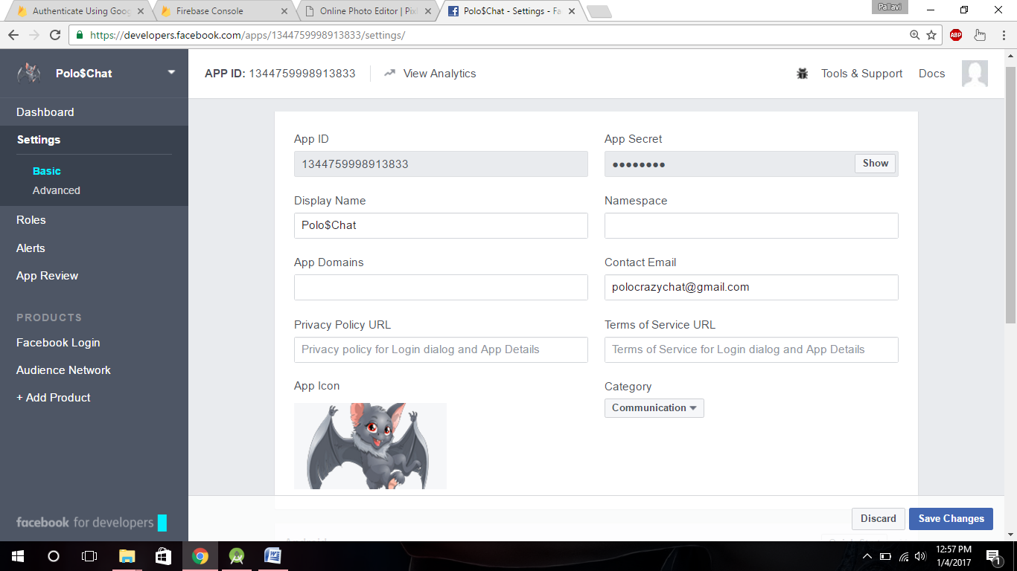

2.Photo editor Pixlr (size 1024X1024 and all possible sizes)

<https://pixlr.com/editor/>