1.Navigation drawer:

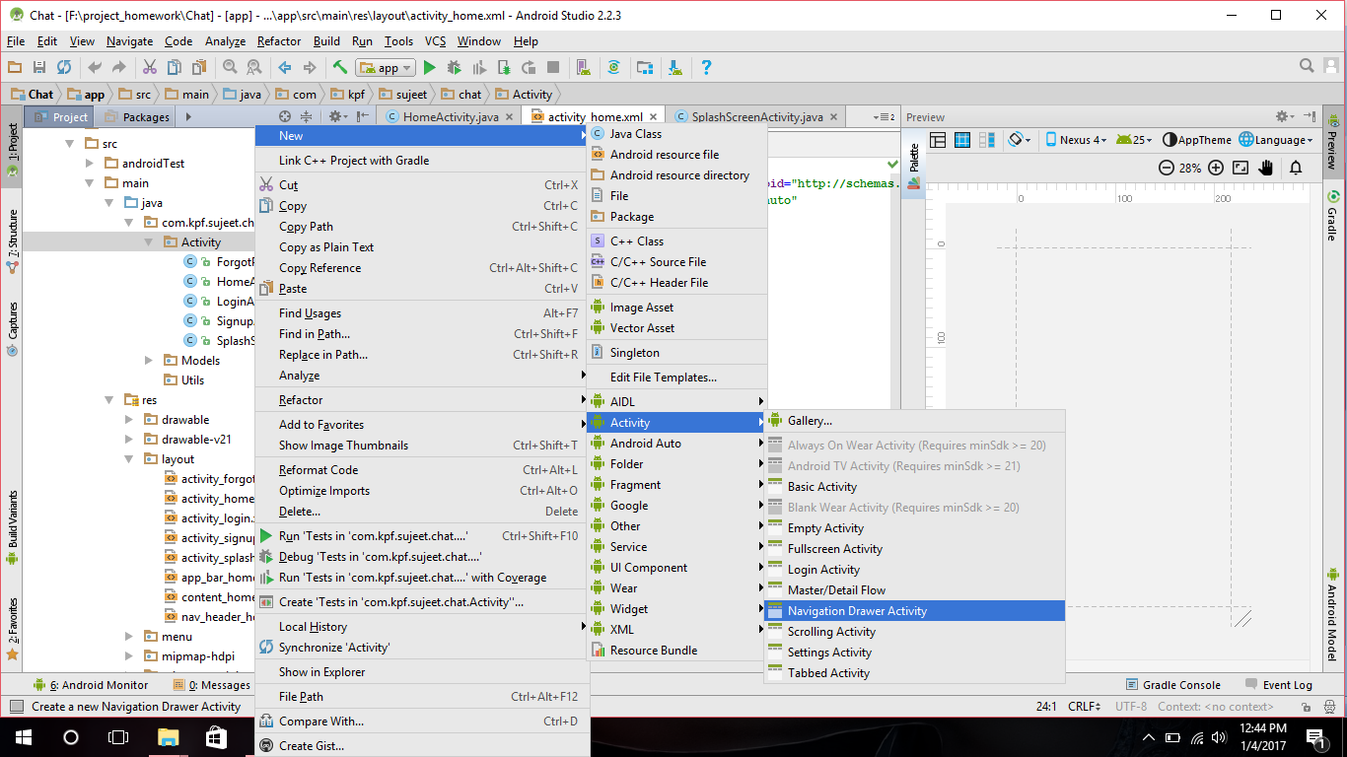

2.

<**android.support.design.widget.NavigationView  
 android:id="@+id/nav_view"  
 android:layout_width="wrap_content"  
 android:layout_height="match_parent"  
 android:layout_gravity="start"  
 android:fitsSystemWindows="true"**

**app:headerLayout="@layout/nav_header_home" //header  
 app:menu="@menu/activity_home_drawer"** /> //drawer

3.ctrl+click on //header

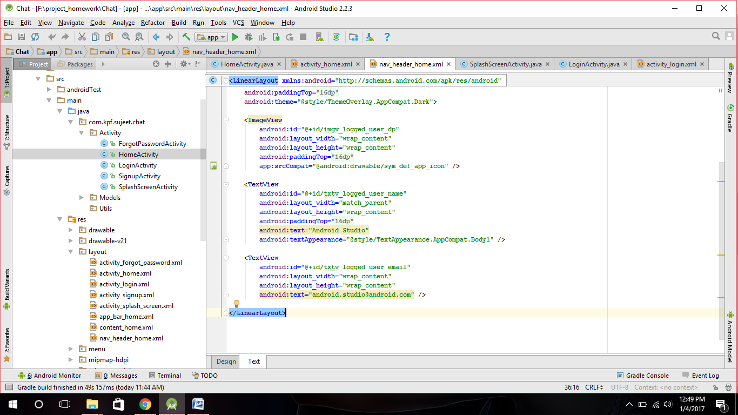

4.ctrl+click on //drawer

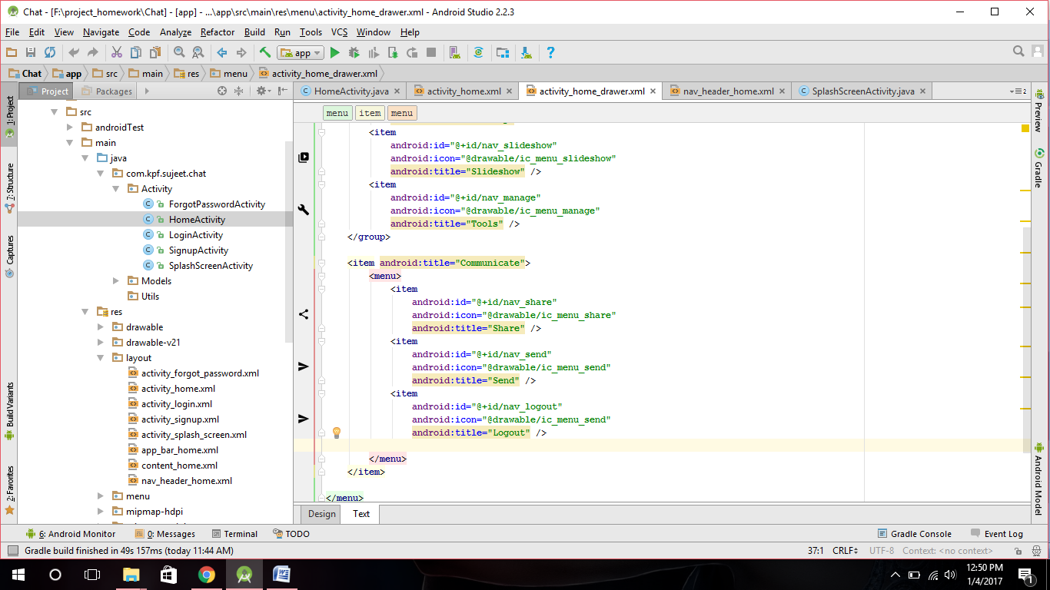

5.change navigation (view on layout)

6.In HomeScreenActivity

**public class** HomeActivity **extends** AppCompatActivity  
 **implements** NavigationView.OnNavigationItemSelectedListener {  
  
 ImageView **imgv_logged_user_dp**;  
 TextView **txtv_logged_user_name**;  
 TextView **txtv_logged_user_email**;

7.

@Override  
 **protected void** onCreate(Bundle savedInstanceState) {  
 **super**.onCreate(savedInstanceState);  
 setContentView(R.layout.***activity_home***);

//some lines of code  
  
  
  
  
  
 NavigationView navigationView = (NavigationView) findViewById(R.id.***nav_view***);  
 navigationView.setNavigationItemSelectedListener(**this**);  
  
  
 View header=navigationView.getHeaderView(0);  
 */*View view=navigationView.inflateHeaderView(R.layout.nav_header_main);*/* **txtv_logged_user_name**=(TextView)header.findViewById(R.id.***txtv_logged_user_name***);  
 **txtv_logged_user_email**=(TextView)header.findViewById(R.id.***txtv_logged_user_email***);  
 **imgv_logged_user_dp**=(ImageView)header.findViewById(R.id.***imgv_logged_user_dp***);  
  
 **if**(FirebaseAuth.*getInstance*().getCurrentUser() !=**null**){  
 FirebaseUser user=FirebaseAuth.*getInstance*().getCurrentUser();  
 **if**(user !=**null**){  
 String name=user.getDisplayName();  
 String email=user.getEmail();  
 Uri photoUrl=user.getPhotoUrl();  
*// imgv_logged_user_dp.setImageURI(photoUrl);* **txtv_logged_user_name**.setText(name);  
 **txtv_logged_user_email**.setText(email);  
  
  
 }  
 **else** {  
 Toast.*makeText*(**this**, **"No User"**, Toast.***LENGTH_SHORT***).show();  
 }  
 }  
  
 }

8.

@Override  
**public boolean** onNavigationItemSelected(MenuItem item) {  
 *// Handle navigation view item clicks here.* **int** id = item.getItemId();  
  
 **if** (id == R.id.***nav_camera***) {  
 *// Handle the camera action* } **else if** (id == R.id.***nav_gallery***) {  
  
 } **else if** (id == R.id.***nav_slideshow***) {  
  
 } **else if** (id == R.id.***nav_manage***) {  
  
 } **else if** (id == R.id.***nav_share***) {  
  
 } **else if** (id == R.id.***nav_send***) {  
  
 } **else if** (id == R.id.***nav_logout***){  
  
 FirebaseAuth.*getInstance*().signOut();*//firebase logout* startActivity(**new** Intent(**this**,LoginActivity.**class**));  
  
  
  
  
  
  
 }