\*\*\*.how to read error(debug)

1.Click on Debug app(shifyt+F9)

2.Force stop on mobile

3.

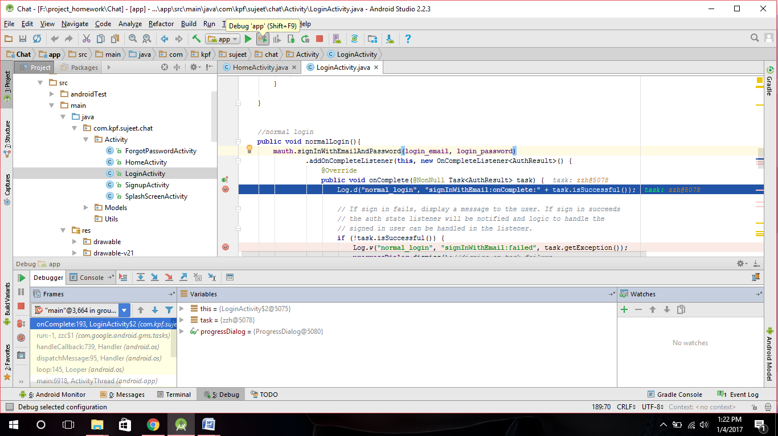

4.now see the values in task

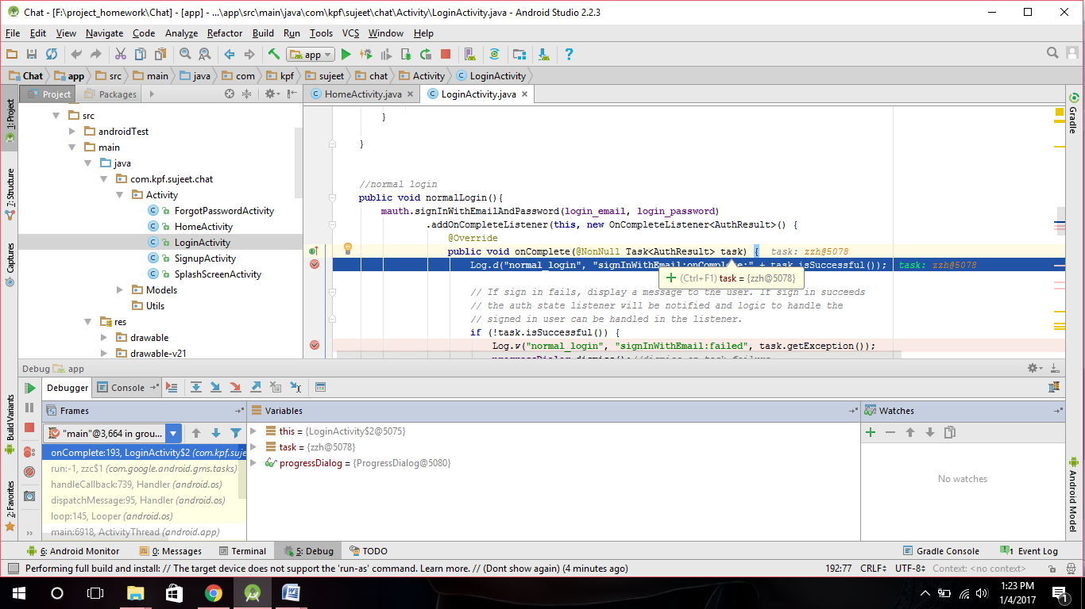

5.

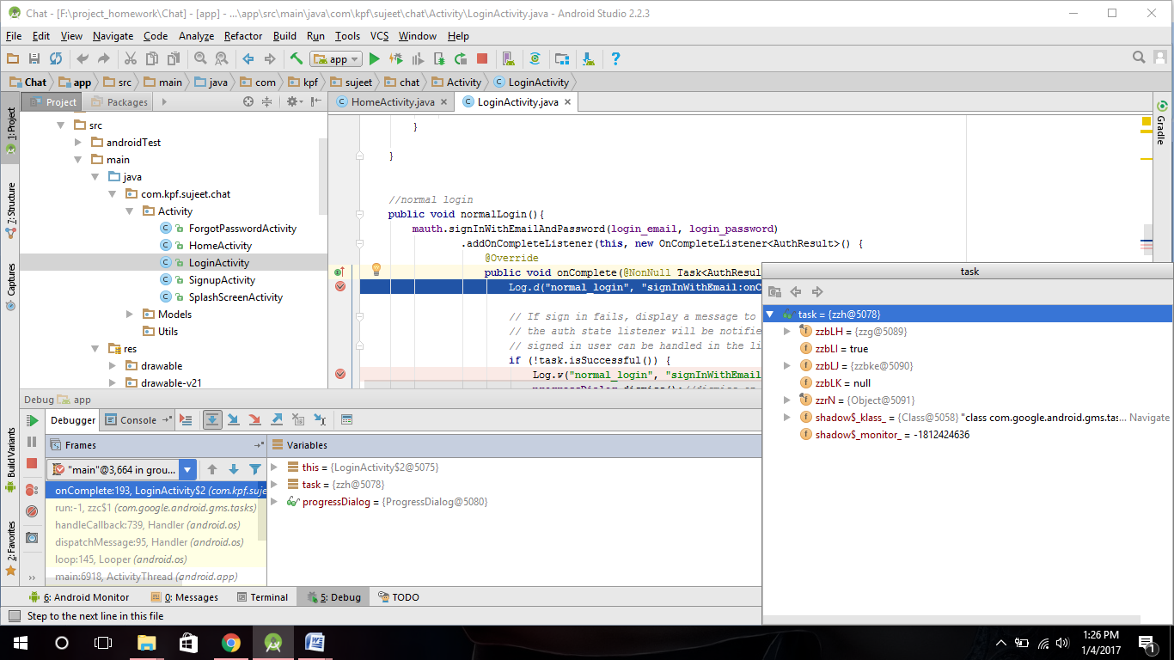

6.go to next step debug by button in “Debugger” at bottom.

