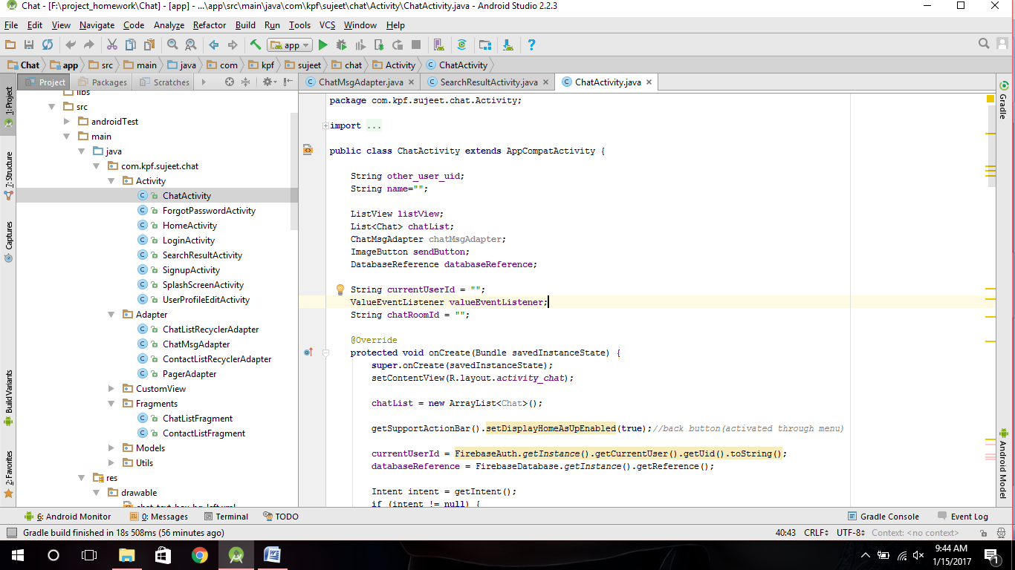

#.ChatActivity

1.

String **other_user_uid**;  
String **name**=**""**;  
  
ListView **listView**;  
List<Chat> **chatList**;  
ChatMsgAdapter **chatMsgAdapter**;  
ImageButton **sendButton**;  
DatabaseReference **databaseReference**;  
  
String **currentUserId** = **""**;  
ValueEventListener **valueEventListener**;  
String **chatRoomId** = **""**;

2.

**chatList** = **new** ArrayList<Chat>();

3.

**currentUserId** = FirebaseAuth.*getInstance*().getCurrentUser().getUid().toString();  
 **databaseReference** = FirebaseDatabase.*getInstance*().getReference();  
  
 Intent intent = getIntent();  
 **if** (intent != **null**) {  
 **other_user_uid** = getIntent().getStringExtra(**"other_user_uid"**);  
 **name** = getIntent().getStringExtra(**"name"**);  
 }**if** (!**name**.equals(**""**)) {  
 setTitle(**name**);  
 }  
  
 **listView** = (ListView)findViewById(R.id.***listView***);  
 **sendButton** =(ImageButton)findViewById(R.id.***sendMessageButton***);  
  
 **sendButton**.setOnClickListener(**new** View.OnClickListener() {  
 @Override  
 **public void** onClick(View view) {  
 sendMessage();  
 }  
 });  
  
}

4.

**public void** sendMessage(){  
  
 String timeStamp = **""**;  
 EditText inputText =(EditText)findViewById(R.id.***messageEditText***);  
 String input=inputText.getText().toString();  
 **if**(**chatRoomId**.equals(**""**)){  
 **chatRoomId** = **currentUserId**+**":"**+**other_user_uid**;  
 }  
 **if**(!input.equals(**""**) && !**currentUserId**.equals(**""**) && !**other_user_uid**.equals(**""**) ){  
 Long timeStampLong = System.*currentTimeMillis*()/1000;  
 timeStamp =timeStampLong.toString();  
 Chat chat=**new** Chat(input,**currentUserId**,timeStamp,**true**);  
 Map<String,Object> postValues = chat.toMap();  
  
 Map<String,Object> childUpdates = **new** HashMap<>();  
 childUpdates.put(**"/chat/"**+**chatRoomId**+**"/"**+timeStamp,postValues);  
  
 **databaseReference**.updateChildren(childUpdates);  
  
 inputText.setText(**""**);  
 }  
 }  
}

5.

@Override  
**protected void** onStart() {  
 **super**.onStart();  
  
 ValueEventListener eventListener = **new** ValueEventListener() {  
 @Override  
 **public void** onDataChange(DataSnapshot dataSnapshot) {  
 **chatList**.clear();  
  
 **if** (dataSnapshot.getValue() != **null**) {  
 DataSnapshot child;  
 Iterator iterator = dataSnapshot.getChildren().iterator();  
 **while** (iterator.hasNext()) {  
 child = (DataSnapshot) iterator.next();  
 **if** (child.getKey().equals(**"chat"**)) {  
 Iterator chatRoomIterator = child.getChildren().iterator();  
 **while** (chatRoomIterator.hasNext()) {  
 DataSnapshot chatRoomSnapshot = (DataSnapshot) chatRoomIterator.next();  
 **if** (chatRoomSnapshot.getKey().equals(**currentUserId** + **":"** + **other_user_uid**)) {  
  
 **chatRoomId** = **currentUserId** + **":"** + **other_user_uid**;  
  
 Iterator iterator1 = chatRoomSnapshot.getChildren().iterator();  
 **while** (iterator1.hasNext()) {  
 DataSnapshot snapshot = (DataSnapshot) iterator1.next();  
  
 Chat chat = snapshot.getValue(Chat.**class**);  
 **chatList**.add(chat);  
 }  
 } **else if** (chatRoomSnapshot.getKey().equals(**other_user_uid** + **":"** + **currentUserId**)) {  
  
 **chatRoomId** = **other_user_uid** + **":"** + **currentUserId**;  
 Iterator iterator1 = chatRoomSnapshot.getChildren().iterator();  
 **while** (iterator1.hasNext()) {  
 DataSnapshot snapshot = (DataSnapshot) iterator1.next();  
  
 Chat chat = snapshot.getValue(Chat.**class**);  
 **chatList**.add(chat);  
  
 }  
 }  
 }  
 }  
 }  
  
 }

6.

ChatMsgAdapter chatMsgAdapter = **new** ChatMsgAdapter(ChatActivity.**this**,**chatList**);  
 **listView**.setAdapter(chatMsgAdapter);  
 **listView**.setSelection(**chatList**.size()-1);  
 }  
  
 @Override  
 **public void** onCancelled(DatabaseError databaseError) {  
  
 }  
 };

7.

**databaseReference**.addValueEventListener(eventListener);  
 **valueEventListener** = eventListener;  
}

8.  
@Override  
**protected void** onStop() {  
 **super**.onStop();  
 **if**(**valueEventListener**!=**null**){  
 **databaseReference**.child(**"chat"**).removeEventListener(**valueEventListener**);  
 }  
}

ChatMsgAdapter code as it is.