#.Copy these:

*Activity ->SearchResultActivity(1)

*Adapter ->ChatMsgAdapter(2)

*res->drawable->

send.png(3),

send_selected.png(4),

send_btn.xml(5),

chat_text_box_bg_left.xml(6),

chat_text_box_right.xml(7)

*layout

activity_chat.xml(8)

chat_message.xml(9)

activity_search_result.xml(10)

*menu ->

options->menu.xml(11)

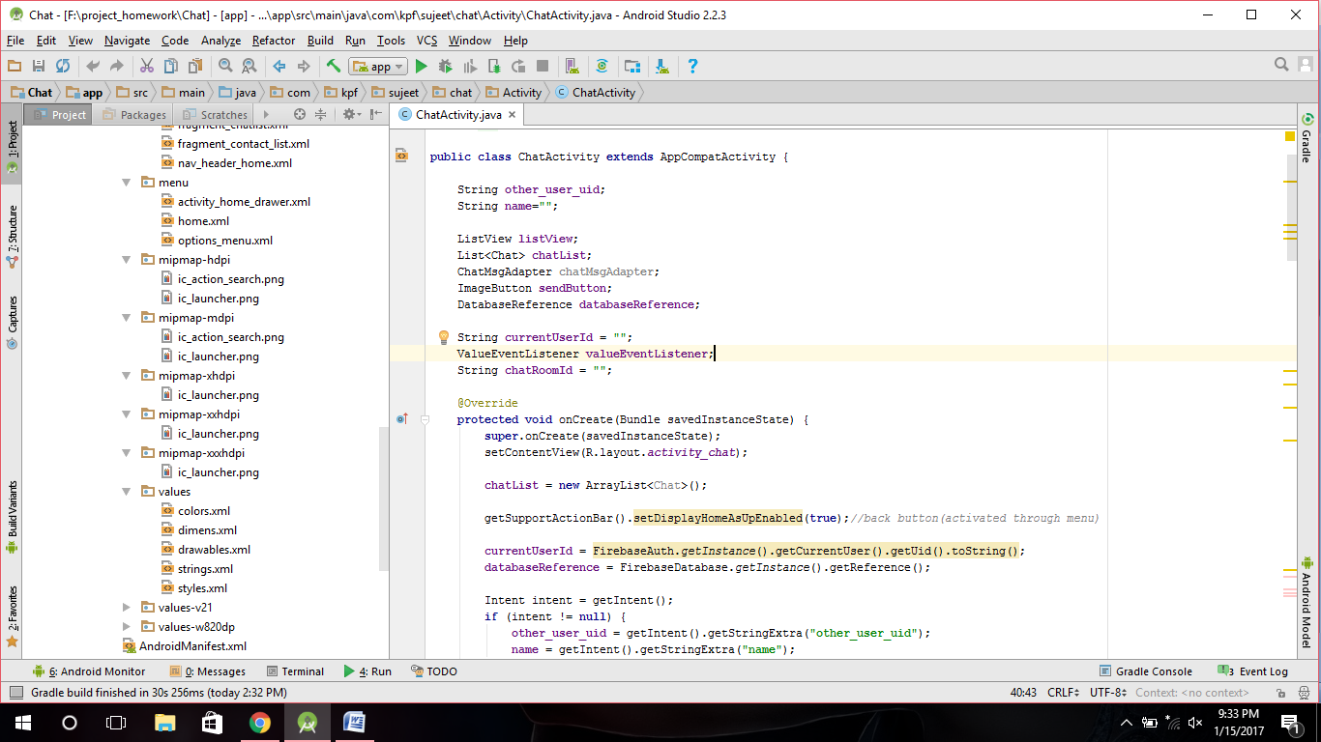

paste in

mipmap-hdpi -> ic_action_search.png(12)

mipmap-mdpi -> ic_action_search.png(13)

mipmap-xhdpi ->ic_launcher.png(14)

mipmap-xxhdpi ->ic_launcher.png(15)

Note: values ->(strings.xml,colors.xml,dimens.xml)