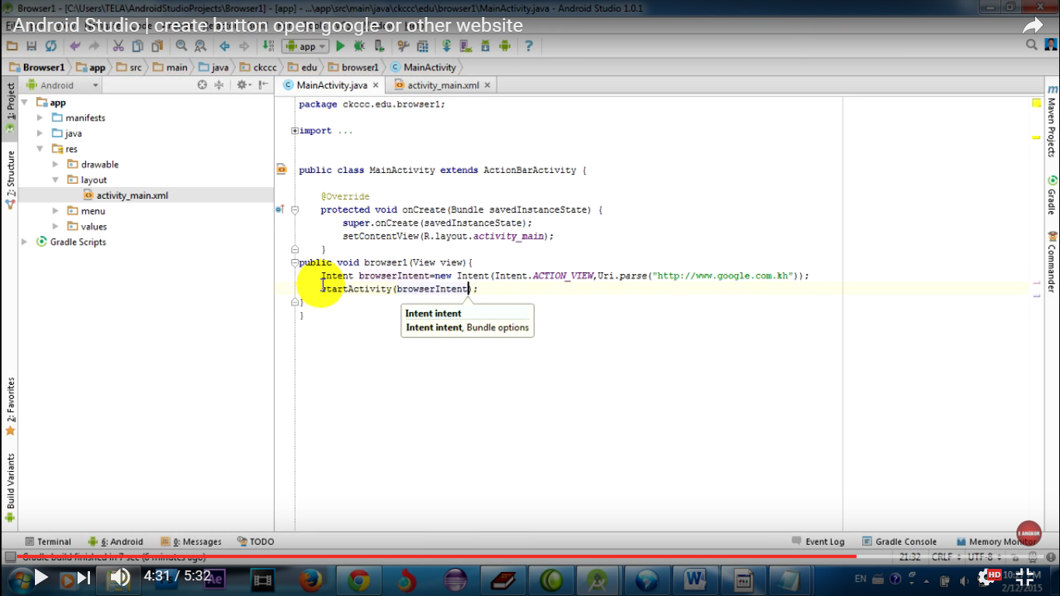

1.

**Available Courses after 12th Science**

Courses after 12th Science with PCB:

* [*MBBS*](https://www.sarvgyan.com/courses/medical/mbbs)
* [*BAMS*](https://www.sarvgyan.com/courses/medical/bams)*(Ayurvedic)*
* [*BHMS*](https://www.sarvgyan.com/courses/medical/bhms)*(Homoeopathy)*
* [*BUMS*](https://www.sarvgyan.com/courses/medical/bums)*(Unani)*
* *BDS*
* *Bachelor of*[*Veterinary Science*](https://www.sarvgyan.com/courses/medical/veterinary)*&*[*Animal Husbandry*](https://www.sarvgyan.com/courses/medical/animal-husbandry)*(B.VSc AH)*
* *Bachelor of Naturopathy &*[*Yogic Science*](https://www.sarvgyan.com/courses/yoga)*(BNYS)*
* *Bachelor of*[*Physiotherapy*](https://www.sarvgyan.com/courses/medical/physiotherapy)
* *Integrated [M.Sc](https://www.sarvgyan.com/courses/science/master-of-science)*
* *B.Sc. Nursing*
* *B.Sc.*[*Dairy Technology*](https://www.sarvgyan.com/courses/dairy-technology)
* *B.Sc. Home Science*
* [*Bachelor of Pharmacy*](https://www.sarvgyan.com/courses/medical/bachelor-of-pharmacy)
* *Biotechnology*
* *BOT (*[*Occupational Therapy*](https://www.sarvgyan.com/courses/medical/occupational-therapy)*)*
* *General Nursing*
* *BMLT (Medical Lab Technology)*
* *Paramedical Courses*
* *B.Sc. Degree*
* *BA*
* *LLB (Bachelor of Law)*
* *Education/ Teaching*
* *Travel & Tourism Courses*
* *Environmental Science*
* [*Fashion Technology*](https://www.sarvgyan.com/courses/fashion-designing)
* [*Hotel Management*](https://www.sarvgyan.com/courses/hotel-management-catering)
* *Designing Courses*
* *Media/*[*Journalism Courses*](https://www.sarvgyan.com/courses/journalism)
* *Film/ Television Courses*
* [*CA Program*](https://www.sarvgyan.com/courses/chartered-accountant)
* [*ICWA Program*](https://www.sarvgyan.com/courses/commerce/icwa)
* [*CS Program*](https://www.sarvgyan.com/courses/company-secretary)

Courses after 12th science with PCM:

* *Engineering (B.E/ B.Tech)*
* [*B.Arch*](https://www.sarvgyan.com/courses/engineering/barch)
* *Integrated M.Sc*
* [*BCA*](https://www.sarvgyan.com/courses/bca)
* [*B.Com*](https://www.sarvgyan.com/courses/commerce/bcom)
* *Defence (Navy, Army, Air force)*
* *B.Sc. Degree*
* *B.Des*
* *BA*
* *LLB (Bachelor of Law)*
* *Education/ Teaching*
* *Travel & Tourism Courses*
* *Environmental Science*
* *Fashion Technology*
* *Hotel Management*
* *Designing Courses*
* *Media/ Journalism Courses*
* *Film/ Television Courses*
* *CA Program*
* *ICWA Program*
* *CS Program*

Diploma courses after 12th Science:

* *Diploma in Beauty Culture & Hair Dressing*
* [*Computer Hardware*](https://www.sarvgyan.com/courses/computer-hardware-networking)
* *Fashion Designing – DFD*
* *Dress Designing – DDD*
* [*Drawing and Painting*](https://www.sarvgyan.com/courses/drawing-painting)
* *Cutting and Tailoring*
* [*Web Designing*](https://www.sarvgyan.com/courses/web-designing)
* [*Graphic Designing*](https://www.sarvgyan.com/courses/graphic-designer)
* *Information Technology*
* *Application Software Development – DASD*
* *Textile Designing – DTD*
* *Hospital & Health Care Management*
* *Physical Medicine and Rehabilitation*
* [*Air Hostess*](https://www.sarvgyan.com/courses/air-hostess)
* *Air Crew*
* [*Event Management*](https://www.sarvgyan.com/courses/event-management)
* *HR Training*
* *Computer Courses*
* [*Foreign Language Courses*](https://www.sarvgyan.com/courses/foreign-languages)
* *Making*