Q1). FEDEX

Requirements:

a).Python : [https://www.python.org/downloads/release/python-362/](https://l.facebook.com/l.php?u=https%3A%2F%2Fwww.python.org%2Fdownloads%2Frelease%2Fpython-362%2F&h=ATOmQpswDDrhOTmwHJYmgRfsMwgPx60O4nEP-Sauv3_Owk7zn7db4ru-AE1jj-eplTMSc1LdmjpluiWJIwHCHZ7gRCeihQrJ05UA1A2MiZEV7rvQvjrO6wv92AfbBlalHcC95kul_jBSxDo)

b).Sublime : [https://www.sublimetext.com/3](https://l.facebook.com/l.php?u=https%3A%2F%2Fwww.sublimetext.com%2F3&h=ATOmQpswDDrhOTmwHJYmgRfsMwgPx60O4nEP-Sauv3_Owk7zn7db4ru-AE1jj-eplTMSc1LdmjpluiWJIwHCHZ7gRCeihQrJ05UA1A2MiZEV7rvQvjrO6wv92AfbBlalHcC95kul_jBSxDo)

c).PyCharm : [https://www.jetbrains.com/pycharm/download/download-thanks.html?platform=windows&code=PCC](https://l.facebook.com/l.php?u=https%3A%2F%2Fwww.jetbrains.com%2Fpycharm%2Fdownload%2Fdownload-thanks.html%3Fplatform%3Dwindows%26code%3DPCC&h=ATOmQpswDDrhOTmwHJYmgRfsMwgPx60O4nEP-Sauv3_Owk7zn7db4ru-AE1jj-eplTMSc1LdmjpluiWJIwHCHZ7gRCeihQrJ05UA1A2MiZEV7rvQvjrO6wv92AfbBlalHcC95kul_jBSxDo)

Open PyCharm.

Press ctrl+alt+s.

Select the python path in Project Interpreter.

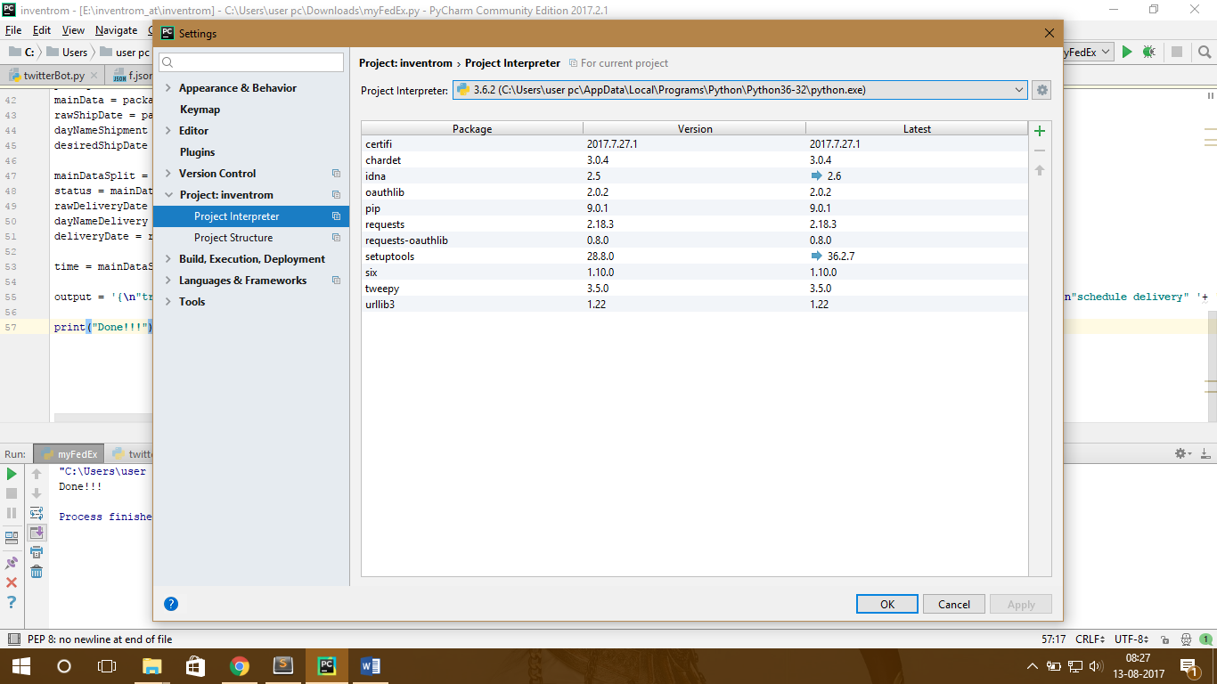

Select the + icon.

Search tweepy and Install package.

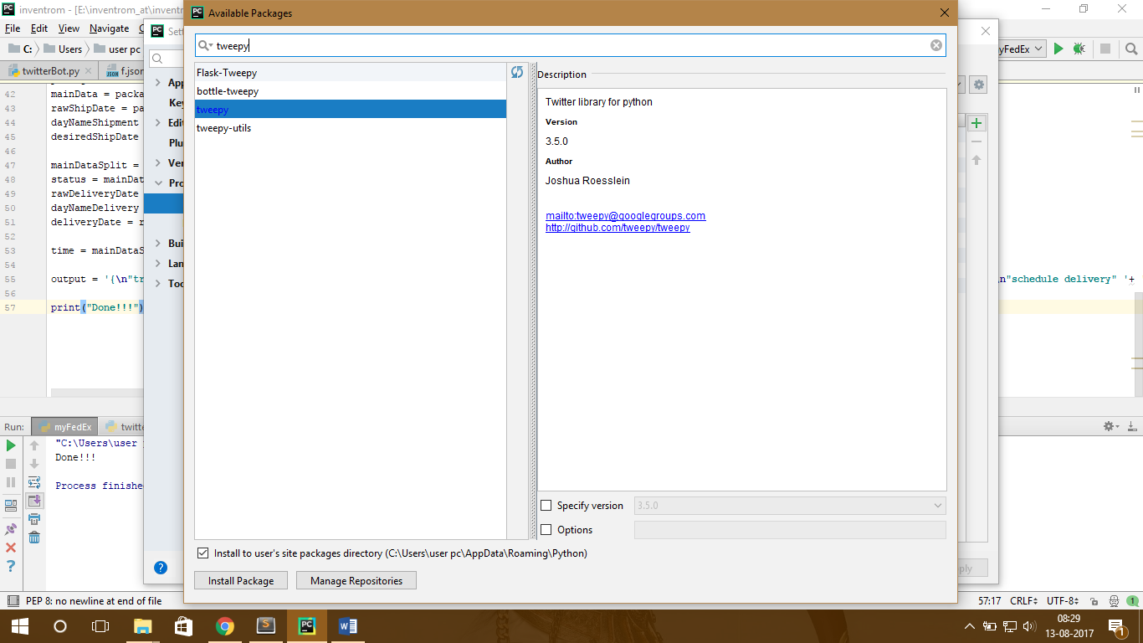

Now configuration is done if result and tweepy are both displayed in the installed list.

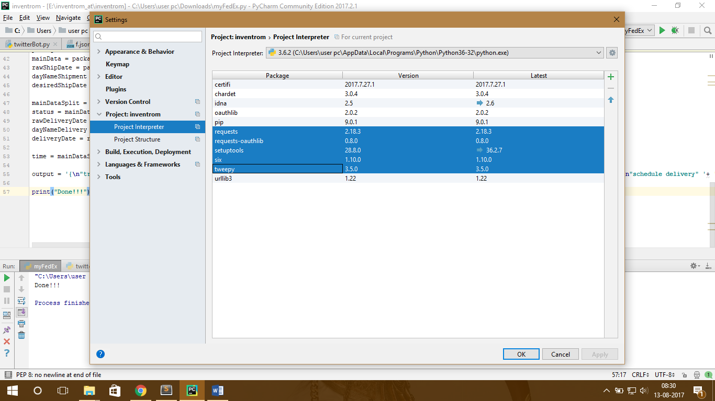

Step 3:

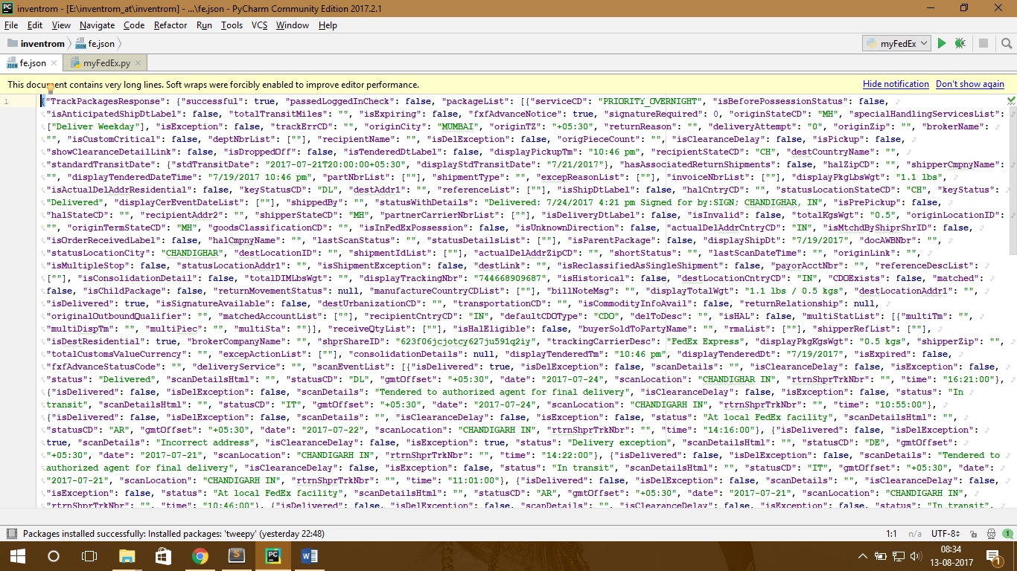

This is the json obtained from FEDEX site. Link : [https://www.fedex.com/apps/fedextrack/?tracknumbers=744668909687](https://l.facebook.com/l.php?u=https%3A%2F%2Fwww.fedex.com%2Fapps%2Ffedextrack%2F%3Ftracknumbers%3D744668909687&h=ATOmQpswDDrhOTmwHJYmgRfsMwgPx60O4nEP-Sauv3_Owk7zn7db4ru-AE1jj-eplTMSc1LdmjpluiWJIwHCHZ7gRCeihQrJ05UA1A2MiZEV7rvQvjrO6wv92AfbBlalHcC95kul_jBSxDo)

Step 4:

Web scraping is done to extract transaction details.

Press ctrl+shift+f10 .

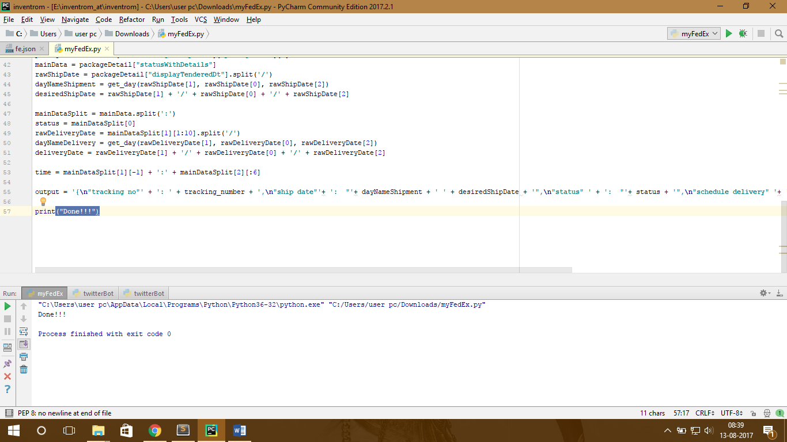

Reference Links:

1. <https://www.analyticsvidhya.com/blog/2015/10/beginner-guide-web-scraping-beautiful-soup-python/>
2. <http://techqa.info/programming/question/18817185/>
3. <https://www.fedex.com/apps/fedextrack/?tracknumbers=744668909687>