3)Twitter Bot

Requirements :

a).Python : [https://www.python.org/downloads/release/python-362/](https://l.facebook.com/l.php?u=https%3A%2F%2Fwww.python.org%2Fdownloads%2Frelease%2Fpython-362%2F&h=ATOmQpswDDrhOTmwHJYmgRfsMwgPx60O4nEP-Sauv3_Owk7zn7db4ru-AE1jj-eplTMSc1LdmjpluiWJIwHCHZ7gRCeihQrJ05UA1A2MiZEV7rvQvjrO6wv92AfbBlalHcC95kul_jBSxDo)

b).Sublime : [https://www.sublimetext.com/3](https://l.facebook.com/l.php?u=https%3A%2F%2Fwww.sublimetext.com%2F3&h=ATOmQpswDDrhOTmwHJYmgRfsMwgPx60O4nEP-Sauv3_Owk7zn7db4ru-AE1jj-eplTMSc1LdmjpluiWJIwHCHZ7gRCeihQrJ05UA1A2MiZEV7rvQvjrO6wv92AfbBlalHcC95kul_jBSxDo)

c).PyCharm : [https://www.jetbrains.com/pycharm/download/download-thanks.html?platform=windows&code=PCC](https://l.facebook.com/l.php?u=https%3A%2F%2Fwww.jetbrains.com%2Fpycharm%2Fdownload%2Fdownload-thanks.html%3Fplatform%3Dwindows%26code%3DPCC&h=ATOmQpswDDrhOTmwHJYmgRfsMwgPx60O4nEP-Sauv3_Owk7zn7db4ru-AE1jj-eplTMSc1LdmjpluiWJIwHCHZ7gRCeihQrJ05UA1A2MiZEV7rvQvjrO6wv92AfbBlalHcC95kul_jBSxDo)

Step 1:

Login to your twitter account with your credentials.



Step 2:

Open <https://apps.twitter.com>

Give app permission

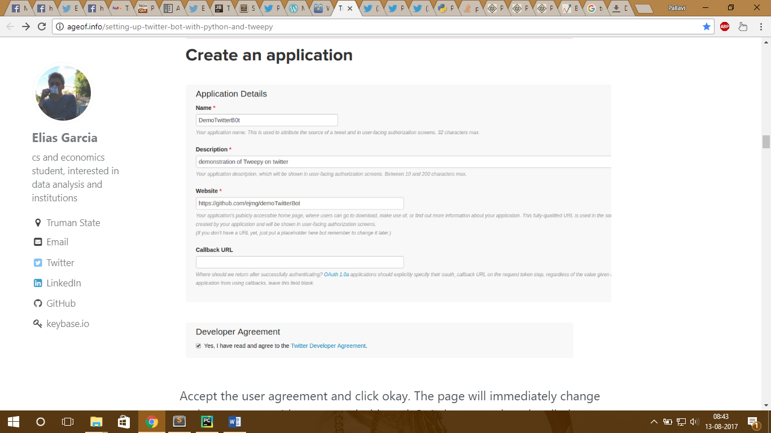

Once it is done get the keys.

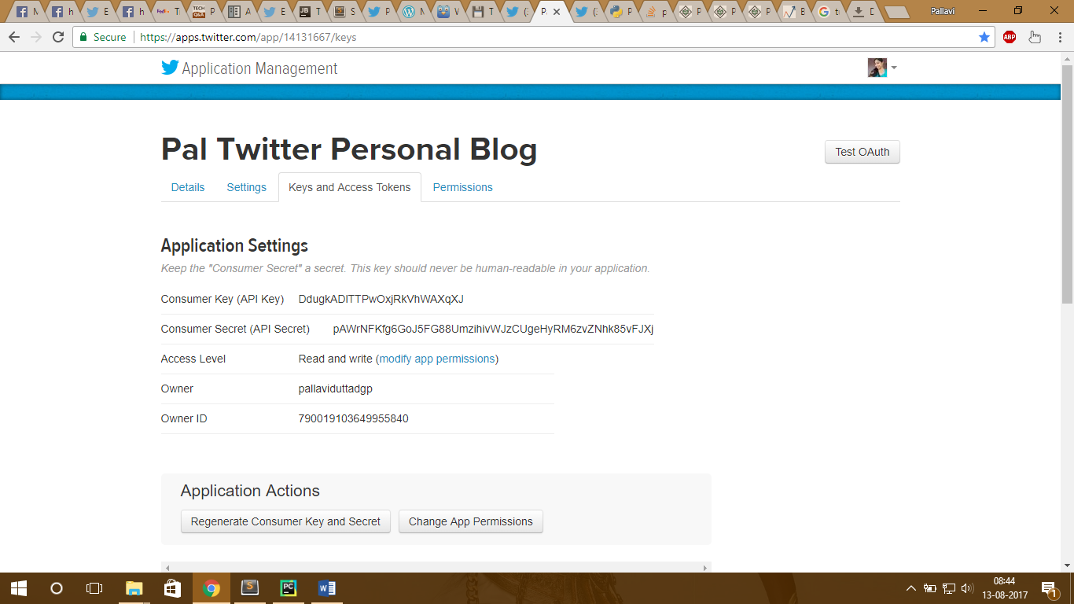

Save the keys in Python file and save the pal_my_keys.py file in the same folder as Twitter’s python code or we can directly place the secret keys in the code itself.

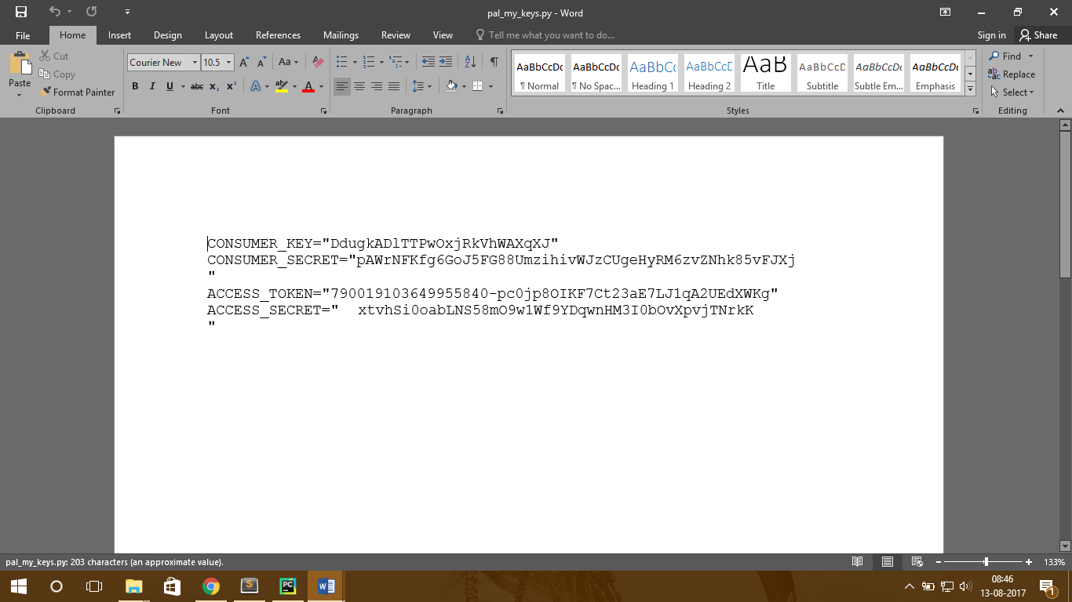

Now following the steps mentioned in the link one by one, we proceed further.

<http://ageof.info/setting-up-twitter-bot-with-python-and-tweepy>

Step 3:

Now open this file containing secret keys in PyCharm.

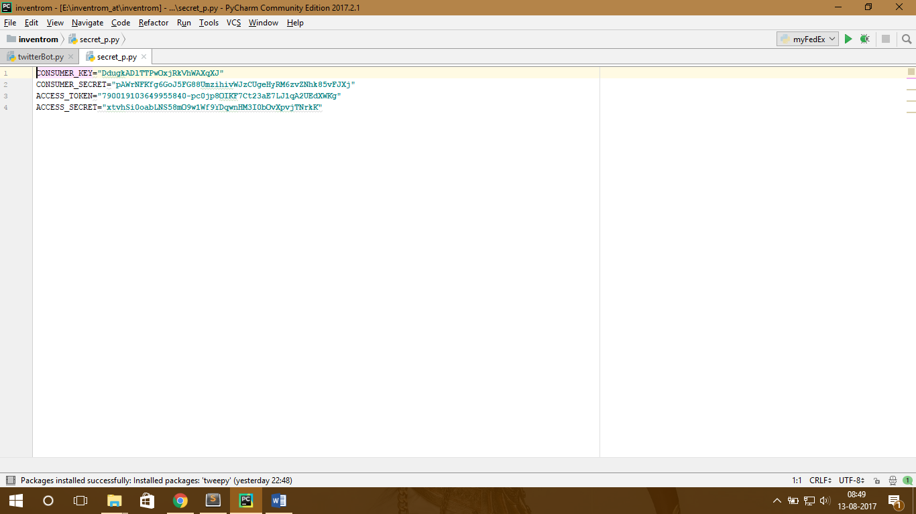

Open twitterBot.py in PyCharm.

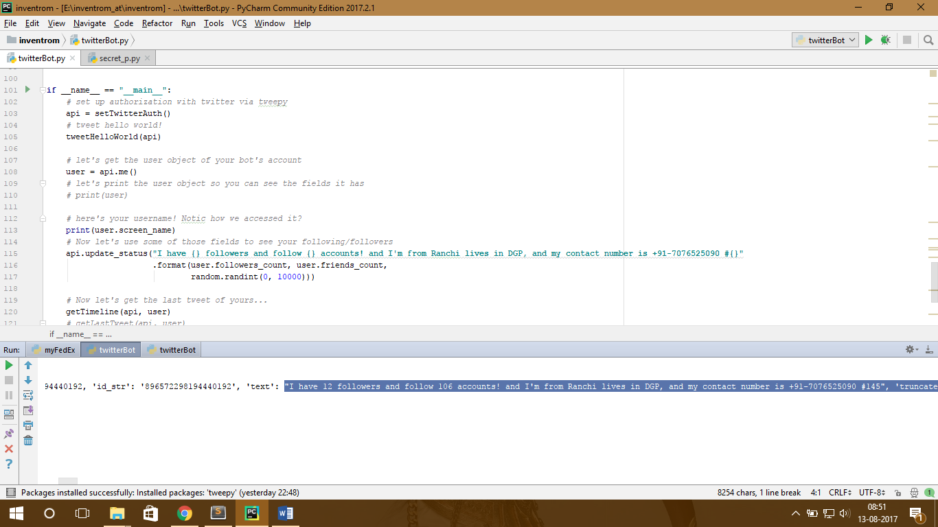

This displays the list of followers I have and the no of people I am following .

The following methods have been used in our program:

* def setTwitterAut():

This function is used for authorization from Twitter API using keys.

* **def getTimeline(api, user):**

This method gets the last 100 tweets from the user's timeline and returns a list of tweet objects.

Here I have used the Cursor method of tweepy to crawl through search results,while simultaneously using list comprehension to make a standard list of the results.

Cursor is basically used for pulling large numbers of tweets

* **def searchTweet(api, searchTerm):**

This function gets 100 search results of the string search, and returns them as a list of tweet objects.

* **api = setTwitterAuth()**

This function sets up authorization with twitter via tweepy.

* **api.update_status("I have {} followers and follow {} accounts #{} LATESTT 2!!!"**

**.format(user.followers_count, user.friends_count,**

**random.randint(0, 10000)))**

These lines of code returns the number of followers and followings.

* **def likeTweetOfUser(api,boltuser,user):**

This likes a tweet once it is tweeted by the bot user.

* **likeTweetOfUser(api, "@boltiot", user):**

This likes any tweet that has the hashtag '#IOT'

Reference Links :

1. <http://ageof.info/setting-up-twitter-bot-with-python-and-tweepy>
2. <https://dev.twitter.com/overview/api/entities-in-twitter-objects#hashtags>
3. <http://tweepy.readthedocs.io/en/v3.5.0/api.html#API.statuses_lookup>
4. <https://marcobonzanini.com/2015/03/02/mining-twitter-data-with-python-part-1/>
5. <http://follows.com/blog/2016/01/tweet-likes-twitter>