Q.1: Query all columns for all American cities in the **CITY** table with populations larger than 100000. The **CountryCode** for America is USA.

The **CITY** table is described as follows:

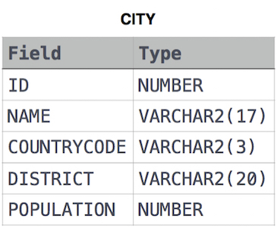

Answer: select * from city where COUNTRYCODE = "USA" and population > 100000

Q.2: Query the **NAME** field for all American cities in the **CITY** table with populations larger than 120000. The *CountryCode* for America is USA.

The **CITY** table is described as follows:



Answer: select NAME from CITY where COUNTRYCODE = "USA" and population > 120000

Q.3: Query all columns (attributes) for every row in the **CITY** table.

The **CITY** table is described as follows:

Answer: select * from city