Q.1: Query all columns for a city in **CITY** with the *ID* 1661.

The **CITY** table is described as follows:

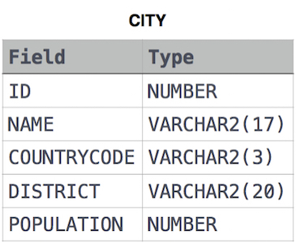

Answer: select * from CITY where ID = 1661

Q.2: Query all attributes of every Japanese city in the **CITY** table. The **COUNTRYCODE** for Japan is JPN

The **CITY** table is described as follows:



Answer: select * from city where COUNTRYCODE = 'JPN'

Q.3: Query the names of all the Japanese cities in the **CITY** table. The **COUNTRYCODE** for Japan is JPN.  
The **CITY** table is described as follows:



Answer: select name from city where COUNTRYCODE = 'JPN'