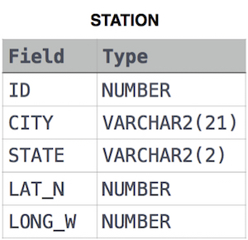Q.1: Query a list of **CITY** and **STATE** from the **STATION** table.  
The **STATION** table is described as follows:

Answer: select CITY, STATE from STATION

Q.2: Query a list of **CITY** names from **STATION** for cities that have an even **ID** number. Print the results in any order, but exclude duplicates from the answer.  
The **STATION** table is described as follows:

Answer: select distinct CITY from STATION where mod(ID, 2) = 0

Q.3: Find the difference between the total number of **CITY** entries in the table and the number of distinct **CITY** entries in the table.  
The **STATION** table is described as follows:



Answer: select count(city) - count(distinct city) from station