**Q.1:** Query the list of *CITY* names starting with vowels (i.e., a, e, i, o, or u) from **STATION**. Your result *cannot* contain duplicates.

**Input Format**

The **STATION** table is described as follows:

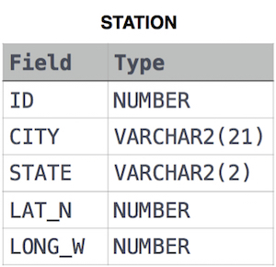

**Answer:** select distinct city from station

where city like 'a%'

or city like 'e%'

or city like 'i%'

or city like 'o%'

or city like 'u%'

**Q.2:** Query the list of *CITY* names ending with vowels (a, e, i, o, u) from **STATION**. Your result *cannot* contain duplicates.

**Input Format**

The **STATION** table is described as follows:



**Answer:** select distinct city from station

where city like '%a' or

city like '%e' or

city like '%i' or

city like '%o' or

city like '%u'

**Q.3:** Query the list of *CITY* names from **STATION** which have vowels (i.e., *a*, *e*, *i*, *o*, and *u*) as both their first *and* last characters. Your result cannot contain duplicates.

**Input Format**

The **STATION** table is described as follows:



**Answer:** select distinct city from station

where (city like 'a%' or city like 'e%' or city like 'i%' or city like 'o%'

or city like 'u%') and

(city like '%a' or city like '%e' or city like '%i' or city like '%o'

or city like '%u')