**Q.13:** Query the list of *CITY* names from **STATION** that *do not start* with vowels. Your result cannot contain duplicates.

**Input Format**

The **STATION** table is described as follows:

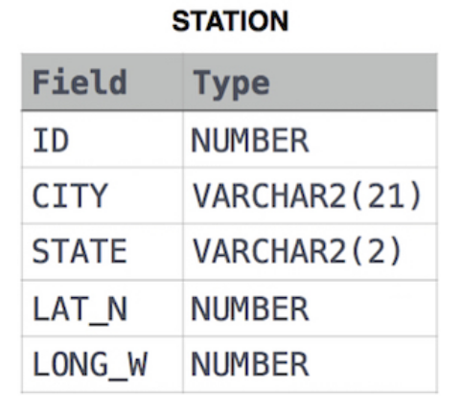

**Answer:** select distinct city from station

where city not like 'a%' and

city not like 'e%' and

city not like 'i%' and

city not like 'o%' and

city not like 'u%'

**Q.14:** Query the list of *CITY* names from **STATION** that *do not end* with vowels. Your result cannot contain duplicates.

**Input Format**

The **STATION** table is described as follows:

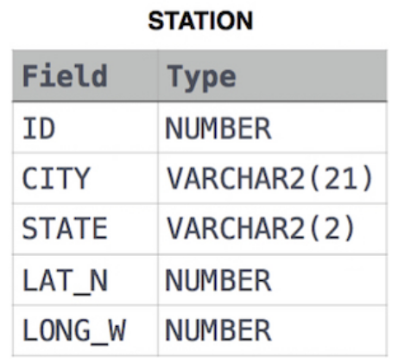

**Answer:** select distinct city from station

where city not like '%a' and

city not like '%e' and

city not like '%i' and

city not like '%o' and

city not like '%u'

**Q.15:** Query the list of *CITY* names from **STATION** that either do not start with vowels or do not end with vowels. Your result cannot contain duplicates.

**Input Format**

The **STATION** table is described as follows:

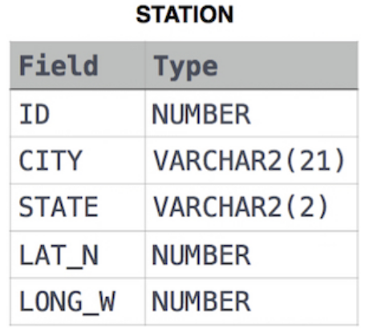

**Answer:** select distinct city from station

where (city not like 'a%' and city not like 'e%' and city not like 'i%' and

city not like 'o%' and city not like 'u%') or

(city not like '%a' and city not like '%e' and city not like '%i' and

city not like '%o' and city not like '%u')