**Q.16:** Query the list of *CITY* names from **STATION** that *do not start* with vowels and *do not end* with vowels. Your result cannot contain duplicates.

**Input Format**

The **STATION** table is described as follows:

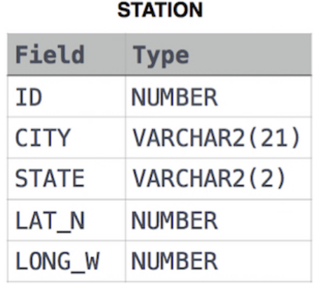

**Answer:** select distinct city from station

where (city not like 'a%' and city not like 'e%' and city not like 'i%' and city not like 'o%' and city not like 'u%') and

(city not like '%a' and city not like '%e' and city not like '%i' and city not like '%o' and city not like '%u')

**Q.17:** Query the *Name* of any student in **STUDENTS** who scored higher than  *Marks*. Order your output by the *last three characters* of each name. If two or more students both have names ending in the same last three characters (i.e.: Bobby, Robby, etc.), secondary sort them by ascending *ID*.

**Input Format**

The **STUDENTS** table is described as follows:

The *Name* column only contains uppercase (A-Z) and lowercase (a-z) letters.

**Sample Input**

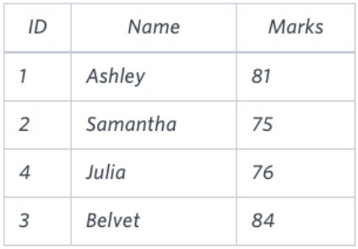

**Answer:** select name from STUDENTS where marks > 75

order by right(name,3), ID asc

**Q.18:** Write a query that prints a list of employee names (i.e.: the *name* attribute) from the **Employee** table in alphabetical order.

**Input Format**

The **Employee** table containing employee data for a company is described as follows:

where *employee_id* is an employee's ID number, *name* is their name, *months* is the total number of months they've been working for the company, and *salary* is their monthly salary.

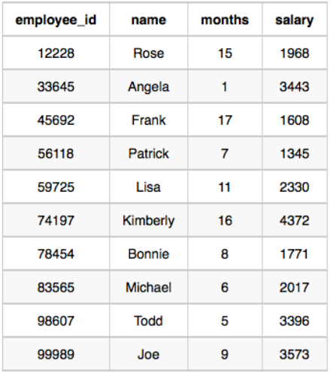**Sample Input**

**Sample Output**

Angela

Bonnie

Frank

Joe

Kimberly

Lisa

Michael

Patrick

Rose

Todd

**Answer:** select name from employee

order by name asc