**Q.19:** Write a query that prints a list of employee names (i.e.: the *name* attribute) for employees in **Employee** having a salary greater than  per month who have been employees for less than  months. Sort your result by ascending *employee_id*.

**Input Format**

The **Employee** table containing employee data for a company is described as follows:

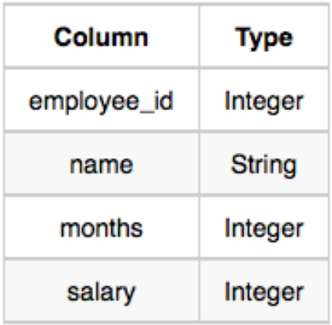

where *employee_id* is an employee's ID number, *name* is their name, *months* is the total number of months they've been working for the company, and *salary* is the their monthly salary.

**Answer:** select name from employee where salary > 2000 and months < 10

order by employee_id asc

**Q.20:** Query the total population of all cities in CITY where *District* is California.

Input Format

The CITY table is described as follows:

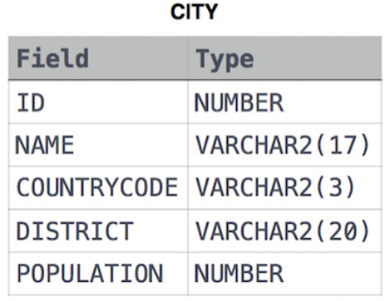

**Answer:** select sum(population) from city where district = 'California'

**Q.21:** Query the average population of all cities in **CITY** where *District* is **California**.

**Input Format**

The **CITY** table is described as follows:

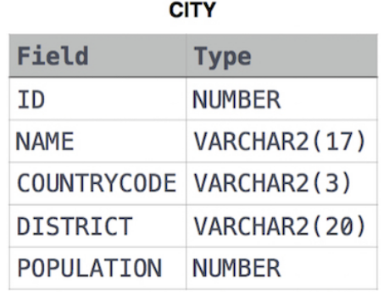

**Answer:** select avg(population) from city where district = 'California'