Conversational Competitor Analysis AI - Project Documentation

1. Project Overview
This project builds a conversational AI system capable of analyzing nearby competitor clothing stores using a local RAG pipeline.
It uses free tools including synthetic footfall data, local embeddings, FAISS vector store, and Ollama LLM.

2. Tech Stack Used
- Python
- Pandas, NumPy
- SentenceTransformers for embeddings
- FAISS for vector search
- Ollama for local LLM
- Streamlit UI

3. Data Preparation
I created a stores.csv file with basic data of 6 Koramangala clothing stores.
Then generated synthetic footfall data for 28 days.
Finally preprocessed hourly aggregates and peak
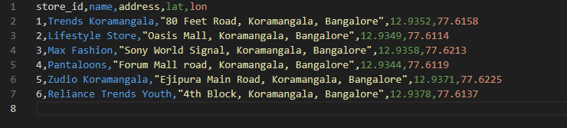
Example Data for Stores

4. Embeddings & Vector Store
I created short descriptive texts for each store and generated embeddings using a free MiniLM model.
FAISS index was created and saved locally.

5. RAG Pipeline
The system retrieves relevant store documents using FAISS based on user queries.
Then the local LLM (via Ollama) generates the final analysis.

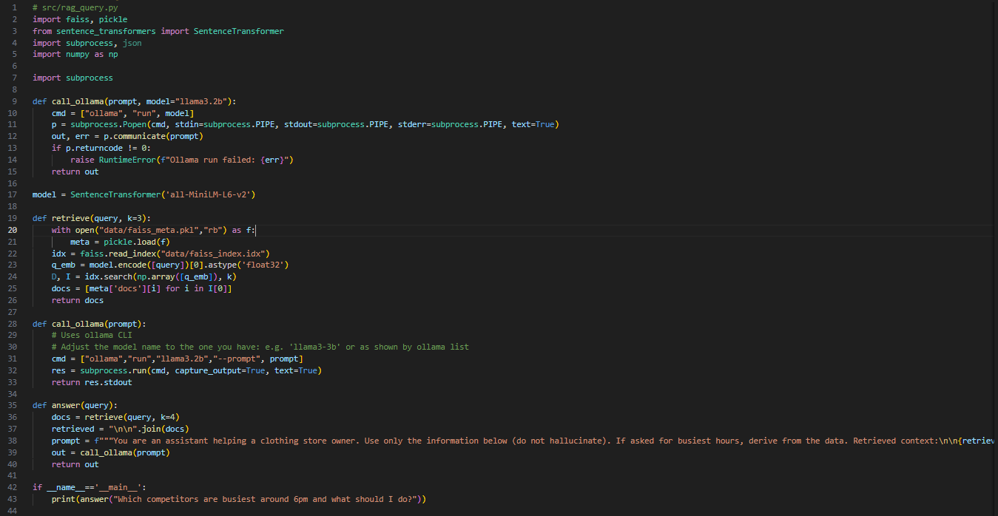6. Streamlit Application
A Streamlit UI was created to run competitor queries, visualize peak hours, and download a PDF report.

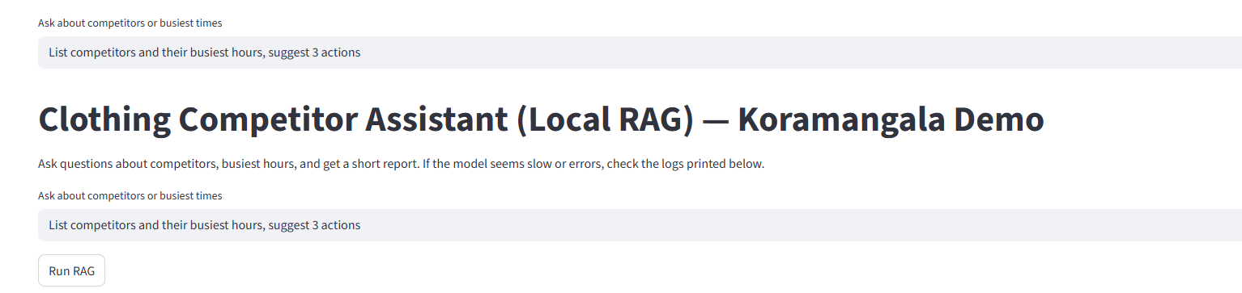7. Sample Query & Output
Example query: 'List competitors and their busiest hours and suggest actions.'
LLM response and chart displayed.
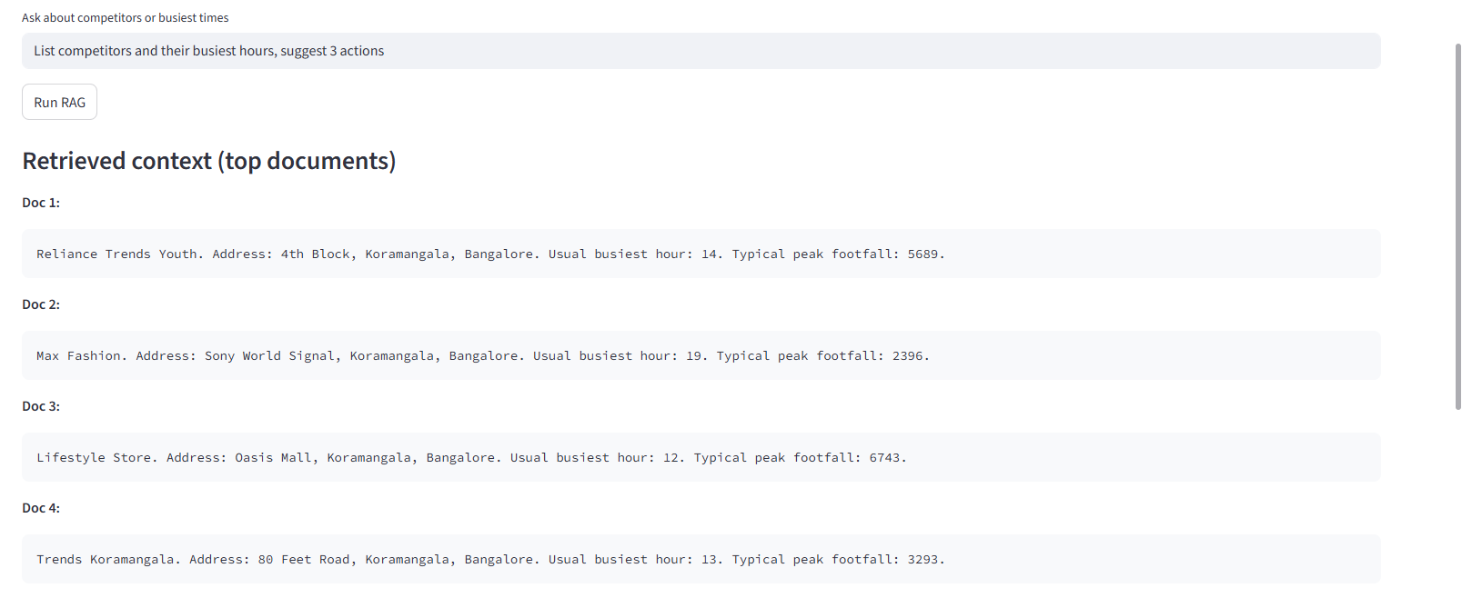
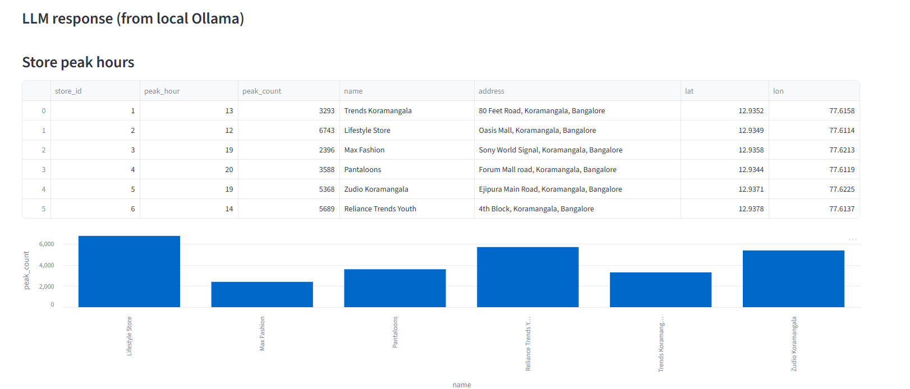

8. PDF Report Generation
A PDF report is generated using WeasyPrint summarizing the data and AI analysis.

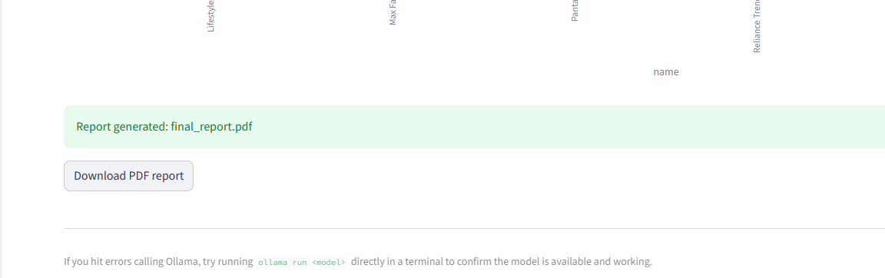9. Conclusion
The entire system runs locally with no paid APIs, demonstrating a fully offline conversational competitor analysis pipeline.

