Personalized Education Assistant - Documentation

1. Project Overview
This project implements a lightweight, fully local Personalized Education Assistant. It generates learning materials, quizzes, and project ideas for any given list of topics. The system runs sequentially each agent performs one task, and the output flows to the next stage.

2. Key Components
- Learning Material Agent: Fetches curated resources using the Serper API and summarizes them using a local LLM.
- Quiz Agent: Generates multiple-choice quizzes for each topic using a local LLM.
- Project Idea Agent: Suggests practical project ideas based on user expertise level.

3. Tools & Technologies Used
- Python 3.11
- Ollama (Local LLM Runtime) with llama3.2:3b model
- Serper API (Free tier) for Google Search-like results
- Pydantic (Structured Output Models)
- subprocess for calling Ollama

4. Installation & Setup Guide
1. Install Python 3.11+ and Git.
2. Clone the project repository and create a virtual environment:
python -m venv .venv
.venv\Scripts\activate
3. Install dependencies:
pip install -r requirements.txt
4. Install Ollama from https://ollama.com/download
5. Pull the model:
ollama pull llama3.2:3b
6. Get a Serper API key (free credits available) and put it in a `.env` file:
SERPER_API_KEY=your_key_here
7. Run the pipeline:
python run_pipeline.py
or
python -m src.pipeline.sequential_pipeline --topics "Pandas,EDA" --level beginner
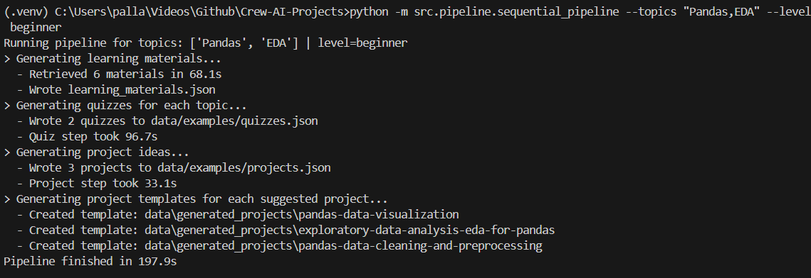

5. Output Files Generated
- data/examples/learning_materials.json
- data/examples/quizzes.json
- data/examples/projects.json
- data/examples/raw/ (debug logs)
- data/generated_projects/ (auto-created project folders)
