RAG-QnA

1. Project Overview
This project implements a Retrieval-Augmented Generation (RAG) system for question answering on AI research papers. The system runs fully offline using Ollama and local embeddings, without any paid APIs or cloud dependencies.
Goal: To allow users to ask natural language questions and get accurate, cited answers from 3–4 AI research papers (e.g., Transformers, RAG, GPT-3).

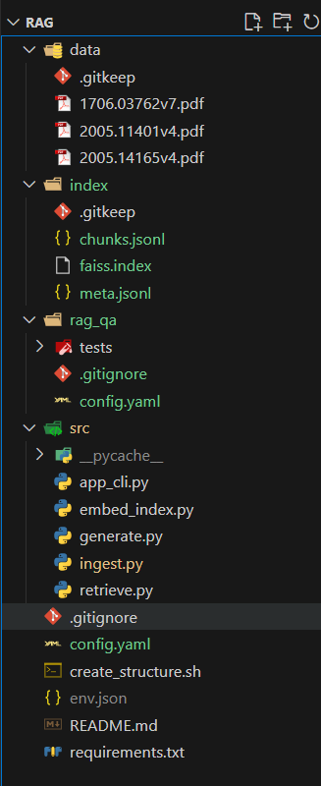

2. Tools & Libraries Used
Language: Python 3.11
LLM: llama3.2:3b (via Ollama)
Embedding Model: nomic-embed-text
Vector Store: FAISS (for similarity search)
Reranker: cross-encoder/ms-marco-MiniLM-L-6-v2 (CPU-friendly)
Frameworks: LangChain Core, Sentence Transformers, PyMuPDF / PyPDF
Environment: Local machine (16 GB RAM, iGPU)

3. Steps Performed

a) Folder Setup
Created a new project directory 'rag_qa' with subfolders data/, index/, and src/. Configured model and parameters in config.yaml.

b) Data Collection
Added 3 AI research papers into data/ folder:
- 1706.03762v7.pdf → Attention is All You Need
- 2005.11401v4.pdf → Retrieval-Augmented Generation (RAG)
- 2005.14165v4.pdf → Language Models are Few-Shot Learners (GPT-3)

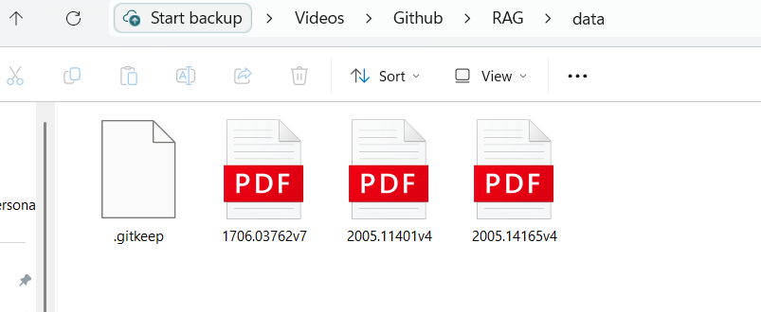

c) Document Preprocessing
Ran ingest.py to extract and clean text from all PDFs. It chunked each paper into small overlapping text segments (~500 tokens) for embedding.

d) Embedding & Indexing
Ran embed_index.py to generate local embeddings using nomic-embed-text via Ollama and built a FAISS index for fast retrieval.

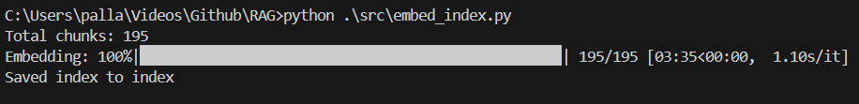e) Retrieval & Reranking
Used FAISS to retrieve top 8 relevant chunks, then reranked them with a SentenceTransformer cross-encoder to pick the best 4.

f) Answer Generation
Ran app_cli.py to interact with the RAG system. The system accepts a user query, retrieves relevant document chunks, generates a grounded answer using llama3.2:3b, and shows citations from the source papers.
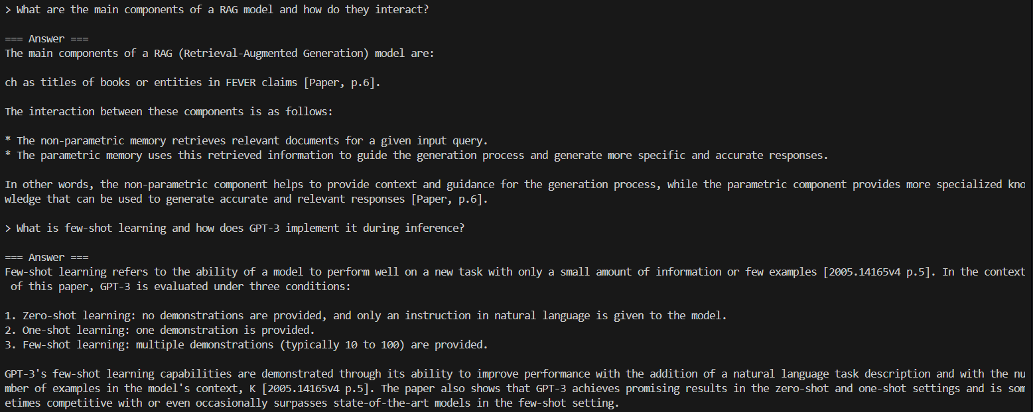

5. Key Outcomes
- Built a fully local RAG system without any API keys.
- Enabled accurate, cited answers directly from original research papers.
- Implemented retrieval, reranking, and generation pipeline end-to-end on a basic laptop.
[Screenshot 10: Task Manager showing Ollama and Python running locally]

6. Future Improvements
- Add Streamlit UI for interactive web interface.
- Integrate OCR (Tesseract) for scanned research papers.
- Evaluate accuracy with sample Q&A pairs.
- Experiment with different embedding and reranking models.

7. Conclusion
This project demonstrates how a local RAG pipeline can provide context-aware question answering from academic documents using open-source models. It highlights the potential for offline, privacy-preserving AI assistants for research and education.

