Project Title: To Supply Leftover Food to Poor

Category: Salesforce

Skills Required: Salesforce Developer

Project Overview

a. Project Objectives and Goals

Objective: This project aims to develop a Salesforce-based application designed to manage andstreamline the distribution of leftover food to underserved communities. The primary goal is to enhance the efficiency of food drop-offs, coordinate tasks, manage volunteers, and generate insightful reports.

2. Detailed Description of Implemented Features

a. Custom Objects

1. Drop-OffPoint:

* Purpose: The Drop-Off Point object captures essential details about locations where food is dropped off. This helps in tracking and managing food distribution points effectively.
* Fields:

 Drop-OffPoint Name: A text field representing the name of the drop-off point.

* Location Details: A text field for additional details about the drop-off point location.
* Distance: A number field that records the distance from the droroff point to the delivery area.
* Venue: A lookup relationship field linking to the Venue Object to provide a connection between drop-off points and venues.

1. Task:
   * + Purpose: The Task Object is used to manage and track various tasks related to food distribution, including assigning tasks to volunteers and recording task details

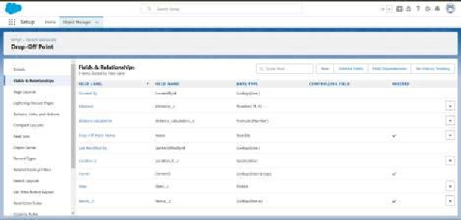

* + - Fields:
    - Task Name: A text field representing the name of the task.
    - Date: A date field indicating when the task is scheduled or

completed. o Rating: A numeric field used to rate the task

performance.

* + - Drop-Off Point: A lookup relationship field linking to the Drop-Off

Point object to associate tasks with specific drop-off points.

* + - Sponsored By: A lookup relationship field linking to the Drop-Off

Point Object to indicate the sponsor Of the task.

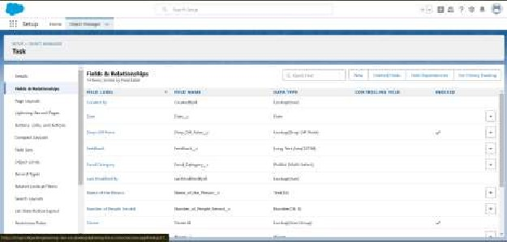

1. Volunteer:
   * + Purpose: The Volunteer object keeps track of individuals who are involved in the

food distribution process, including their contact information and assigned tasks.

* + - Fields:
    - Volunteer Name: A text field for the name of the volunteer.
    - Contact Email: An email field for the volunteer's contact email.
    - Contact Phone: A phone field for the volunteer's contact number.
    - Assigned Tasks: A related list showing tasks assigned to the volunteer

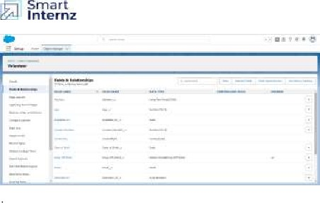

1. Execution Detail:
   * + Purpose: The Execution Detail object captures detailed information about food

distribution activities, including which volunteers and task are associated with

each distribution.

* + - Fields:

 Execution Detail Name: A text field for naming the execution

detail record.

* + - Volunteer: A master-detail relationship field linking to the Volunteer object

to associate execution details with a specific volunteer.

* + - Task: A master-detail relationship field linking to the Task object to

associate execution details with a specific task.

* + - Details: A text field for additional information about the execution.

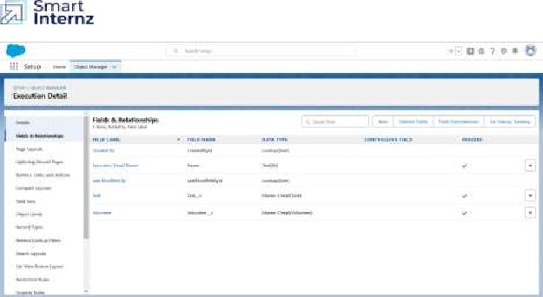

2.2 Object Relationships

* Master-Detail Relationships:
* Execution Detail to Volunteer: Ensures that each execution detail record is linked

to a volunteer, making volunteer information essential for each distribution record.

* Execution Detail to Task: Ensures that each execution detail record is linked to a

task, making task information essential for each distribution record. • Lookup

Relationships:

* Task to Drop-Off Point: Connects tasks to drop-off points, providing context on

where each task is executed.

* Task to Volunteer: Connects tasks to volunteers, enabling tracking of which

volunteer is responsible for each task.

* Drop-Off Point to Venue: Links drop-off points to venues, facilitating a detailed

understanding Of where food is being dropped Off.

2.3 Sharing Rules

TO ensure that records are shared appropriately based on distance criteria, the following sharing

rules were set up:

* Rule 1:
* Label: Rule 1
* Criteria: Records where the distance is less than 15 km
* Access: Shared with Public Group - Iksha
* Rule 2:
* Label: Rule 2
* Criteria: Records where the distance is between 1 5 km and 30 km
* Access: Shared with Public Group - NSS

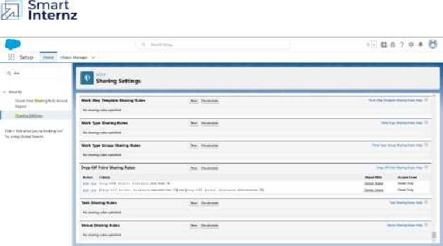

2.4 Flow and Dashboard

* Flow: Venue Flow
* Purpose: To manage and capture detailed information related to food drop-off

points.

* Components:
* Text Component: For entering the venue name.
* Email Component: For entering the contact email of the venue.
* Phone Component: For entering the contact phone number of the

venue. o Text Component: For entering the venue location.

a Number Components: For entering latitude and longitude values of the venue.



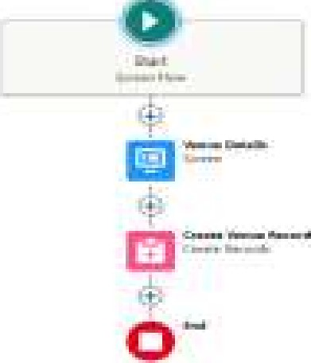



* Dashboard:
* Name: Organization Details
* Components:
* Lightning Table: Displays detailed information about venues and drop-off

points, facilitating a comprehensive view of the data.

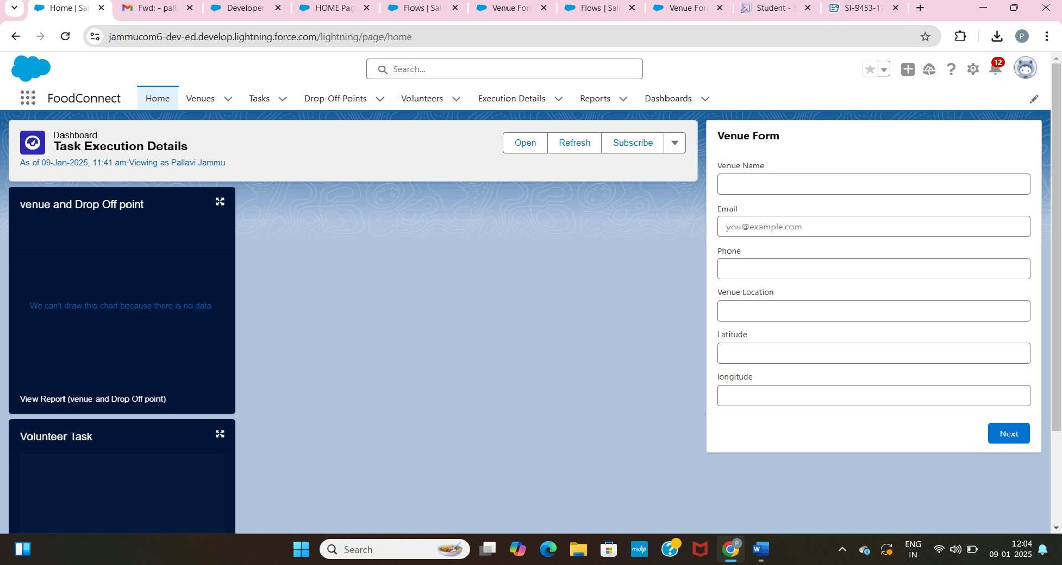

1. Configuration and Setup Instructions

3.1 Creating Custom Objects

1. Drop-Off Point:

* Navigate to Object Manager > Create > Custom Object.
* Enter details such as the label name, record name, and Other settings for Drop

Off Point.

2. Task:

* Navigate to Object Manager > Create > Custom Object.
* Enter details such as the label name, record name, and other settings for Task.

3. Volunteer:

* Navigate to Object Manager > Create > Custom Object.
* Enter details such as the label name, record name, and other settings

for Volunteer.

4. Execution Detail:

* Navigate to Object Manager > Create > Custom Object.
* Enter details such as the label name, record name, and other settings

for Execution Detail.

3.2 Sharing Rules Setup

* GO to Sharing Settings.
* Define new sharing rules for Drop-Off Point based on distance criteria, ensuring

appropriate access for different public groups.

3.3 Lightning App Builder

1. Create Home Page:

* Go to Lightning App Builder > New.
* Select Home Page and name it "HOME Page"
* Add Flow and Dashboard components to the page.

2. Save and Activate:

* Click on Save and Activation.
* Set the page as the default for the FoodConnect app.

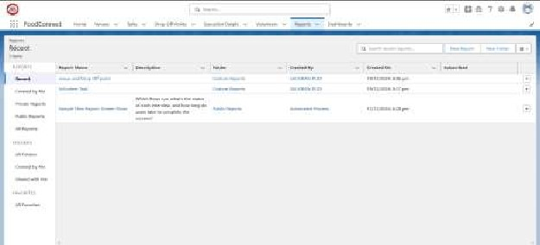

3.4 Report Types and Dashboards

1. Custom Report Types:

 Create report types for Venue with Drop-Off with Volunteer and Volunteers with

Execution Details and Tasks.

1. Reports:
   * Generate and configure reports using the custom report types to track and analyse relevant data
2. Dashboards:
   * Configure dashboards to visualise data from reports and other

components, providing insights into the overall distribution process.

1. Deliverables

* Code Files: Include Apex triggers and any other code implemented. • Output

Screenshots: Provide screenshots of custom objects, flows, dashboards, and reports

to illustrate the setup.

* Project Documentation: Detailed descriptions of implemented features, configurations,

and setup instructions.

* Project Demonstration Video: A video showcasing the functionality of the

application, including key features and processes.