PIZZA SALES SQL QUERIES

**A.KPI’s**

1.Total Revenue

select sum(total_price) as total_revenue

from pizza_sales.pizza_sales ;

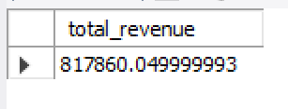

2.Average Order value

select sum(total_price) / count(distinct(order_id)) as avg_ord_val

from pizza_sales.pizza_sales ;

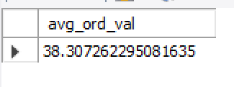

3.Total Pizza Sold

select sum(quantity) as total_pizza_sold

from pizza_sales.pizza_sales;

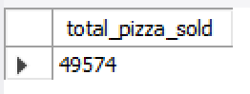

4.Total Order

select count(distinct(order_id)) as total_order

from pizza_sales.pizza_sales;

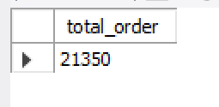

5.Average Pizza Per Order

select sum(quantity) / count(distinct(order_id)) as avg_pizza_per_order

from pizza_sales.pizza_sales;

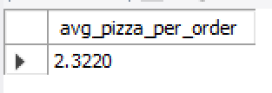

**B. Daily Trend for Total Order’s**

select dayname(order_date_fixed) as day_name,

count(distinct(order_id)) as total_orders

from pizza_sales

group by dayname(order_date_fixed) ;

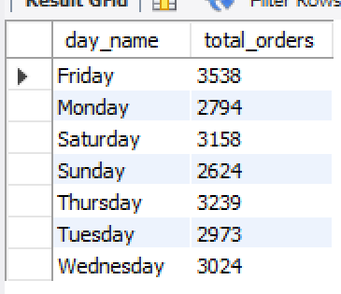

**C. Monthly Trends for Orders**

select monthname(order_date_fixed) as month_name,

count(distinct(order_id)) as total_orders

from pizza_sales

group by monthname(order_date_fixed);

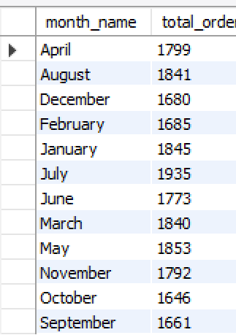

**D. Percentage Of Sales By Pizza Category**

select pizza_category,

round(sum(total_price) * 100 / (select sum(total_price) from pizza_sales),2) as percentage_per_pizza_category

from pizza_sales

group by pizza_category;

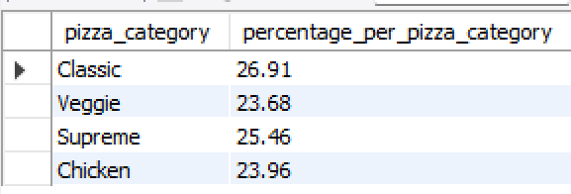

**E. Percentage Of Sales By Pizza Size**

select pizza_size,

sum(total_price) as total_revenue,

round(sum(total_price) * 100 / (select sum(total_price)from pizza_sales),2) as sales_by_pizza_size

from pizza_sales

group by pizza_size

order by pizza_size;

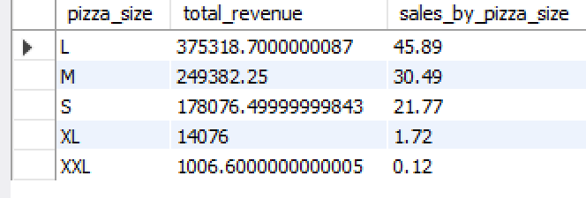

**F. Total Pizzas Sold by Pizza Category**

select pizza_category,

sum(quantity) as total_quantity_sold

from pizza_sales

group by pizza_category

order by total_quantity_sold desc;

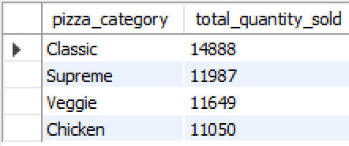

**G.Top 5 Pizzas by Revenue**

select pizza_name,

count(quantity) as total_sales,

round(sum(total_price), 2) as total_revenue

from pizza_sales.pizza_sales

group by pizza_name

order by total_revenue desc limit 5;

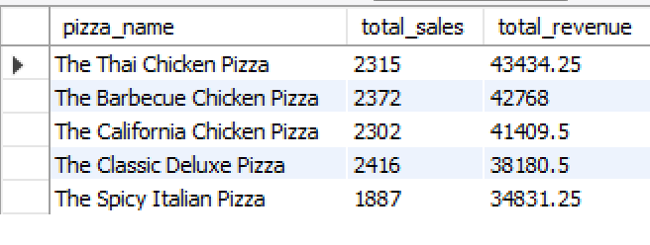

**H. Bottom 5 Pizzas by Revenue**

select pizza_name,

count(quantity) as total_sales,

round(sum(total_price), 2) as total_revenue

from pizza_sales.pizza_sales

group by pizza_name

order by total_revenue limit 5;

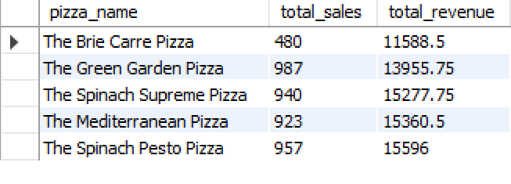

**I. Top 5 Pizzas by Quantity**

SELECT pizza_name,

SUM(quantity) AS total_sales

FROM pizza_sales.pizza_sales

GROUP BY pizza_name

ORDER BY total_sales desc LIMIT 5;

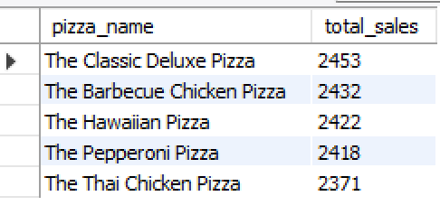

**J. Bottom 5 Pizzas by Quantity**

SELECT pizza_name,

SUM(quantity) AS total_sales

FROM pizza_sales.pizza_sales

GROUP BY pizza_name

ORDER BY total_sales LIMIT 5;

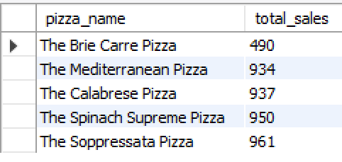

**K. Top 5 Pizzas by Total Orders**

SELECT pizza_name,

count(distinct(order_id)) AS total_sales

FROM pizza_sales.pizza_sales

GROUP BY pizza_name

ORDER BY total_sales desc LIMIT 5;

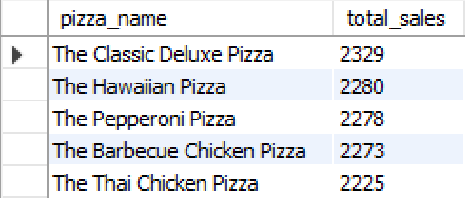

**L. Bottom 5 Pizzas by Total Orders**

SELECT pizza_name,

count(distinct(order_id)) AS total_sales

FROM pizza_sales.pizza_sales

GROUP BY pizza_name

ORDER BY total_sales asc LIMIT 5;

