**User Profile Entry Form Specification**

Please create an User Profile Entry Form by using Visual Studio C#.NET as Windows application (exe). The screen image is as follows.

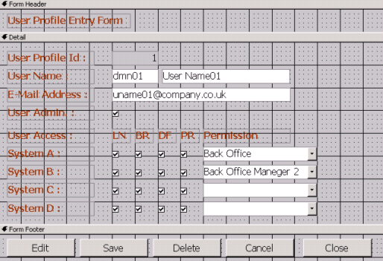

System specification from a project manager is ….

1. User Profile Id is allocated automatically by Database
2. User Name is consisted from Domain and Full name.
3. User Admin check box shows the permission to edit this User Profile information.
4. 10 systems (System A-L) are registered.
5. 4 branches (LN, BR, DF and PR) are registered.
6. Permission is defined by each system.
7. When data (record) is deleted by users, please set “-1” to the status field of each tables. (Not physically deleted.)
8. Please use .NET Framework 4.0 or lower version.
9. Do not use any third party components/dlls.
10. Do not use .NET Entity Framework.
11. Do not use SQL Server stored procedures/triggers.

Please spend 2 days (48 hours) and send files (both source codes and exe/dll files) to your agents by e-mail.

* You can add any other functions/forms/Datagirds etc which you believe it will be necessary for this entry form.