OBSERVATIONS

Results for Small Room (RT60 = 0.3 s)
White Noise:
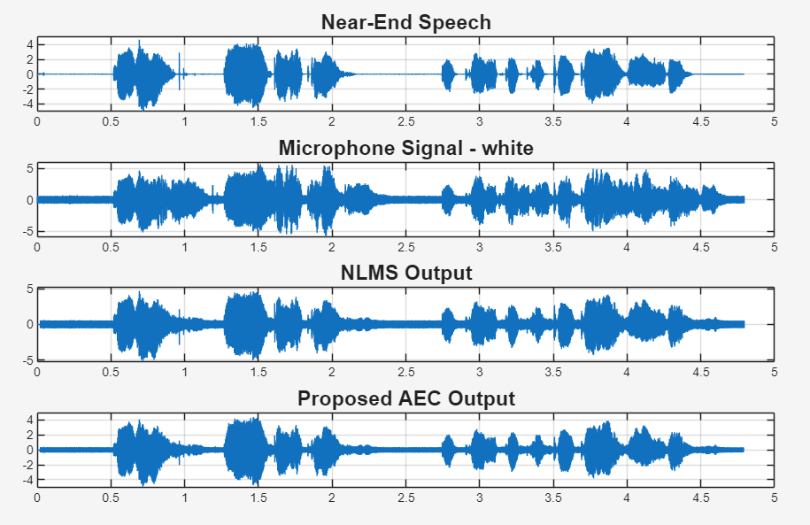
Fig. 1: Waveform Analysis under White Noise
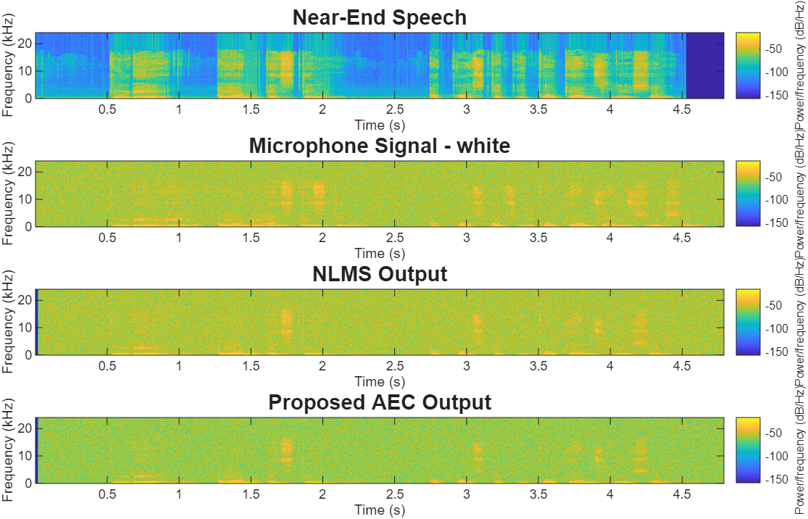
Fig. 2: Spectrogram Analysis under White Noise
The waveform shows effective suppression of the dominant acoustic echo while preserving the near-end speech. The corresponding spectrogram exhibits reduced white noise and residual echo with clearly preserved speech harmonics, indicating improved speech quality under low-reverberation conditions.

Babble Noise:
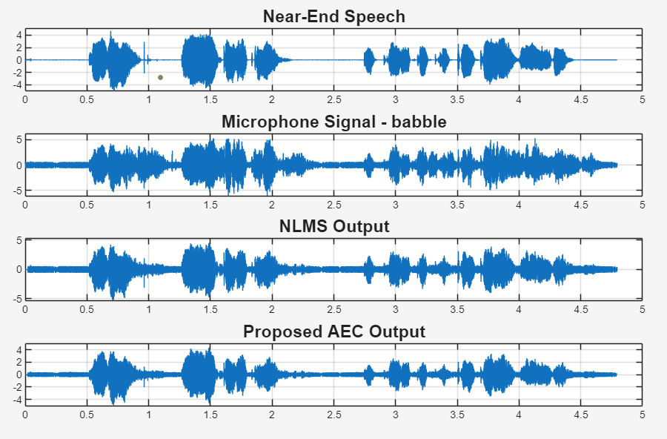
Fig. 3: Waveform Analysis under Babble Noise
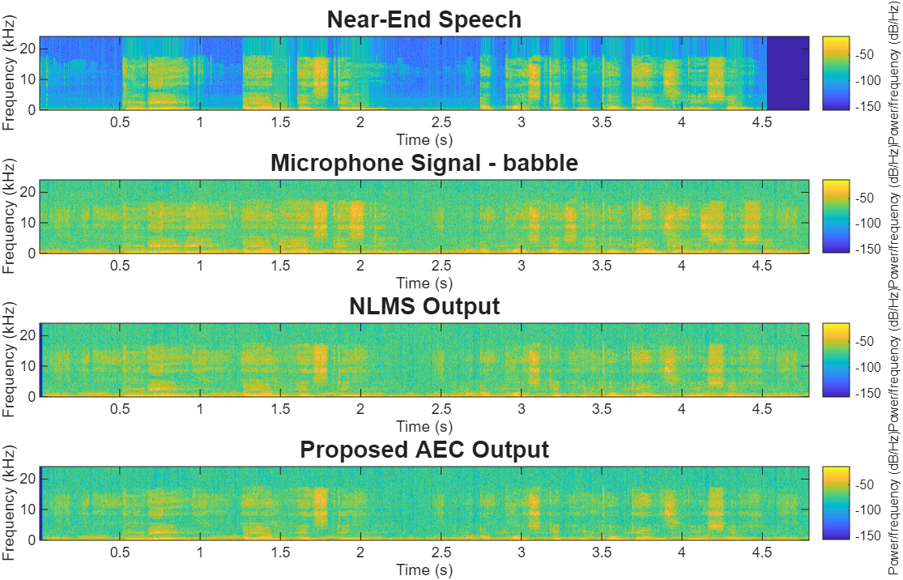
Fig. 4: Spectrogram Analysis under Babble Noise
Babble noise overlaps with speech frequencies, making echo suppression more challenging. The proposed framework effectively reduces residual interference while preserving the dominant speech components, resulting in improved waveform clarity and spectrogram representation.
Factory Noise:
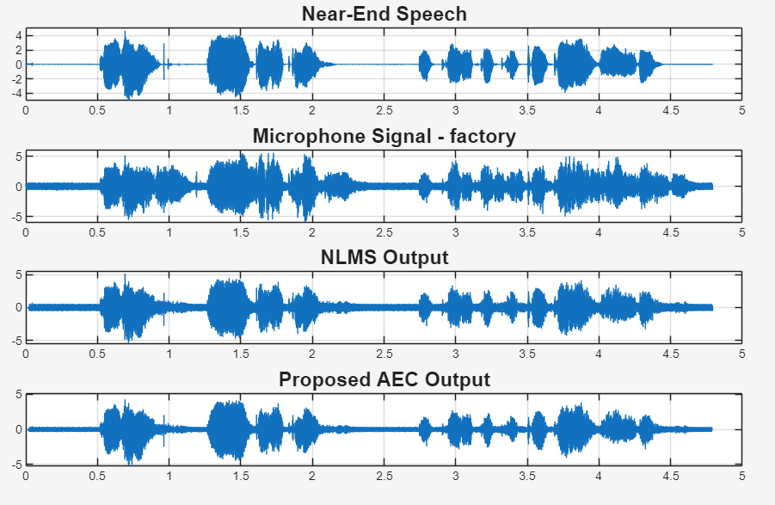
Fig. 5: Waveform Analysis under Factory Noise
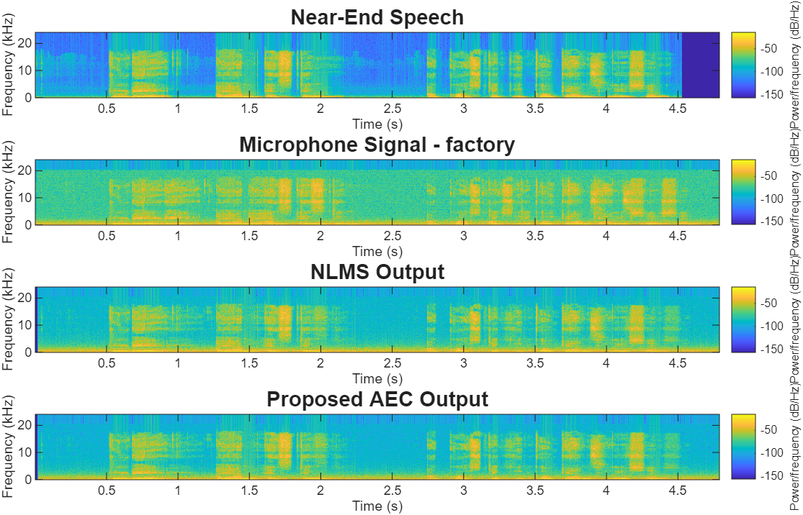
Fig. 6: Spectrogram Analysis under Factory Noise

Factory noise introduces strong broadband interference that masks speech components. The enhanced waveform and spectrogram indicate effective suppression of residual echo and background noise while preserving the primary speech frequencies.

Cockpit Noise:
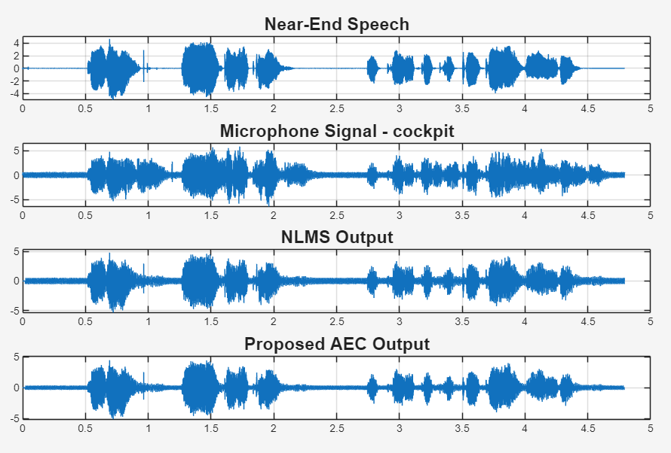
Fig. 7: Waveform Analysis under Cockpit Noise

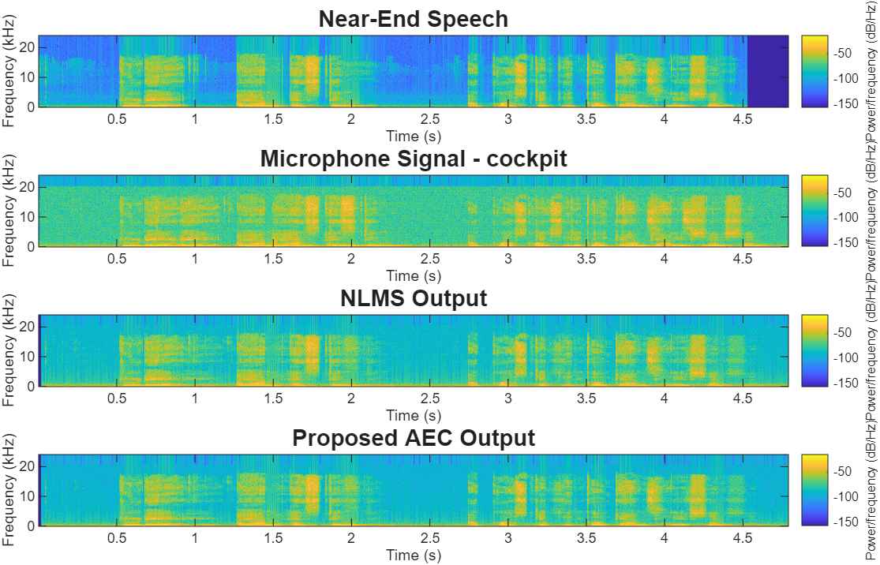
Fig. 8: Spectrogram Analysis under Cockpit Noise
Cockpit noise mainly affects the low-frequency region of the speech spectrum. The proposed framework effectively attenuates the acoustic echo and low-frequency interference while maintaining speech clarity in both the waveform and spectrogram.
Street Noise:
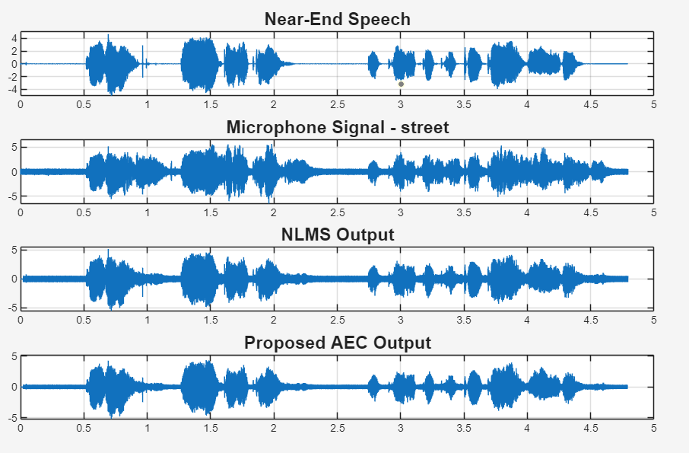
Fig. 9: Waveform Analysis under Street Noise
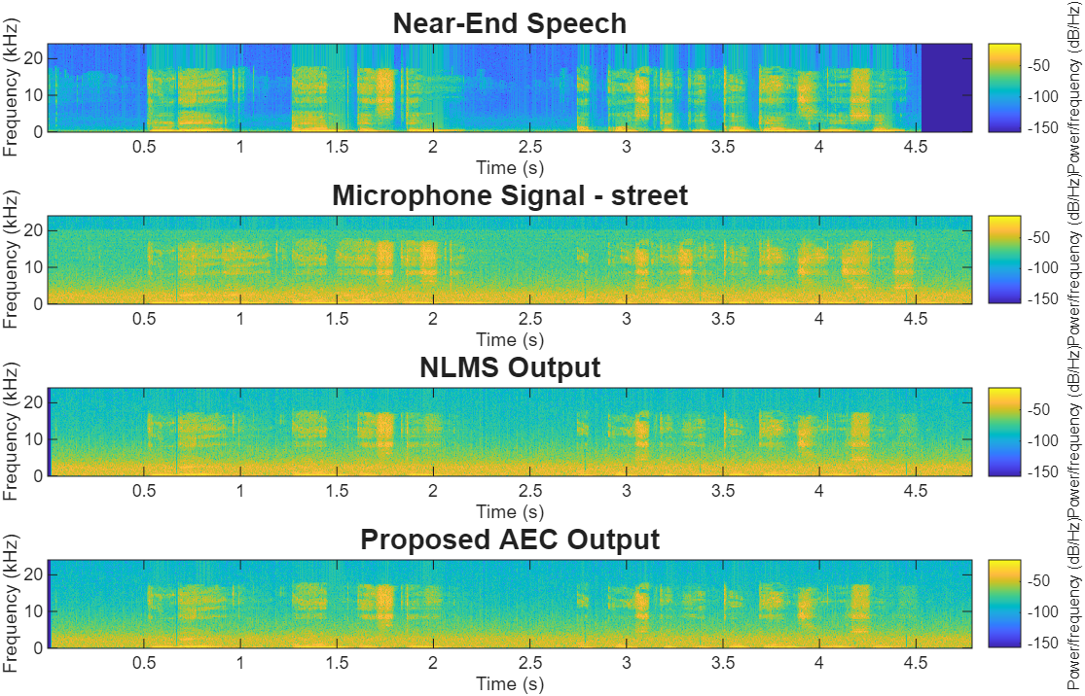
Fig. 10: Spectrogram Analysis under Street Noise
Street noise contains both stationary and non-stationary components. The proposed framework effectively suppresses acoustic echo and environmental interference, resulting in improved waveform clarity and better-preserved speech harmonics.

Car Noise:
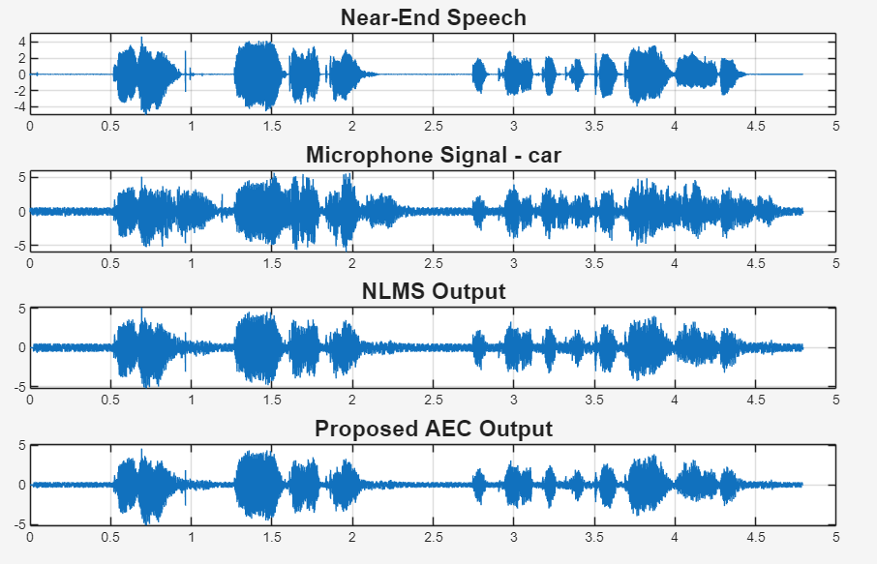
Fig. 11: Waveform Analysis under Car Noise
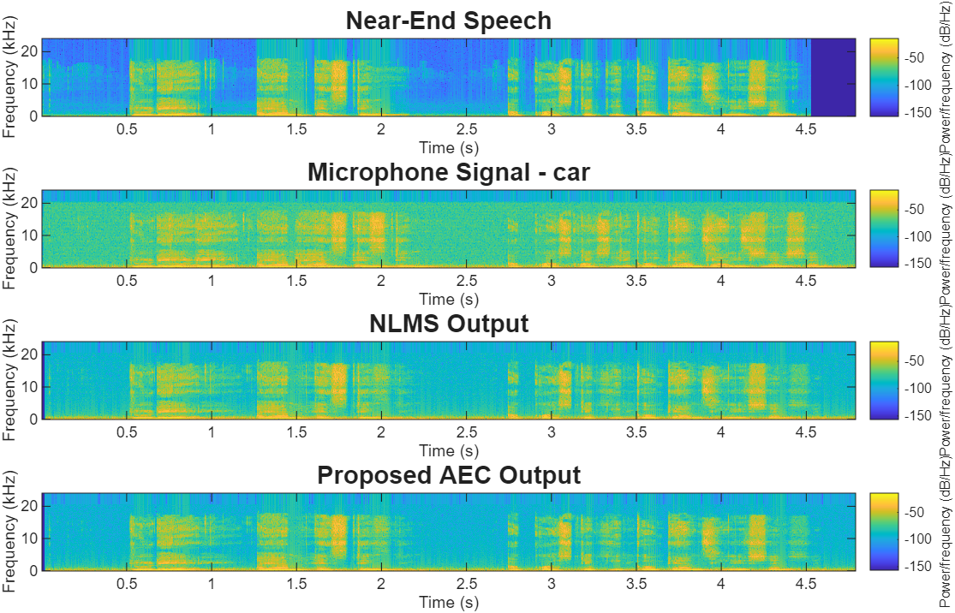
Fig. 12: Spectrogram Analysis under Car Noise
Car noise is dominated by low-frequency engine and road components. The proposed framework effectively reduces echo and background interference while preserving the temporal and spectral characteristics of the speech signal.

Observations with:
White Noise:

Table 1: Performance Evaluation Metrics for Small Room (RT60 = 0.3 s)
SNRin (dB) | ERLE (dB) | SNRout (dB) | SI-SDR (dB) | STOI
-10 | 13.26 | -7.87 | -9.07 | 0.275
-5 | 13.26 | -2.91 | -3.72 | 0.370
0 | 13.26 | 1.95 | 1.39 | 0.467
5 | 13.26 | 6.59 | 6.19 | 0.567
10 | 13.26 | 10.67 | 10.41 | 0.667
15 | 13.26 | 13.75 | 13.58 | 0.750
20 | 13.26 | 15.57 | 15.45 | 0.810

Table 1 shows that Output SNR, SI-SDR, and STOI improve consistently with increasing input SNR. The nearly constant ERLE values indicate stable acoustic echo cancellation, while the proposed framework effectively enhances speech quality.
Babble Noise:

Table 2: Performance Evaluation Metrics for Small Room (RT60 = 0.3 s)
SNRin | ERLE | SNRout | SI-SDR | STOI
-10 | 13.26 | -8.06 | -14.14 | 0.100
-5 | 13.26 | -3.30 | -7.87 | 0.216
0 | 13.26 | 1.11 | -2.12 | 0.385
5 | 13.26 | 5.30 | 3.81 | 0.562
10 | 13.26 | 9.39 | 8.92 | 0.698
15 | 13.26 | 12.85 | 12.74 | 0.786
20 | 13.26 | 15.15 | 15.12 | 0.834

Table 2 demonstrates steady improvements in Output SNR, SI-SDR, and STOI with increasing input SNR. Stable ERLE values confirm reliable echo cancellation despite the speech-like characteristics of babble noise.
Factory Noise:
Table 3: Performance Evaluation Metrics for Small Room (RT60 = 0.3 s)
SNRin | ERLE | SNRout | SI-SDR | STOI
-10 | 13.26 | -7.91 | -11.03 | 0.239
-5 | 13.26 | -3.02 | -5.41 | 0.373
0 | 13.26 | 1.76 | 0.32 | 0.504
5 | 13.26 | 6.37 | 5.63 | 0.617
10 | 13.26 | 10.53 | 10.16 | 0.713
15 | 13.26 | 13.70 | 13.51 | 0.788
20 | 13.26 | 15.58 | 15.46 | 0.833

Table 3 indicates consistent improvements in speech enhancement performance across all input SNR levels. The stable ERLE values demonstrate effective echo cancellation under industrial noise conditions.
Cockpit Noise:

Table 4: Performance Evaluation Metrics for Small Room (RT60 = 0.3 s)
SNRin | ERLE | SNRout | SI-SDR | STOI
-10 | 13.26 | -7.88 | -10.04 | 0.588
-5 | 13.26 | -2.94 | -4.30 | 0.703
0 | 13.26 | 1.94 | 1.17 | 0.779
5 | 13.26 | 6.64 | 6.19 | 0.823
10 | 13.26 | 10.84 | 10.57 | 0.851
15 | 13.26 | 13.99 | 13.83 | 0.867
20 | 13.26 | 15.79 | 15.68 | 0.879

Table 4 shows progressive improvements in Output SNR, SI-SDR, and STOI with increasing input SNR. The consistent ERLE values indicate stable performance of the NLMS adaptive filter.
Street Noise:

Table 5: Performance Evaluation Metrics for Small Room (RT60 = 0.3 s)
SNRin | ERLE | SNRout | SI-SDR | STOI
-10 | 13.26 | -7.89 | -10.15 | 0.175
-5 | 13.26 | -2.96 | -4.31 | 0.250
0 | 13.26 | 1.89 | 1.08 | 0.333
5 | 13.26 | 6.52 | 6.01 | 0.436
10 | 13.26 | 10.63 | 10.33 | 0.542
15 | 13.26 | 13.73 | 13.55 | 0.643
20 | 13.26 | 15.56 | 15.44 | 0.723

Table 5 demonstrates consistent improvements in speech quality and intelligibility across the evaluated SNR range. The stable ERLE values confirm reliable acoustic echo cancellation.
Car Noise:
Table 6: Performance Evaluation Metrics for Small Room (RT60 = 0.3 s)
SNRin | ERLE | SNRout | SI-SDR | STOI
-10 | 13.26 | -7.90 | -10.39 | 0.459
-5 | 13.26 | -2.95 | -4.31 | 0.600
0 | 13.26 | 1.92 | 1.16 | 0.716
5 | 13.26 | 6.59 | 6.13 | 0.791
10 | 13.26 | 10.76 | 10.48 | 0.833
15 | 13.26 | 13.89 | 13.72 | 0.854
20 | 13.26 | 15.70 | 15.59 | 0.868

Table 6 shows that Output SNR, SI-SDR, and STOI improve steadily with increasing input SNR. The nearly constant ERLE values indicate effective acoustic echo cancellation under car noise conditions.

Results for Medium Room (RT60 = 0.6 s)
White Noise:
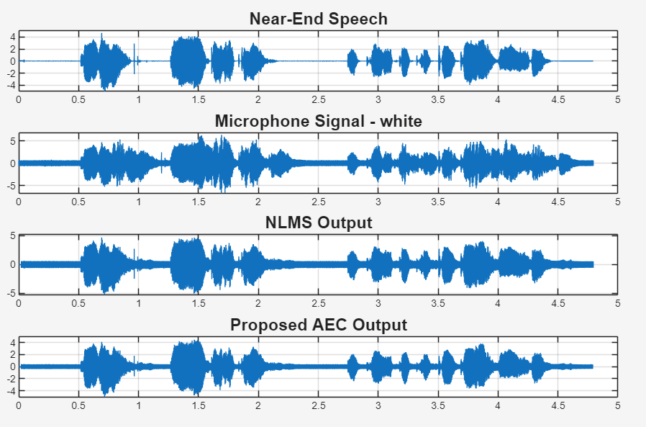
Fig. 13: Waveform Analysis under White Noise

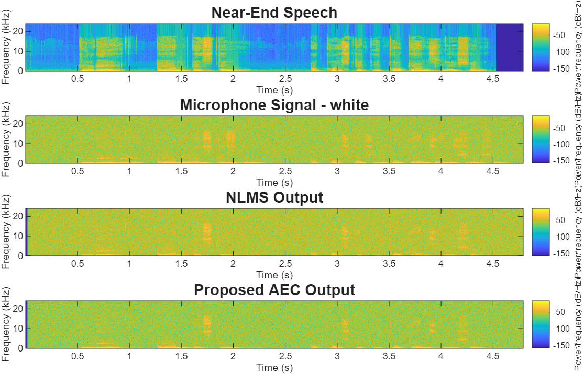
Fig. 14: Spectrogram Analysis under White Noise
The Medium Room introduces moderate reverberation, resulting in a more complex acoustic echo path. The proposed framework effectively suppresses acoustic echo and white noise, producing a clearer waveform and better-preserved speech components in the spectrogram.

Babble Noise:
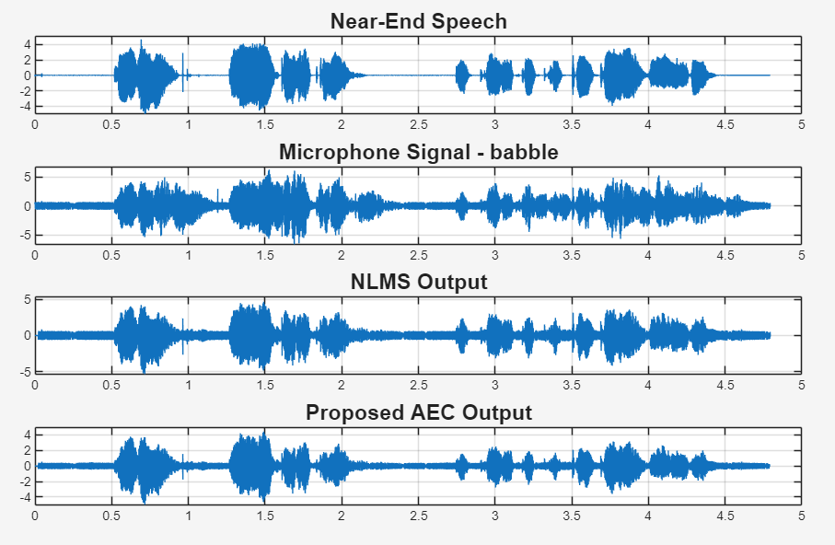
Fig. 15: Waveform Analysis under Babble Noise

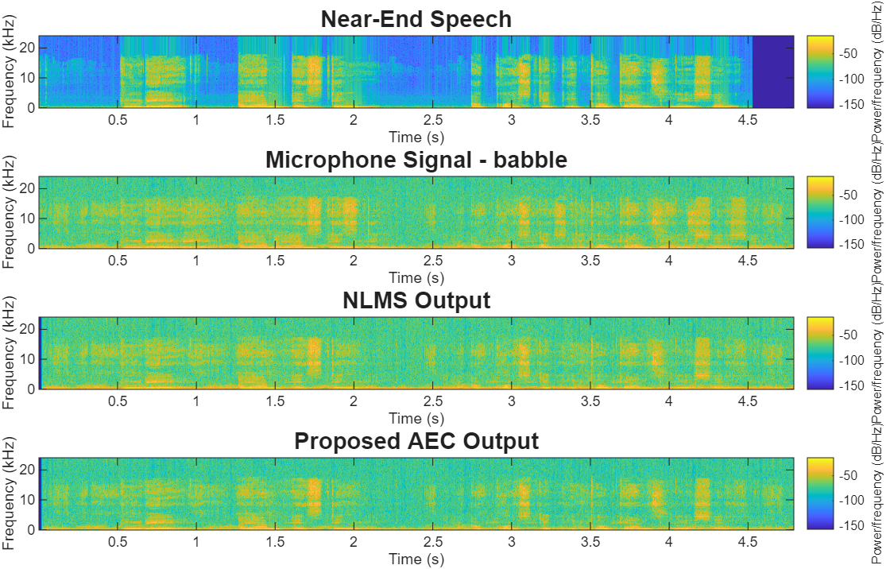
Fig. 16: Spectrogram Analysis under Babble Noise
Babble noise combined with moderate reverberation increases speech masking. The proposed framework effectively reduces residual interference while preserving the dominant speech components, resulting in improved waveform clarity and spectrogram quality.
Factory Noise:
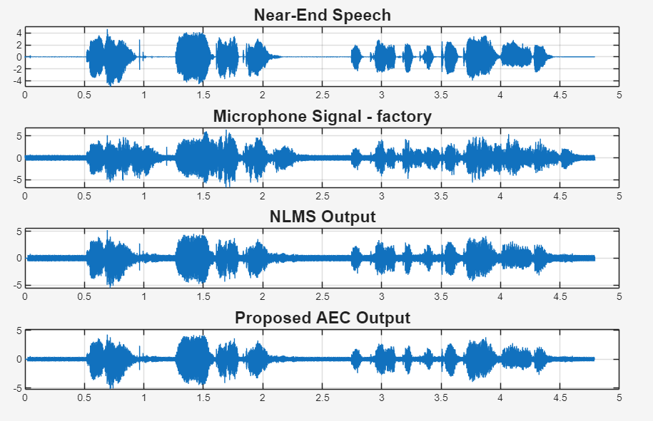
Fig. 17: Waveform Analysis under Factory Noise
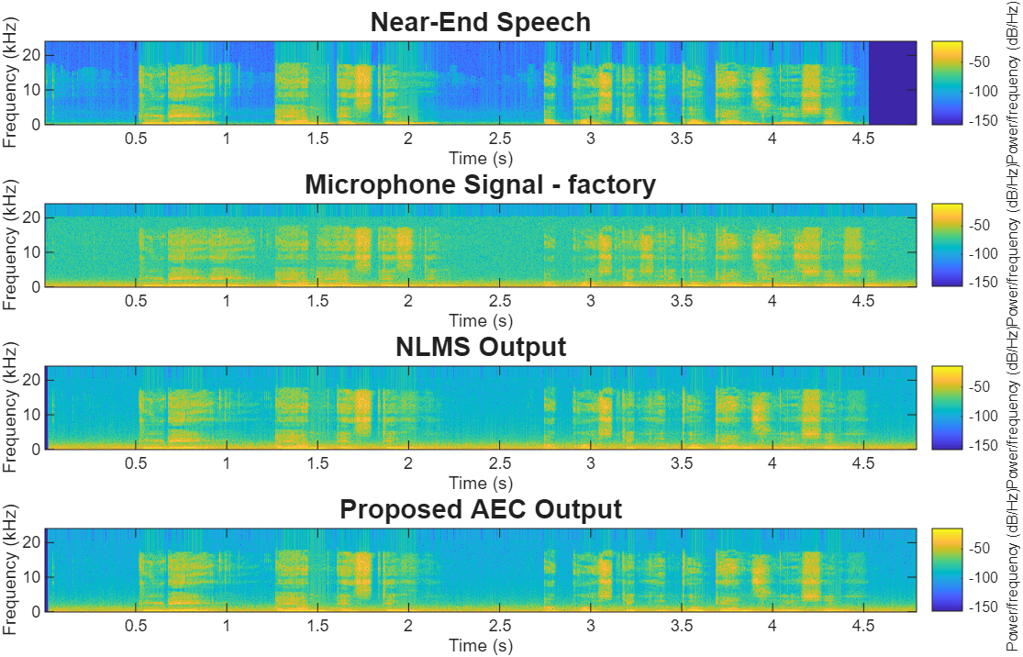
Fig. 18: Spectrogram Analysis under Factory Noise
Factory noise introduces strong broadband interference under moderate reverberation. The enhanced waveform and spectrogram indicate effective suppression of acoustic echo and background noise while preserving the primary speech frequencies.
Cockpit Noise:
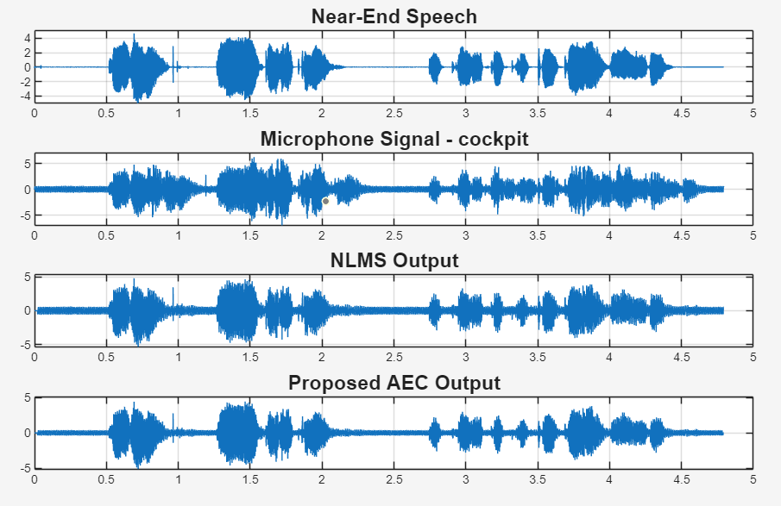
Fig. 19: Waveform Analysis under Cockpit Noise

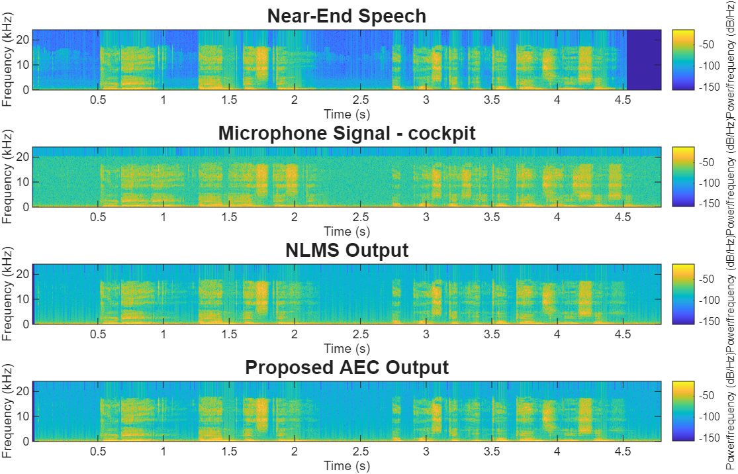
Fig. 20: Spectrogram Analysis under Cockpit Noise
Cockpit noise contains dominant low-frequency components that increase processing complexity. The proposed framework effectively suppresses residual echo and background interference while maintaining speech clarity in both the waveform and spectrogram.
Street Noise:
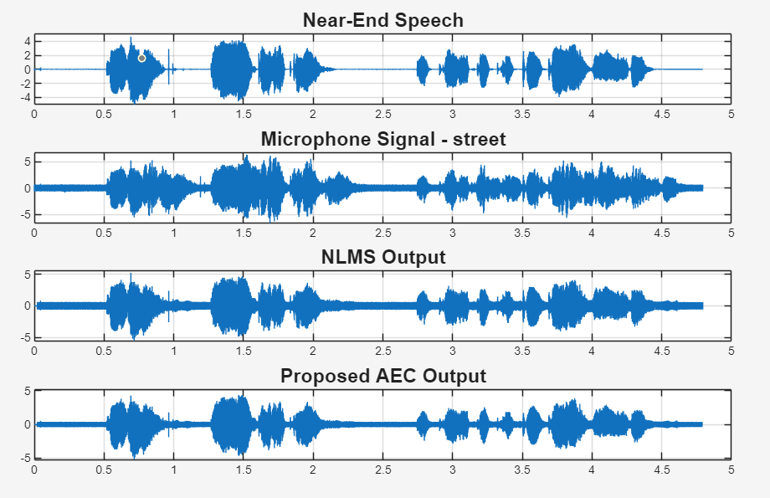
Fig. 21: Waveform Analysis under Street Noise

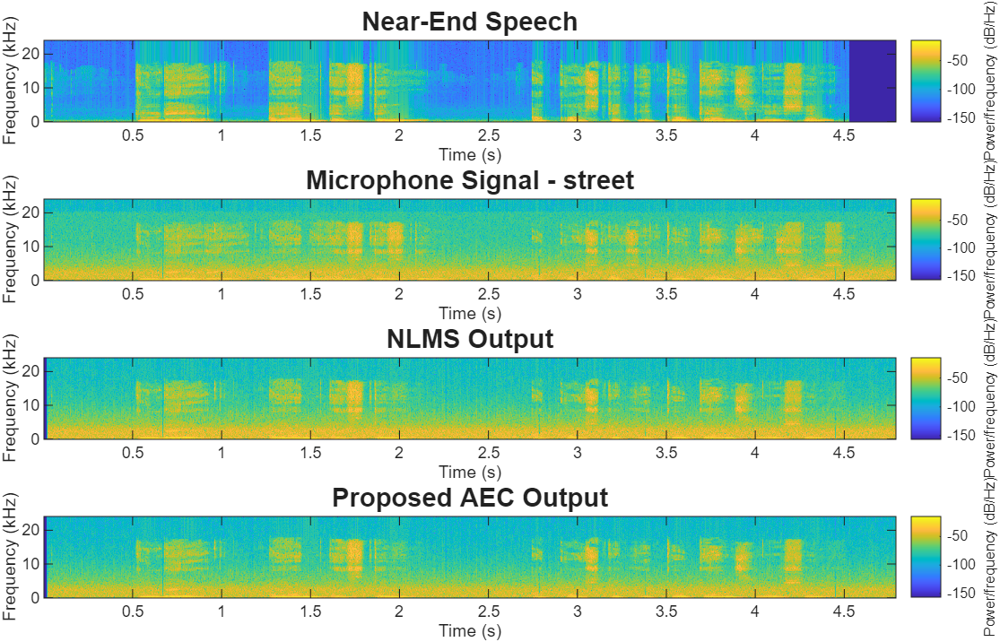
Fig. 22: Spectrogram Analysis under Street Noise
Street noise contains both stationary and non-stationary interference. The proposed framework effectively reduces acoustic echo and environmental noise, producing a clearer waveform and better-preserved speech harmonics.
Car Noise:
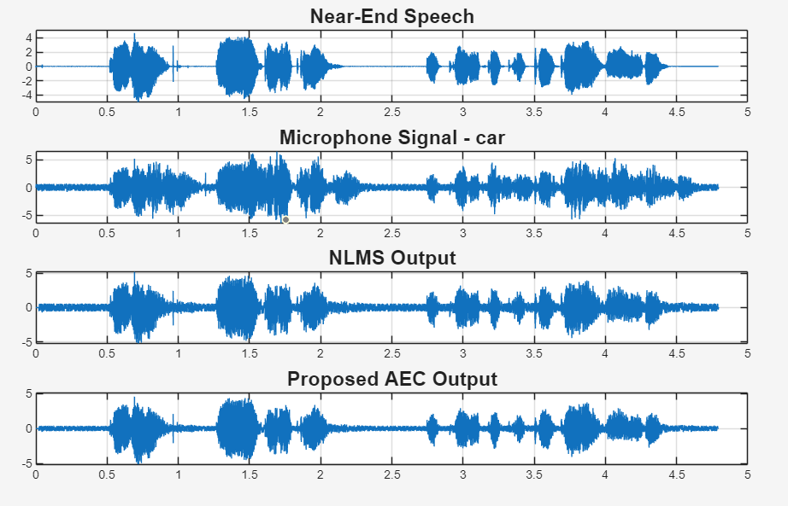
Fig. 23: Waveform Analysis under Car Noise

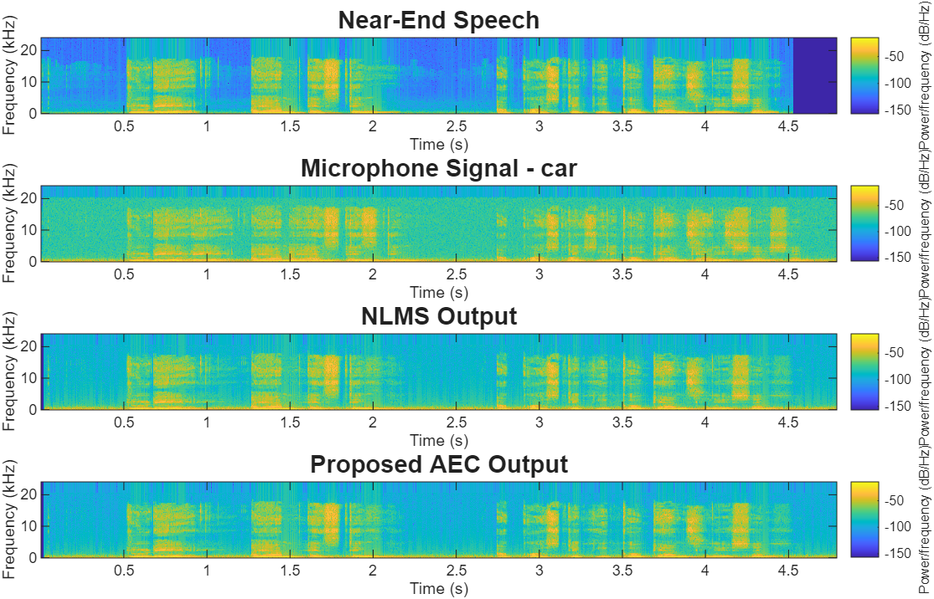
Fig. 24: Spectrogram Analysis under Car Noise
Car noise mainly affects the low-frequency region of the speech spectrum. The proposed framework effectively suppresses acoustic echo and background interference while preserving the temporal and spectral characteristics of speech.
Observations with:
White Noise:
Table 7: Performance Evaluation Metrics for Medium Room (RT60 = 0.6 s)
SNRin (dB) | ERLE (dB) | SNRout (dB) | SI-SDR (dB) | STOI
-10 | 17.97 | -8.59 | -9.89 | 0.264
-5 | 17.97 | -3.62 | -4.49 | 0.358
0 | 17.97 | 1.29 | 0.68 | 0.457
5 | 17.97 | 6.07 | 5.63 | 0.558
10 | 17.97 | 10.50 | 10.22 | 0.660
15 | 17.97 | 14.23 | 14.07 | 0.747
20 | 17.97 | 16.83 | 16.75 | 0.811

Table 7 shows consistent improvements in Output SNR, SI-SDR, and STOI as the input SNR increases. The stable ERLE values indicate reliable echo cancellation despite the increased reverberation.

Babble Noise:

Table 8: Performance Evaluation Metrics for Medium Room (RT60 = 0.6 s)
SNRin (dB) | ERLE | SNRout (dB) | SI-SDR | STOI
-10 | 17.97 | -8.77 | -15.16 | 0.091
-5 | 17.97 | -3.97 | -8.75 | 0.196
0 | 17.97 | 0.53 | -2.93 | 0.359
5 | 17.97 | 4.74 | 3.04 | 0.537
10 | 17.97 | 8.97 | 8.43 | 0.682
15 | 17.97 | 12.81 | 12.74 | 0.780
20 | 17.97 | 15.78 | 15.87 | 0.839

Table 8 demonstrates progressive improvements in speech quality and intelligibility across the evaluated SNR range. The nearly constant ERLE values confirm stable NLMS-based echo cancellation.
Factory Noise:
Table 9: Performance Evaluation Metrics for Medium Room (RT60 = 0.6 s)
SNRin (dB) | ERLE | SNRout | SI-SDR | STOI
-10 | 17.97 | -8.63 | -11.86 | 0.219
-5 | 17.97 | -3.73 | -6.26 | 0.351
0 | 17.97 | 1.08 | -0.52 | 0.485
5 | 17.97 | 5.76 | 4.94 | 0.601
10 | 17.97 | 10.16 | 9.76 | 0.700
15 | 17.97 | 13.90 | 13.72 | 0.781
20 | 17.97 | 16.63 | 16.58 | 0.837

Table 9 shows steady improvements in Output SNR, SI-SDR, and STOI with increasing input SNR. Stable ERLE values demonstrate consistent acoustic echo cancellation performance.
Cockpit Noise:

Table 10: Performance Evaluation Metrics for Medium Room (RT60 = 0.6 s)
SNRin (dB) | ERLE | SNRout | SI-SDR | STOI
-10 | 17.97 | -8.60 | -10.88 | 0.570
-5 | 17.97 | -3.65 | -5.14 | 0.691
0 | 17.97 | 1.26 | 0.40 | 0.777
5 | 17.97 | 6.06 | 5.56 | 0.828
10 | 17.97 | 10.57 | 10.28 | 0.861
15 | 17.97 | 14.42 | 14.26 | 0.880
20 | 17.97 | 17.09 | 17.02 | 0.897

Table 10 indicates consistent improvements in objective speech quality metrics. The stable ERLE values confirm reliable echo cancellation under moderate reverberation.

Street Noise:
Table 11: Performance Evaluation Metrics for Medium Room (RT60 = 0.6 s)
SNRin (dB) | ERLE | SNRout | SI-SDR | STOI
-10 | 17.97 | -8.62 | -11.04 | 0.165
-5 | 17.97 | -3.67 | -5.14 | 0.239
0 | 17.97 | 1.21 | 0.34 | 0.322
5 | 17.97 | 5.94 | 5.40 | 0.424
10 | 17.97 | 10.36 | 10.04 | 0.531
15 | 17.97 | 14.11 | 13.94 | 0.635
20 | 17.97 | 16.75 | 16.68 | 0.720

Table 11 demonstrates continuous improvement in Output SNR, SI-SDR, and STOI across all evaluated SNR levels. Stable ERLE values indicate robust acoustic echo cancellation.
Car Noise:
Table 12: Performance Evaluation Metrics for Medium Room (RT60 = 0.6 s)
SNRin (dB) | ERLE | SNRout | SI-SDR | STOI
-10 | 17.97 | -8.61 | -11.29 | 0.437
-5 | 17.97 | -3.66 | -5.17 | 0.577
0 | 17.97 | 1.25 | 0.40 | 0.701
5 | 17.97 | 6.04 | 5.52 | 0.786
10 | 17.97 | 10.53 | 10.23 | 0.838
15 | 17.97 | 14.38 | 14.22 | 0.866
20 | 17.97 | 17.05 | 16.98 | 0.884

Table 12 shows consistent enhancement in speech quality and intelligibility with increasing input SNR. The stable ERLE values demonstrate reliable acoustic echo cancellation performance.

Results for Large Room (RT60 = 0.9 s)
White Noise:
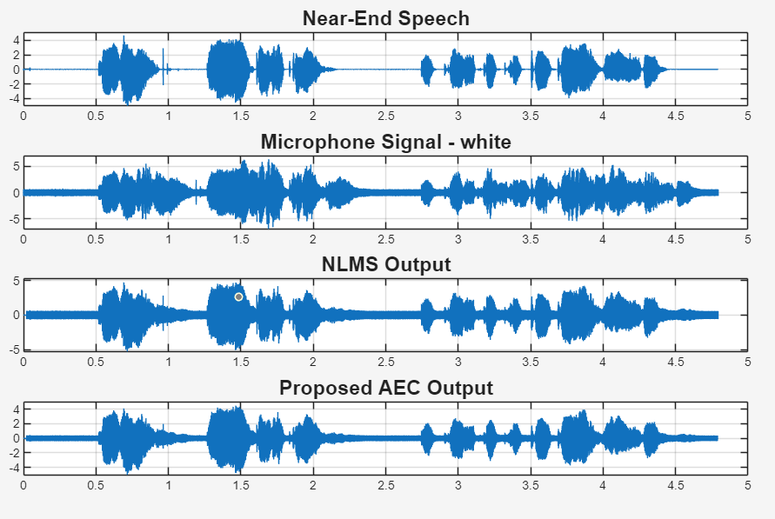
Fig. 25: Waveform Analysis under White Noise
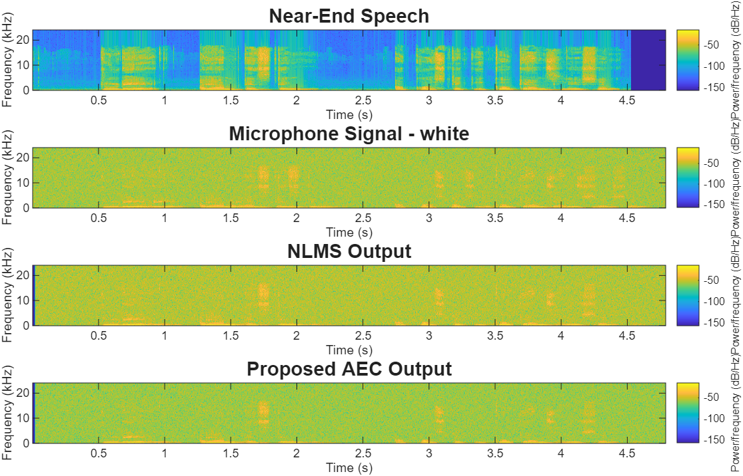
Fig. 26: Spectrogram Analysis under White Noise
The Large Room represents the most challenging acoustic environment due to its longer reverberation time. The proposed framework effectively suppresses acoustic echo and white noise, producing a clearer waveform and preserving speech harmonics in the spectrogram.
Babble Noise:
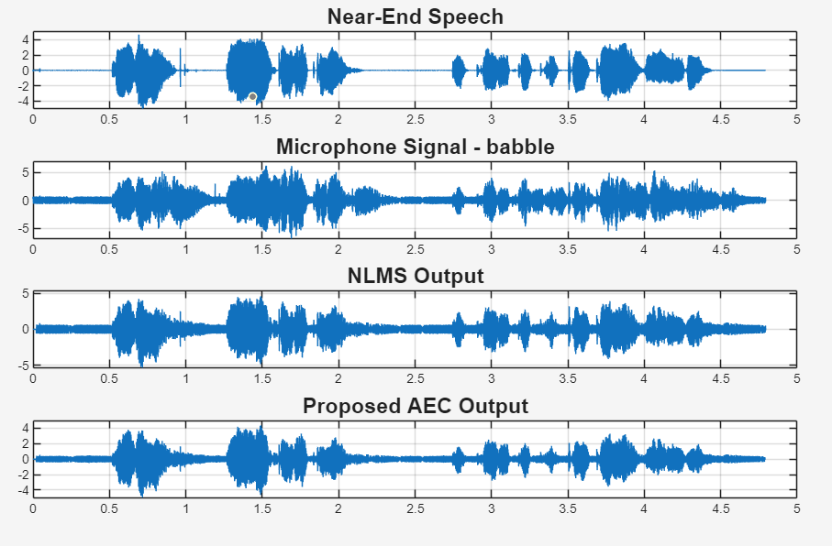
Fig. 27: Waveform Analysis under Babble Noise
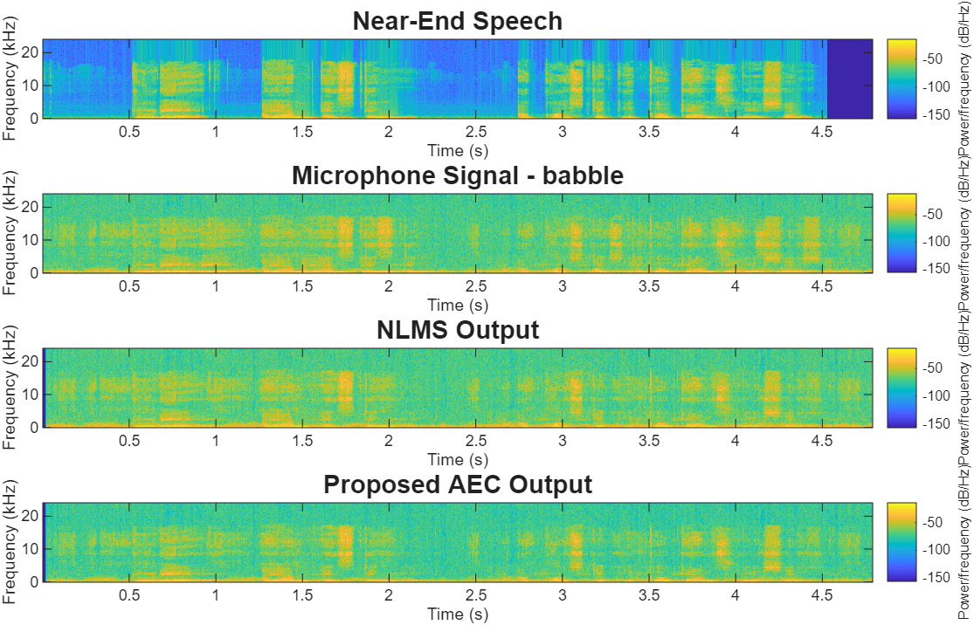
Fig. 28: Spectrogram Analysis under Babble Noise
Babble noise combined with strong reverberation presents a challenging speech enhancement scenario. The proposed framework effectively suppresses residual interference while preserving the dominant speech components in the enhanced signal.
Factory Noise:
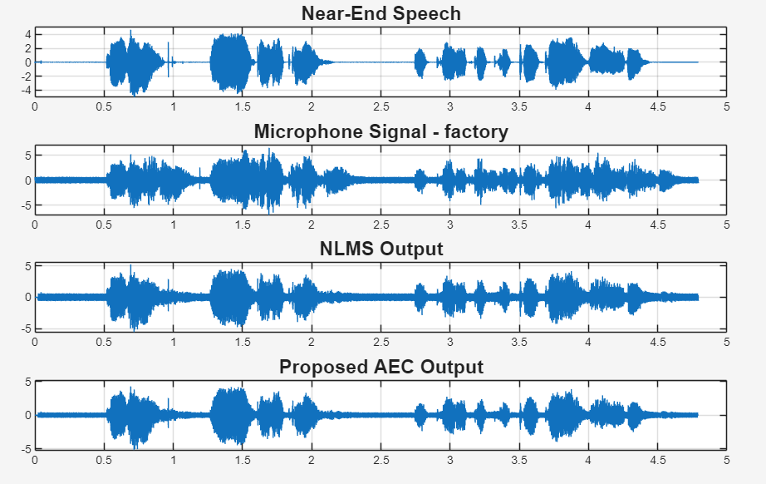
Fig. 29: Waveform Analysis under Factory Noise
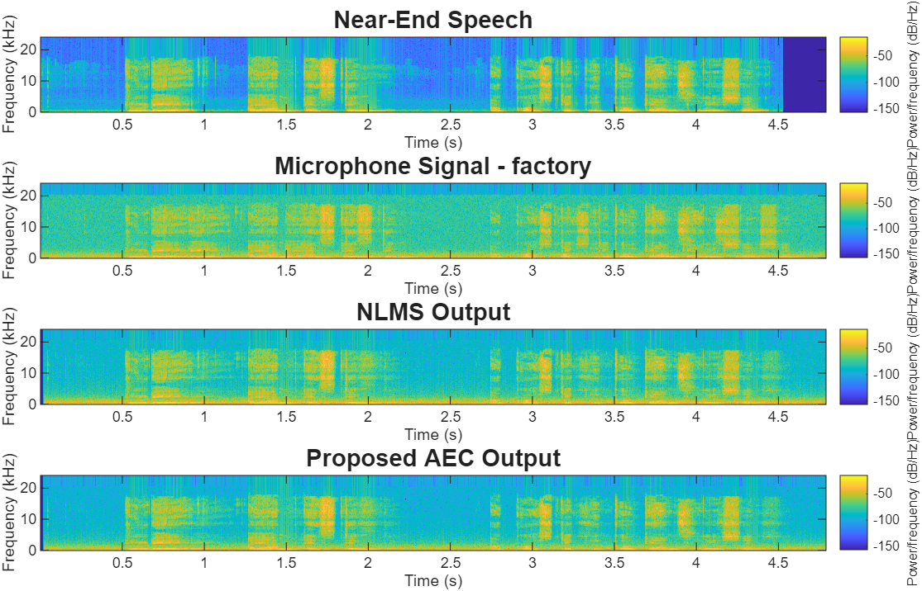
Fig. 30: Spectrogram Analysis under Factory Noise
Factory noise introduces significant broadband interference in the reverberant environment. The enhanced waveform and spectrogram indicate effective suppression of acoustic echo and residual noise while maintaining speech frequency components.
Cockpit Noise:
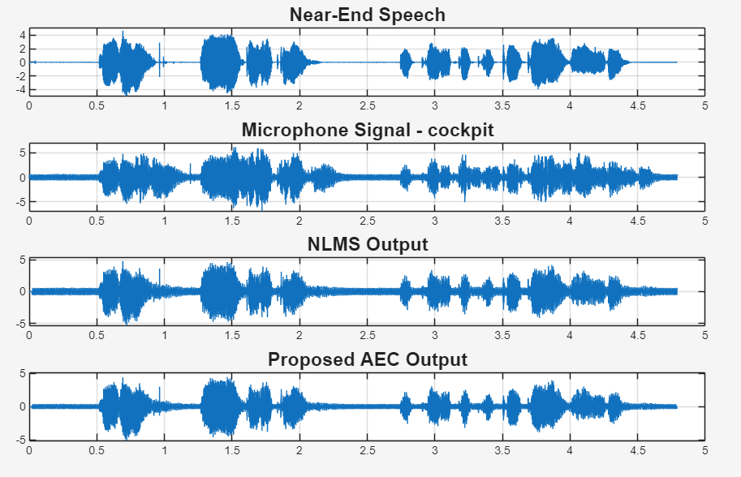
Fig. 31: Waveform Analysis under Cockpit Noise
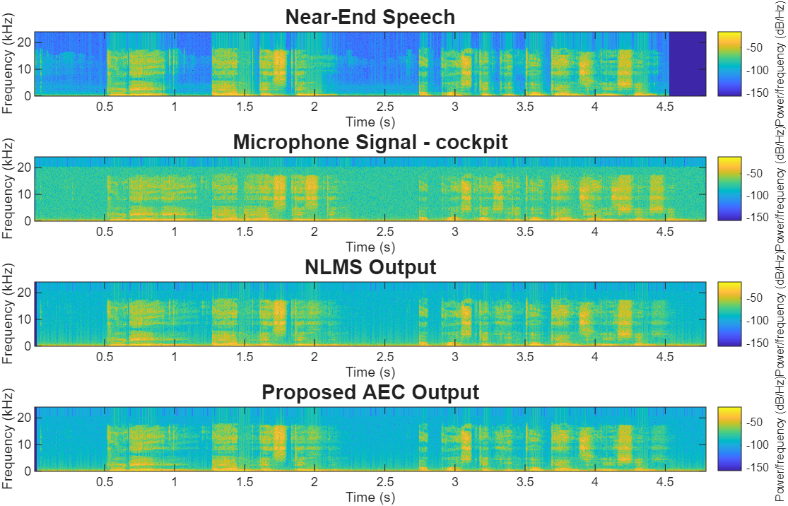
Fig. 32: Spectrogram Analysis under Cockpit Noise
Cockpit noise produces dominant low-frequency interference together with long-duration reverberation. The proposed framework effectively suppresses acoustic echo and background interference while preserving speech characteristics in the enhanced signal.
Street Noise:
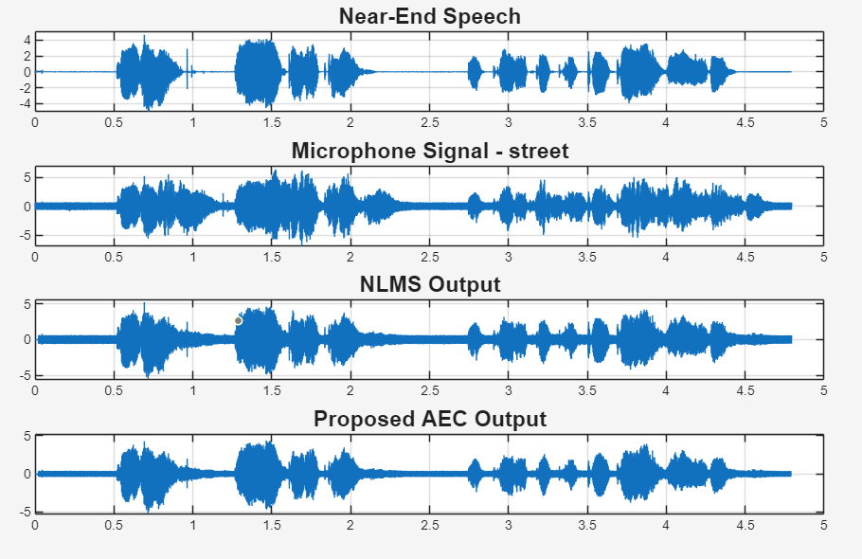
Fig. 33: Waveform Analysis under Street Noise
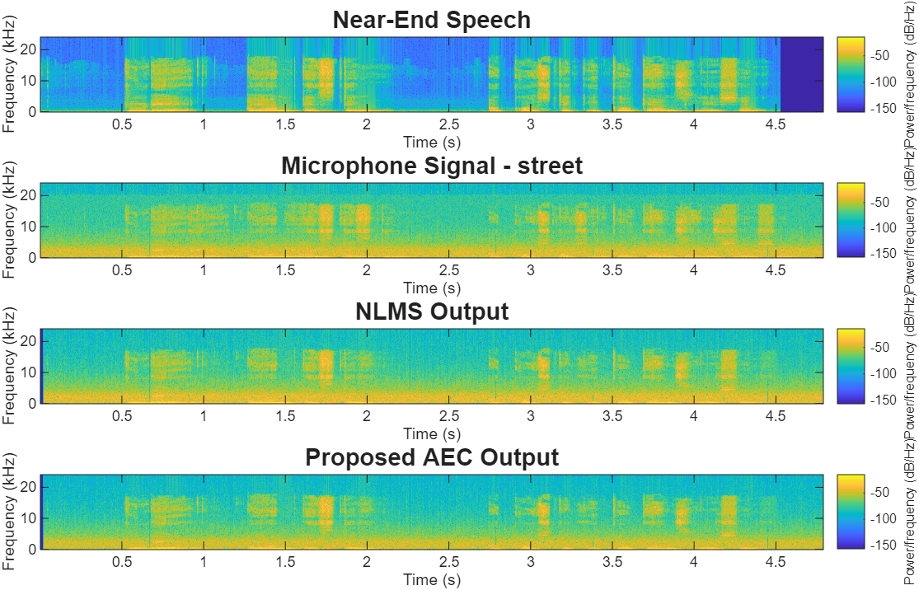
Fig. 34: Spectrogram Analysis under Street Noise
Street noise contains highly dynamic interference that increases processing complexity in the Large Room. The proposed framework effectively suppresses acoustic echo and environmental noise, resulting in improved waveform clarity and speech representation.
Car Noise:
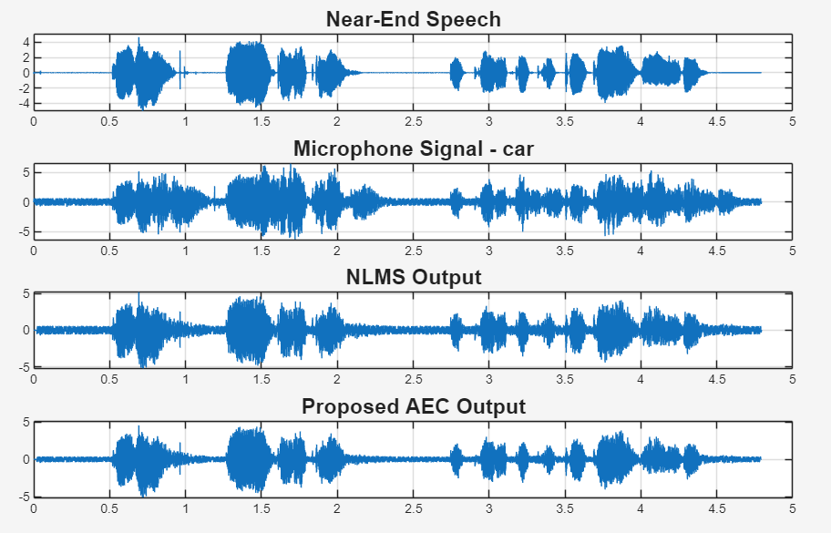
Fig. 35: Waveform Analysis under Car Noise
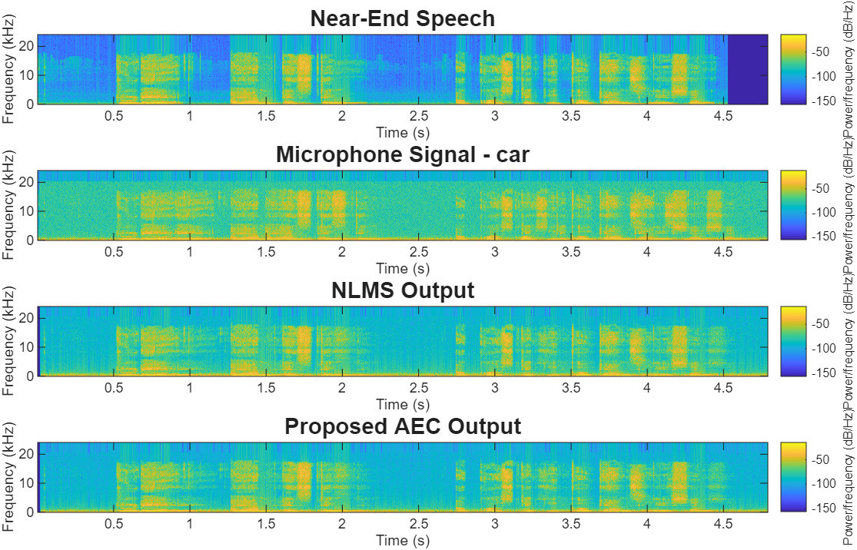
Fig. 36: Spectrogram Analysis under Car Noise
Car noise introduces persistent low-frequency interference together with increased reverberation. The proposed framework effectively reduces acoustic echo and residual noise while preserving the temporal and spectral characteristics of the speech signal.

Observations with:
White Noise:
Table 13: Performance Evaluation Metrics for Large Room (RT60 = 0.9 s)
SNRin (dB) | ERLE (dB) | SNRout (dB) | SI-SDR (dB) | STOI
-10 | 16.25 | -8.70 | -10.03 | 0.261
-5 | 16.25 | -3.73 | -4.62 | 0.354
0 | 16.25 | 1.16 | 0.54 | 0.450
5 | 16.25 | 5.88 | 5.44 | 0.550
10 | 16.25 | 10.16 | 9.85 | 0.652
15 | 16.25 | 13.53 | 13.34 | 0.739
20 | 16.25 | 15.68 | 15.56 | 0.801

Table 13 shows consistent improvements in Output SNR, SI-SDR, and STOI with increasing input SNR. Stable ERLE values indicate reliable acoustic echo cancellation despite the increased reverberation.
Babble Noise:
Table 14: Performance Evaluation Metrics for Large Room (RT60 = 0.9 s)
SNRin (dB) | ERLE | SNRout | SI-SDR | STOI
-10 | 16.25 | -8.88 | -15.34 | 0.088
-5 | 16.25 | -4.08 | -8.91 | 0.192
0 | 16.25 | 0.41 | -3.10 | 0.354
5 | 16.25 | 4.59 | 2.83 | 0.532
10 | 16.25 | 8.71 | 8.13 | 0.677
15 | 16.25 | 12.33 | 12.20 | 0.772
20 | 16.25 | 14.89 | 14.87 | 0.828

Table 14 demonstrates steady improvements in speech quality and intelligibility across the evaluated SNR range. The nearly constant ERLE values confirm consistent adaptive echo cancellation.
Factory Noise:
Table 15: Performance Evaluation Metrics for Large Room (RT60 = 0.9 s)
SNRin (dB) | ERLE | SNRout | SI-SDR | STOI
-10 | 16.25 | -8.73 | -11.99 | 0.216
-5 | 16.25 | -3.84 | -6.41 | 0.348
0 | 16.25 | 0.97 | -0.66 | 0.482
5 | 16.25 | 5.62 | 4.78 | 0.599
10 | 16.25 | 9.92 | 9.50 | 0.697
15 | 16.25 | 13.37 | 13.16 | 0.775
20 | 16.25 | 15.61 | 15.51 | 0.826

Table 15 shows progressive improvements in Output SNR, SI-SDR, and STOI as the input SNR increases. Stable ERLE values indicate effective echo suppression under highly reverberant conditions.
Cockpit Noise:
Table 16: Performance Evaluation Metrics for Large Room (RT60 = 0.9 s)
SNRin (dB) | ERLE | SNRout | SI-SDR | STOI
-10 | 16.25 | -8.71 | -11.04 | 0.569
-5 | 16.25 | -3.76 | -5.29 | 0.689
0 | 16.25 | 1.13 | 0.25 | 0.771
5 | 16.25 | 5.88 | 5.37 | 0.818
10 | 16.25 | 10.23 | 9.92 | 0.847
15 | 16.25 | 13.68 | 13.49 | 0.864
20 | 16.25 | 15.82 | 15.71 | 0.877

Table 16 demonstrates consistent improvements in objective performance metrics with increasing input SNR. Stable ERLE values confirm reliable adaptive echo cancellation performance.
Street Noise:
Table 17: Performance Evaluation Metrics for Large Room (RT60 = 0.9 s)
SNRin (dB) | ERLE | SNRout | SI-SDR | STOI
-10 | 16.25 | -8.72 | -11.18 | 0.164
-5 | 16.25 | -3.77 | -5.26 | 0.237
0 | 16.25 | 1.11 | 0.22 | 0.319
5 | 16.25 | 5.82 | 5.26 | 0.419
10 | 16.25 | 10.13 | 9.79 | 0.525
15 | 16.25 | 13.60 | 13.41 | 0.629
20 | 16.25 | 15.75 | 15.64 | 0.712

Table 17 indicates continuous improvements in Output SNR, SI-SDR, and STOI across the evaluated SNR range. The stable ERLE values demonstrate robust acoustic echo cancellation.
Car Noise:
Table 18: Performance Evaluation Metrics for Large Room (RT60 = 0.9 s)
SNRin (dB) | ERLE | SNRout | SI-SDR | STOI
-10 | 16.25 | -8.72 | -11.44 | 0.433
-5 | 16.25 | -3.78 | -5.31 | 0.574
0 | 16.25 | 1.11 | 0.25 | 0.696
5 | 16.25 | 5.84 | 5.32 | 0.778
10 | 16.25 | 10.17 | 9.85 | 0.828
15 | 16.25 | 13.65 | 13.46 | 0.854
20 | 16.25 | 15.79 | 15.68 | 0.870

Table 18 demonstrates consistent enhancement in speech quality and intelligibility with increasing input SNR. Stable ERLE values confirm reliable echo cancellation under highly reverberant conditions.

