**DAB203 Lab#5 [Marks 10]**

**Use the SQLBook database for this lab. Use the appropriate Table(s) for the query.**  
**Your query along with the results of the query should be pasted in Excel**. There are 5 questions, and each question should be answered on a different worksheet in Excel. Thus, each worksheet will have query, results, and corresponding chart, as applicable. The worksheets should be named as Q1, Q2 and so on. **The first worksheet should have your Name and Student ID written.**  
Make sure to properly format the charts with Axis titles and legends where appropriate.  
**Each question is worth 2 Marks.**

Q1. Create a query for daily distribution (Day of the week) of sum of TotalPrice on BillDate. Create the appropriate chart in Excel.

**For Q2 to Q5, your queries should consider data with startdate from 2004-01-01.**

Q2. Create a query to show yearly distribution of number of subscribers by start date for each of the four channels for the years 2004 and later. Your SQL query result should be in the following format.

|  |  |  |  |  |
| --- | --- | --- | --- | --- |
| Year | Chain | Dealer | Mail | Store |
|  |  |  |  |  |
|  |  |  |  |  |

Q3. Create a query to show yearly distribution of number of subscribers by stop date for each of the four channels. Combine the result with result of Q2. in Excel and clean up data so that the final output looks like this.

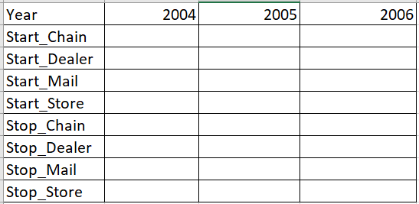

Generate a clustered column chart in Excel.

Q4. Create a query for the monthly rate plan to show number of subscribers in each plan. Make sure you only count the active subscribers. Your SQL query results should be in the following format.

|  |  |  |  |
| --- | --- | --- | --- |
| Month | Topmost | Middle | Bottom |
|  |  |  |  |
|  |  |  |  |

Q5. Write a query to show the tenure (in terms of years) and total monthly fee for subscribers who have stopped subscription.