create two VPC's (Demo1-VPC)(Demo2-VPC) in same region

perform the VPC peering between two VPC's

Creating 2 VPC’s in [**us-east-1**](https://us-east-1.console.aws.amazon.com/vpcconsole/home?region=us-east-1#VpcDetails:VpcId=vpc-02a69a32e386b18b9) Region as Demo1-VPC AND Demo2-VPC

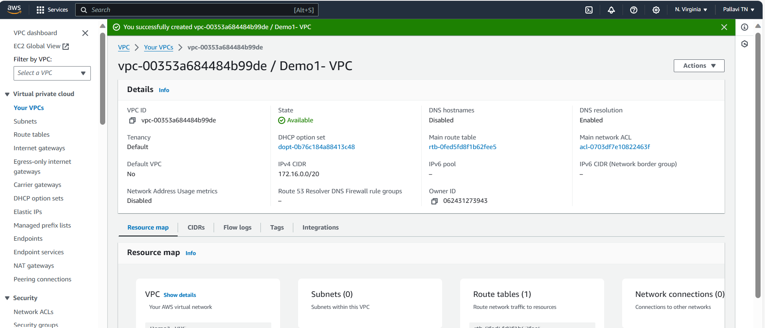



Make sure that both the CIDR Block should not Overlap

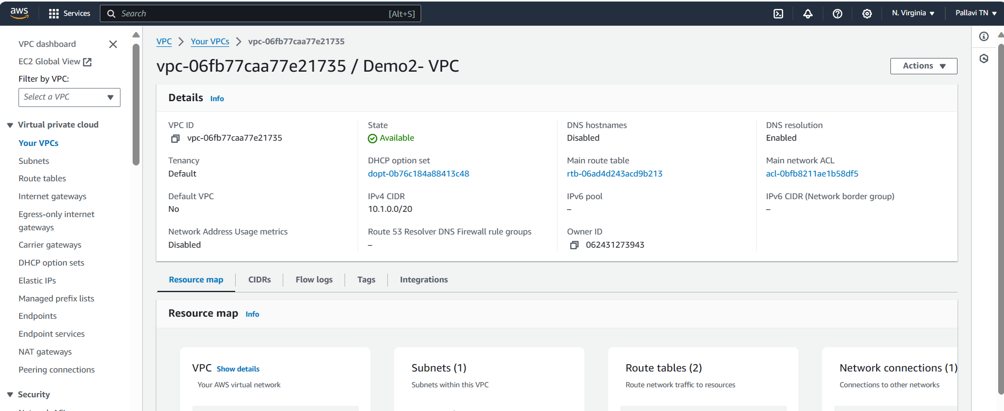



Created the subnets for the Vpc’s and also Internet Gateways for both the VPC’s and attached IGW to the VPC’s accordingly.

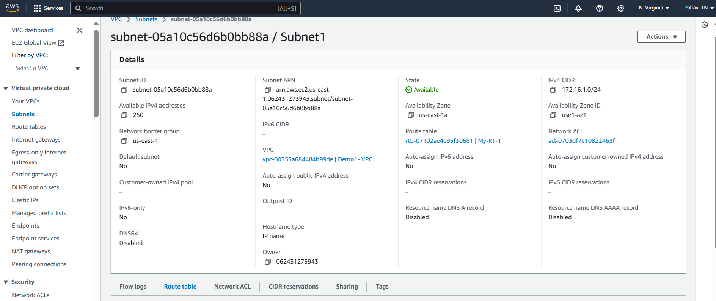



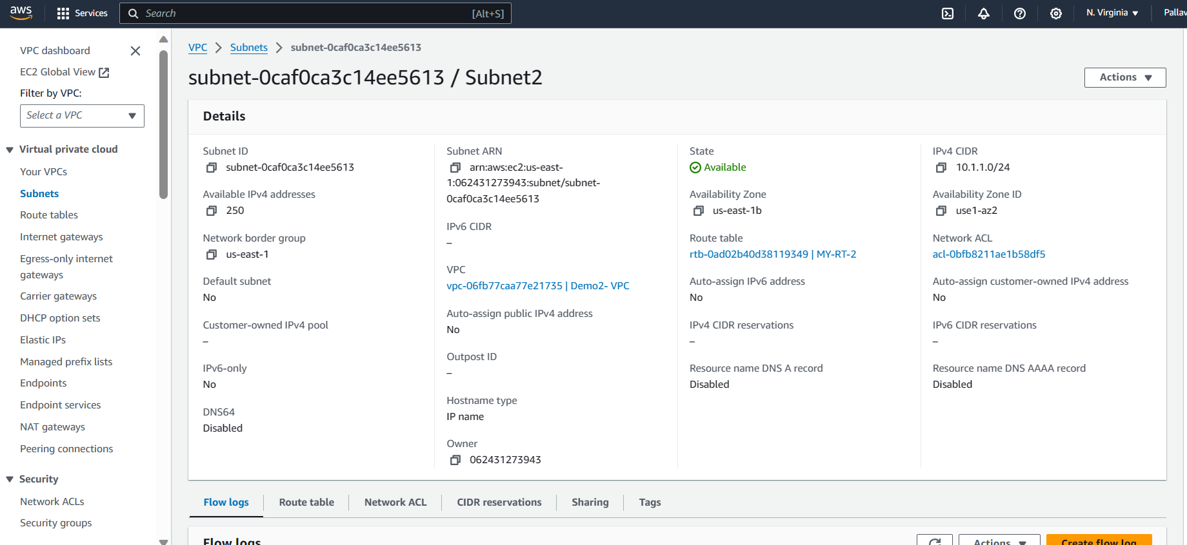



Created the INTERNET GATEWAY and Attached to the VPC’s

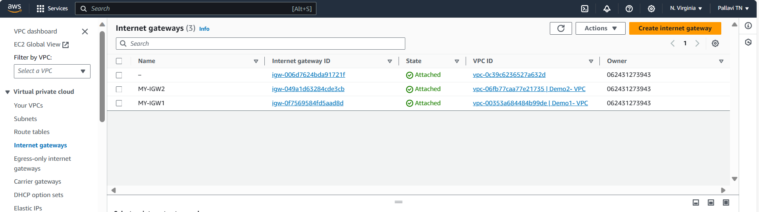



ROUTE TABLE CREATED:

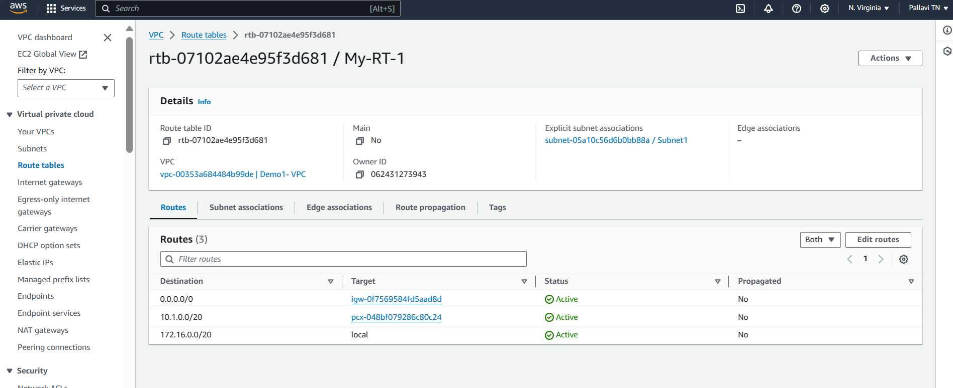



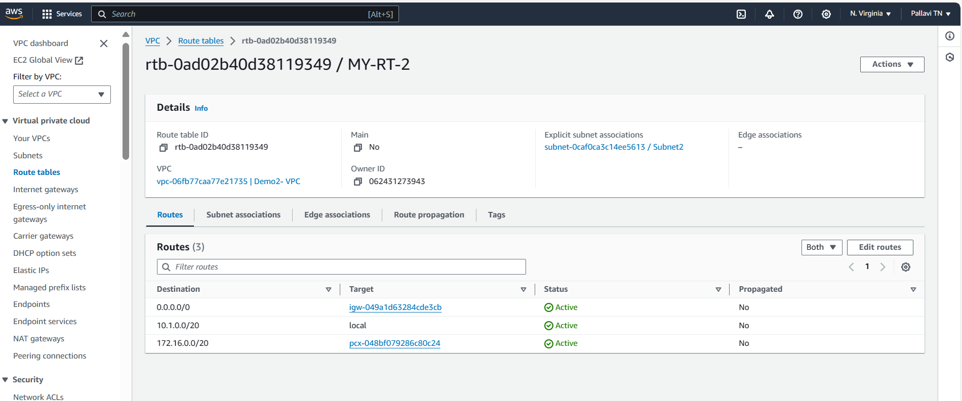



**added the Routes and attached the subnets with the Route table to make the Subnet association**

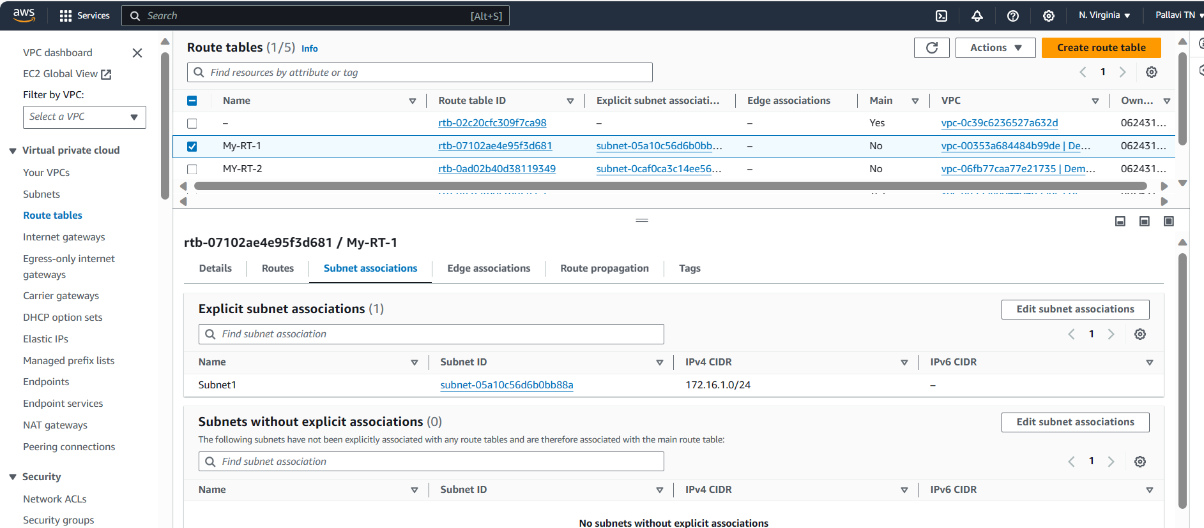



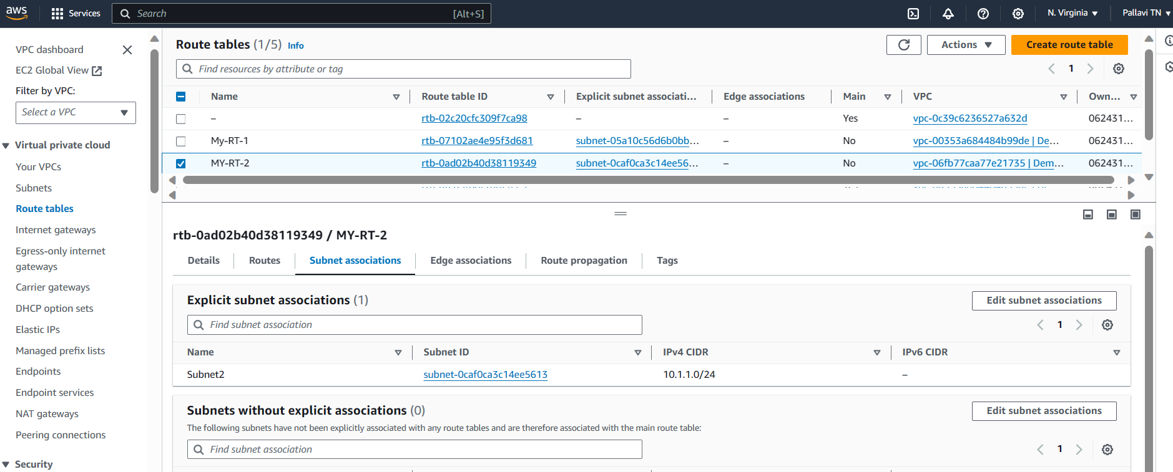



**CREATED THE PEERING CONNECTION BETWEEN THE DEMO1-VPC AND DEMO2-VPC AND ACCEPTED THE REQUEST**

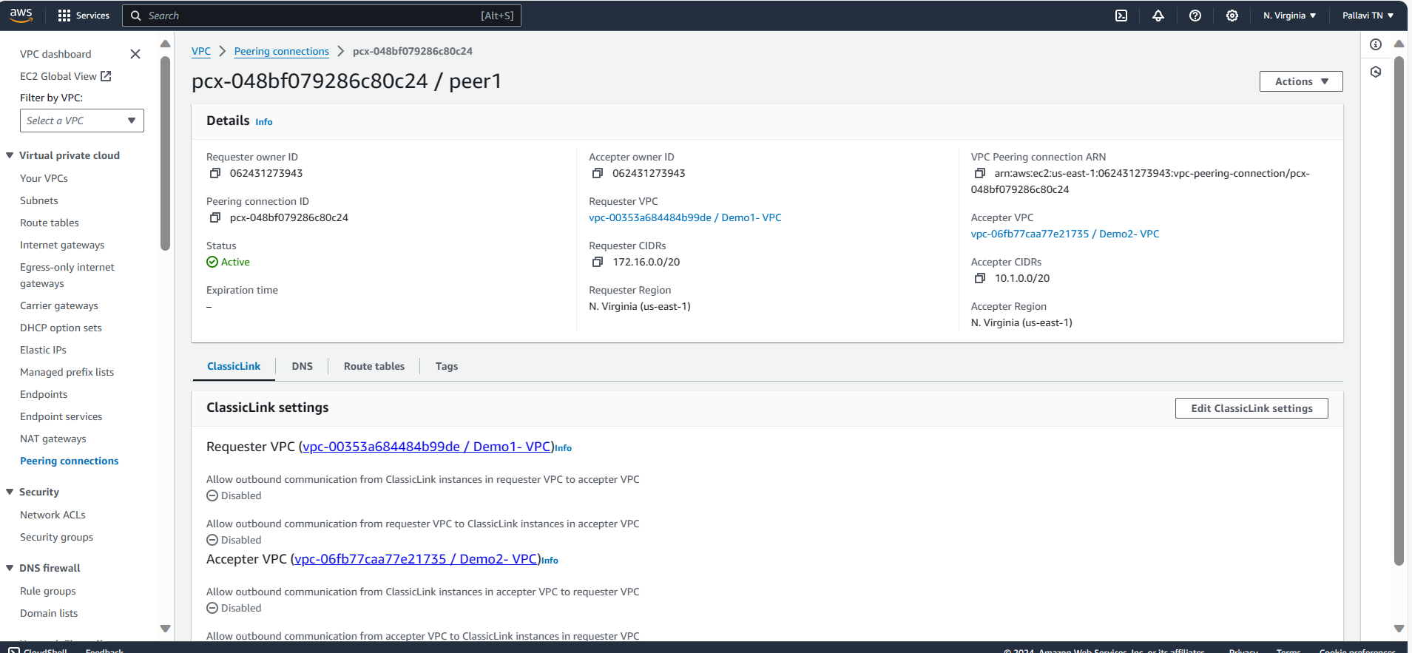



**LAUNCHED 2 EC2 INSTANCES IN THE 2 DIFFERENT VPC’S AND CONNECTED TO THE ONE EC2 AND TRY TO CHECK CONNECTIVITY TO THE OTHER EC2 BY PINGING THE PUBLIC IP OF OTHER INSTANCE.**

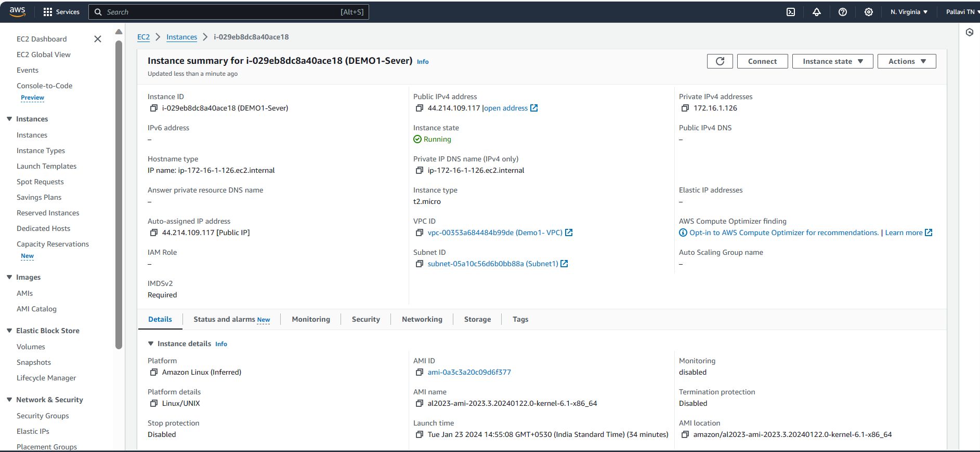



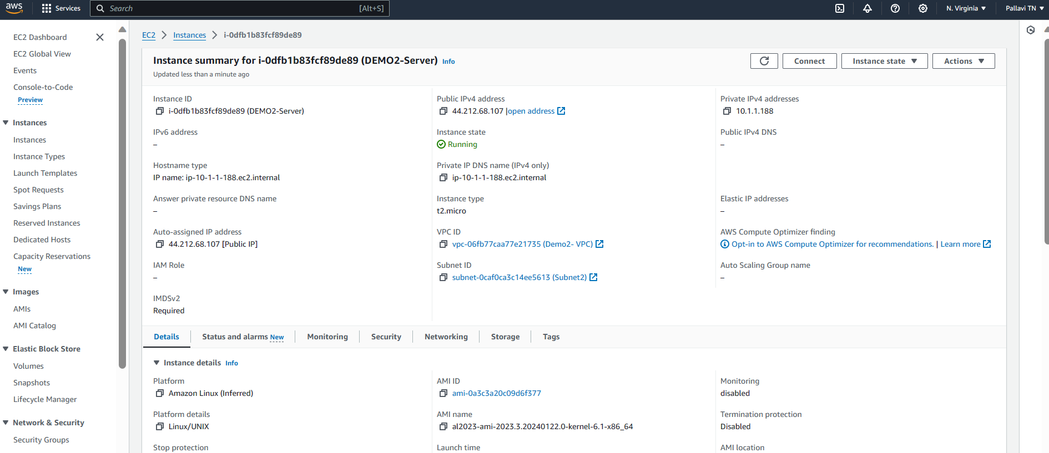



**Connected toto the DEMO2-Sever and try to check the connectivity for Demo2 server by pinging the pubic IP of Demo2 server**

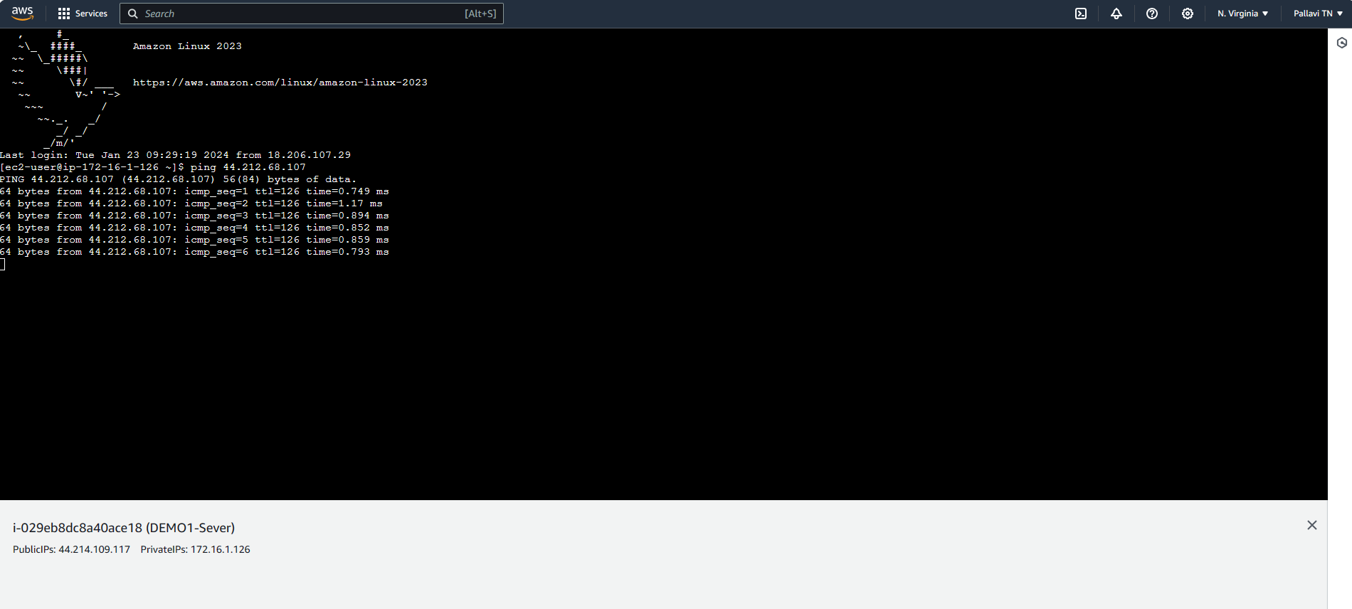



**We can see the response for >> ping** 44.212.68.107 so the peering connection has done successfully.