Setting up vs
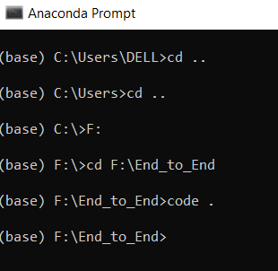

Setting up vs terminal
enter below command in terminal
conda create -p venv python==3.8 -y
conda activate venv/
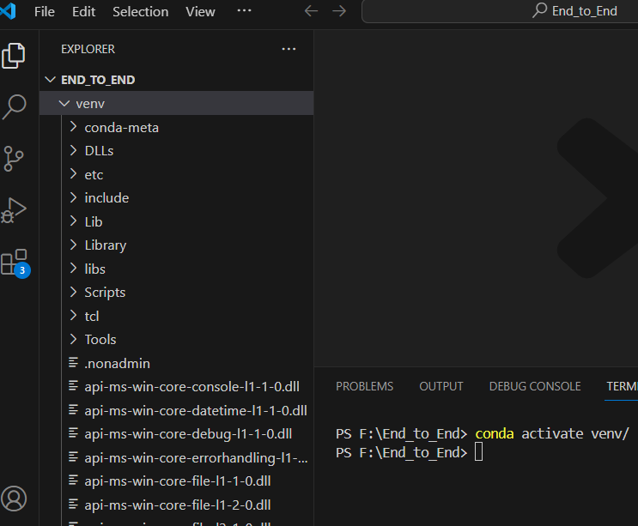

cloning the reposatory
first initialize the git
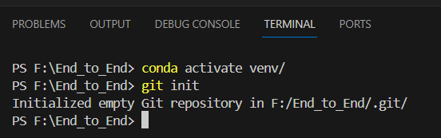

create readme file

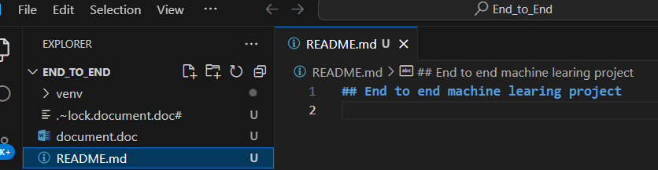

git add README.md
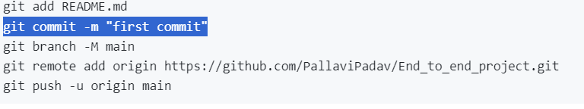
execute above in terminal.

Check using
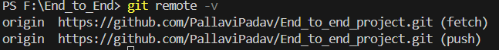

set authentication
commit
create gitignore file and commit
set up need to be created
setup.py responsible for creating a package of entire package. From there anybody can install and use it

create a init py such that every thing will be like a package
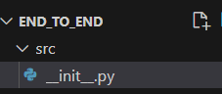

first initialize the git

