**A CRM Application to Handle the Clients and their property Related Requirements**

**Project Overview**

• **Introduction**: The project, titled Dreams World Properties, was launched to meet the need for a streamlined, automated CRM system designed to manage client interactions, ensure accurate data capture, and optimize workflows within the real estate industry. Salesforce was chosen as the core platform due to its powerful automation capabilities and strong data management functionality.

• **Scope** **and Purpose**: The main goal is to establish a seamless system where client data from the company's website is automatically imported into Salesforce. By classifying clients as approved or non-approved, the system improves customer engagement, tailors property recommendations, and facilitates faster decision-making for both clients and the business.

• **Expected Benefits**: This CRM solution aims to minimize manual data entry, enhance data precision, and provide clients with a personalized experience. The system is expected to increase client engagement, streamline workflow efficiency, and support business growth through real-time insights derived from customer data.

• **Integration with Existing Systems**: This project also integrated with current client management systems to ensure that client data flows seamlessly across all platforms utilized by Dreams World Properties.

**Objectives**

**Business Goals**

• **Enhanced Customer Experience**: The system will allow Dreams World Properties to tailor recommendations that meet each client’s unique requirements.

• **Improved Operational Efficiency**: Automating data collection and client categorization will reduce manual workload, enabling the sales team to focus on high-priority tasks.

• **Data-Driven Decision Making**: By centralizing client data and optimizing workflows, the company will be able to make well-informed, data-driven decisions.

• **Reduced Client Response Time:** A core objective is to reduce response time by automating the categorization and prioritization of client inquiries, allowing for faster follow-ups and a proactive sales approach.

• **Increased Property Conversion Rates**: By providing clients with property options relevant to their profiles and approval status, the CRM aims to boost property conversions, ultimately driving higher sales and revenue.

**Specific Outcomes**

• **Accurate Data Entry:** Automation minimizes errors, resulting in reliable customer information.

• **Enhanced Client Satisfaction**: Approved clients are presented with customized property options, enhancing their experience.

• **Shortened Processing Time**: Automation of the approval process decreases wait times, providing clients with quicker access to property recommendations.

**Salesforce Key Features and Concepts Utilized**

• **Flows**: Used to automate tasks such as data updates, record creation, and client categorization based on established criteria. Flows ensure that all client data from website engagement is captured and stored in Salesforce in real time.

• **Approval Process**: A multi-step process that classifies clients into approved or non-approved categories, controlling access to specific property listings and helping prioritize qualified leads.

• **Lightning Web Component (LWC)**: LWCs were developed to create interactive, responsive elements within the user interface, enhancing the visual experience and allowing clients to view property options based on their approval status.

• **Apex**: Custom logic, implemented with Apex, manages complex data processing, including client categorization, property listing management, and business rule enforcement.

• **App Builder**: Utilized to create customized layouts for Salesforce users, App Builder enables integration of LWCs and provides an intuitive interface for sales representatives to manage client information.

**Other Tools and Technologies Used**

• **Visual Studio Code (VS Code)**: VS Code served as the primary development environment for writing and debugging Apex and LWC code, expediting development with extensions and Salesforce integrations.

• **Jotform Integration**: Jotform was used to streamline client data collection. Client information collected via Jotform was seamlessly connected to Salesforce, enhancing data accuracy and providing an efficient data collection process.

**Detailed Steps to Solution Design**

• **Data Model Design**: Custom objects and relationships were defined to manage client and property data, including entities like Client, Property, Engagement, and Approval Status. Each entity includes custom fields capturing specific information such as property preferences and contact details.

• **User Interface Design**: With LWC and App Builder, a user-friendly interface was developed to facilitate easy access to client information and property listings. This design meets the needs of both sales representatives and clients, providing intuitive navigation and responsive design elements.

• **Business Logic and Automation**:

Flows: Automate record movement based on client actions and engagement triggers from the website.

Approval Process: Manages client categorization based on pre-established criteria, ensuring that only approved clients receive property recommendations.

Apex Classes: Responsible for tasks like retrieving property details according to user preferences, calculating recommendations, and updating client records.

• **Integration with Website**: API connections enabled the automatic transfer of client data from the website to Salesforce, tested to ensure smooth data flow and minimal disruption to client experience.

**Testing and Validation**

• **Unit Testing**: Thorough testing of individual Apex classes and triggers ensured functionality of client categorization, approval processes, and data handling.

• **User Interface Testing**: All LWC components were tested across devices and screen sizes to ensure consistency and responsiveness. User feedback led to iterative UI enhancements.

• **System Testing**: Comprehensive end-to-end testing validated the CRM's complete workflow from data capture to client engagement, including the approval process, property recommendation, and automated updates.

• **Performance Testing:** Ensured the system handles data capture and client categorization efficiently, supporting high volumes of website interactions without performance issues.

**Key Scenarios Addressed by Salesforce in the Implementation Project**

• **Client Onboarding and Data Capture**: Client data from website interactions is automatically transferred to Salesforce, creating records with contact details, preferences, and engagement status for a streamlined onboarding experience.

• **Client Categorization**: Automated workflows organize clients into Approved and Non-Approved categories. Approved clients access exclusive property listings and receive tailored recommendations, improving their experience.

• **Property Recommendations**: Property listings align with approved clients' preferences, with the system generating recommendations based on criteria such as location, budget, and property type to increase conversion chances.

• **Operational Efficiency**: By automating data handling and reducing manual tasks, the CRM enables the sales team to focus on high-value activities, like client interactions and closing sales, enhancing productivity.

**Conclusion**

The Salesforce CRM solution for Dreams World Properties successfully automated client management and personalized user interactions, resulting in improved engagement and a more efficient sales process. By leveraging Salesforce tools such as Flows, Apex, and LWC, the system increased operational efficiency, minimized human error, and elevated client satisfaction. This streamlined CRM solution provides a solid foundation for future growth and scalability within the real estate sector.

• **Strengthened Client Relations and Trust**: The CRM fostered improved client relationships through consistent, personalized engagement, crucial in building trust within the real estate industry.

• **Future-Ready Scalability**: Built on Salesforce’s robust platform, this CRM solution is highly scalable and prepared to accommodate future growth as the company expands and client demands evolve.

**JOTFORM**

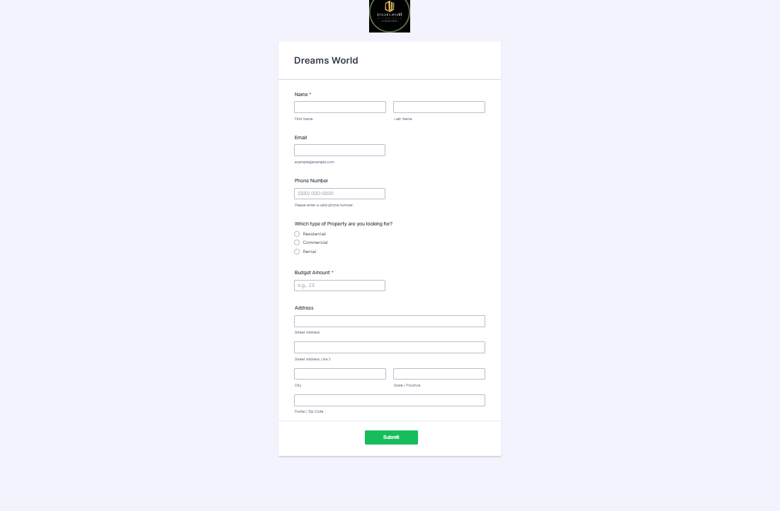

**JOTFORM SUBMISSION**

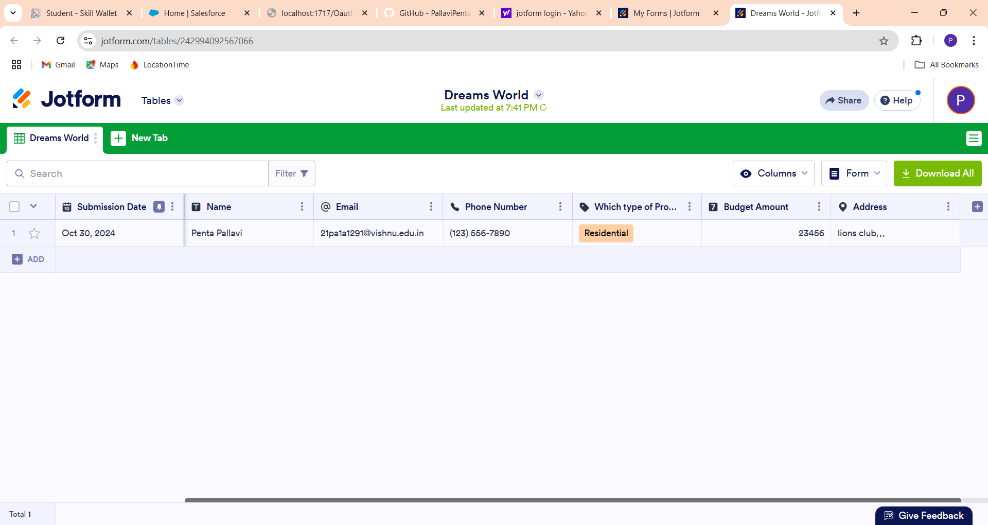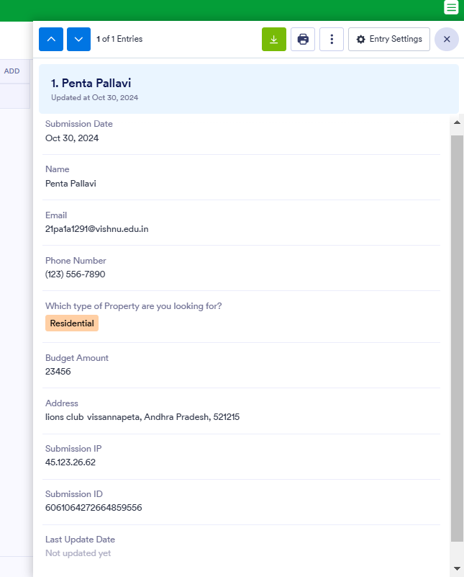

**PROPERTY**

