**Name:** Pallavi Pokuri

**SID:** S565489

**Introduction**

My data set is Indian food, which include the types of Indian food among the states and regions. By this dataset we can have the visualizations which can help to understand the timings to prepare and cook the Indian food items.

**The domain of the data set:** Indian food Data

Exploring the flavors of Indian Cuisine – An Indian Food Dataset

**Dataset:**



**Data source:**

<https://www.kaggle.com/datasets/kritirathi/indian-food-dataset-with>

**Number of records:** 256

**Number of columns:** 10

**Visualization tools selected:**

Tableau public

**Data cleaning strategies if any:**

Data cleaning strategies are not included because dataset is clean with no null values and that helps to reach the goals for the given dataset.

**The goals of your project and the complete screenshots of charts generated for each goal.**

(i) Goal 1: To identify the minimum cook time of vegetarian food in the states of India

(ii) Goal 2: To find the average preparing time of the food which is spicy flavored

(iii) Goal3: To know the States which eat only vegetarian food as main course

(iv) Goal4: To observe the cooking time of the states which include potato ingredient in food

(v) Goal 5: To calculate the average preparation time of food items for only south region from 60 to 400 minutes.

(vi) Goal 6: To identify States which contain maximum preparation time of the food items.

**Goal1:**

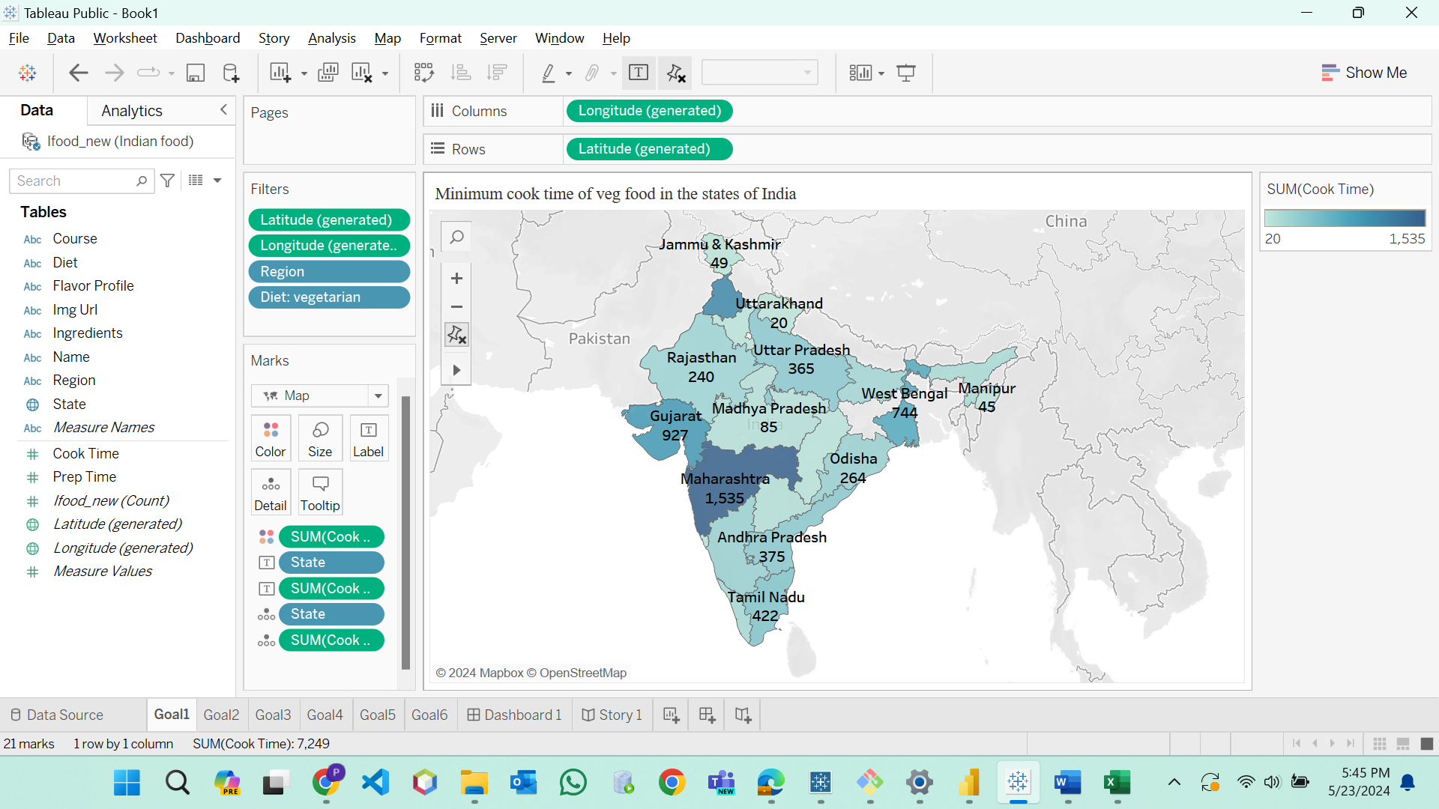

**Fig1:**

**Story for chart 1:** The above map(fig1) describes the minimum cooking time of vegetarian food can be seen according to the intensity of the color. Uttarakhand state will take less cooking time which is in light blue color. The second state which will take less time to cook food is Manipur.

**Goal2:**

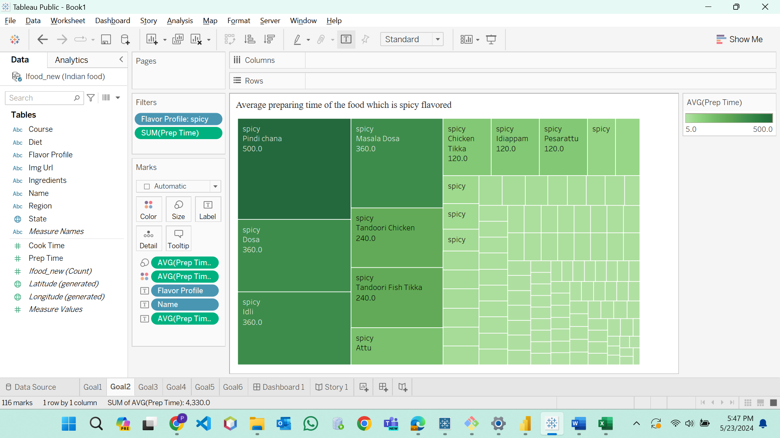

**Fig 2:**

**Story for chart 2:** The tree map(fig2) explains the average preparation time of spicy food which is more for pindi chana that is represented in dark green color whereas other food items took less time to prepare.

**Goal3:**

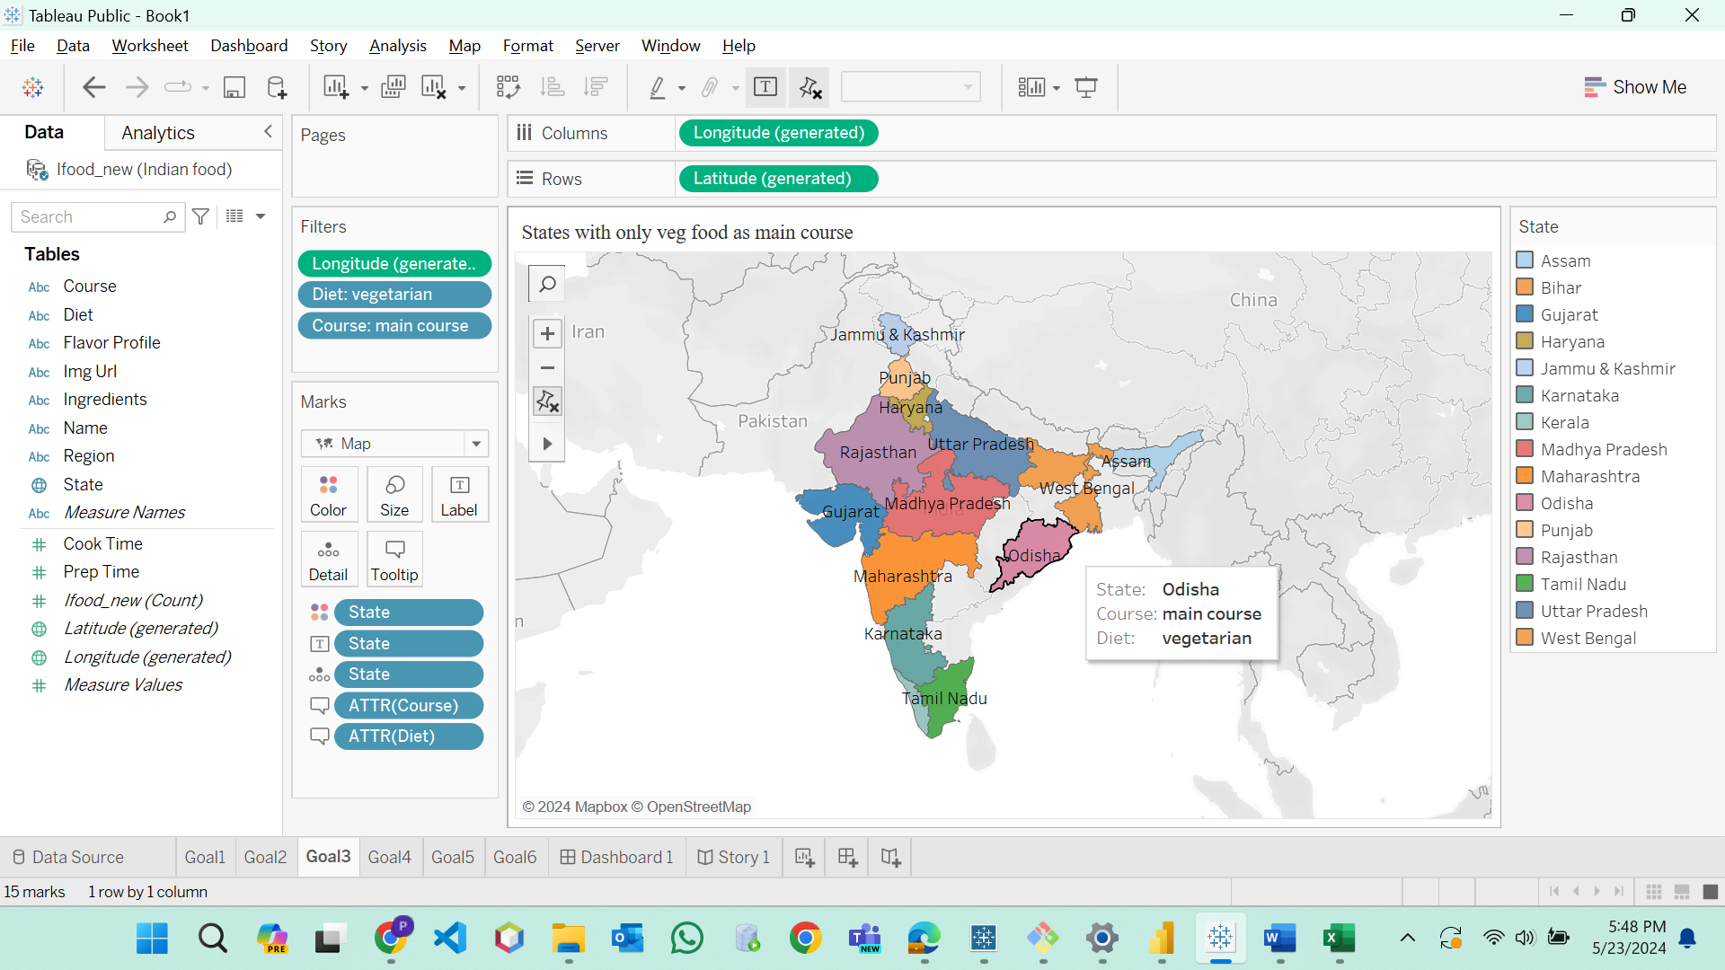

**Fig3:**

**Story for chart 3:** This map(fig3) helps to observe the states which have only vegetarian food for main course. Only 15 states will have vegetarian food for their main course as shown in the above map.

**Goal4:**

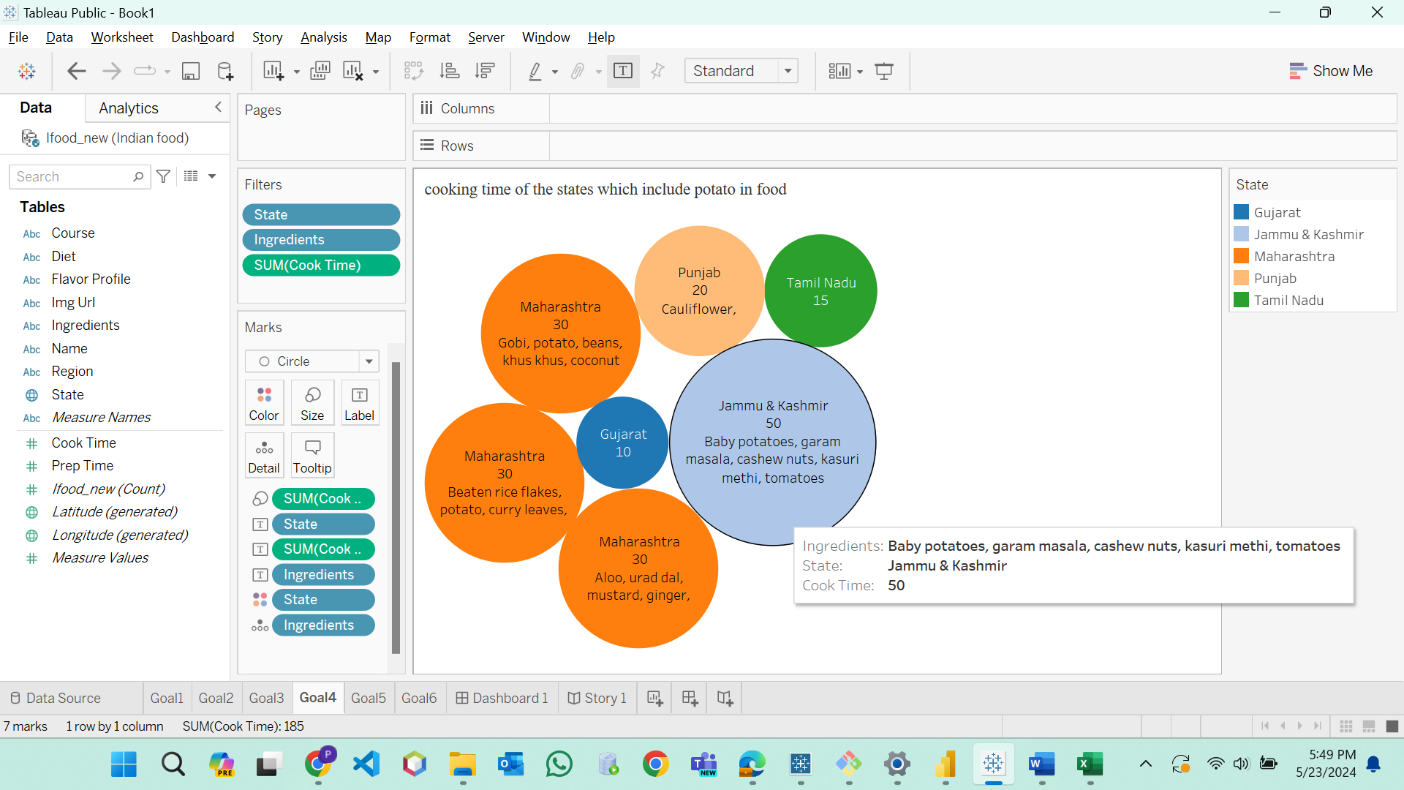

**Fig4:**

**Story for chart 4:** The packed bubble chart(fig4) helps to identify the cooking time of the states which have included the potato ingredient in the food. Jammu and Kashmir have the more cooking time than other states which include potato in the ingredients.

**Goal5:**

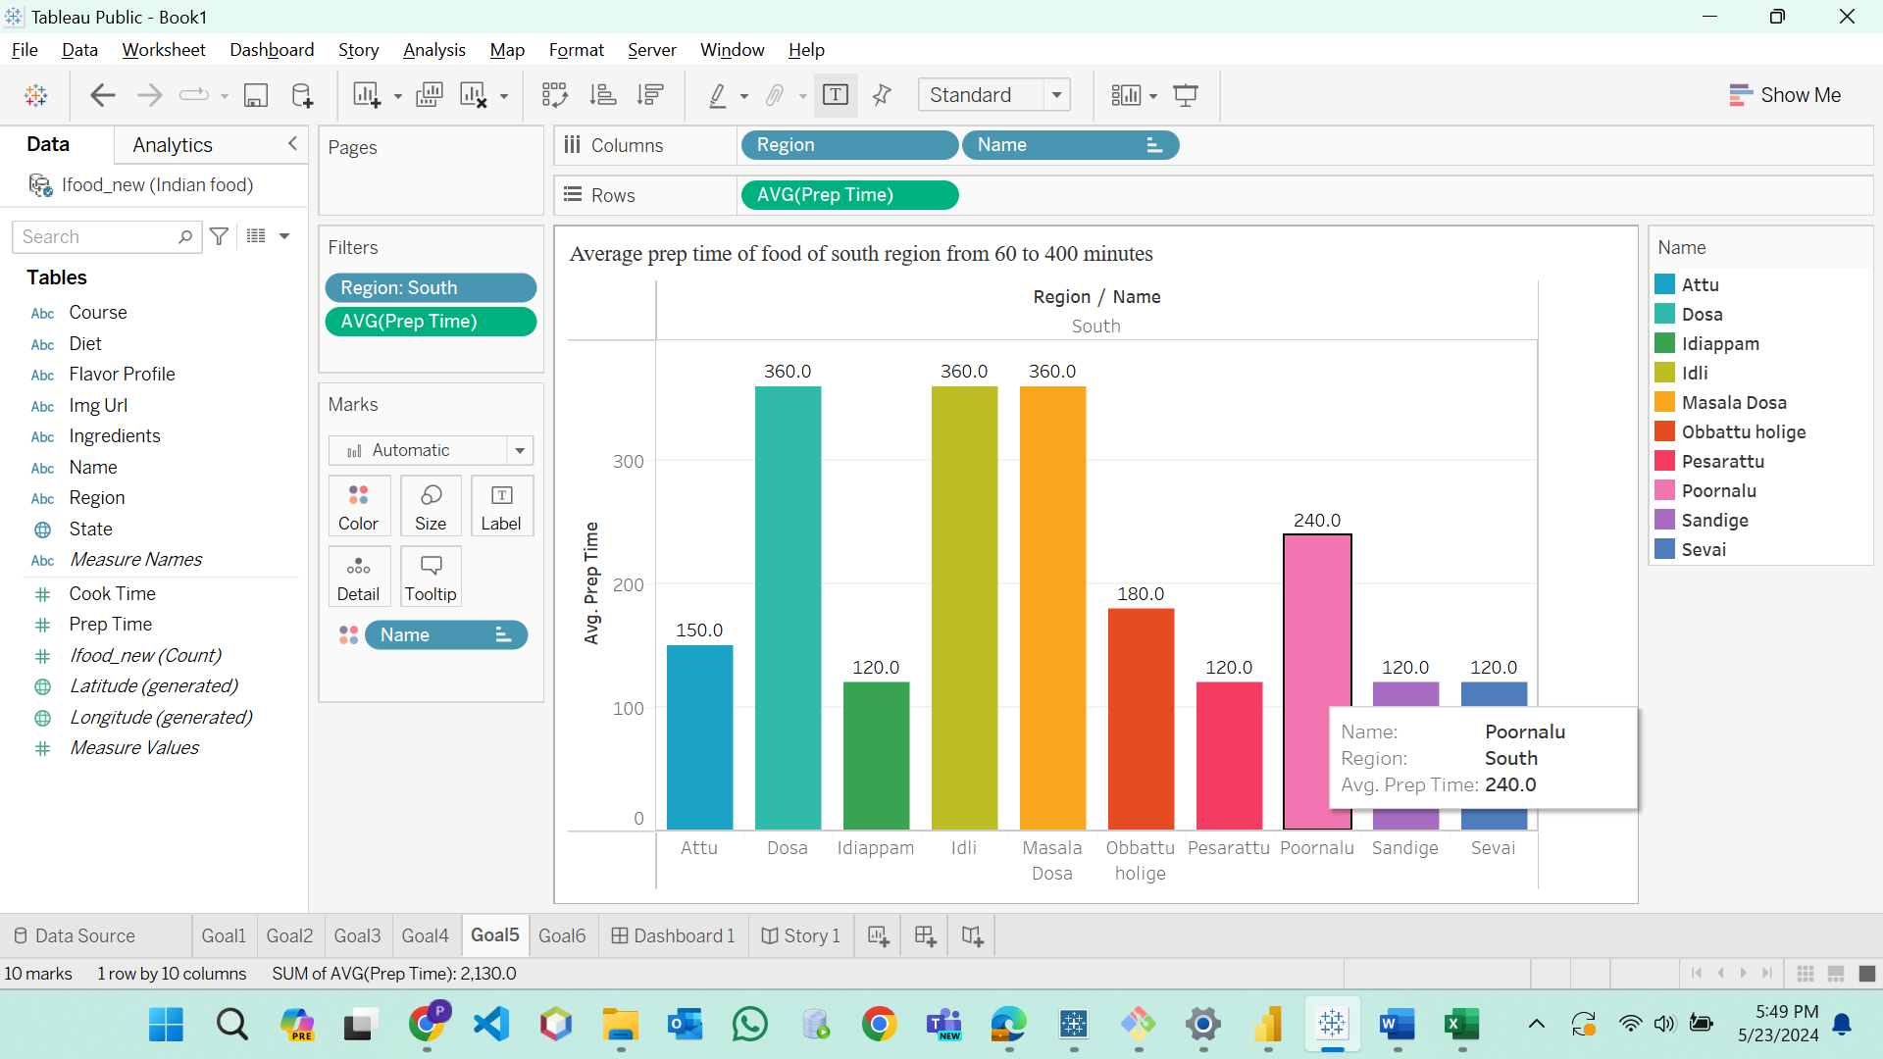

**Fig5:**

**Story for chart 5**: The column chart(fig5) describes the average preparation time taken for the food items in only south region. Dosa, Idly, Masala dosa will take same preparation time whereas other food items take less time.

**Goal6:**

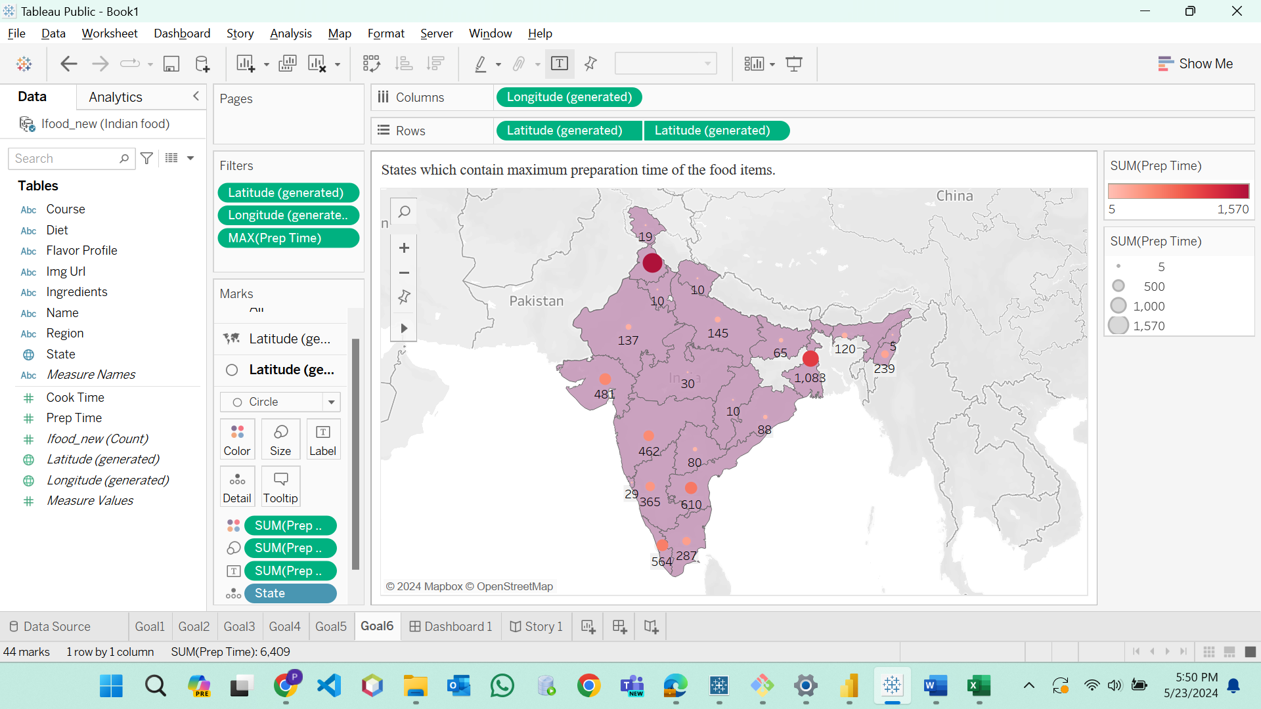

**Fig6:**

**Story for chart 6:** This dual layer map(fig6) explains the maximum preparation time of the states which can be observed in the map. Punjab state will take more time to prepare the food which is dark red color with bigger circle in the map.

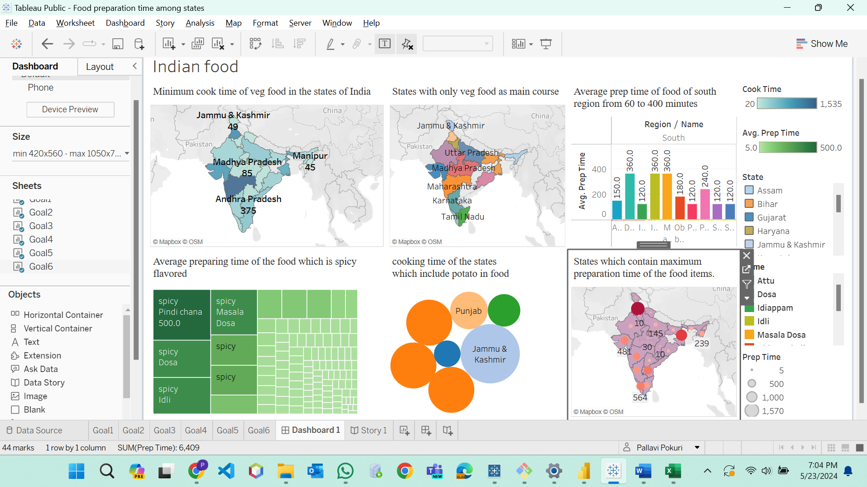

**Fig7: Dashboard**

**Tableau public link:** <https://public.tableau.com/app/profile/pallavi.pokuri/vizzes>

**Conclusion:** Above visualizations helps to identify the timings of Indian food for preparing and cooking the food items which can bitter, sour, spicy and sweet in different states. It also helpful to categorize the vegetarian food among the states through the visualizations. Overall, Indian food have different timings to prepare and cook the various kinds of food.