Project Structure
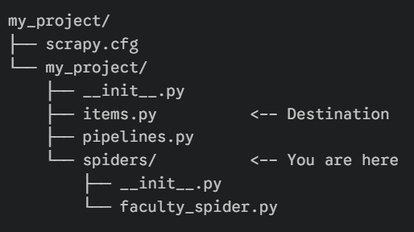
- import scrapy

- python -m scrapy startproject faculty_scraper : ‘python -m’ to use scrapy downloaded at any location on laptop, not just on path.

- python -m venv new_venv : new virtual window
.\new_venv\Scripts\activate : to activate virtual window

pip install --upgrade pip
pip install scrapy
- Handling pagination / multiple profile pages

- faculty_finder/ <-- Root Project Folder
├── api_server.py <-- NEW: FastAPI code (The "Serving" step)
├── logs/ <-- NEW: Directory for LLM logs
│ └── llm_usage.md <-- NEW: Documentation of our conversation
└── faculty_scraper/ <-- Your current Scrapy folder
├── scrapy.cfg <-- KEEP: Deploy configuration
└── faculty_scraper/ <-- Inner project module
├── items.py <-- KEEP: Defines data containers [cite: 73, 76]
├── pipelines.py <-- MODIFY: Storage logic for SQLite [cite: 61, 73]
├── settings.py <-- MODIFY: Project settings
└── spiders/ <-- KEEP: Your spider files [cite: 73, 88]

- pipieline.py : Each item pipeline component (sometimes referred as just “Item Pipeline”) is a Python class that implements a simple method. They receive an item and perform an action over it, also deciding if the item should continue through the pipeline or be dropped and no longer processed.
Typical uses of item pipelines are:
- cleansing HTML data
- validating scraped data (checking that the items contain certain fields)
- checking for duplicates (and dropping them)
- storing the scraped item in a database

- Typically, Request objects are generated in the spiders and pass across the system until they reach the Downloader, which executes the request and returns a Response object which travels back to the spider that issued the request.

- 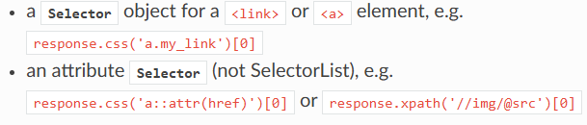

- Scrapy provides a built-in mechanism for extracting data (called selectors) but you can easily use BeautifulSoup (or lxml) instead, if you feel more comfortable working with them. After all, they’re just parsing libraries which can be imported and used from any Python code.

- In HTML, <a is the start of an anchor tag, which is the standard way to create hyperlinks on a webpage.

- In your FacultyFinder project, these tags are the "bridges" your spider crosses to move from the main directory to individual faculty profiles.

- HREF : hypertext reference

- .\new_venv\Scripts\activate

uvicorn api_server:app –reload

- scrapy crawl faculties : to web scrape data
- to download:
open file ‘FACULTY FOLDER’
in terminal write:
.\new_venv\Scripts\activate
cd faculty_scraper
python -m scrapy crawl faculties
cd..
uvicorn api_server:app --reload
  - ctrl+click on link next to ‘View Faculty Data:’, shown in terminal
- Ctrl + C to stop the server

- scrapy shell https://www.daiict.ac.in/faculty
response.css('title::text').get()

- Databases are usually locked to your computer or a specific server.

Database: If you want to show your data to a teammate, they have to install SQLite and open the .db file.

JSON: You can send a JSON file over email, Slack, or GitHub. It is "human-readable" and can be opened in any text editor without special software.

- Opening and closing a connection to a database is "expensive" for a computer.
One Connection: You open the "door" once, move all the boxes (faculty data) inside, and then lock the door.
Multiple Connections: You open the door, put in one box, lock it, unlock it, put in another box, lock it again... This wastes time and processing power.
- When you call self.conn.commit(), the library ensures that the data is safely written to the disk. This prevents data loss if your computer crashes or the spider stops unexpectedly.

- Properly closes the connection so other programs (like your FastAPI server) can access the file without "Database Locked" errors. Else it would be like, one spider is using the database by building a connection with it, so now other spiders can’t use it to store data or other programs like fastAPI can’t use it to access data.

- Python File = file stored on disk
Python Module = python file when imported into another python file
Python Package = folder containing multiple modules
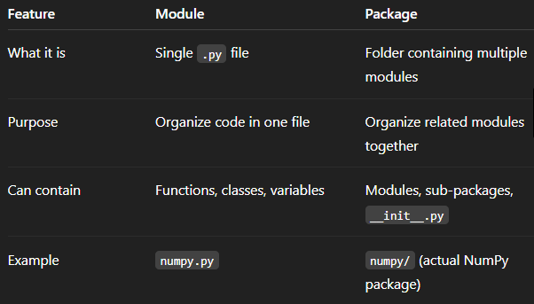
- When your spider finds a faculty member and "yields" the item:
- Scrapy checks settings.py to see if ITEM_PIPELINES is active.
- It sees your class at priority 300.
- It triggers open_spider to create the database.
- It passes the data into process_item to clean it and run the INSERT command.
- Finally, when the website is fully scraped, it triggers close_spider to lock the file.
📝 Why this is Important for your Grade
If you forget to enable this in settings.py, your database (faculty_data.db) will be created (because open_spider runs), but it will remain empty.

- • Range: You can use any integer between 0 and 1000.
• Lower Numbers (0-100): These run "earlier" in the process, usually for basic tasks like checking if an item is empty.
• Middle Numbers (300-500): These are standard for Data Transformation and Database Storage.
• Higher Numbers (700-1000): These run last, often used for exporting data to a file or sending an external notification.

Scrapy looks at your settings.py and creates a list of all active pipelines. It then sorts them by their number and runs them in that order.
- If you only have one pipeline (like you do now), Scrapy will run it regardless of whether the number is 1, 300, or 999.

- If you renamed process_item to something like save_my_data, Scrapy would ignore it. The spider would run, but the data would never reach the database because the "link" was broken. You must use the exact names defined in the Scrapy documentation so the engine knows where to send the data.

Scrapy's internal engine is programmed to look for these specific names at different stages of the scraping journey:
- The "Startup" Event: The engine is programmed to look for a function named open_spider and run it once the moment the engine starts.
- The "Item Dropped" Event: Every time an item comes out of the spider, the engine is programmed to look for a function named process_item and run it. Since items come out one by one, this function naturally runs multiple times.
- The "Shutdown" Event: When the engine sees there are no more URLs to visit, it is programmed to look for close_spider and run it once before turning itself off.

Scrapy recognizes those names and connects them to its internal "event" system. These are reserved words in scrapy framework.

- Conn.cursor() is used to navigate and interact with the data inside your database.
Modifications did:
- Updates pipelines.py to correct database schema as it did not include all features included in items.py earlier.

settings.py
- BOT_NAME = "faculty_scraper"
just an identifier for your Scrapy project. Scrapy mainly uses it for:
- Logging
- User-Agent (if you reference it)
- Internal project identification
It does not control how spiders are discovered or run.
- SPIDER_MODULES = ["faculty_scraper.spiders"]
Scrapy uses this to find all your spiders when you run "scrapy crawl <spider_name>”
- NEWSPIDER_MODULE = "faculty_scraper.spiders"
• It is only used when you run genspider.
• It tells Scrapy where to place new spider files.
- ROBOTSTXT_OBEY = True
Obey robots.txt rules and access only permitted pages

- CONCURRENT_REQUESTS_PER_DOMAIN = 1
No. of requests sent to site at once, which is 1
- DOWNLOAD_DELAY = 1
Delay of 1 second between 2 consequent downloads.
- ITEM_PIPELINES = {
"faculty_scraper.pipelines.FacultyScraperPipeline": 300,
}
ITEM_PIPELINES activates the pipeline so that it process and save the data extracted by the spider.

ITEM_PIPELINES is a reserved name for variable in scrapy framework. Scrapy looks for the variable and knows what to do with it.

Division of labor:
- The Spider is what "starts the scraping." It goes to the website and finds the information.
- The Pipeline is the "Storage Room." It doesn't find the data; it just waits for the spider to send it something to clean and save.

- FEED_EXPORT_ENCODING = "utf-8"
ensures special characters (like symbols, accented letters, or non-English text) are saved correctly when you export your data to a file like a JSON or CSV.
- 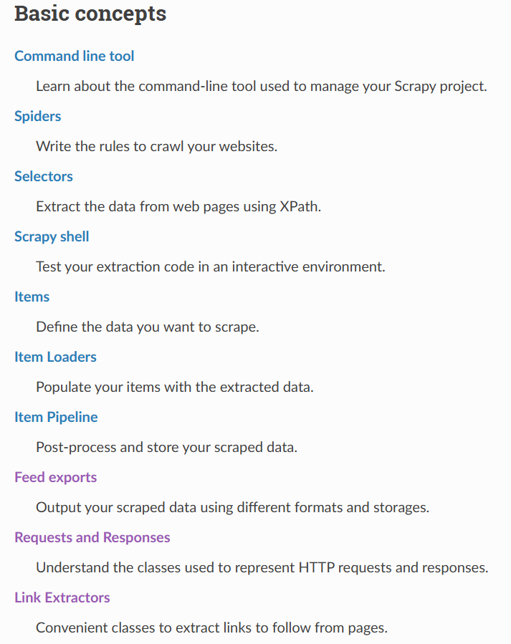

pipelines.py
- Opened a connection with ‘faculty_data’ database using sqlite3
- Created table ‘faculty_data’ if doesn’t exists
- Cleared its content if already exists

- Cleaned data
- Added cleaned data into table

- Closed connection with the database

- item.get(field) -> returns value corresponding to a key in dictionary. Returns None if key is missing
item[field] -> returns value corresponding to a key in dictionary. But raises error if key is missing.
- cleaned_data = {key: (item.get(key) if item.get(key) else None) for key in item.keys()}

if field is missing, value is replace with None corresponding to that key in dictionary

- Scrapy often captures extra newlines and tabs from the HTML source code. This ensures you only save the actual text.
- 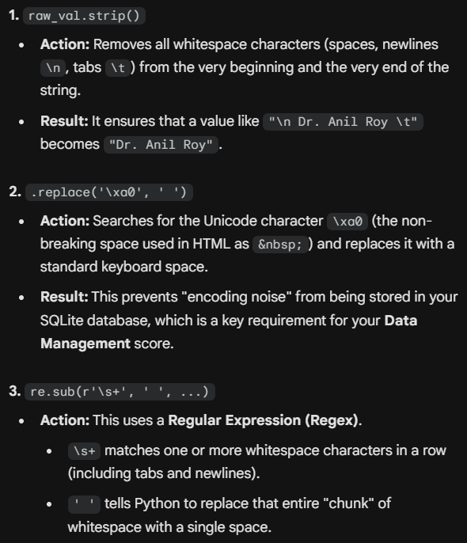

Items.py
It serves as a "Table of Contents" for your project. Anyone looking at items.py can instantly see what data your scraper is designed to collect.

It tells the spider, the format in which it has to extract data.

The Data Shipping Workflow
- The Extraction (Spider): The Spider finds a professor's name on the DA-IICT website.
- The Packaging (Items.py): The Spider creates a "box" using the FacultyItem class. It puts the name in the name slot and the email in the email slot.
- The Shipment (Yield): The Spider "yields" (sends) that filled box.
- The Processing (Pipelines.py): The Scrapy engine catches the box and carries it to the process_item function in your pipeline. This is where you open the box, clean the text, and put it into your SQLite database.

middlewares.py
- Downloader Middlewares (Between Engine and Internet)
These handle the Request and Response. They are used for:
- User-Agent Switching: Making your scraper look like a real web browser (Chrome or Safari) so the university website doesn't block you.
- Proxy Management: Rotating IP addresses to avoid being banned.
- Retries: Automatically trying again if a page fails to load.
- Spider Middlewares (Between Engine and Spider)
These handle the Items and Requests coming out of your spider. They are used for:
- Post-processing: Modifying the data right after the spider extracts it but before it hits the pipeline.
- Error Handling: Managing specific spider errors gracefully.

scrapy.cfg
Its primary job is to tell the scrapy command-line tool where to find the settings and which project is currently active.

__init__.py
In the world of Python, __init__.py is a special file used to mark a directory as a Python package
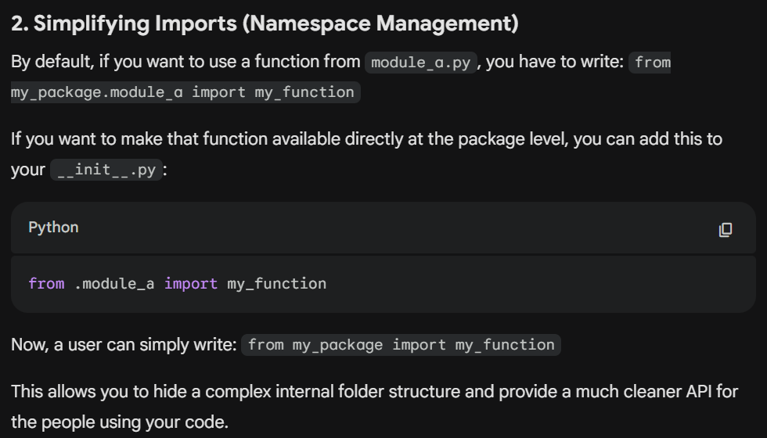
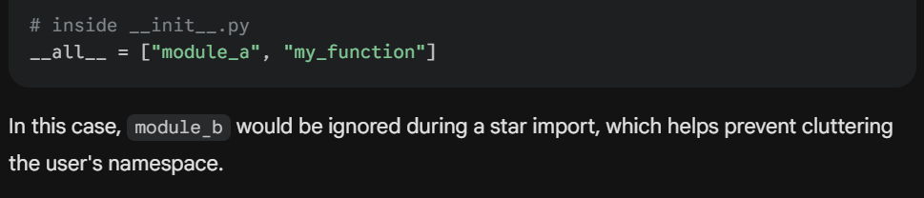
Faculty_spider.py
In Python’s relative import syntax:
- . (one dot): Look in the current directory (the spiders folder).
- .. (two dots): Look in the parent directory (the my_project folder)
After Scrapy downloads the main faculty list page (https://www.daiict.ac.in/faculty), it hands that page back to parse() function as the response object.
- def parse(self, response):

- parse() is a reserved method name in Scrapy

- The response object is a Python object created by Scrapy that contains everything the spider downloaded from the URL

- faculty_links = response.css("div.personalDetails h3 a::attr(href)").getall()

- extracts list of URLs from the site.

- You were telling Scrapy: "Take the response (the faculty list page), use its css tool to find all the links, and save them to a list."

- It looks at the HTML of the page, finds all links (<a> tags) inside those specific CSS classes, and pulls out the href (the URL).

- In Scrapy, start_urls is a reserved attribute. You don't need to "call" it or pass it to a function manually.

- self.logger.info(f"FOUND {len(faculty_links)} LINKS")

• print() just throws text into the terminal. It can easily get buried or look like "noise."
• self.logger formats the message nicely with a timestamp, the log level (INFO), and the name of the spider. It looks like this:
2023-10-27 10:00:00 [faculties] INFO: FOUND 45 LINKS

- for link in faculty_links:
yield response.follow(link, callback=self.parse_faculty)

moves spider from list page to profile page.

- 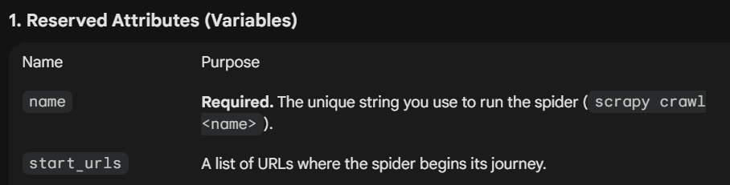

- If you decide to include it, here is a professional way to phrase it:
  - Efficiency & Concurrency The scraper is built using Python's yield keyword. Unlike a standard function that returns a single value and stops, our parse methods act as Generators. This allows the Scrapy engine to:
  - Follow links as soon as they are found.
  - Stream items to the output file immediately after extraction.
  - Process multiple pages at the same time (Concurreny), making the crawl significantly faster than a sequential script.

- "In this spider, yield acts like a repeated return. Unlike a standard return that ends the function, yield produces a value and pauses the function's execution, allowing it to produce multiple outputs (Requests or Items) from a single function call."
__pycache__
- When you run your Scrapy spider, Python first "compiles" your .py files into .pyc files (Python Compiled).

- It stores these compiled files inside the __pycache__ folder.

- The next time you run scrapy crawl faculties, Python checks the __pycache__ folder. If the .pyc file is already there and you haven't changed your source code, Python skips the "translation" step and jumps straight to executing the bytecode. This makes your programs (especially large ones like Scrapy) start up much faster.

api_server.py
Now that your Scrapy spider has finished its job and saved the data into a database,
you are using FastAPI to build a "window" (an API) so others can view that data.
This code creates a web server that reads your SQLite database and serves it as JSON.
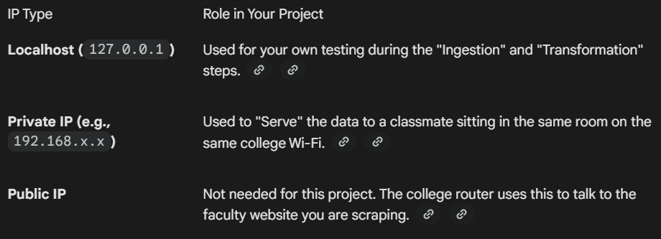
API (application programming interface): It acts as the "translator" or "messenger". It takes a request from a user (like a URL in a browser), goes to the database, gets the data, and brings it back to the user in a format they understand, like JSON.

DO
  - Remove space and empty lines and check if exist:
- Research
- Teaching
- Publication
- Specialization
- professional_link

  - 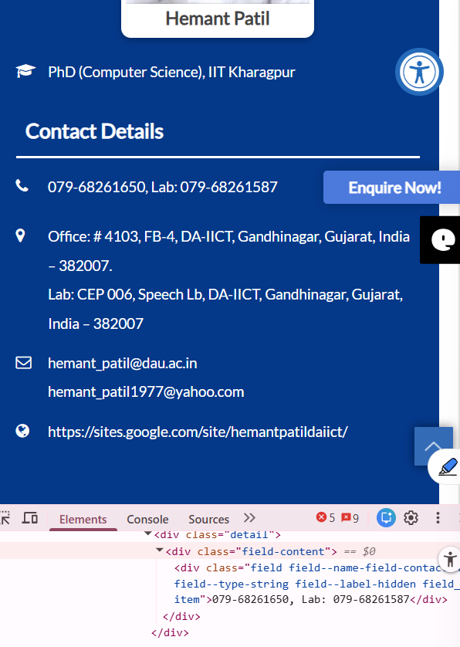
Double phone no. as a single string

  - Clear strings in list for any new line etc. character

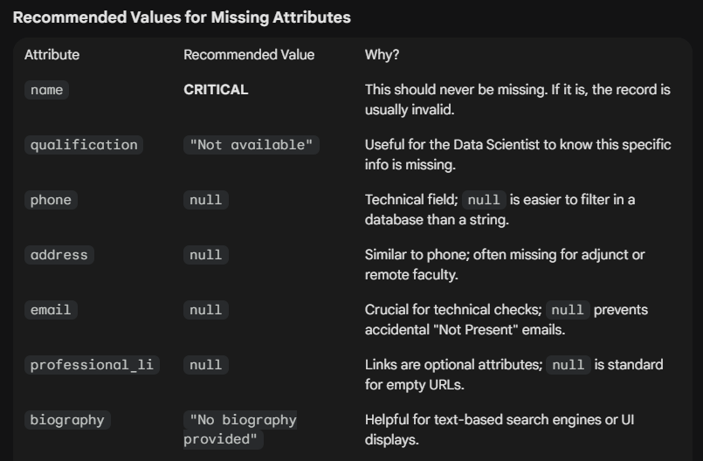
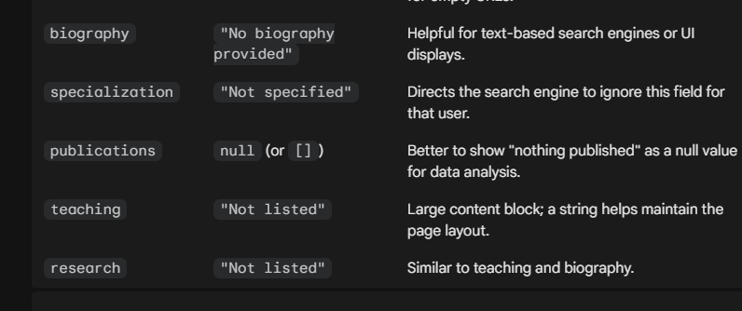
STRUCTURE
image_url
name
qualification
phone
address
email
professional_link
biography
specialization
publications
teaching
research
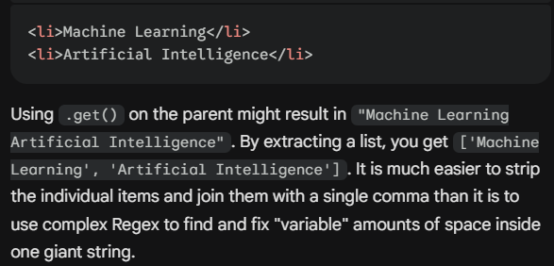
Modified Project:
- chmod +x depipeline.sh : to make Data Engineering Pipeline (depipeline.sh) script executable
- installed power shell extension
- In a professional Data Engineering Pipeline (DEPipeline), we often distinguish between "In-flight Transformation" (cleaning data as it arrives) and "Batch Transformation" (processing stored data).
- data persisted does not just mean data added; it means data is saved to a non-volatile, permanent storage medium (like a hard drive, SSD, or database) so that it remains accessible even after the application closes, the system shuts down, or the power is turned off.
To execute project on linux
- Ctrl + alt + T – open terminal
- Cd ~ -change directory
- Ctrl +shift + v – paste text in linux terminal
- sudo apt update : Install Python and Virtual Environment Tools
sudo apt install python3-venv python3-pip
- Set up the Virtual Environment:
python3 -m venv venv
source ~/faculty_venv/bin/activate
pip install -r requirements.txt
- pip install scrapy fastapi uvicorn sentence-transformers faiss-cpu : download all required libraries
- If you want each scraping session to be fresh, change your depipeline.ps1 or command line to use the -O (uppercase O) flag instead of -o. The uppercase flag tells Scrapy to overwrite the file if it already exists.

Virtual Machine
- With a virtual machine, you can install other operating systems on your pc
- Ctrl + shift + escape = task manager
- To download VM:
Task manager > performance > virtualization enabled on right side
- The ISO file contains all the installation files for the OS.
LINUX
# Grant execution permissions
chmod +x depipeline.sh
source ~/faculty_venv/bin/activate

# 1. Ingestion
./depipeline.sh ingestion --url https://www.daiict.ac.in/faculty --input raw.json

# 2. Transformation
./depipeline.sh transformation --input raw.json --output cleaned.json

# 3. Storage
./depipeline.sh storage --output cleaned.json --db faculty_data.db

# 4. Serving
./depipeline.sh serving --db faculty_data.db

To find location of project file and go to it
cd ~/"faculty_finder_project" && echo "Now in: $PWD"
WINDOWS
# #. Allow script execution for this session (if needed)
Set-ExecutionPolicy -ExecutionPolicy RemoteSigned -Scope Process

#1. To find location of project file and go to it.
$folder = Get-ChildItem -Path C:\ -Filter "faculty_finder_project" -Recurse -Directory -ErrorAction SilentlyContinue | Select-Object -First 1; if ($folder) { Set-Location $folder.FullName } else { Write-Host "Folder not found." -ForegroundColor Red }

# 2. Run Ingestion (Scraping)
# 1. Ingestion
.\depipeline.ps1 -STAGE ingestion -READ_URL "https://www.daiict.ac.in/faculty" -RAW_FILE "raw_data.json"

# 2. Transformation
.\depipeline.ps1 -STAGE transformation -RAW_FILE "raw_data.json" -CLEAN_FILE "cleaned_data.json"

# 3. Storage
.\depipeline.ps1 -STAGE storage -CLEAN_FILE "cleaned_data.json" -DB_NAME "faculty_data.db"

# 4. Serving
.\depipeline.ps1 -STAGE serving -DB_NAME "faculty_data.db"
-----------------------
powershell

response.css("div.field--name-field-faculty-names.field__item::text").get()
response.css("div.field--name-field-faculty-name.field__item::text").get()
response.css("div.field--name-field-contact-no.field__item::text").get()
response.css("div.field--name-field-address.field__item::text").getall()

