1. Write a Python program to print "Hello Python"?

**Solution:**

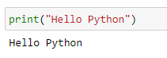

1. Write a Python program to do arithmetical operations addition and division.?

**Solution:**

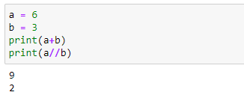

1. Write a Python program to find the area of a triangle?

**Solution:**

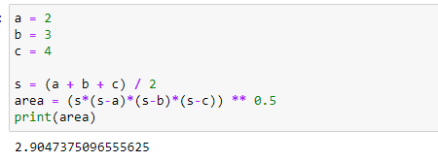

1. Write a Python program to swap two variables?

**Solution:**

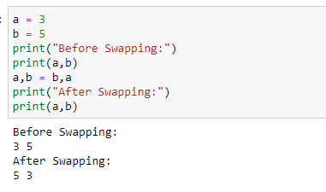

1. Write a Python program to generate a random number?

**Solution:**

