1. Write a Python program to convert kilometers to miles?

**Solution:**

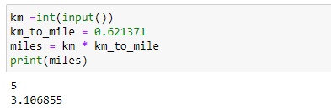

1. Write a Python program to convert Celsius to Fahrenheit?

**Solution:**

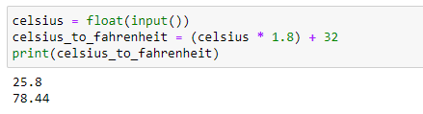

1. Write a Python program to display calendar?

**Solution:**

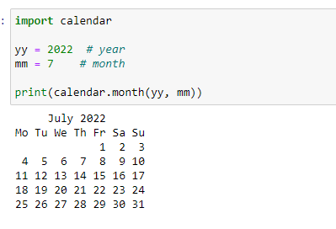

1. Write a Python program to solve quadratic equation?

**Solution:**

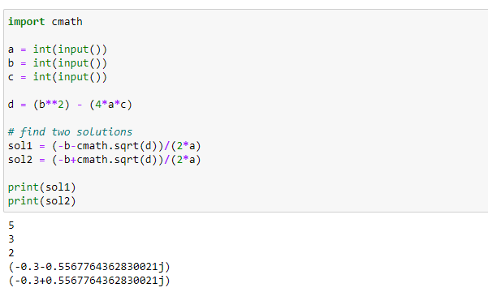

1. Write a Python program to swap two variables without temp variable?

**Solution:**

