1. Write a Python Program to Find the Factorial of a Number?

**Solution:**

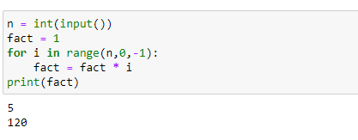

1. Write a Python Program to Display the multiplication Table?

**Solution:**

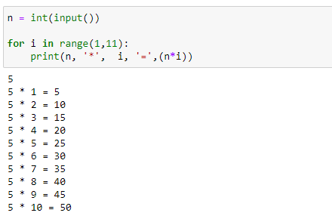

1. Write a Python Program to Print the Fibonacci sequence?

**Solution:**

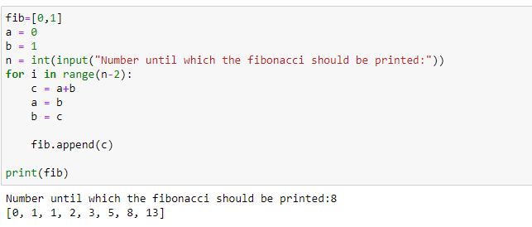

1. Write a Python Program to Check Armstrong Number?

**Solution:**

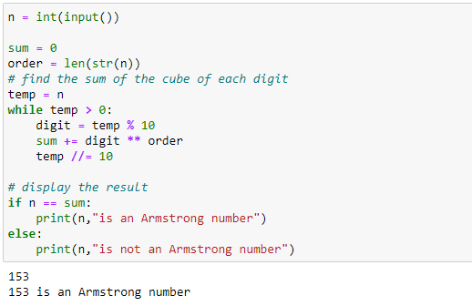

1. Write a Python Program to Find Armstrong Number in an Interval?

**Solution:**

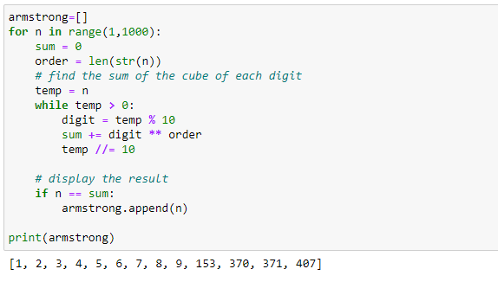

1. Write a Python Program to Find the Sum of Natural Numbers?

**Solution:**

