1. Write a Python Program to Check if a Number is Positive, Negative or Zero?

**Solution:**

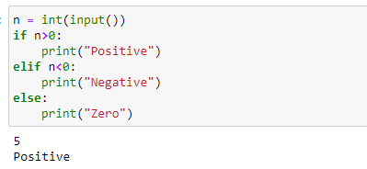

1. Write a Python Program to Check if a Number is Odd or Even?

**Solution:**

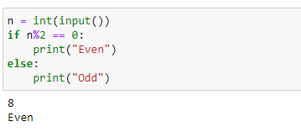

1. Write a Python Program to Check Leap Year?

**Solution:**

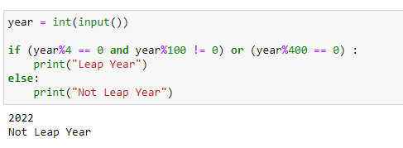

1. Write a Python Program to Check Prime Number?

**Solution:**

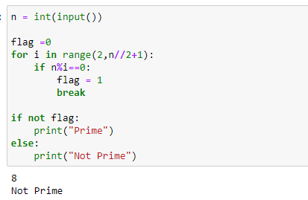

1. Write a Python Program to Print all Prime Numbers in an Interval of 1-10000?

**Solution:**

