1. Write a Python Program to Display Fibonacci Sequence Using Recursion?

**Solution:**

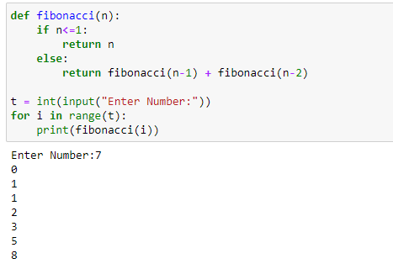

1. Write a Python Program to Find Factorial of Number Using Recursion?

**Solution:**

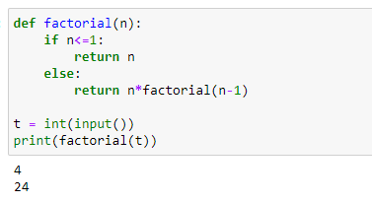

1. Write a Python Program to calculate your Body Mass Index?

**Solution:**

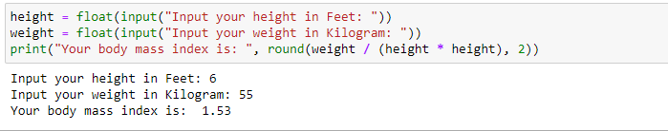

1. Write a Python Program to calculate the natural logarithm of any number?

**Solution:**

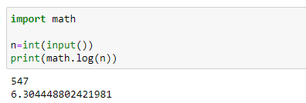

1. Write a Python Program for cube sum of first n natural numbers?

**Solution:**

