1. Write a Python Program to find sum of array?

**Solution:**

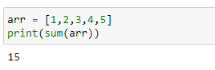

1. Write a Python Program to find largest element in an array?

**Solution:**

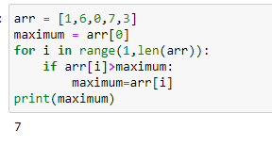

1. Write a Python Program for array rotation?

**Solution:**

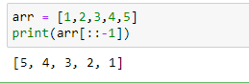

1. Write a Python Program to Split the array and add the first part to the end?

**Solution:**

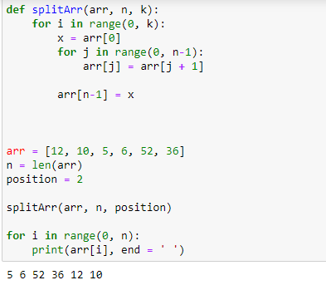

1. Write a Python Program to check if given array is Monotonic?

**Solution:**

