Assignment Document:

1. Change the title/ Image
2. Feeds/Posts
3. Implement SignIn/SignUp logic  
   - SignIn/ SignUp logic implemented   
   - accounts module (login/ signup component)  
   - “user-data.service.ts” to get user data & registerdata of new user
4. Popular Tags/ Favourites

* tags.services.ts modified to get favorite tags from local tagsData.json file

1. Only SignIn Users allowed to see Posts/Feeds

Over All Design Diagram:  
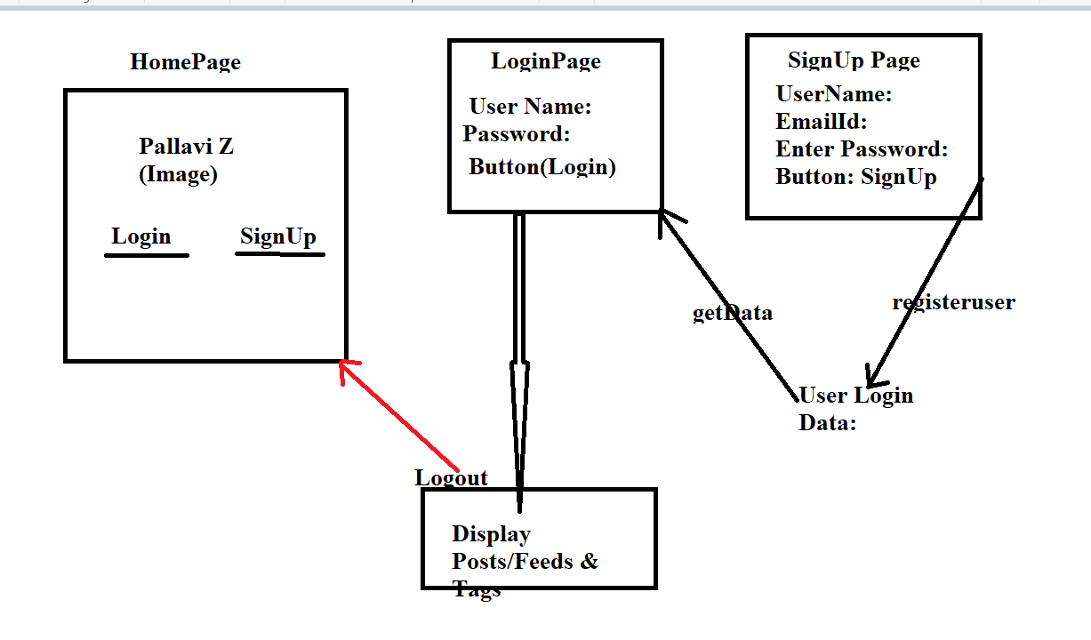

* Login Page:  
  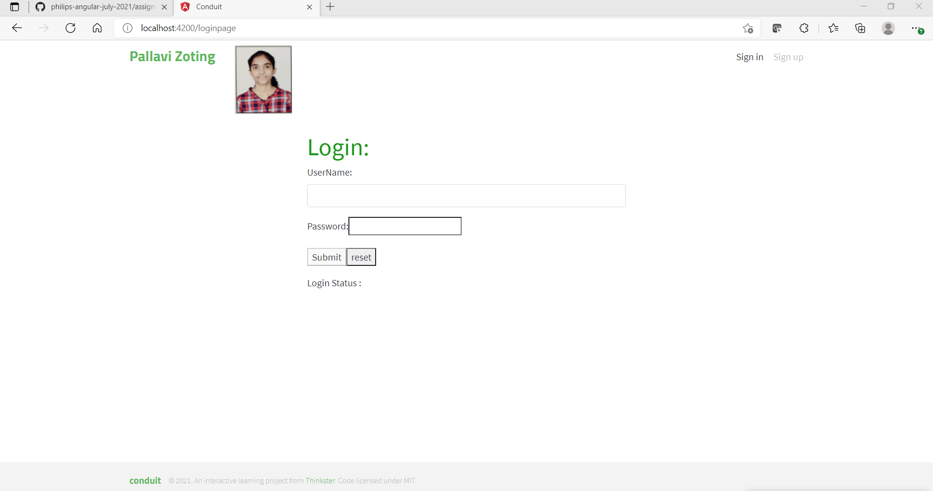
* If credentials are valid: Display Posts/Feeds(filter feeds by tags)  
  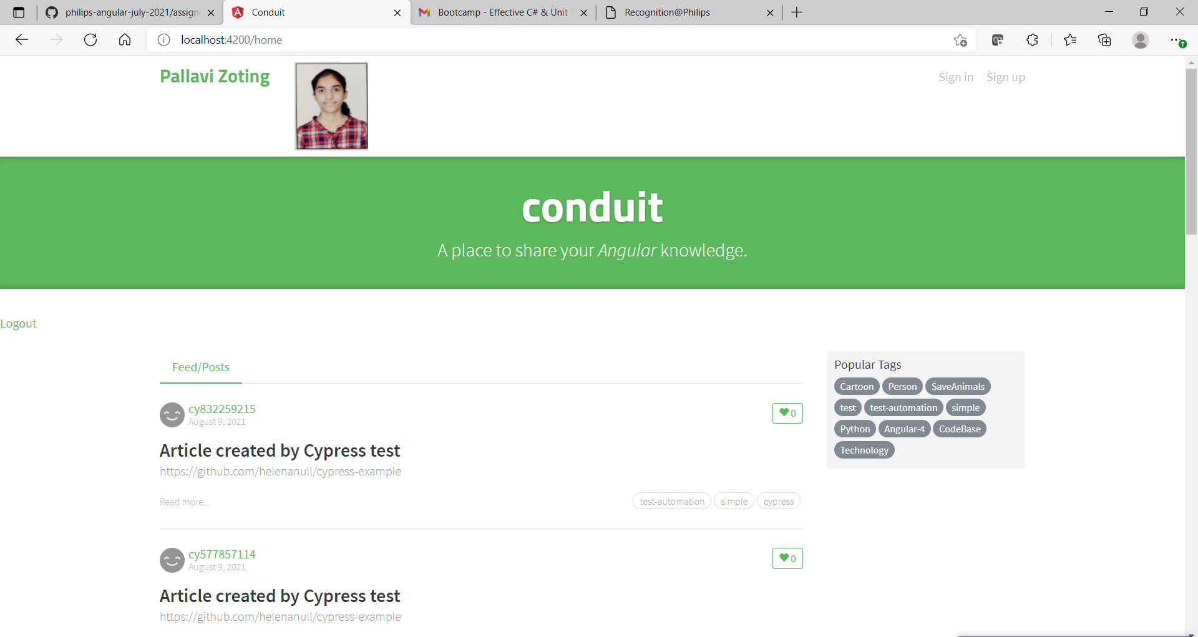
* SignUp Page:  
  1. If user already exist, then display “user already registered”, else register new user.

