ShopNest Store Power BI Capstone Report

Introduction
This report presents a comprehensive Power BI dashboard created using the ShopNest dataset. The dashboard provides insights into sales performance, customer behavior, delivery efficiency, and product performance. Various visualizations are used to answer key business questions.

1. Top Categories by Total Price
📌 Question Statement
Identify and visually represent the top 10 product categories by total sales.
📊 Visualization
Bar chart showing top 10 categories by revenue
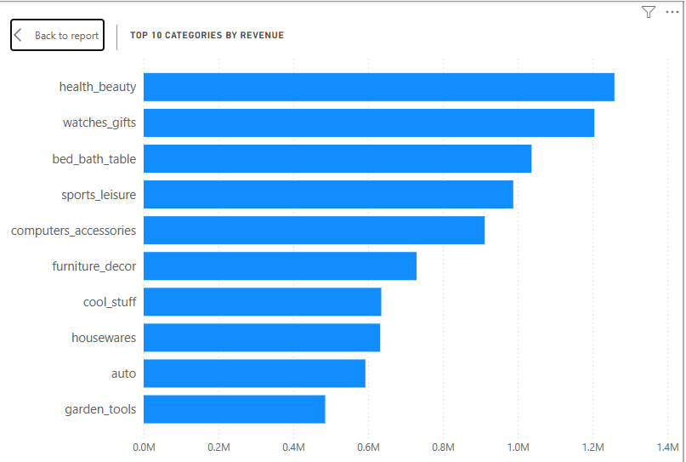
🧠 Explanation
The visualization highlights the highest revenue-generating categories. This helps the business focus on profitable segments and optimize inventory and marketing strategies.

2. Delayed Orders Analysis
📌 Question Statement
Determine the number of delayed orders in each category.
📊 Visualization
Stacked bar chart with delayed vs on-time orders by category.
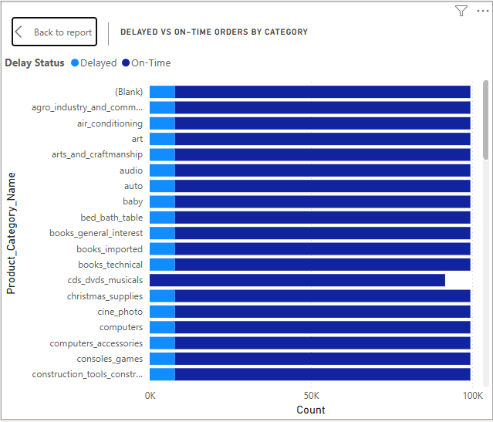

🧠 Explanation
Orders are classified as delayed if the delivery date exceeds the estimated delivery date. This analysis helps identify categories with frequent delivery issues, enabling operational improvements.

3. Monthly Comparison of Delayed vs On-Time Orders
📌 Question Statement
Compare delayed and on-time orders across months.
📊 Visualization
Clustered column chart showing monthly comparison.
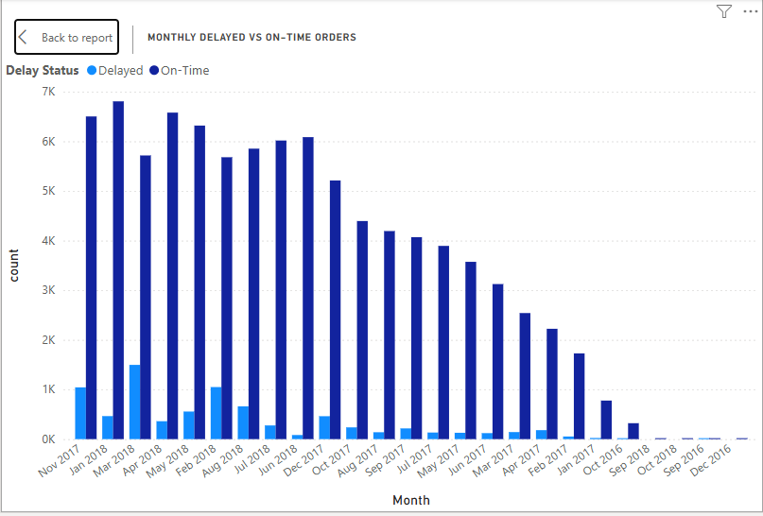
🧠 Explanation
This visual reveals trends in delivery performance over time. Seasonal spikes in delays can indicate logistical challenges during peak periods.

4. Payment Method Analysis
📌 Question Statement
Analyze the most frequently used payment methods.
📊 Visualization
Donut chart showing distribution of payment types.
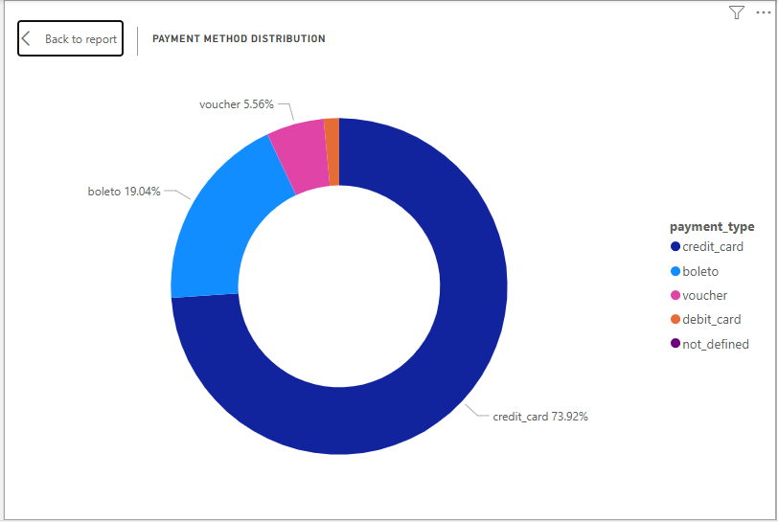
🧠 Explanation
The chart shows customer payment preferences, helping businesses optimize payment options and improve customer experience.

5. Product Rating Analysis
📌 Question Statement
Identify top 10 highest-rated and bottom 10 lowest-rated products.
📊 Visualization
Bar charts for top and bottom rated products.
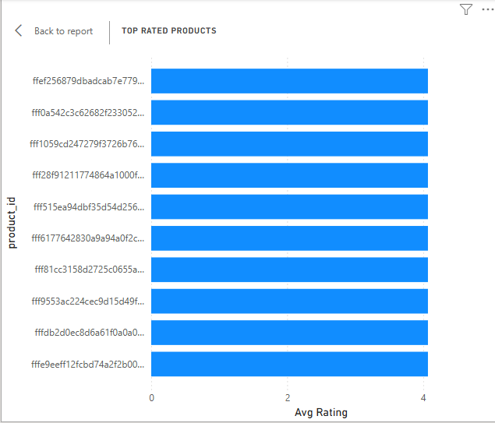
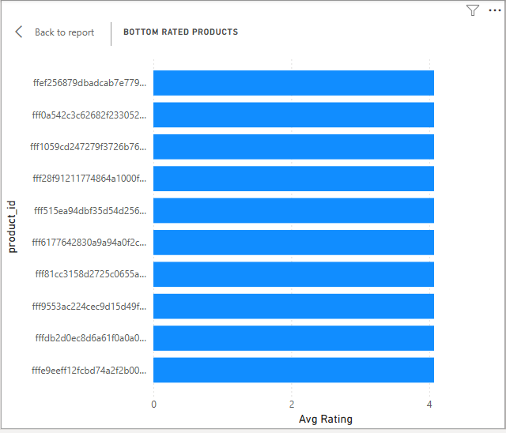
🧠 Explanation
This analysis helps identify best-performing products and those needing improvement, supporting quality control and customer satisfaction strategies.

6. State-wise Sales Analysis
📌 Question Statement
Identify states with high and low sales.
📊 Visualization
Map or bar chart showing sales by state.

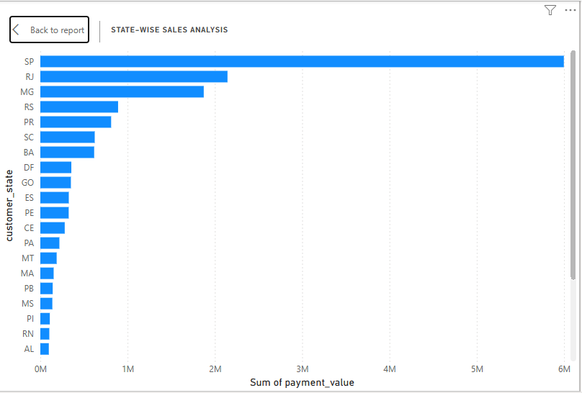
🧠 Explanation
This helps understand regional performance and identify potential markets for expansion or improvement.

7. Seasonal Sales Patterns
📌 Question Statement
Analyze quarterly sales trends.
📊 Visualization
Line chart showing sales by quarter.
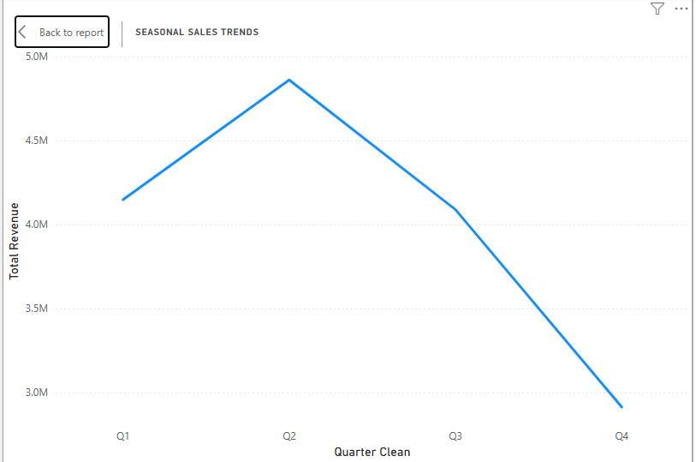
🧠 Explanation
This visualization reveals seasonal trends and helps in planning inventory and promotions accordingly.

8. Revenue Analysis
📌 Question Statement
Analyze total revenue and its trend over time.
📊 Visualization
Line chart showing yearly revenue trend.
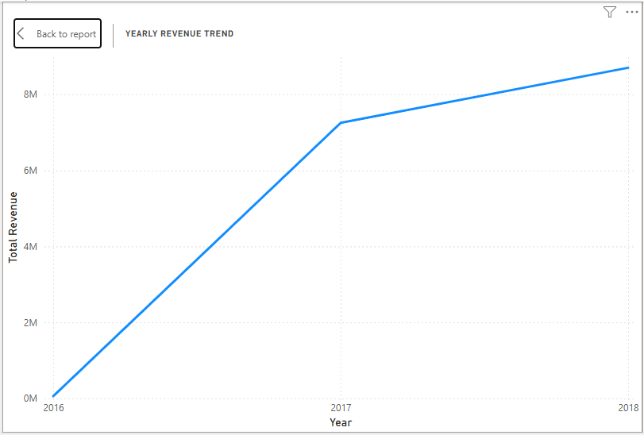
🧠 Explanation
This helps track business growth and evaluate long-term performance.

Conclusion
The Power BI dashboard provides a complete overview of ShopNest’s business performance. It enables data-driven decision-making by highlighting key insights related to sales, delivery efficiency, customer preferences, and product performance.

