Name: Pallavi Chaudhary

Student Code: AF0316472

Batch code: ANP-C6008

Lab Assignment 1

1) Define a JPA entity class named Product that maps to a database table named products. The Product entity should have the following attributes:

* id (Primary Key)
* name
* price

Use appropriate JPA annotations to map the entity to the database table.

-> Set up a Hibernate configuration file (hibernate.cfg.xml) to configure the data source, connection properties, and dialect. Ensure that hibernate is set to create/update the database schema automatically.

-> Write Java code to perform CRUD (Create, Read, Update, Delete) operations on the Product entity using Hibernate. Implement methods to:

* Insert a new product into the database.
* Retrieve a product by its ID.
* Update the details of a product.
* Delete a product by its ID.

**package** com.firstproject.newProject;

**import** jakarta.persistence.Column;

**import** jakarta.persistence.Entity;

**import** jakarta.persistence.Id;

//import org.hibernate.dialect.MySQL8Dialect;

//student table creates automatically

@Entity // table

**public** **class** Products {

@Column

**private** String name; // creates column name

@Id //primary key

**private** **int** id; //creates column pw but primary key...it has to be unique for all the people

@Column

**private** **int** price;

//getter and setter

**public** String getName() {

**return** name;

}

**public** **void** setName(String name) {

**this**.name = name;

}

**public** **int** getId() {

**return** id;

}

**public** **void** setId(**int** id) {

**this**.id = id;

}

**public** **int** getPrice() {

**return** price;

}

**public** **void** setPrice(**int** price) {

**this**.price = price;

}

@Override

**public** String toString() {

**return** "Products [name=" + name + ", id=" + id + ", price=" + price + "]";

}

}

**package** com.firstproject.newProject;

**import** org.hibernate.Session;

**import** org.hibernate.SessionFactory;

**import** org.hibernate.Transaction;

**import** org.hibernate.cfg.Configuration;

**import** jakarta.persistence.Entity;

//import org.hibernate.dialect.MySQL8Dialect;

//student table creates automatically

@Entity // table

**public** **class** App1 {

**public** **static** **void** main(String[] args) {

//Scanner s = new Scanner(System.in);

//System.out.println("Enter the password : ");

Products p = **new** Products();

p.setId(1); //set this password

p.setName("Biscuit"); //set this name

p.setPrice(10); //step 1

Configuration con2 = **new** Configuration();

con2.configure("hibernate.cgf.xml");

//step 2

SessionFactory factory2 = con2.buildSessionFactory();

//Step 3

Session session2 = factory2.openSession();

//session.save(s1);

session2.persist(p);

//TCL

Transaction tx2 = session2.beginTransaction();

tx2.commit();

//closing

factory2.close();

session2.close();

}

}

<!DOCTYPE hibernate-configuration PUBLIC

"-//Hibernate/Hibernate Configuration DTD 3.0//EN"

"http://www.hibernate.org/dtd/hibernate-configuration-3.0.dtd">

<hibernate-configuration>

<session-factory>

<!-- DB -->

<!-- Set Driver Name -->

<property name = "connection.driver_class">com.mysql.cj.jdbc.Driver</property>

<!-- Set URL -->

<property name = "connection.url">jdbc:mysql://localhost:3306/college</property>

<!-- Set User Name -->

<property name = "connection.username">root</property>

<!-- Set Password -->

<property name = "connection.password">1234</property>

<!-- Dialect-->

<property name = "dialect">org.hibernate.dialect.MySQLDialect</property>

<property name = "hbm2ddl.auto">create</property>

<property name = "show_sql">true</property>

<property name = "format_sql">true</property>

<!-- Mapping Config-->

<mapping class="com.firstproject.newProject.Products"/>

</session-factory>

</hibernate-configuration>

<!--hiberate configuration dtd file 3.0 -->

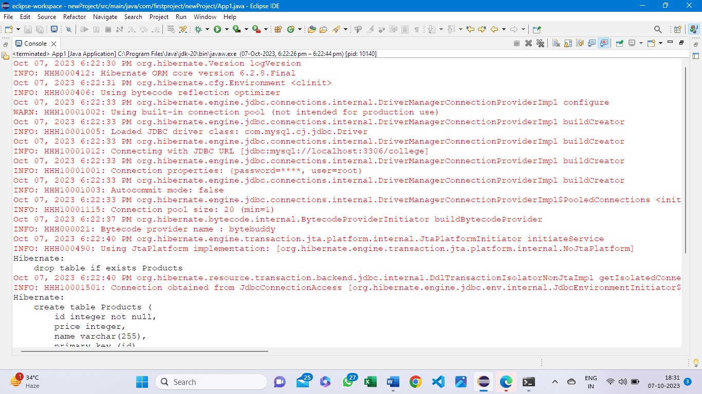

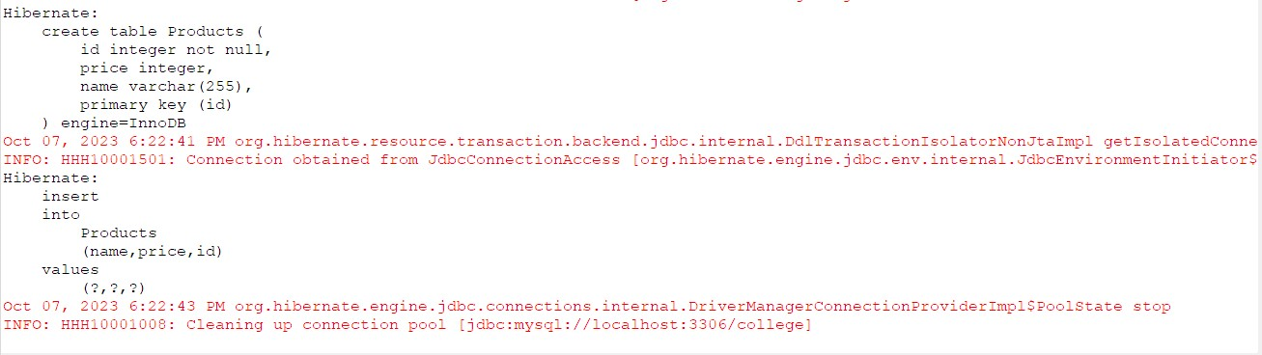

mysql> use college;

Database changed

mysql> show tables;

+-------------------+

| Tables_in_college |

+-------------------+

| customer |

| password |

| products |

| student |

+-------------------+

4 rows in set (0.06 sec)

mysql> select * from products;

+----+-------+---------+

| id | price | name |

+----+-------+---------+

| 1 | 10 | Biscuit |

+----+-------+---------+

1 row in set (0.00 sec)

*************Updating product’s details********

mysql> select * from products;

+----+-------+---------+

| id | price | name |

+----+-------+---------+

| 1 | 10 | Biscuit |

| 2 | 20 | Biscuit |

+----+-------+---------+

2 rows in set (0.23 sec)

mysql> update Products set price = 50, name = juice where id = 1;

ERROR 1054 (42S22): Unknown column 'juice' in 'field list'

mysql> update Products set price = 50, name = "juice" where id = 1;

Query OK, 1 row affected (0.30 sec)

Rows matched: 1 Changed: 1 Warnings: 0

mysql> select * from products;

+----+-------+---------+

| id | price | name |

+----+-------+---------+

| 1 | 50 | juice |

| 2 | 20 | Biscuit |

+----+-------+---------+

2 rows in set (0.00 sec)

*****************************Deleting a product by it’s id**************************

mysql> select * from products;

+----+-------+-----------+

| id | price | name |

+----+-------+-----------+

| 1 | 10 | chocolate |

| 2 | 50 | juice |

| 3 | 100 | pepsi |

+----+-------+-----------+

3 rows in set (0.00 sec)

mysql> delete from Products where id = 1;

Query OK, 1 row affected (0.10 sec)

mysql> select * from products;

+----+-------+-------+

| id | price | name |

+----+-------+-------+

| 2 | 50 | juice |

| 3 | 100 | pepsi |

+----+-------+-------+

2 rows in set (0.00 sec)