

Department of Computer Science & Engineering
Shri Sant Gajanan Maharaj College of Engineering, Shegaon – 444 203

2025-2026

Third year, Fifth Semester
B.E. (Computer Science and Engineering)

Compiler Design, Sub Code: 5KS02
TEC (Teaching Evaluation Component)
On
Mini-Compiler for a Custom Simple Language (Mini-L)
in structured text format

Submitted By
Roll no. 13
Pallavi U Pawar

INDEX

Sr. No | CONTENTS
1 | INTRODUCTION
2 | OBJECTIVES AND SCOPE
3 | SYSTEM REQUIREMENT
4 | SYSTEM ARCHITECTURE
5 | METHODOLOGY / IMPLEMENTATIONN STEPS
6 | DATA COLLECTION AND PREPROCESSING
7 | MODEL SELECTION AND TRAINING
8 | FLOW DIAGRAM
9 | CODE SNIPPETS
10 | USER INTERFACE
11 | INPUT AND OUTPUT SCREENSHOTS
12 | TOOLS AND TECHNOLOGIES USED
13 | CHALLENGES FACED
14 | CONCLUSION

1.INTRODUCTION

Software development is a multi-phased process encompassing design, coding, testing, and deployment. At the heart of this process lies the compiler, the foundational system software responsible for translating human-readable source code into machine-executable instructions. Compilers bridge the crucial gap between high-level programming concepts and the low-level architecture of computer hardware. Without a systematic translation mechanism, complex instructions defined by programmers could not be executed efficiently or accurately. The study of compiler design, therefore, is paramount, as it provides a deep, hands-on understanding of how modern programming languages function and interact with underlying hardware.
The process of compilation is meticulously organized into sequential phases, beginning with analyzing the source code's structure and concluding with generating optimized target code. Many introductory courses focus solely on the theoretical foundations of these phases, such as Automata Theory for lexical analysis and Formal Language Theory for syntax analysis. However, true mastery requires practical application. This project, titled Design and Implementation of a Mini-Compiler for a Simplified Programming Language (Mini-L) with Intermediate Code Generation, aims to transition from theory to practice by constructing a working front-end compiler.
The system is specifically designed to take a simple, custom programming language (Mini-L) as input and systematically process it through three critical phases: Lexical Analysis, Syntax Analysis, and Intermediate Code Generation (ICG). The culmination of this process is the generation of Three-Address Code (TAC), a machine-independent representation essential for subsequent compiler back-end tasks like optimization and machine-specific code emission. The ultimate goal is to create a functional prototype that not only validates the theoretical principles taught in Compiler Design but also demonstrates the practical challenges and solutions involved in translating high-level constructs (like arithmetic expressions and control flow statements) into a structured, executable intermediate form. This exercise is critical for enhancing programming accuracy, deepening the understanding of code execution, and fostering skills necessary for language development and compiler tool creation.

2.OBJECCTIVES AND SCOPE

Objectives:

The core objectives for the implementation of the Mini-Compiler for Mini-L are:
- To design and specify the grammar for the custom simplified programming language, Mini-L
- To implement the Lexical Analyzer using the principles of Finite Automata and Regular Expressions, capable of generating tokens from the Mini-L source code.
- To implement the Syntax Analyzer (Parser) using Context-Free Grammar principles to check the structural correctness of the input program.
- To integrate Symbol Table Management within the parsing process to store and retrieve metadata about identifiers (e.g., name, type, scope).
- To perform Syntax-Directed Translation by embedding semantic actions within the parser to generate Three-Address Code (TAC), the chosen intermediate representation.
- To successfully translate basic programming constructs (declarations, arithmetic expressions, assignment, and control flow statements like if-else) into valid TAC.
- To demonstrate the functionality via a user-friendly Command Line Interface (CLI), showing the clear mapping from source code input to TAC output.

Scope:

The scope defines the boundaries and primary application of the implemented Mini-L Mini-Compiler:
- Language Support: The system strictly supports the Mini-L language specification, which includes the int data type, basic arithmetic operators (+, -, *, /), assignment, and flow control (if-else).
- Compiler Phases Covered: The project covers the essential front-end phases: Lexical Analysis, Syntax Analysis, and Intermediate Code Generation.
- Target Output: The primary output is Three-Address Code (TAC); the project does not include the back-end phases (Code Optimization or final Target Machine Code Generation).
- Tools and Platform: The compiler is built using standard compiler construction tools: Flex (for Lexical Analysis) and Bison (for Syntax Analysis and ICG), using the C/C++ language.
- Applicability: The project serves as a practical, foundational tool applicable in compiler design education, language specification testing, and demonstrating core theoretical concepts in formal languages and automata theory.

3.SYSTEM REQUIREMENTS

Hardware Requirements:

The requirements are minimal, as the project involves command-line execution and standard C/C++ compilation.
- Processor: Intel Core i3 or equivalent (or higher)
- RAM: Minimum 4 GB (8 GB recommended)
- Hard Disk: 500 MB free space (sufficient for tools, source code, and binaries)
- Display: 1024×768 resolution or higher

Software Requirements:

The software stack focuses on the standard, powerful tools used in professional compiler construction.
- Operating System (Platform - Sr. 11): Linux (e.g., Ubuntu, Fedora) or Windows (via MinGW or Cygwin/WSL)
- Programming Language (Sr. 10): C/C++
- Compiler Tools:
  - Flex (Lexical Analyzer Generator): Required to generate the C code for the Lexical Analyzer.
  - Bison (Parser Generator): Required to generate the C code for the Syntax Analyzer and handle semantic actions.
  - GCC (GNU Compiler Collection): Standard C/C++ compiler required to build the final executable from the generated C files.
- Development Tools:
  - IDE/Editor: Visual Studio Code / Gedit / Vim
  - Version Control: Git
- Cloud Platform (Optional - Sr. 12): AWS EC2 or Google Cloud Compute Engine (for optional remote demonstration).

4.SYSTEM ARCHITECTURE

The Mini-Compiler's architecture is modular, based on the three implemented phases: Lexical Analysis, Syntax Analysis, and Intermediate Code Generation (ICG).

4.1 Block Diagram
The overall system architecture is best represented by the flow of information through the implemented phases:
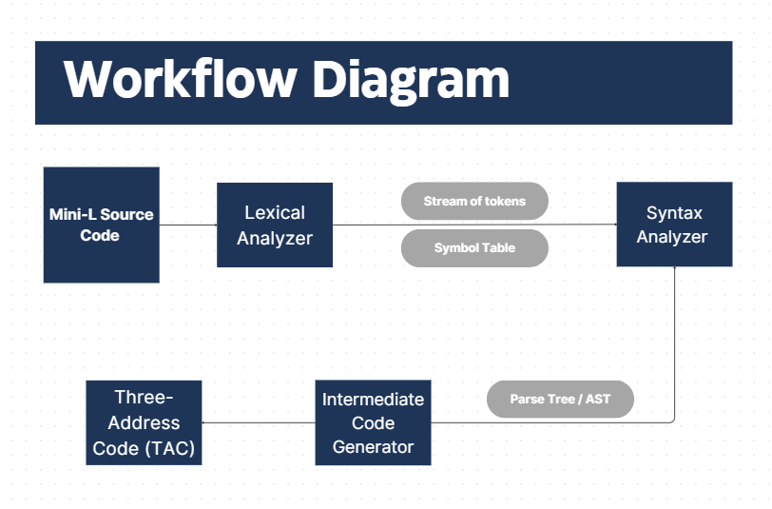

4.2 Description of Modules
1. Lexical Analyzer (Scanner)
- Tool Used: Flex (Lexical Analyzer Generator).
- Function: Reads the input Mini-L source code character-by-character.
- Task: Groups characters into meaningful units called tokens (e.g., keywords, identifiers, operators, literals). It also removes whitespace and comments.
- Output: A stream of tokens passed to the Parser. It interacts with the Symbol Table to enter new identifiers.
2. Syntax Analyzer (Parser)
- Tool Used: Bison (Parser Generator).
- Function: Receives the token stream from the Lexer.
- Task: Checks if the sequence of tokens forms a valid program structure according to the Mini-L Context-Free Grammar (CFG). If an error is detected, it reports it. If correct, it builds an implicit or explicit Abstract Syntax Tree (AST).
- Task: It executes embedded semantic actions associated with the grammar rules.
3. Intermediate Code Generator (ICG)
- Function: Integrated within the Bison parser's semantic actions (Syntax-Directed Translation).
- Task: Translates the parsed high-level language constructs (like arithmetic expressions and if-else statements) into a low-level, machine-independent format called Three-Address Code (TAC). This involves generating temporary variables and labels.
- Output: The final sequence of Three-Address Code instructions.
4. Symbol Table (Data Structure - Sr. 4)
- Function: Acts as the central data storage for all identifier information.
- Task: Stores the identifier's lexeme, data type, and scope, assisting both the Lexer (in classifying tokens) and the Parser (in performing semantic checks and ICG).

5. METHOOLOGY / IMPLEMENTATION STEPS

The implementation follows a structured approach based on the classic pipeline of compiler construction tools, using the C language environment with Flex and Bison.
Step 1: Language and Grammar Definition
- Define Mini-L Specification: Establish the complete set of keywords, data types (int), operators, and control flow constructs (if-else, assignment) that the compiler will support (Scope).
- Context-Free Grammar (CFG) Construction: Write the formal CFG rules that define the valid syntax structure of the Mini-L language, serving as the input for the Bison tool.
Step 2: Lexical Analyzer Development
- Token Pattern Definition: Create the Flex input file (test.l) containing Regular Expressions (REs) for every token in Mini-L (identifiers, literals, keywords, operators).
- Flex Compilation: Use the flex command to process test.l, which generates the C code file (lex.yy.c) containing the core scanning function (yylex()).
Step 3: Syntax Analyzer (Parser) Development
- Parser Rule Implementation: Create the Bison input file (test.y) containing the CFG rules (from Step 1).
- Declaration and Precedence: Define token types and operator precedence/associativity rules within test.y to resolve ambiguities in the grammar (e.g., multiplication over addition).
- Bison Compilation: Use the bison -d command to process test.y, generating the C code file (y.tab.c) for the parser and a header file (y.tab.h) for token sharing with the Lexer.
Step 4: Intermediate Code Generation (ICG) Integration
- Symbol Table Integration (Database Schema): Implement the Symbol Table structure (e.g., a linked list or hash map in C) and integration functions (insert(), lookup()).
- Semantic Actions: Embed C code snippets (semantic actions) directly into the Bison grammar rules (test.y). These actions are executed whenever a grammar rule is successfully matched.
- TAC Generation Logic: Implement the C functions (e.g., generate_TAC(), new_temp()) to produce the output in the required Three-Address Code (TAC) format, handling temporary variables for expressions and labels for control flow.
Step 5: Final Compilation and Execution
- Linkage: Use the GCC compiler to link the Lexer code (lex.yy.c), the Parser code (y.tab.c), and any custom C files (Symbol Table, TAC functions) into a single executable binary (e.g., mini_compiler).
- Execution and Output Display: Execute the binary using the Mini-L source code as input. The compiled application processes the code and immediately displays the resulting Three-Address Code to the command line, confirming successful compilation and translation.

6. Data Collection and Preprocessing

Source Data and Collection (Input Structure)
The "data" for the Syntax Analyzer is the Stream of Tokens generated by the Lexical Analyzer (Flex). This stream acts as the pre-processed input that the Parser must validate. The structure of this stream is dictated by the formal Context-Free Grammar (CFG) of Mini-L.
- Grammar Collection: The CFG is carefully designed to include all valid structural sequences (e.g., how an if statement must be followed by a condition, and then a block of code).
- Token Input: The Parser receives tokens (which are already classified and tagged by the Lexer) rather than raw characters, making the parsing task efficient.
Preprocessing Steps (Parsing Process)
The parser performs structural validation and initiates translation through the following steps:
- Parsing/Rule Matching: The parser (generated by Bison) attempts to match the sequence of incoming tokens to the CFG rules defined in the text.y file.
- Implicit Tree Construction: As rules are matched, the parser conceptually builds a Parse Tree or Abstract Syntax Tree (AST), validating the hierarchy of the program.
- Symbol Table Lookup: The parser performs crucial lookups in the Symbol Table to ensure identifiers are declared correctly and used within the correct scope (early semantic checking).
- Syntax Error Reporting: If the token stream violates any CFG rule (e.g., missing semicolon or unbalanced parentheses), the parser immediately halts and reports a syntax error to the user.

7. Model Selection and Training

The compiler's equivalent of "Model Selection" is choosing the Intermediate Representation (IR) format, and "Training" is the process of generating that IR via Syntax-Directed Translation (SDT).
Chosen Model: Intermediate Code Representation
- Model: Three-Address Code (TAC)
- Description: TAC is a preferred intermediate representation for its simplicity and structure. Every instruction has at most one operator and three addresses (operand and a result). This structure facilitates subsequent code optimization and platform-specific code generation.
  - Example: A complex arithmetic expression like x = a * b + 5 is broken down into simple steps: t1 = a * b; t2 = t1 + 5; x = t2.
Training Process (Translation Process)
The compiler is "trained" (i.e., designed) to translate high-level language constructs into TAC by defining specific actions within the parser rules:
- Syntax-Directed Translation (SDT): The translation logic is defined as semantic actions (C code snippets) embedded directly into the Bison grammar rules.
- Assignment Translation: Whenever the parser recognizes an assignment rule Identifier = Expression, the semantic action calls a function to generate the final TAC assignment line.
- Expression Evaluation: The parser uses the semantic actions to introduce and manage temporary variables t_{n} to hold the results of sub-expressions, ensuring correct operator precedence is maintained during translation.
- Control Flow Logic: For statements like if-else, semantic actions manage the generation of labels L_{n} and conditional/unconditional jump instructions (if condition goto L1, goto L2), forming the essential structure of the TAC flow.

8.Flow Diagrams

9. Code Snippets

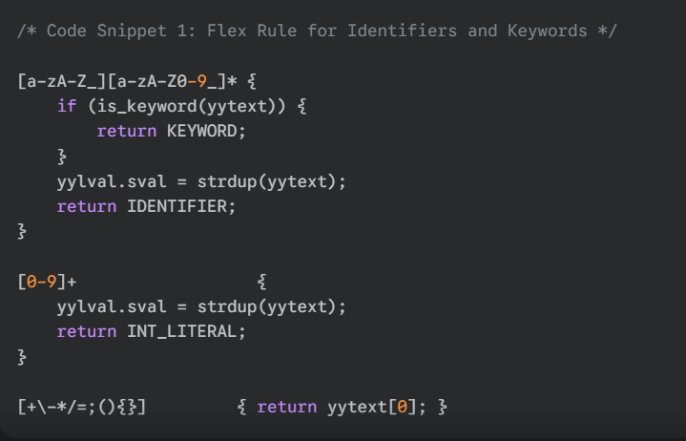
Functionality: This is the core scanning logic. It recognizes sequences of letters and numbers as IDENTIFIER tokens, while checking for reserved KEYWORDs, and recognizes numeric constants.
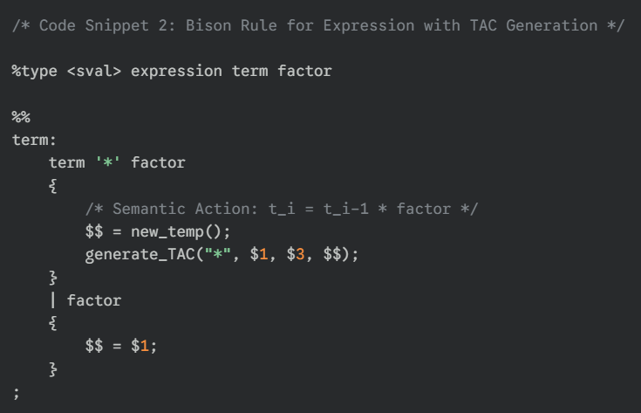
Functionality: This rule enforces that multiplication (*) is performed before expression evaluation continues (higher precedence). The semantic action immediately calls the ICG function to generate a TAC instruction, storing the result in a new temporary variable (new_temp()).
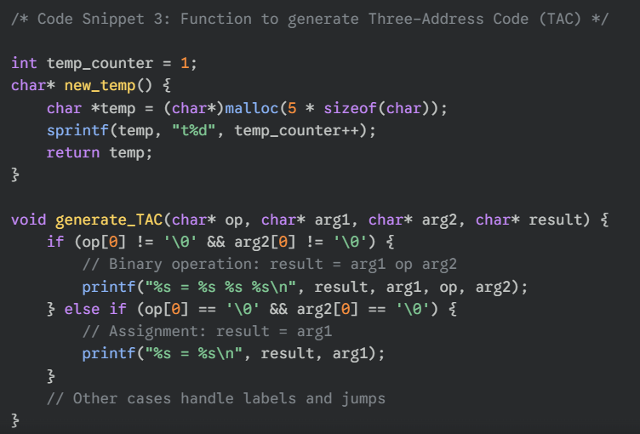
Functionality: new_temp() creates unique temporary variable names (e.g., t1, t2). generate_TAC() formats the arguments into the standard TAC output and prints it.
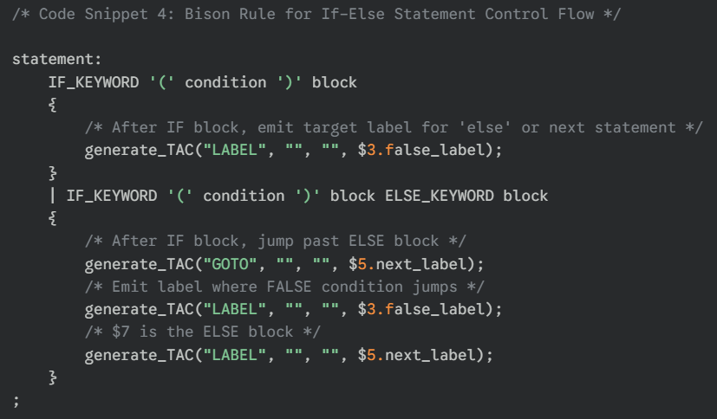
Functionality: This uses placeholders (3.false_label, 5.next_label) to manage the branching logic in TAC, ensuring the conditional code jumps to the correct location.

10.USER INTERFACE
Since the project is a compiler built with Flex and Bison, it operates via a Command Line Interface (CLI) rather than a graphical user interface (GUI). The command line serves as both the front-end for execution and the display medium for the output.
Front-End Appearance
The user interface consists of standard terminal commands:
- Compilation: The user compiles the project by linking the Flex and Bison generated files with custom code.
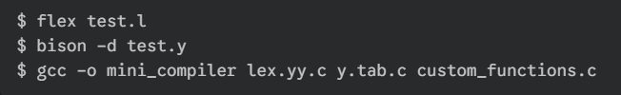
- Execution: The user executes the compiler, typically redirecting the source code file as input.

11.INPUT AND OUTPUT
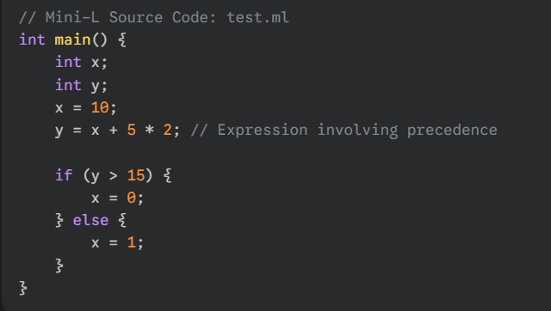
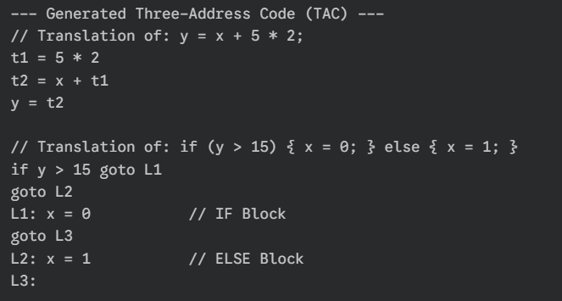

12.TOOLS AND TECHNOLOGIES USED

The Mini-Compiler project leverages industry-standard tools for compiler construction, ensuring a robust and academically relevant implementation.
Category | Technology | Purpose in Project
Programming Language (Sr. 10) | C/C++ | Core language used for implementing Symbol Table logic, ICG functions, and linking the generated files.
Lexical Analyzer Tool | Flex (Lex) | Used to generate the C code for the Lexical Analyzer based on Regular Expressions.
Syntax Analyzer Tool | Bison (Yacc) | Used to generate the C code for the Parser, define the Context-Free Grammar, and embed Semantic Actions for ICG.
Compiler/Linker | GCC (GNU Compiler Collection) | Used to compile and link the .c files generated by Flex and Bison into a single executable binary.
Platform (Sr. 11) | Linux/Windows (CLI) | The primary operating environment for tool execution and testing the compiler.
Version Control (Sr. 13) | GitHub | Used to manage source code versions (.l, .y, .c files) and share the project with a descriptive README.md.

13.CHALLENGES FACED

Building the Mini-Compiler presented several challenges inherent to the complexity of language processing, all of which were overcome during the implementation process.
- Grammar Ambiguity: Defining a Context-Free Grammar for $\text{Mini-L}$ that is unambiguous, especially for expressions involving multiple operators (like $a + b * c$). This required correctly setting operator precedence and associativity rules within the $\text{Bison}$ file.
- Intermediate Code Management: Developing robust logic for generating Three-Address Code (TAC), particularly for control flow statements (if-else). This involved ensuring unique and correct label generation and managing the jumps (goto) to the appropriate instruction blocks.
- Symbol Table Integration: Correctly managing the scope and data types of variables (though simplified in $\text{Mini-L}$), requiring smooth integration of Symbol Table lookup and update functions into the Lexical and Syntax analysis phases.
- Toolchain Setup: Setting up the $\text{Flex/Bison}$ environment on the chosen platform and ensuring seamless communication between the Lexer (yylex()) and the Parser (yyparse()) via shared tokens and data structures.

14.CONCLUSION

The Mini-Compiler for Mini-L project successfully achieved its primary objective: the implementation of the complete front-end of a compiler. By systematically implementing the Lexical Analysis, Syntax Analysis, and Intermediate Code Generation (ICG) phases, the project provided a practical application of theoretical concepts from Automata Theory and Formal Languages. The successful output of Three-Address Code (TAC) confirms the system's ability to accurately translate complex high-level statements (arithmetic, control flow) into a linear, machine-independent representation. This work demonstrates the foundational steps required for any language processor, thereby enhancing the understanding of compiler structure, error detection, and the preparation of code for final execution.

DECLARATION

This is to certify that the work embodied in the project report titled "Design and Implementation of a Mini-Compiler for a Simplified Programming Language (Mini-L) with Intermediate Code Generation" is an authentic record of my own research and development. The work presented in this report is original to the best of my knowledge and has not been submitted to any other university or institution for the award of any degree or certification.

Signature

Place : Shegaon
Date : 06/11/2025
Github link:

