Practical 1 : Wildcards
Generic Class:
package Pallavi;

import java.util.Scanner;

class Box<T> {
private T value;

public void set(T value) {
this.value = value;
}

public T get() {
return value;
}
}

public class GenericClass {
public static void main(String[] args) {

Scanner sc = new Scanner(System.in);

Box<String> strBox = new Box<>();
System.out.print("Enter Name: ");
strBox.set(sc.nextLine());

Box<Integer> intBox = new Box<>();
System.out.print("Enter Roll No: ");
intBox.set(sc.nextInt());

System.out.println("Name: " + strBox.get());
System.out.println("Roll No.: " + intBox.get());
}
}
Generic Method:
package Pallavi;

import java.util.Scanner;

class GenericMethod {

// Generic Method
public static <T> void printArray(T[] array) {
for (T element : array) {
System.out.print(element + " ");
}
System.out.println();
}

public static void main(String[] args) {

Scanner sc = new Scanner(System.in);

// Integer array input
System.out.print("Enter size of Integer array: ");
int n1 = sc.nextInt();
Integer[] intArray = new Integer[n1];

System.out.println("Enter Integer elements:");
for (int i = 0; i < n1; i++) {
intArray[i] = sc.nextInt();
}

// String array input
System.out.print("Enter size of String array: ");
int n2 = sc.nextInt();
sc.nextLine(); // clear buffer
String[] strArray = new String[n2];

System.out.println("Enter String elements:");
for (int i = 0; i < n2; i++) {
strArray[i] = sc.nextLine();
}

// Double array input
System.out.print("Enter size of Double array: ");
int n3 = sc.nextInt();
Double[] dblArray = new Double[n3];

System.out.println("Enter Double elements:");
for (int i = 0; i < n3; i++) {
dblArray[i] = sc.nextDouble();
}

// Call generic method
System.out.println("Integer Array:");
printArray(intArray);

System.out.println("String Array:");
printArray(strArray);

System.out.println("Double Array:");
printArray(dblArray);
}
}

Upper Bound:
package Pallavi;

import java.util.*;

public class UpperBound {

// Upper-bounded wildcard method
public static void printNumbers(List<? extends Number> list) {
for (Number n : list) {
System.out.print(n + " ");
}
System.out.println();
}

public static void main(String[] args) {

Scanner sc = new Scanner(System.in);

// Integer list input
System.out.print("Enter number of integers: ");
int n1 = sc.nextInt();
List<Integer> intList = new ArrayList<>();

System.out.println("Enter integers:");
for (int i = 0; i < n1; i++) {
intList.add(sc.nextInt());
}

// Double list input
System.out.print("Enter number of doubles: ");
int n2 = sc.nextInt();
List<Double> doubleList = new ArrayList<>();

System.out.println("Enter doubles:");
for (int i = 0; i < n2; i++) {
doubleList.add(sc.nextDouble());
}

System.out.println("Integer List:");
printNumbers(intList);

System.out.println("Double List:");
printNumbers(doubleList);
}
}
Lower Bound:
package Pallavi;

import java.util.*;

public class LowerBound {

// Lower-bounded wildcard method
public static void addNumbers(List<? super Integer> list, int n) {
Scanner sc = new Scanner(System.in);
System.out.println("Enter " + n + " numbers:");
for (int i = 0; i < n; i++) {
list.add(sc.nextInt());
}
}

public static void main(String[] args) {

Scanner sc = new Scanner(System.in);
List<Number> numList = new ArrayList<>();

System.out.print("How many numbers do you want to add? ");
int n = sc.nextInt();

addNumbers(numList, n);

System.out.println("List after adding elements:");
for (Object obj : numList) {
System.out.print(obj + " ");
}
}
}

Un Bounded:
package Pallavi;

import java.util.*;

public class Unbounded {

// Unbounded wildcard method
public static void printList(List<?> list) {
for (Object item : list) {
System.out.print(item + " ");
}
System.out.println();
}

public static void main(String[] args) {

Scanner sc = new Scanner(System.in);

// Integer list input
System.out.print("Enter number of integers: ");
int n1 = sc.nextInt();
List<Integer> intList = new ArrayList<>();

System.out.println("Enter integers:");
for (int i = 0; i < n1; i++) {
intList.add(sc.nextInt());
}

// String list input
System.out.print("Enter number of strings: ");
int n2 = sc.nextInt();
sc.nextLine(); // clear buffer
List<String> strList = new ArrayList<>();

System.out.println("Enter strings:");
for (int i = 0; i < n2; i++) {
strList.add(sc.nextLine());
}

// Double list input
System.out.print("Enter number of doubles: ");
int n3 = sc.nextInt();
List<Double> doubleList = new ArrayList<>();

System.out.println("Enter doubles:");
for (int i = 0; i < n3; i++) {
doubleList.add(sc.nextDouble());
}

// Print lists
System.out.print("Integer List: ");
printList(intList);

System.out.print("String List: ");
printList(strList);

System.out.print("Double List: ");
printList(doubleList);
}
}

Practical 2 : Iterator
For Each:
package Pallavi;

import java.util.*;

public class ForEach {
public static void main(String[] args) {

Scanner sc = new Scanner(System.in);
List<String> fruits = new ArrayList<>();

System.out.print("Enter number of fruits: ");
int n = sc.nextInt();
sc.nextLine(); // clear buffer

System.out.println("Enter fruit names:");
for (int i = 0; i < n; i++) {
fruits.add(sc.nextLine());
}

System.out.println("List of Fruits:");
for (String fruit : fruits) { // for-each loop
System.out.println(fruit);
}
}
}
ListIterator:
package Pallavi;

import java.util.*;

public class IteratorList {
public static void main(String[] args) {

Scanner sc = new Scanner(System.in);
List<String> names = new ArrayList<>();

System.out.print("Enter number of names: ");
int n = sc.nextInt();
sc.nextLine(); // clear buffer

System.out.println("Enter names:");
for (int i = 0; i < n; i++) {
names.add(sc.nextLine());
}

ListIterator<String> iterator = names.listIterator();

System.out.println("\nList in Forward Direction:");
while (iterator.hasNext()) {
System.out.println(iterator.next());
}

System.out.println("\nList in Backward Direction:");
while (iterator.hasPrevious()) {
System.out.println(iterator.previous());
}
}
}

Practical 3 : Set
Set Iterator:
package Pallavi;

import java.util.*;

public class SetIterator {
public static void main(String[] args) {

Scanner sc = new Scanner(System.in);
Set<String> cities = new LinkedHashSet<>();

System.out.print("Enter number of cities: ");
int n = sc.nextInt();
sc.nextLine(); // clear buffer

System.out.println("Enter city names:");
for (int i = 0; i < n; i++) {
cities.add(sc.nextLine());
}

System.out.println("\nCities (Forward Direction):");
Iterator<String> itr = cities.iterator();
while (itr.hasNext()) {
System.out.println(itr.next());
}

System.out.println("\nCities (Reverse Direction):");
List<String> cityList = new ArrayList<>(cities);
ListIterator<String> listItr = cityList.listIterator(cityList.size());
while (listItr.hasPrevious()) {
System.out.println(listItr.previous());
}
}
}
Set Interface(operations):
package Pallavi;

import java.util.*;

public class SetOperations {

public static void main(String[] args) {

Scanner sc = new Scanner(System.in);
Set<String> set1 = new HashSet<>();

System.out.print("Enter number of items for Set 1: ");
int n1 = sc.nextInt();
sc.nextLine(); // clear buffer

System.out.println("Enter items for Set 1:");
for (int i = 0; i < n1; i++) {
set1.add(sc.nextLine());
}

Set<String> set2 = new HashSet<>();
System.out.print("Enter number of items for Set 2: ");
int n2 = sc.nextInt();
sc.nextLine(); // clear buffer

System.out.println("Enter items for Set 2:");
for (int i = 0; i < n2; i++) {
set2.add(sc.nextLine());
}

set1.addAll(set2);
System.out.println("After adding Set 2 into Set 1: " + set1);

System.out.print("Enter item to remove: ");
String removeItem = sc.nextLine();
set1.remove(removeItem);
System.out.println("After removal: " + set1);

System.out.print("Enter item to search: ");
String searchItem = sc.nextLine();
if (set1.contains(searchItem))
System.out.println(searchItem + " is present in the set.");
else
System.out.println(searchItem + " is not present in the set.");
}
}

Practical 4 : Map
Map Interface:
package Pallavi;

import java.util.*;

public class MapInterface {
public static void main(String[] args) {

Scanner sc = new Scanner(System.in);
Map<Integer, String> map1 = new HashMap<>();

System.out.print("Enter number of entries for Map 1: ");
int n = sc.nextInt();
sc.nextLine(); // clear buffer

System.out.println("Enter key and value pairs:");
for (int i = 0; i < n; i++) {
System.out.print("Key: ");
int key = sc.nextInt();
sc.nextLine(); // clear buffer
System.out.print("Value: ");
String value = sc.nextLine();
map1.put(key, value);
}

System.out.println("Map 1: " + map1);

System.out.print("Enter key to remove: ");
int removeKey = sc.nextInt();
map1.remove(removeKey);
System.out.println("After removing key " + removeKey + ": " + map1);

System.out.print("Enter key to search: ");
int searchKey = sc.nextInt();
if (map1.containsKey(searchKey))
System.out.println("Key " + searchKey + " is present in the map.");
else
System.out.println("Key " + searchKey + " is not present in the map.");

System.out.print("Enter key to get value: ");
int getKey = sc.nextInt();
System.out.println("Value for key " + getKey + ": " + map1.get(getKey));

System.out.print("Enter number of entries for Map 2: ");
int m = sc.nextInt();
sc.nextLine();
Map<Integer, String> map2 = new HashMap<>();
System.out.println("Enter key and value pairs for Map 2:");
for (int i = 0; i < m; i++) {
System.out.print("Key: ");
int key = sc.nextInt();
sc.nextLine();
System.out.print("Value: ");
String value = sc.nextLine();
map2.put(key, value);
}

map1.putAll(map2);
System.out.println("After adding Map 2 into Map 1: " + map1);

System.out.println("All keys and values in Map 1:");
for (Map.Entry<Integer, String> entry : map1.entrySet()) {
System.out.println("Key: " + entry.getKey() + ", Value: " + entry.getValue());
}
}
}

Practical 5 : Lambda
Lambda Expression:
public class LambdaHello {
interface Greeting {
void sayHello();
}

public static void main(String[] args) {
Greeting greeting = () -> System.out.println("Hello World");
greeting.sayHello();
}
}
Lambda with single parameter:
import java.util.Scanner;

public class LambdaSingleParam {
interface Square {
int calculate(int x);
}

public static void main(String[] args) {
Scanner sc = new Scanner(System.in);
System.out.print("Enter a number: ");
int num = sc.nextInt();

Square square = (x) -> x * x;
int result = square.calculate(num);

System.out.println("Square of " + num + " is: " + result);
}
}
Lambda expression with multiple parameters:
import java.util.Scanner;

public class LambdaMultiParam {
interface Add {
int sum(int a, int b);
}

public static void main(String[] args) {
Scanner sc = new Scanner(System.in);
System.out.print("Enter first number: ");
int num1 = sc.nextInt();
System.out.print("Enter second number: ");
int num2 = sc.nextInt();

Add addition = (a, b) -> a + b;
int result = addition.sum(num1, num2);

System.out.println("Sum of " + num1 + " and " + num2 + " is: " + result);
}
}
Lambda fahrenheit to celsius:
import java.util.Scanner;

public class LambdaFahrenheitToCelsius {
interface TemperatureConverter {
double convert(double fahrenheit);
}

public static void main(String[] args) {
Scanner sc = new Scanner(System.in);
System.out.print("Enter temperature in Fahrenheit: ");
double f = sc.nextDouble();

TemperatureConverter fahrenheitToCelsius = (temp) -> (temp - 32) * 5 / 9;
double c = fahrenheitToCelsius.convert(f);

System.out.println(f + " Fahrenheit = " + c + " Celsius");
}
}
Lambda KM to Miles:
import java.util.Scanner;

public class LambdaKmToMiles {
interface DistanceConverter {
double convert(double kilometers);
}

public static void main(String[] args) {
Scanner sc = new Scanner(System.in);
System.out.print("Enter distance in kilometers: ");
double km = sc.nextDouble();

DistanceConverter kmToMiles = (k) -> k * 0.621371;
double miles = kmToMiles.convert(km);

System.out.println(km + " Kilometers = " + miles + " Miles");
}
}
Lambda Concatinate:
import java.util.Scanner;

public class LambdaConcatinate {

interface Concat {
String join(String a, String b);
}

public static void main(String[] args) {
Scanner sc = new Scanner(System.in);
System.out.print("Enter first string: ");
String str1 = sc.nextLine();
System.out.print("Enter second string: ");
String str2 = sc.nextLine();

Concat c = (a, b) -> a + b;
System.out.println("Concatenated String: " + c.join(str1, str2));
}
}
Practical 6 : JSP
OUT:
OUTDemo.jsp
<%@ page language="java" contentType="text/html; charset=UTF-8"
pageEncoding="UTF-8"%>
<!DOCTYPE html>
<html>
<head>
<meta charset="UTF-8">
<title>User Input Example</title>
</head>
<body>

<h2>Enter your name:</h2>
<form method="get">
Name: <input type="text" name="username">
<input type="submit" value="Submit">
</form>

<%
String name = request.getParameter("username");
if (name != null && !name.isEmpty()) {
out.println("<h3>Hello, " + name + "!</h3>");
out.println("Current Time: " + new java.util.Date());
}
%>

</body>
</html>
Request:
RequestParameter.html
<!DOCTYPE html>
<html>
<head>
<meta charset="UTF-8">
<title>User Input</title>
</head>
<body>

<form action="RequestDemo.jsp" method="post">
Enter Name:
<input type="text" name="uname">
<br><br>
<input type="submit" value="Submit">
</form>

</body>
</html>

RequestDemo.jsp
<%@ page language="java" contentType="text/html; charset=UTF-8"
pageEncoding="UTF-8"%>

<!DOCTYPE html>
<html>
<head>
<meta charset="UTF-8">
<title>Request Implicit Object</title>
</head>
<body>

<%
String name = request.getParameter("uname");

out.println("<h2>Welcome " + name + "</h2>");
%>
</body>
</html>

Session:
Index.html
<!DOCTYPE html>
<html>
<head>
<meta charset="UTF-8">
<title>Session Example</title>
</head>
<body>

<h2>Enter Your Name</h2>
<form action="SaveSession.jsp" method="get">
Enter your name:
<input type="text" name="uname">
<input type="submit" value="Submit">
</form>

</body>
</html>
SaveSession.Jsp:
<%@ page language="java" contentType="text/html; charset=UTF-8"
pageEncoding="UTF-8"%>

<%
String name = request.getParameter("uname");

// Store value in session
session.setAttribute("username", name);

// Redirect to display page
response.sendRedirect("displaySession.jsp");
%>

displaySession.jsp
<%@ page language="java" contentType="text/html; charset=UTF-8"
pageEncoding="UTF-8"%>

<!DOCTYPE html>
<html>
<head>
<meta charset="UTF-8">
<title>Session Output</title>
</head>
<body>

<%
String storedName = (String) session.getAttribute("username");
%>

<h2>Welcome <%= storedName %>!</h2>
<p>Your name was successfully retrieved from the session.</p>

</body>
</html>

temporary storage using Bean

UserBean.java
package example;
import java.io.Serializable;

public class UserBean implements Serializable {
private int id;
private String name;

public UserBean() {}

public int getId() {
return id;
}
public void setId(int id) {
this.id = id;
}

public String getName() {
return name;
}
public void setName(String name) {
this.name = name;
}
}
UserInput.jsp
<!DOCTYPE html>
<html>
<head>
<title>User Input</title>
</head>
<body>

<h2>Enter User Details</h2>
<form action="User.jsp" method="get">
User ID: <input type="text" name="id"><br><br>
User Name: <input type="text" name="name"><br><br>
<input type="submit" value="Submit">
</form>

</body>
</html>
User.jsp
<%@ page language="java" contentType="text/html; charset=UTF-8"
pageEncoding="UTF-8"%>

<!DOCTYPE html>
<html>
<head>
<title>User Bean Example</title>
</head>
<body>

<jsp:useBean id="user" class="example.UserBean" scope="session" />

<!-- Automatically sets values from request -->
<jsp:setProperty name="user" property="*" />

<h2>User Details</h2>
<p>User ID: <jsp:getProperty name="user" property="id" /></p>
<p>User Name: <jsp:getProperty name="user" property="name" /></p>

</body>
</html>
Standrd Action tags:
StandardAction.java
package example;
public class StandardAction {

private String name;
private int age;

public StandardAction() {}
public String getName() {
return name;
}
public void setName(String name) {
this.name = name;
}
public int getAge() {
return age;
}
public void setAge(int age) { this.age = age; }
}

Input.jsp
<%@ page language="java" contentType="text/html; charset=UTF-8" %>
<html>
<head>
<title>Standard Action Tags Example</title>
</head>

<body>
<h2>Enter User Details</h2>

<form action="processjsp.jsp" method="post">
Name: <input type="text" name="name"><br><br>
Age: <input type="number" name="age"><br><br>
<input type="submit">
</form>
</body>
</html>
Processjsp.jsp
<%@ page language="java" contentType="text/html; charset=UTF-8" %>
<jsp:useBean id="user" class="example.StandardAction" scope="session"/>
<jsp:setProperty name="user" property="*"/>
<html>

<body>
<h2>User Details (Using Standard Action Tags)</h2>

<p>Name: <jsp:getProperty name="user" property="name" /></p>
<p>Age: <jsp:getProperty name="user" property="age" /></p>
<hr>

<h3>Including another JSP</h3>
<jsp:include page="footer.jsp" />
<br><br>

<h3>Forwarding Example</h3>
<jsp:forward page="successjsp.jsp" />

</body>
</html>

Succesjsp.jsp
<%@ page language="java" contentType="text/html; charset=UTF-8"
pageEncoding="UTF-8"%>

<html>

<body>

<h2>You have been forwarded to this page using jsp:forward</h2>

<jsp:include page="footer.jsp" />

</body>
</html>

footer.jsp
<hr>
<footer>
<p>This is footer</p>
<p>This content is included using jsp:include tag.</p>
</footer>

Output:
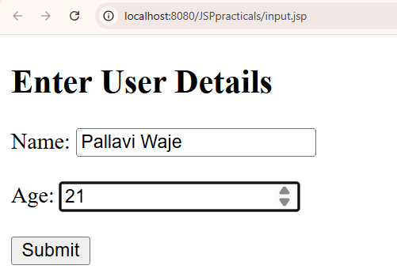
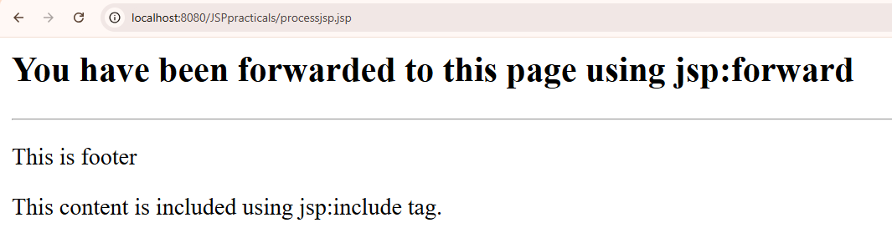
JSP directives
Main.jsp
<%@ page language="java" contentType="text/html; charset=UTF-8"
pageEncoding="UTF-8"%>
<!DOCTYPE html>
<html>
<head>
<meta charset="UTF-8">
<title>Insert title here</title>
</head>
<body>

<h3>JSP Directives Demonstration</h3>
<h4>Types of JSP Directives:</h4>

<ul>
<li><b>Page Directive</b> – used for page settings.</li>
<li><b>Include Directive</b> – used to include another jsp file.</li>
<li><b>Taglib Directive</b> – Used to include custom/JSTL tag libraries (not used in this example).</li>
</ul>

<!-- Include footer -->
<%@ include file="footer1.jsp" %>

</body>
</html>

header.jsp
<!-- header.jsp -->
<h2>Welcome to JSP Directives Example</h2>
<hr>

Footer1.jsp
<hr>
<footer>
<p>This is footer</p>
<p>This content is included using jsp:include tag.</p>
</footer>

Output:
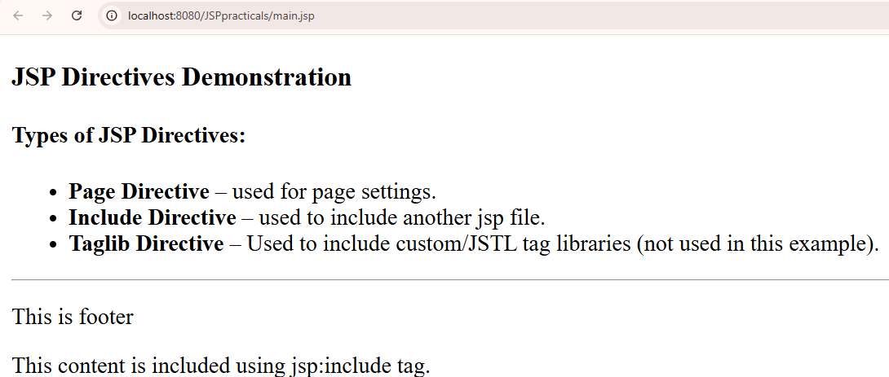
Session Tracking using Cookies

Code:

Index.jsp

<%@ page language="java" contentType="text/html; charset=UTF-8" pageEncoding="UTF-8"%>
<html>
<body>
<h2>Login Page</h2>
<form action="welcome.jsp" method="get">
Enter Name: <input type="text" name="uname">
<input type="submit" value="Login">
</form>
</body>
</html>

Welcome.jsp

<%@ page language="java" contentType="text/html; charset=UTF-8" pageEncoding="UTF-8"%>
<%@ page import="jakarta.servlet.http.Cookie" %>
<%
String name = request.getParameter("uname");
if (name != null && !name.isEmpty()) {
Cookie c = new Cookie("username", name);
c.setMaxAge(60*60); // 1 hour
response.addCookie(c);
}
%>
<html>
<body>
<h2>Welcome Page</h2>
<p>Welcome, <%= (name != null ? name : "Guest") %>!</p>
<a href="dashboard.jsp">Go to Dashboard</a>
</body>
</html>

Dashboard.jsp

<%@ page language="java" contentType="text/html; charset=UTF-8" pageEncoding="UTF-8"%>
<%@ page import="jakarta.servlet.http.Cookie" %>
<%
Cookie[] cookies = request.getCookies();
String user = "Guest";

if (cookies != null) {
for (Cookie ck : cookies) {
if ("username".equals(ck.getName())) {
user = ck.getValue();
break;
}
}
}
%>
<html>
<body>
<h2>Dashboard</h2>
<p>User from Cookie: <%= user %></p>
<a href="login.jsp">Back to Login</a>
</body>
</html>

Output:
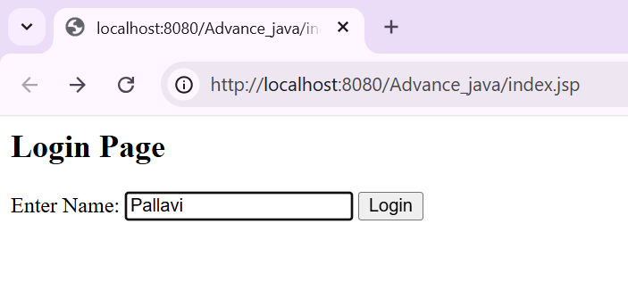
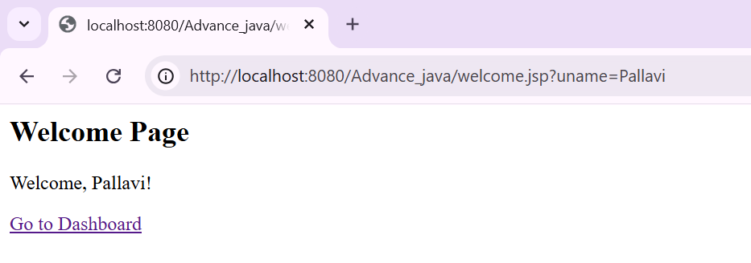

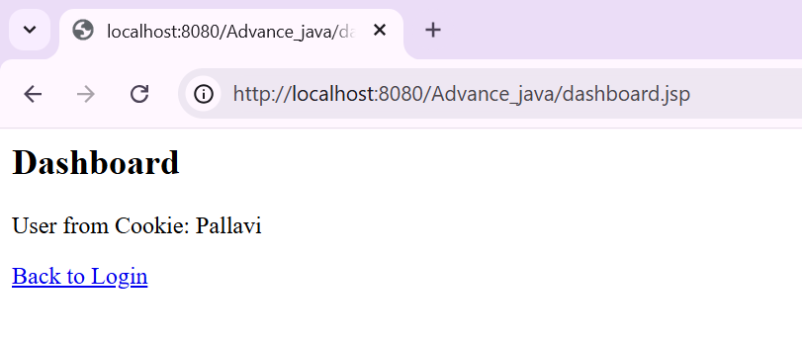
demonstrate JSTL Tags.
Code:
jstlDemo.jsp:
<%@ page contentType="text/html;charset=UTF-8" %>
<%@ taglib uri="http://java.sun.com/jsp/jstl/core" prefix="c" %>

<html>
<body>
<c:set var="name" value="Pallavi" />
Name: <c:out value="${name}" />
</body>
</html>

Create a Telephone directory using JSP and store all the information within a database, so that later could be retrieved as per the requirement. Make your own assumptions.

Create database in MySQL Workbench:
CREATE DATABASE telephonedb;
USE telephonedb;

CREATE TABLE contacts (
id INT AUTO_INCREMENT PRIMARY KEY,
name VARCHAR(50),
phone VARCHAR(15),
email VARCHAR(50)
);
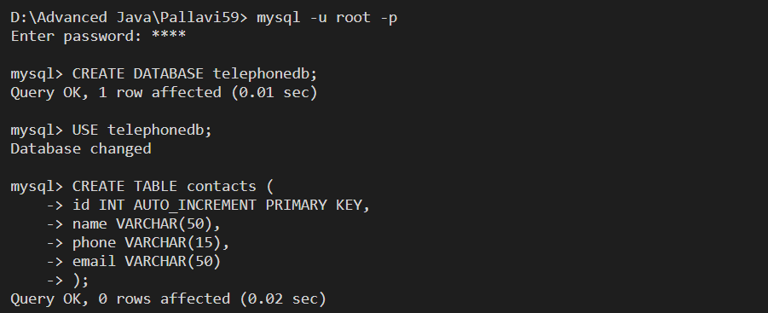
addContact.jsp
<html>
<head>
<title>Add Contact</title>
</head>
<body>
<h2>Add Telephone Contact</h2>
<form action="saveContact.jsp" method="post">
Name: <input type="text" name="name"><br><br>
Phone: <input type="text" name="phone"><br><br>
Email: <input type="text" name="email"><br><br>
<input type="submit" value="Save">
</form>
<br>
<a href="viewContacts.jsp">View Contacts</a>
</body>
</html>

saveContact.jsp
<%@ page import="java.sql.*" %>
<%
String name = request.getParameter("name");
String phone = request.getParameter("phone");
String email = request.getParameter("email");

Class.forName("com.mysql.cj.jdbc.Driver");
Connection con = DriverManager.getConnection(
"jdbc:mysql://localhost:3306/telephonedb", "root", "password");

PreparedStatement ps = con.prepareStatement(
"INSERT INTO contacts(name, phone, email) VALUES(?,?,?)");

ps.setString(1, name);
ps.setString(2, phone);
ps.setString(3, email);
ps.executeUpdate();
con.close();
%>
<h3>Contact Saved Successfully!</h3>
<a href="addContact.jsp">Add Another Contact</a><br>
<a href="viewContacts.jsp">View Contacts</a>

viewContacts.jsp
<%@ page import="java.sql.*" %>
<html>
<head>
<title>View Contacts</title>
</head>
<body>
<h2>Telephone Directory</h2>
<table border="1">
<tr>
<th>Name</th>
<th>Phone</th>
<th>Email</th>
</tr>
<%
Class.forName("com.mysql.cj.jdbc.Driver");
Connection con = DriverManager.getConnection(
"jdbc:mysql://localhost:3306/telephonedb", "root", "password");

Statement st = con.createStatement();
ResultSet rs = st.executeQuery("SELECT * FROM contacts");

while(rs.next()) {
%>
<tr>
<td><%= rs.getString("name") %></td>
<td><%= rs.getString("phone") %></td>
<td><%= rs.getString("email") %></td>
</tr>
<%
}
con.close();
%>
</table>
<br>
<a href="addContact.jsp">Add New Contact</a>
</body>
</html>
Output:
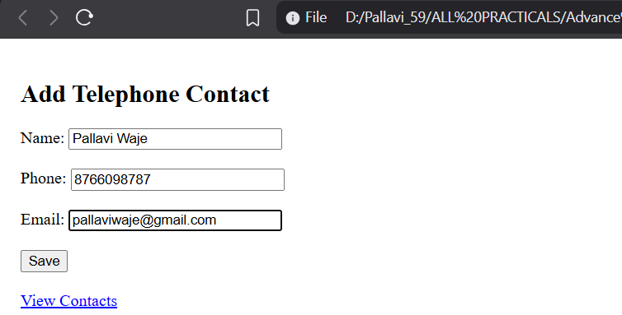
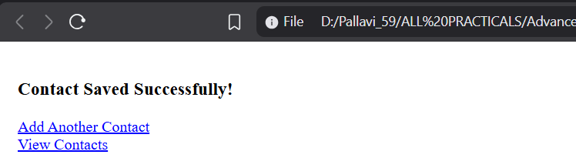

Practical 7: Assignment based Spring Framework

1. Write a program to print Singer Name and Age using spring framework.
Code:
Student.java
package in.sp.beans;
public class Student
{
private String name;
private int rollno;
private String emailid;

public String getName() {
return name;
}
public void setName(String name) {
this.name = name;
}
public int getRollno() {
return rollno;
}
public void setRollno(int rollno) {
this.rollno = rollno;
}
public String getEmailid() {
return emailid;
}
public void setEmailid(String emailid) {
this.emailid = emailid;
}
public void display()
{
System.out.println("Name : "+name);
System.out.println("Roll No : "+rollno);
System.out.println("Email Id : "+emailid);
}
}

applicationContext.xml
<?xml version="1.0" encoding="UTF-8"?>
<beans xmlns="http://www.springframework.org/schema/beans"
xmlns:xsi="http://www.w3.org/2001/XMLSchema-instance"
xsi:schemaLocation="
http://www.springframework.org/schema/beans http://www.springframework.org/schema/beans/spring-beans.xsd">

<bean class="in.sp.beans.Student" id="stdId">
<property name="name" value="Pallavi" />
<property name="rollno" value="59" />
<property name="emailid" value="pallavi@gmail.com" />
</bean>
</beans>

AppConfig.java
package in.sp.config;

import org.springframework.context.annotation.Bean;
import org.springframework.context.annotation.Configuration;

import in.sp.beans.Student;

@Configuration
public class AppConfig
{
@Bean
public Student stdId()
{
Student std = new Student();

std.setName("Pallavi");
std.setRollno(102);
std.setEmailid("pallavi@gmail.com");
return std;
}
}

MainApp.java

package in.sp.main;

import org.springframework.context.ApplicationContext;
import org.springframework.context.support.ClassPathXmlApplicationContext;
import in.sp.beans.Student;

public class MainApp
{
public static void main(String[] args)
{

//Spring container is created

ApplicationContext context = new ClassPathXmlApplicationContext("in/sp/resources/applicationContext.xml");

//Bean object is requested from Spring Container and stored in Student reference

Student stdBean = (Student) context.getBean("stdId");
stdBean.display();
}
}

Output:

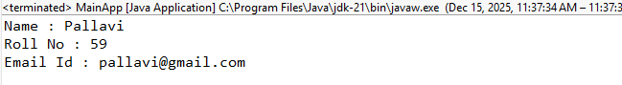
2. Write a program to demonstrate dependency injection via setter method.(Primitive)
Code:

Engine.java
package in.sp.beans;
import org.springframework.stereotype.Component;

@Component
public class Engine
{
public void start()
{
System.out.println("Engine started...");
}
}

Car.java

package in.sp.beans;
import org.springframework.stereotype.Component;

@Component
public class Car
{
private Engine engine; // Engine dependency

// Setter method for dependency injection
public void setEngine(Engine engine)
{
this.engine = engine;
}

public void drive()
{
engine.start();
System.out.println("Car is running...");
}
}
AppConfig.java

package in.sp.config;

import in.sp.beans.Car;
import in.sp.beans.Engine;
import org.springframework.context.annotation.Bean;
import org.springframework.context.annotation.ComponentScan;
import org.springframework.context.annotation.Configuration;

@Configuration
@ComponentScan(basePackages = "in.sp.beans")
public class AppConfig
{
@Bean
public Engine engine()
{
return new Engine(); // Manually creating the Engine bean
}

@Bean
public Car car()
{
Car car = new Car(); // Creating Car bean manually
car.setEngine(engine()); // Manually setting the Engine dependency through setter
return car;
}
}

MainApp.java

package in.sp.main;

import org.springframework.context.ApplicationContext;
import org.springframework.context.annotation.AnnotationConfigApplicationContext;

import in.sp.beans.Car;
import in.sp.config.AppConfig;

public class MainApp
{
public static void main(String[] args)
{
// Loading Spring context from annotations
ApplicationContext context = new AnnotationConfigApplicationContext(AppConfig.class);

Car car = context.getBean(Car.class);

car.drive();
}
}

Output:

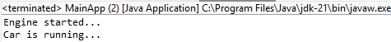

3. Write a program to demonstrate dependency injection via Constructor.(Primitive)
Code:
Engine.java

package in.sp.beans;
import org.springframework.stereotype.Component;

@Component
public class Engine
{
public void start()
{
System.out.println("Engine started...");
}
}

Car.java

package in.sp.beans;
import org.springframework.stereotype.Component;

@Component
public class Car
{
private Engine engine;

// Dependency Injection via Constructor
public Car(Engine engine)
{
this.engine = engine;
}

public void drive()
{
engine.start();
System.out.println("Car is running...");
}
}

AppConfig.java

package in.sp.config;
import in.sp.beans.Car;
import in.sp.beans.Engine;
import org.springframework.context.annotation.Bean;
import org.springframework.context.annotation.ComponentScan;
import org.springframework.context.annotation.Configuration;

@Configuration
@ComponentScan(basePackages = "in.sp.beans")
public class AppConfig
{
@Bean
public Engine engine()
{
return new Engine(); // Manually creating the Engine bean
}
@Bean
public Car car()
{
return new Car(engine()); // Manually injecting the Engine bean into Car
}
}

MainApp.java

package in.sp.main;
import org.springframework.context.ApplicationContext;
import org.springframework.context.annotation.AnnotationConfigApplicationContext;
import in.sp.beans.Car;
import in.sp.config.AppConfig;

public class MainApp
{
public static void main(String[] args)
{
// Loading Spring context from annotations
ApplicationContext context = new AnnotationConfigApplicationContext(AppConfig.class);
Car car = context.getBean(Car.class);
car.drive();
}
}
Output:
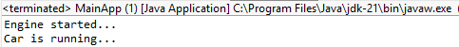
4. Write a program to demonstrate dependency injection via setter method.(Non Primitive)
Code:

Engine.java
package in.sp.beans;

public class Engine
{
public void start()
{
System.out.println("Engine started...");
}
}

Car.java
package in.sp.beans;

public class Car
{
private Engine engine;

// Dependency Injection via Setter Method
public void setEngine(Engine engine)
{
this.engine = engine;
}

public void drive()
{
engine.start();
System.out.println("Car is running...");
}
}

applicationContext.java
<?xml version="1.0" encoding="UTF-8"?>
<beans xmlns="http://www.springframework.org/schema/beans"
xmlns:xsi="http://www.w3.org/2001/XMLSchema-instance"
xsi:schemaLocation="http://www.springframework.org/schema/beans
http://www.springframework.org/schema/beans/spring-beans.xsd">

<!-- Engine bean -->
<bean id="engine" class="in.sp.beans.Engine" />

<!-- Car bean with setter injection for Engine -->
<bean id="car" class="in.sp.beans.Car">
<property name="engine" ref="engine" />
</bean>
</beans>

MainApp.java
package in.sp.main;

import org.springframework.context.ApplicationContext;
import org.springframework.context.support.ClassPathXmlApplicationContext;
import in.sp.beans.Car;

public class MainApp
{
public static void main(String[] args)
{
// Loading Spring context from XML configuration

ApplicationContext context = new ClassPathXmlApplicationContext("in/sp/resources/applicationContext.xml");

Car car = context.getBean(Car.class);
car.drive();
}
}

Output:

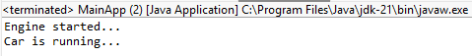

5.Write a program to demonstrate dependency injection via Constructor.(Non Primitive)By Ref
Code:

Engine.java
package in.sp.beans;
public class Engine
{
public void start()
{
System.out.println("Engine started...");
}
}

Car.java
package in.sp.beans;
public class Car
{
private final Engine engine;

// Dependency Injection via Constructor
public Car(Engine engine)
{
this.engine = engine;
}

public void drive()
{
engine.start();
System.out.println("Car is running...");
}
}

applicationContext.xml
<?xml version="1.0" encoding="UTF-8"?>
<beans xmlns="http://www.springframework.org/schema/beans"
xmlns:xsi="http://www.w3.org/2001/XMLSchema-instance"
xsi:schemaLocation="http://www.springframework.org/schema/beans
http://www.springframework.org/schema/beans/spring-beans.xsd">

<!-- Engine bean -->
<bean id="engine" class="in.sp.beans.Engine" />

<!-- Car bean with constructor injection for Engine -->
<bean id="car" class="in.sp.beans.Car">
<constructor-arg ref="engine" />
</bean>
</beans>

Output:
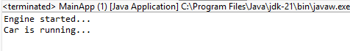

6. Write a program to demonstrate dependency injection via Constructor. (Collection)
Code:
Engine.java

package in.sp.beans;
public class Engine
{
private String name;
public Engine(String name)
{
this.name = name;
}
public void start()
{
System.out.println(name + " engine started...");
}
}

Car.java

package in.sp.beans;

import java.util.List;

public class Car
{
private List<Engine> engines;

// Constructor Injection (Collection)
public Car(List<Engine> engines)
{
this.engines = engines;
}
public void drive()
{
for(Engine e : engines)
{
e.start();
}
System.out.println("Car is running...");
}
}

applicationcontext.xml

<?xml version="1.0" encoding="UTF-8"?>
<beans xmlns="http://www.springframework.org/schema/beans"
xmlns:xsi="http://www.w3.org/2001/XMLSchema-instance"
xsi:schemaLocation="http://www.springframework.org/schema/beans
http://www.springframework.org/schema/beans/spring-beans.xsd">

<!-- Engine beans -->
<bean id="engine1" class="in.sp.beans.Engine">
<constructor-arg value="Petrol"/>
</bean>

<bean id="engine2" class="in.sp.beans.Engine">
<constructor-arg value="Diesel"/>
</bean>

<!-- Car bean with constructor injection (Collection) -->
<bean id="car" class="in.sp.beans.Car">
<constructor-arg>
<list>
<ref bean="engine1"/>
<ref bean="engine2"/>
</list>
</constructor-arg>
</bean>
</beans>

Test.java

package in.sp.test;

import org.springframework.context.ApplicationContext;
import org.springframework.context.support.ClassPathXmlApplicationContext;
import in.sp.beans.Car;

public class Test
{
public static void main(String[] args)
{
ApplicationContext context =
new ClassPathXmlApplicationContext("applicationContext.xml");

Car car = context.getBean("car", Car.class);
car.drive();
}
}

Output:

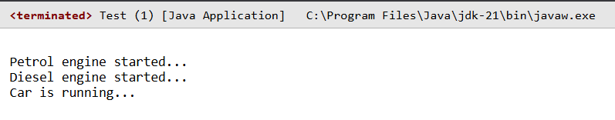

7.Write a program to demonstrate Autowiring
Code:

No (constructor)
Engine.java

package in.sp.beans;
public class Engine
{
public void start()
{
System.out.println("Engine started...");
}
}

Car.java

package in.sp.beans;
public class Car
{
private Engine engine;

// Constructor for dependency injection
public Car(Engine engine)
{
this.engine = engine;
}

public void drive()
{
engine.start();
System.out.println("Car is running...");
}
}

applicationContext.java

<?xml version="1.0" encoding="UTF-8"?>
<beans xmlns="http://www.springframework.org/schema/beans"
xmlns:xsi="http://www.w3.org/2001/XMLSchema-instance"
xsi:schemaLocation="
http://www.springframework.org/schema/beans http://www.springframework.org/schema/beans/spring-beans.xsd">

<!-- Define Engine bean -->
<bean id="engine" class="in.sp.beans.Engine" />

<!-- Define Car bean with constructor-based dependency injection -->
<bean id="car" class="in.sp.beans.Car">
<constructor-arg ref="engine" />
</bean>
</beans>

MainApp.java
package in.sp.main;
import org.springframework.context.ApplicationContext;
import org.springframework.context.support.ClassPathXmlApplicationContext;
import in.sp.beans.Car;

public class MainApp
{
public static void main(String[] args)
{
// Load Spring context from XML configuration
ApplicationContext context = new ClassPathXmlApplicationContext("in/sp/resources/applicationContext.xml");

// Retrieve the Car bean
Car car = context.getBean(Car.class);

// Call the drive method
car.drive();
}
}

Output:
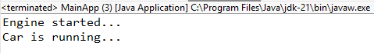

Practical 8: Assignment based Aspect Oriented Programming
1. Write a program to demonstrate Spring AOP – before advice.
Code:
Pom.xml

<projectxmlns="http://maven.apache.org/POM/4.0.0"xmlns:xsi="http://www.w3.org/2001/XMLSchema- instance"xsi:schemaLocation="http://maven.apache.org/POM/4.0.0http://maven.apache.org/xsd/maven-4.0.0.xsd">
<modelVersion>4.0.0</modelVersion>
<groupId>com.springMca</groupId>
<artifactId>springMca</artifactId>
<version>0.0.1-SNAPSHOT</version>
<packaging>jar</packaging>
<name>springMca</name>
<url>http://maven.apache.org</url>

<properties>
<project.build.sourceEncoding>UTF-8</project.build.sourceEncoding>
</properties>
<dependencies>

<!--https://mvnrepository.com/artifact/org.springframework/spring-core-->
<dependency>
<groupId>org.springframework</groupId>
<artifactId>spring-core</artifactId>
<version>5.2.3.RELEASE</version>
</dependency>
<!--https://mvnrepository.com/artifact/org.springframework/spring-context-->
<dependency>
<groupId>org.springframework</groupId>
<artifactId>spring-context</artifactId>
<version>5.2.3.RELEASE</version>
</dependency>
<!--https://mvnrepository.com/artifact/org.springframework/spring-aop-->
<dependency>
<groupId>org.springframework</groupId>
<artifactId>spring-aop</artifactId>
<version>5.2.3.RELEASE</version>
</dependency>
<!--https://mvnrepository.com/artifact/org.aspectj/aspectjrt-->
<dependency>
<groupId>org.aspectj</groupId>
<artifactId>aspectjrt</artifactId>
<version>1.9.7</version>
</dependency>
<!--https://mvnrepository.com/artifact/org.aspectj/aspectjweaver-->
<dependency>
<groupId>org.aspectj</groupId>
<artifactId>aspectjweaver</artifactId>
<version>1.9.6</version>
</dependency>
<dependency>
<groupId>junit</groupId>
<artifactId>junit</artifactId>
<version>3.8.1</version>
<scope>test</scope>
</dependency>
</dependencies>
</project>

Interface.java

packageaop;
publicinterfaceGuitar{
publicvoidmakeSong();
}
TargetObject.java
Package aop;
publicclassbrookimplementsGuitar{
publicvoidmakeSong(){
System.out.println("Song Started"); System.out.println("Song Ended");
}
}

AspectClass.java

Package aop;
import org.aspectj.lang.annotation.After; import org.aspectj.lang.annotation.AfterReturning;import org.aspectj.lang.annotation.AfterThrowing; import org.aspectj.lang.annotation.Around; import org.aspectj.lang.annotation.Aspect; import org.aspectj.lang.annotation.Before;
@Aspect
publicclassmcaAspect{
@Before("execution(*brook.makeSong())")
publicvoidbeforeSong(){
System.out.println("YahooYahoo:IambeforeAspect");
}
}
ConfigurationClass.java

<?xmlversion="1.0"encoding="UTF-8"?>
<beans xmlns="http://www.springframework.org/schema/beans"xmlns:xsi="http://www.w3.org/2001/XMLSchema-instance"xmlns:context="http://www.springframework.org/schema/context"xmlns:aop="http://www.springframework.org/schema/aop
xsi:schemaLocation="http://www.springframework.org/schema/beanshttp://www.springframework.org/schema/beans/spring-beans.xsdhttp://www.springframework.org/schema/aophttp://www.springframework.org/schema/aop/spring-aop.xsd">
<aop:aspectj-autoproxy/>
<beanname="brook"class="aop.brook"/>
<beanname="mcaaspect"class="aop.mcaAspect"/>
</beans>

MainClass.java

Package aop;
import org.springframework.context.ApplicationContext;
import org.springframework.context.support.ClassPathXmlApplicationContext;

publicclassApp{
public static void main(String[] args) {
ApplicationContext context= new ClassPathXmlApplicationContext("aop/aopConfig.xml"); Guitar temp = (Guitar) context.getBean("brook"); temp.makeSong();
}
}
Output:
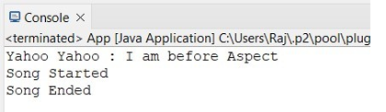

2. Write a program to demonstrate Spring AOP – after advice.
Code:
StudentService.java

package in.sp.service;

public class StudentService
{
public void registerStudent()
{
System.out.println("Student registration completed.");
}
}

AfterAdvice.java

package in.sp.aspect;

public class AfterAdvice
{
public void afterMethod()
{
System.out.println("After Advice: Method execution finished.");
System.out.println("Pallavi Waje : 59");

}
}

applicationContext.xml

<?xml version="1.0" encoding="UTF-8"?>
<beans xmlns="http://www.springframework.org/schema/beans"
xmlns:aop="http://www.springframework.org/schema/aop"
xmlns:xsi="http://www.w3.org/2001/XMLSchema-instance"
xsi:schemaLocation="
http://www.springframework.org/schema/beans
http://www.springframework.org/schema/beans/spring-beans.xsd
http://www.springframework.org/schema/aop
http://www.springframework.org/schema/aop/spring-aop.xsd">

<!-- Target class -->
<bean id="studentService" class="in.sp.service.StudentService"/>

<!-- Aspect class -->
<bean id="afterAdvice" class="in.sp.aspect.AfterAdvice"/>

<!-- AOP Configuration -->
<aop:config>
<aop:aspect ref="afterAdvice">
<aop:after method="afterMethod"
pointcut="execution(* in.sp.service.StudentService.registerStudent(..))"/>
</aop:aspect>
</aop:config>
</beans>

MainApp.java
package in.sp.main;
import org.springframework.context.ApplicationContext;
import org.springframework.context.support.ClassPathXmlApplicationContext;
import in.sp.service.StudentService;
public class MainApp
{
public static void main(String[] args)
{
ApplicationContext context =
new ClassPathXmlApplicationContext("applicationContext.xml");
StudentService service = context.getBean("studentService", StudentService.class);
service.registerStudent()
}
}
Output:
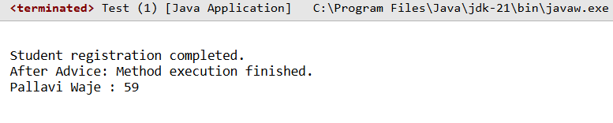

3. Write a program to demonstrate Spring AOP – around advice.
Code:
StudentService.java
package in.sp.service;

public class StudentService
{
public void registerStudent()
{
System.out.println("Pallavi Waje 59");
}
}

AroundAdvice.java
package in.sp.aspect;

import org.aopalliance.intercept.MethodInterceptor;
import org.aopalliance.intercept.MethodInvocation;

public class AroundAdvice implements MethodInterceptor
{
@Override
public Object invoke(MethodInvocation invocation) throws Throwable
{
System.out.println("Around Advice: Before method execution");

Object result = invocation.proceed(); // call target method

System.out.println("Around Advice: After method execution");

return result;
}
}

applicationContext.xml
<?xml version="1.0" encoding="UTF-8"?>
<beans xmlns="http://www.springframework.org/schema/beans"
xmlns:xsi="http://www.w3.org/2001/XMLSchema-instance"
xsi:schemaLocation="
http://www.springframework.org/schema/beans
http://www.springframework.org/schema/beans/spring-beans.xsd">

<!-- Target class -->
<bean id="studentService" class="in.sp.service.StudentService"/>

<!-- Around Advice -->
<bean id="aroundAdvice" class="in.sp.aspect.AroundAdvice"/>

<!-- Proxy Factory -->
<bean id="proxy" class="org.springframework.aop.framework.ProxyFactoryBean">
<property name="target" ref="studentService"/>
<property name="interceptorNames">
<list>
<value>aroundAdvice</value>
</list>
</property>
</bean>
</beans>

MainApp.java
package in.sp.main;

import org.springframework.context.ApplicationContext;
import org.springframework.context.support.ClassPathXmlApplicationContext;

public class MainApp
{
public static void main(String[] args)
{
ApplicationContext context =
new ClassPathXmlApplicationContext("applicationContext.xml");

Object obj = context.getBean("proxy");
in.sp.service.StudentService service =
(in.sp.service.StudentService) obj;

service.registerStudent();
}
}

Output:
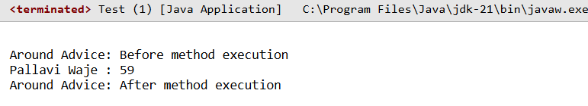

4. Write a program to demonstrate Spring AOP – after returning advice.

Code:
StudentService.java
package in.sp.service;

public class StudentService
{
public String getStudentName()
{
System.out.println("Fetching student name...");
return "Pallavi Waje 59";
}
}

AfterReturningAdvice.java
package in.sp.aspect;

public class AfterReturningAdvice
{
public void afterReturningMethod(Object returnValue)
{
System.out.println("After Returning Advice: Method returned -> " + returnValue);
}
}

applicationContext.xml
<?xml version="1.0" encoding="UTF-8"?>
<beans xmlns="http://www.springframework.org/schema/beans"
xmlns:aop="http://www.springframework.org/schema/aop"
xmlns:xsi="http://www.w3.org/2001/XMLSchema-instance"
xsi:schemaLocation="
http://www.springframework.org/schema/beans
http://www.springframework.org/schema/beans/spring-beans.xsd
http://www.springframework.org/schema/aop
http://www.springframework.org/schema/aop/spring-aop.xsd">

<!-- Target bean -->
<bean id="studentService" class="in.sp.service.StudentService"/>

<!-- Aspect bean -->
<bean id="afterReturningAdvice" class="in.sp.aspect.AfterReturningAdvice"/>

<!-- AOP Configuration -->
<aop:config>
<aop:aspect ref="afterReturningAdvice">
<aop:after-returning
method="afterReturningMethod"
pointcut="execution(* in.sp.service.StudentService.getStudentName(..))"
returning="returnValue"/>
</aop:aspect>
</aop:config>
</beans>

MainApp.java
package in.sp.main;

import org.springframework.context.ApplicationContext;
import org.springframework.context.support.ClassPathXmlApplicationContext;
import in.sp.service.StudentService;

public class MainApp
{
public static void main(String[] args)
{
ApplicationContext context =
new ClassPathXmlApplicationContext("applicationContext.xml");

StudentService service =
context.getBean("studentService", StudentService.class);
service.getStudentName();
}
}

Output:
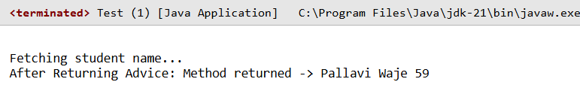
5. Write a program to demonstrate Spring AOP – after throwing advice.
Code:
StudentService.java
package in.sp.service;

public class StudentService
{
public void processStudent()
{
System.out.println("Processing student...");
int x = 10 / 0; // Exception occurs
}
}

AfterThrowingAdvice.java
package in.sp.aspect;

public class AfterThrowingAdvice
{
public void afterThrowingMethod(Exception ex)
{
System.out.println("After Throwing Advice: Exception occurred -> " + ex);
}
}

applicationContext.xml
<?xml version="1.0" encoding="UTF-8"?>
<beans xmlns="http://www.springframework.org/schema/beans"
xmlns:aop="http://www.springframework.org/schema/aop"
xmlns:xsi="http://www.w3.org/2001/XMLSchema-instance"
xsi:schemaLocation="
http://www.springframework.org/schema/beans
http://www.springframework.org/schema/beans/spring-beans.xsd
http://www.springframework.org/schema/aop
http://www.springframework.org/schema/aop/spring-aop.xsd">

<!-- Target bean -->
<bean id="studentService" class="in.sp.service.StudentService"/>

<!-- Aspect bean -->
<bean id="afterThrowingAdvice" class="in.sp.aspect.AfterThrowingAdvice"/>

<!-- AOP Configuration -->
<aop:config>
<aop:aspect ref="afterThrowingAdvice">
<aop:after-throwing
method="afterThrowingMethod"
pointcut="execution(* in.sp.service.StudentService.processStudent(..))"
throwing="ex"/>
</aop:aspect>
</aop:config>
</beans>

MainApp.java
package in.sp.main;

import org.springframework.context.ApplicationContext;
import org.springframework.context.support.ClassPathXmlApplicationContext;
import in.sp.service.StudentService;

public class MainApp
{
public static void main(String[] args)
{
ApplicationContext context =
new ClassPathXmlApplicationContext("applicationContext.xml");

StudentService service =
context.getBean("studentService", StudentService.class);
service.processStudent();
}
}

Output:
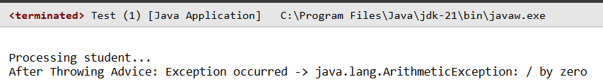

6. Write a program to demonstrate Spring AOP – pointcuts.
Code:
StudentService.java
package in.sp.service;

public class StudentService
{
public void addStudent()
{
System.out.println("Student added.");
}
public void deleteStudent()
{
System.out.println("Student deleted.");
}
}

LoggingAspect.java
package in.sp.aspect;
public class LoggingAspect
{
public void logMethod()
{
System.out.println("Pointcut matched: Logging executed.");
}
}

applicationContext.xml
<?xml version="1.0" encoding="UTF-8"?>
<beans xmlns="http://www.springframework.org/schema/beans"
xmlns:aop="http://www.springframework.org/schema/aop"
xmlns:xsi="http://www.w3.org/2001/XMLSchema-instance"
xsi:schemaLocation="
http://www.springframework.org/schema/beans
http://www.springframework.org/schema/beans/spring-beans.xsd
http://www.springframework.org/schema/aop
http://www.springframework.org/schema/aop/spring-aop.xsd">

<!-- Target bean -->
<bean id="studentService" class="in.sp.service.StudentService"/>

<!-- Aspect bean -->
<bean id="loggingAspect" class="in.sp.aspect.LoggingAspect"/>

<!-- AOP Configuration -->
<aop:config>

<!-- Pointcut definition -->
<aop:pointcut id="studentMethods"
expression="execution(* in.sp.service.StudentService.*(..))"/>

<!-- Advice using pointcut -->
<aop:aspect ref="loggingAspect">
<aop:before method="logMethod" pointcut-ref="studentMethods"/>
</aop:aspect>
</aop:config>
</beans>

MainApp.java
package in.sp.main;

import org.springframework.context.ApplicationContext;
import org.springframework.context.support.ClassPathXmlApplicationContext;
import in.sp.service.StudentService;

public class MainApp
{
public static void main(String[] args)
{
ApplicationContext context =
new ClassPathXmlApplicationContext("applicationContext.xml");

StudentService service =
context.getBean("studentService", StudentService.class);

service.addStudent();
service.deleteStudent();
}
}
Output:
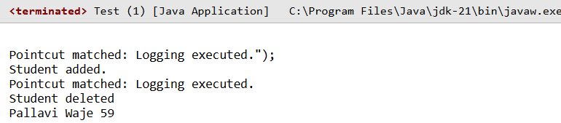

Practical 9: Assignment based Spring JDBC

1. Write a program to insert, update and delete records from the given table.
Create a table:
CREATE TABLE student (
id INT PRIMARY KEY,
name VARCHAR(50),
marks INT
);
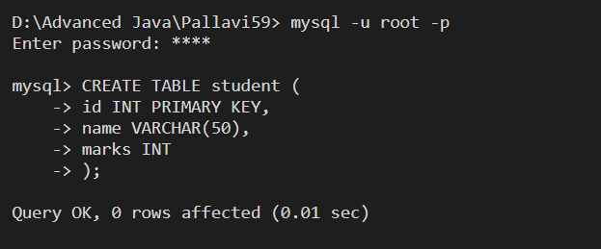
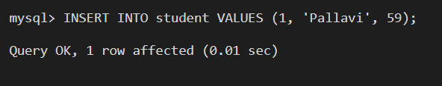
StudentCrud.java
import java.sql.*;

public class StudentCRUD
{
public static void main(String[] args)
{
try
{
// Load driver
Class.forName("com.mysql.cj.jdbc.Driver");

// Create connection
Connection con = DriverManager.getConnection(
"jdbc:mysql://localhost:3306/testdb",
"root",
"root"
);

Statement stmt = con.createStatement();

// INSERT record
String insertQuery =
"INSERT INTO student VALUES (1, 'Pallavi', 59)";
stmt.executeUpdate(insertQuery);
System.out.println("Record inserted");

// UPDATE record
String updateQuery =
"UPDATE student SET marks=65 WHERE id=1";
stmt.executeUpdate(updateQuery);
System.out.println("Record updated");

// DELETE record
String deleteQuery =
"DELETE FROM student WHERE id=1";
stmt.executeUpdate(deleteQuery);
System.out.println("Record deleted");

// Close connection
con.close();
}
catch (Exception e)
{
System.out.println(e);
}
}
}

Output:
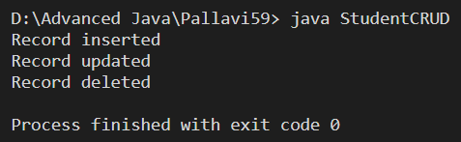
2. Write a program to demonstrate PreparedStatement in Spring JdbcTemplate
Create a database in mysql workbench:
CREATE TABLE student (
id INT,
name VARCHAR(50),
marks INT
);
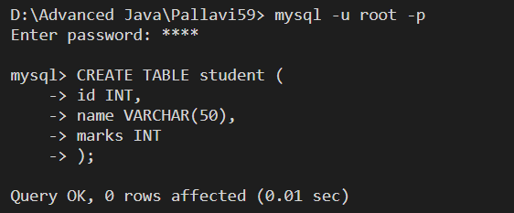
StudentDao.java
package in.sp.dao;
import java.sql.PreparedStatement;
import java.sql.SQLException;
import org.springframework.jdbc.core.JdbcTemplate;
import org.springframework.jdbc.core.PreparedStatementSetter;

public class StudentDao
{
private JdbcTemplate jdbcTemplate;

public void setJdbcTemplate(JdbcTemplate jdbcTemplate)
{
this.jdbcTemplate = jdbcTemplate;
}

public int insertStudent(final int id, final String name, final int marks)
{
String sql = "INSERT INTO student VALUES (?, ?, ?)";

return jdbcTemplate.update(sql, new PreparedStatementSetter()
{
public void setValues(PreparedStatement ps) throws SQLException
{
ps.setInt(1, id);
ps.setString(2, name);
ps.setInt(3, marks);
}
});
}
}

Applicatoncontext.xml
<?xml version="1.0" encoding="UTF-8"?>
<beans xmlns="http://www.springframework.org/schema/beans"
xmlns:xsi="http://www.w3.org/2001/XMLSchema-instance"
xsi:schemaLocation="
http://www.springframework.org/schema/beans
http://www.springframework.org/schema/beans/spring-beans.xsd">

<!-- DataSource -->
<bean id="dataSource"
class="org.springframework.jdbc.datasource.DriverManagerDataSource">
<property name="driverClassName" value="com.mysql.cj.jdbc.Driver"/>
<property name="url" value="jdbc:mysql://localhost:3306/testdb"/>
<property name="username" value="root"/>
<property name="password" value="root"/>
</bean>

<!-- JdbcTemplate -->
<bean id="jdbcTemplate"
class="org.springframework.jdbc.core.JdbcTemplate">
<property name="dataSource" ref="dataSource"/>
</bean>

<!-- DAO -->
<bean id="studentDao" class="in.sp.dao.StudentDao">
<property name="jdbcTemplate" ref="jdbcTemplate"/>
</bean>
</beans>

MainApp.java
package in.sp.main;

import org.springframework.context.ApplicationContext;
import org.springframework.context.support.ClassPathXmlApplicationContext;
import in.sp.dao.StudentDao;

public class MainApp
{
public static void main(String[] args)
{
ApplicationContext context =
new ClassPathXmlApplicationContext("applicationContext.xml");

StudentDao dao = context.getBean("studentDao", StudentDao.class);

int result = dao.insertStudent(1, "Pallavi", 59);

if(result > 0)
System.out.println("Record inserted successfully");
}
}
Output:
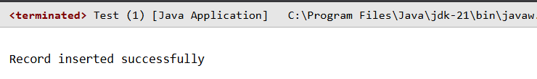
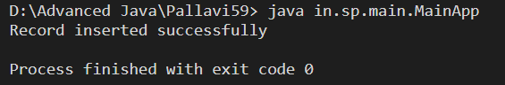
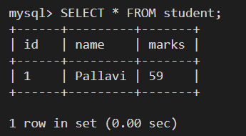

Practical 10: Assignment based Spring Boot and RESTful Web Services

1. Write a program to create a simple Spring Boot application that prints a message.

SpringbootwebApplication.java
Package com.example.springbootweb;
import org.springframework.boot.SpringApplication;
import org.springframework.boot.autoconfigure.SpringBootApplication;

@SpringBootApplication
public class SpringbootwebApplication {

public static void main(String[] args) {
SpringApplication.run(SpringbootwebApplication.class, args);
}
}

HelloController.java
package com.example.springbootweb;
import org.springframework.web.bind.annotation.GetMapping;
import org.springframework.web.bind.annotation.RestController;

@RestController
public class HelloController {
@GetMapping("/hello")
public String hello() {
return "Pallavi Waje 59";
}
}
Output:

