1. **Java Program to Add two Numbers.**

**Code :**

import java.util.Scanner;

class Add

{

    public static void main(String args[])

    {

        Scanner sc = new Scanner(System.in);

        System.out.println("enter the a : ");

        int a= sc.nextInt();

        System.out.println("entre the b : ");

        int b = sc.nextInt();

        int add;

        add=a+b;

        System.out.println("Addition of a and b is :"+add);

    }

}

**Output :**

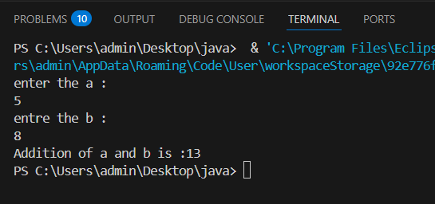

1. **Java Program to Subtract two Numbers.**

**Code :**

import java.util.Scanner;

class Sub

{

    public static void main(String args[])

    {

        Scanner sc = new Scanner(System.in);

        System.out.println("enter the a : ");

        float a= sc.nextFloat();

        System.out.println("entre the b : ");

        float b = sc.nextFloat();

        float sub;

        sub=a-b;

        System.out.println("Substraction of a and b is :"+sub);

    }

}

**Output :**

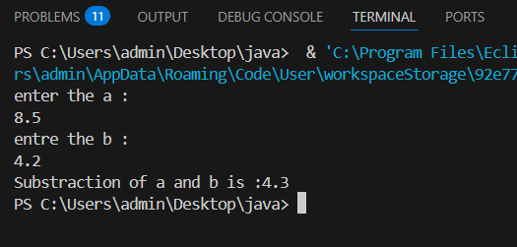

1. **Java Program to Multiply two Numbers**

**Code :**

import java.util.Scanner;

class Mul

{

    public static void main(String args[])

    {

        Scanner sc = new Scanner(System.in);

        System.out.println("enter the a : ");

        double a= sc.nextDouble();

        System.out.println("entre the b : ");

        double b = sc.nextDouble();

        double mul;

        mul=a*b;

        System.out.println("Multiplication of a and b is :"+mul);

    }

}

**Output :**

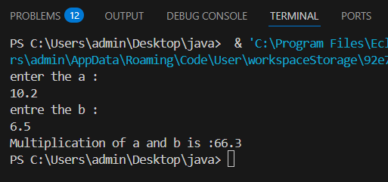

1. **Java Program to Check Whether a Number is Even or Odd.**

**Code :**

import java.util.Scanner;

class Evodd

{

    public static void main(String args[])

    {

        Scanner sc = new Scanner(System.in);

        System.out.println("enter the a : ");

        int a= sc.nextInt();

        if(a%2==0)

        {

            System.out.println(" it is even ");

        }

        else

        {

            System.out.println("it is odd ");

        }

    }

}

**Output :**

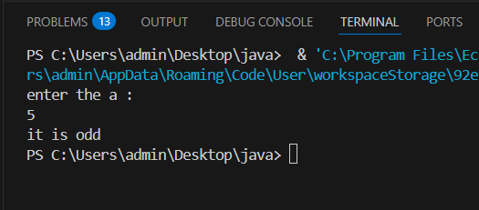

1. **Check whether a character is a Vowel or Consonant.**

**Code :**

import java.util.Scanner;

class Vowel

{

    public static void main(String args[])

    {

        Scanner sc = new Scanner(System.in);

        System.out.println("enter the a letter : ");

        char ch = sc.next().charAt(0);

        if(ch == 'A' || ch == 'E' || ch == 'I' || ch == 'O' || ch == 'U')

        {

            System.out.println(" it is vowel(upper case) ");

        }

        else if(ch == 'a' || ch == 'e' || ch == 'i' || ch == 'o' || ch == 'u')

        {

              System.out.println(" it is vowel(lower case) ");

        }

        else

        {

            System.out.println("it is consonant");

        }

    }

}

**Output :**

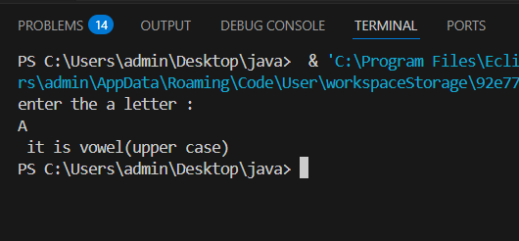

1. **Java Program to find Average of Two Numbers**

**Code :**

import java.util.Scanner;

class Average

{

    public static void main(String args[])

    {

        Scanner sc = new Scanner(System.in);

        System.out.println("enter the a : ");

        int a= sc.nextInt();

        System.out.println("entre the b : ");

        int b = sc.nextInt();

        int average = (a+b)/2;

        System.out.println("total average is :"+average);

    }

}

**Output :**

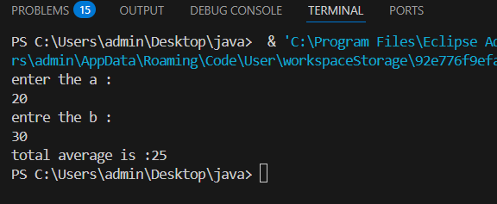

1. **Java Program to find Average of Three Numbers**

**Code :**

import java.util.Scanner;

class Average

{

    public static void main(String args[])

    {

        Scanner sc = new Scanner(System.in);

        System.out.println("enter the a : ");

        int a= sc.nextInt();

        System.out.println("entre the b : ");

        int b = sc.nextInt();

        System.out.println("entre the c : ");

        int c = sc.nextInt();

        int average = (a+b+c)/2;

        System.out.println("total average is :"+average);

    }

}

**Output :**

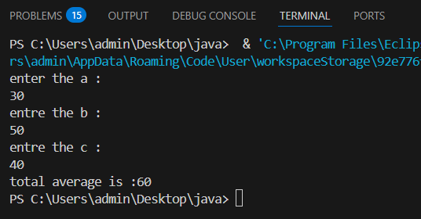

1. **Java Program to find the Area of Square**

**Code :**

import java.util.Scanner;

class Square

{

    public static void main(String args[])

    {

        Scanner sc = new Scanner(System.in);

        System.out.println("enter the side : ");

        int side = sc.nextInt();

        int area;

        area=side*side;

        System.out.println("area of square is  :"+area);

    }

}

**Output :**

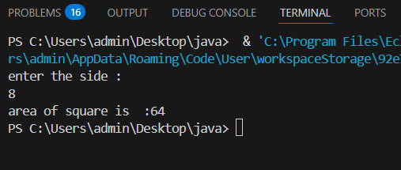

1. **Java Program to Calculate Simple Interest**

**Code :**

import java.util.Scanner;

class Sinterest

{

    public static void main(String args[])

    {

        Scanner sc = new Scanner(System.in);

        System.out.println("enter the principal : ");

        int principal = sc.nextInt();

        System.out.println("enter the rate : ");

        int rate = sc.nextInt();

        System.out.println("enter the time : ");

        int time = sc.nextInt();

        int simple_interest=(principal*rate*time)/100;

        System.out.println("simple_interest is :"+simple_interest);

    }

}

**Output :**

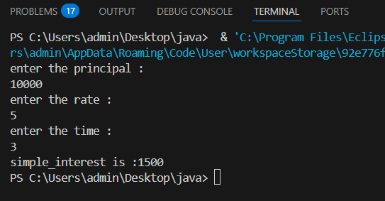

**10.Java Program to Calculate Compound Interest**

**Code :**

import java.util.Scanner;

class Cinterest

{

    public static void main(String args[])

    {

        Scanner sc = new Scanner(System.in);

        System.out.println("enter the principal : ");

        double principal = sc.nextDouble();

        System.out.println("enter the rate : ");

        double rate = sc.nextDouble();

        System.out.println("enter the time : ");

        double time = sc.nextDouble();

        double compound_interest=principal * (Math.pow((1 + rate / 100), time) - 1);

        System.out.println("compound_interest is :"+compound_interest);

    }

}

**Output :**

