Implementation of SDRAM Controller on FPGA
Name: Pallavi Naidu
Professor: Prof. A.K. Swain
Institute: National Institute of Technology Rourkela
Tool Used: Vivado 2018.2

Simulation Results and Logic Summary
The SDRAM controller is implemented using a finite state machine (FSM) that performs SDRAM initialization, burst write, burst read, refresh, and precharge operations. The controller first initializes the SDRAM by applying precharge and refresh commands followed by loading the mode register. After initialization, the controller enters the idle state and waits for read or write requests.
During burst write operation, deterministic data is generated using the relation f2s_data = f_addr + burst_index. The generated data is transferred through the bidirectional SDRAM data bus sdram_dq while the controller increments the write column counter. During burst read operation, the data received from SDRAM is compared with the expected value, and any mismatch increments the error counter.
The design also includes a debounce module for push-button inputs, a binary-to-BCD converter for displaying error counts, and an LED multiplexer for driving the seven-segment display. The SDRAM testbench contains an internal SDRAM memory model that emulates ACTIVATE, WRITE, READ, PRECHARGE, and burst operations.
Brief Description of Waveform Signals
- clk – Main FPGA clock signal that continuously toggles between 0 and 1.
- rst_n – Active-low reset signal.
  - 0 → controller reset active
  - 1 → normal operation
- key[2:0] – Push-button control inputs.
  - 0 → key pressed
  - 1 → key released
  - led[3:0] – Status indication outputs.
  - 0011 → successful write operation
  - 1111 → successful read operation
  - sdram_clk – Clock signal supplied to SDRAM.
  - sdram_cke – SDRAM clock-enable signal.
  - 1 → SDRAM enabled
  - 0 → SDRAM clock disabled
  - sdram_cs_n – SDRAM chip-select signal (active low).
  - 0 → SDRAM selected
  - 1 → SDRAM deselected
  - sdram_ras_n – Row-address strobe signal.
  - 0 → row command active
  - 1 → inactive
  - sdram_cas_n – Column-address strobe signal.
  - 0 → column operation active
  - 1 → inactive
  - sdram_we_n – Write-enable signal.
  - 0 → write/precharge operation
  - 1 → read or inactive operation
  - sdram_addr[12:0] – SDRAM row/column address bus.
  - sdram_ba[1:0] – SDRAM bank-address signal selecting memory bank 0–3.
  - sdram_dqm[1:0] – Data-mask signals.
  - 0 → data enabled
  - 1 → data masked
  - sdram_dq[15:0] – Bidirectional SDRAM data bus.
  - valid hexadecimal values → active data transfer
  - ZZZZ → high-impedance state
  - dq_drive[15:0] – Internal data-driver signal of SDRAM model.
  - valid data → memory drives bus
  - ZZZZ → bus released
  - write_col[31:0] – Tracks current burst-write column number.
  - read_col[31:0] – Tracks current burst-read column number.
  - active_addr[14:0] – Stores currently activated SDRAM row and bank address.
  - mem_write_en – Memory write enable signal.
  - 1 → write burst active
  - 0 → no write operation
  - mem_read_en – Memory read enable signal.
  - 1 → read burst active
0 → no read operation
cas_ctr[31:0] – CAS latency counter used before valid read data appears.
  - DEBOUNCE_HOLD – Debounce timing constant used for stable key detection.

Figure 1: Initial SDRAM controller waveform during initialization phase.
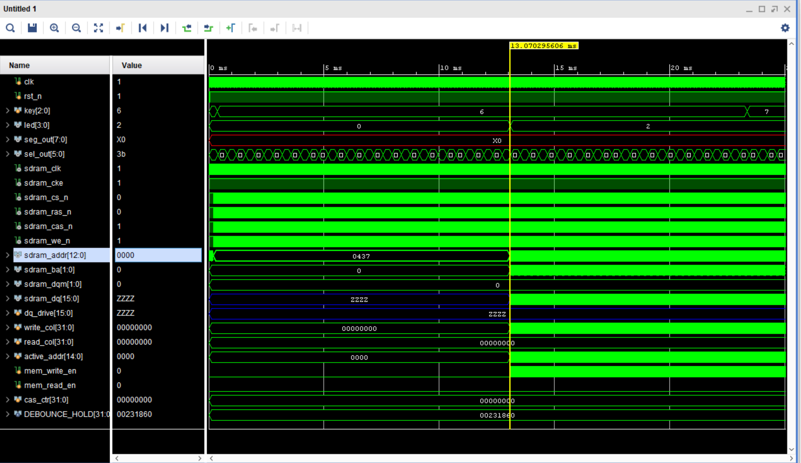
The waveform shows the initial state of the SDRAM controller after reset release. The SDRAM clock is active while the controller remains in initialization mode. The address line sdram_addr remains at 0437 during the initialization delay interval, which corresponds to the waiting period before normal SDRAM operation begins. During this period, the data bus sdram_dq remains in high impedance state (ZZZZ), indicating that no read or write operation is active. The bank address and active address remain zero, confirming that the controller has not yet started burst transactions.

Figure 2: Continuous burst write operation across SDRAM banks.
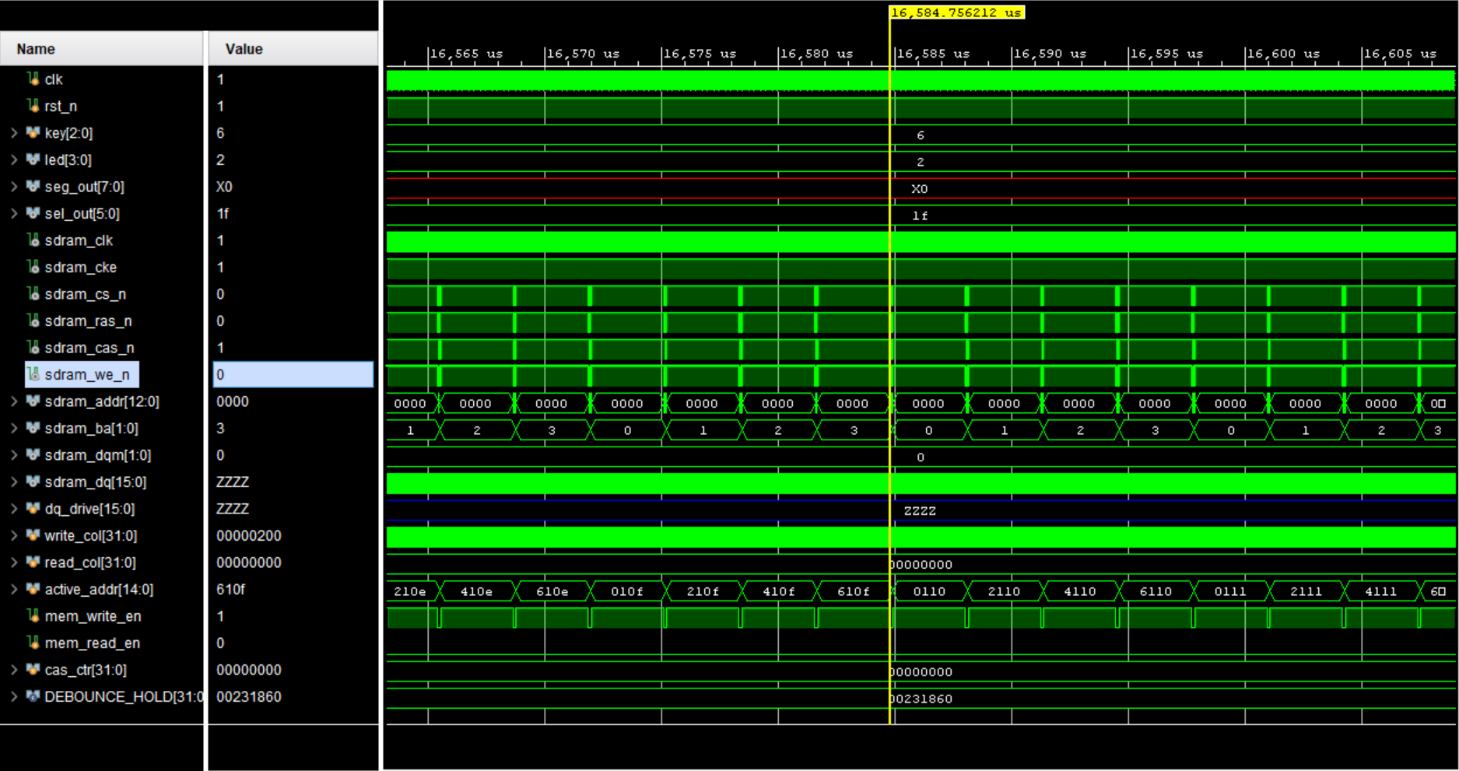
This waveform shows burst writing across multiple SDRAM banks. The bank address sdram_ba changes continuously, indicating sequential bank access. The write enable logic remains active while mem_write_en stays asserted. The active_addr value changes according to the currently activated SDRAM row and bank. The column address remains at zero because full-page burst mode is used in the controller design.

Figure 3: Sequential bank activation during burst write.
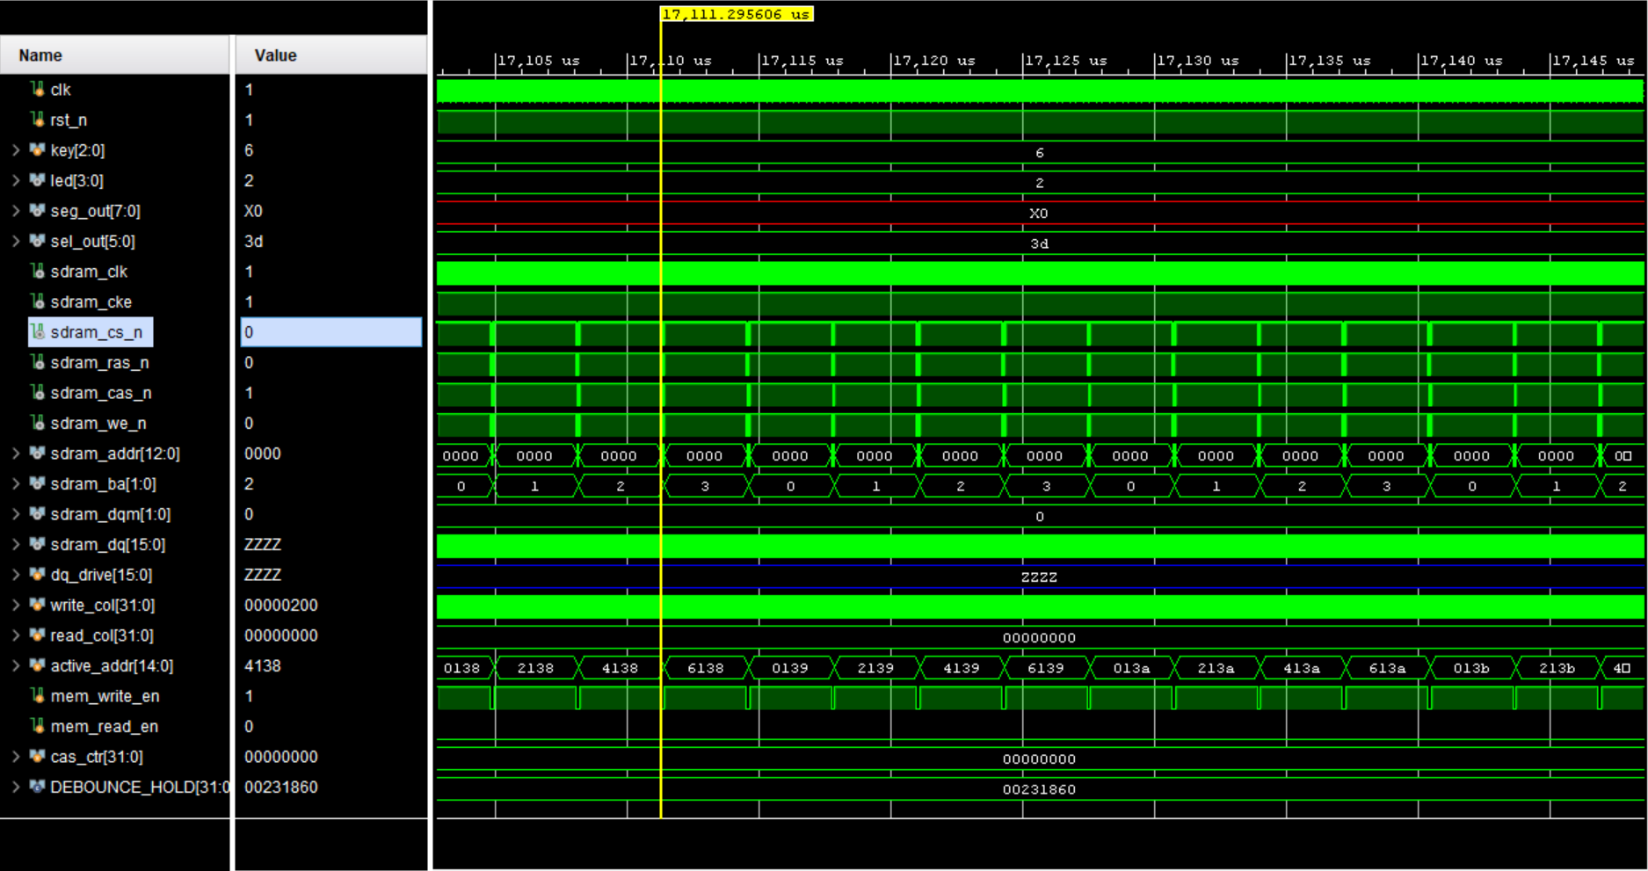
The waveform demonstrates another burst write sequence where the controller cycles through SDRAM banks while incrementing active addresses. The controller issues SDRAM commands through the combination of sdram_cs_n, sdram_ras_n, sdram_cas_n, and sdram_we_n signals. The SDRAM remains in write mode as mem_write_en stays high.

Figure 4: SDRAM address transition from initialization to active operation.
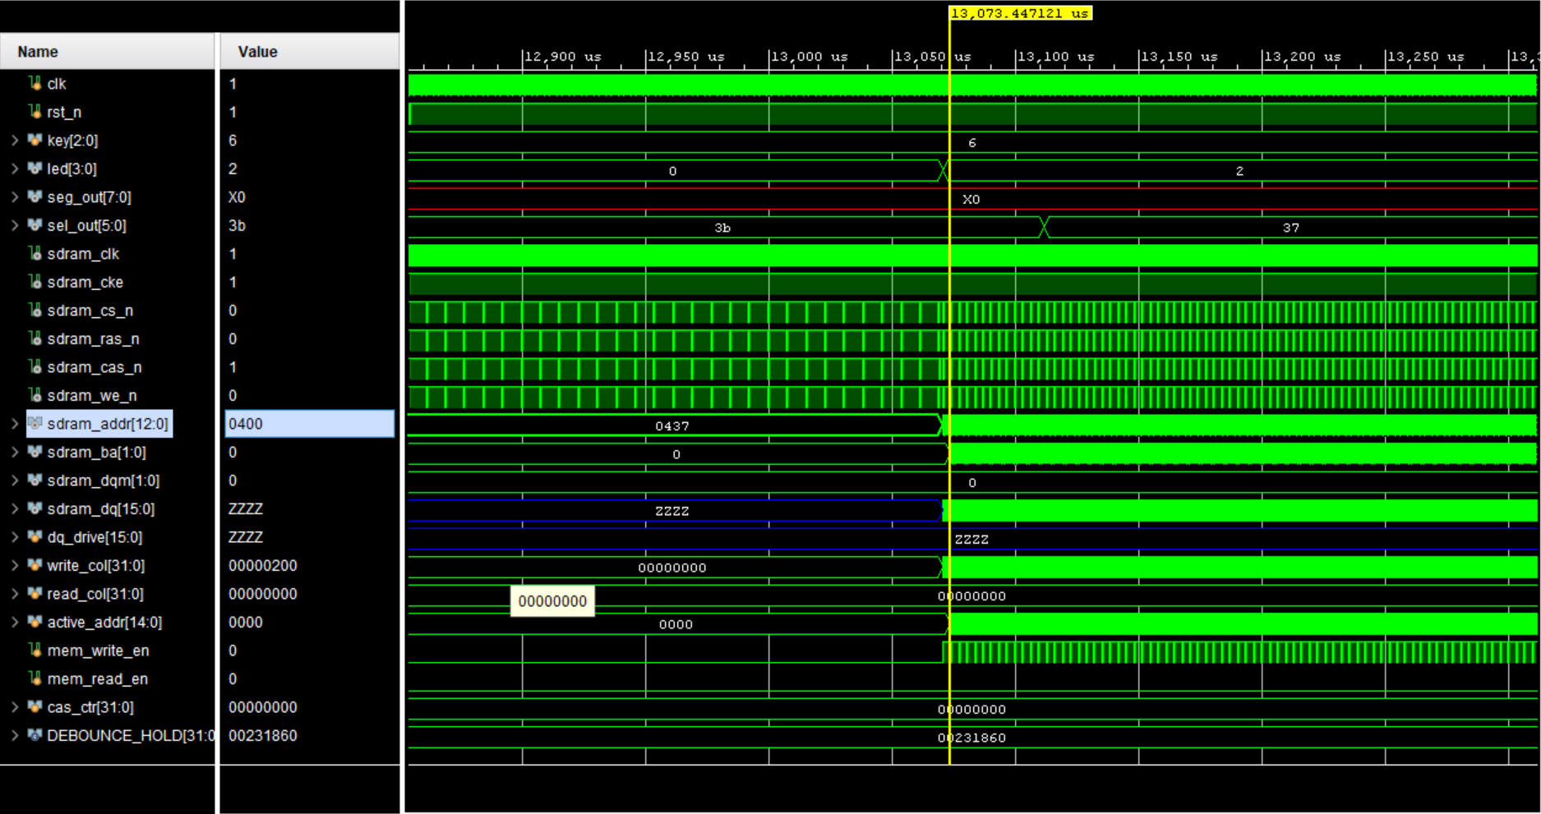
This waveform captures the transition from initialization to active write operation. Initially, sdram_addr holds the value 0437 during the initialization period. Later, the address changes to 0400 as the controller enters active memory access mode. The write enable signal begins toggling, indicating the start of burst transactions.

Figure 5: Start of burst data transfer on SDRAM data bus.
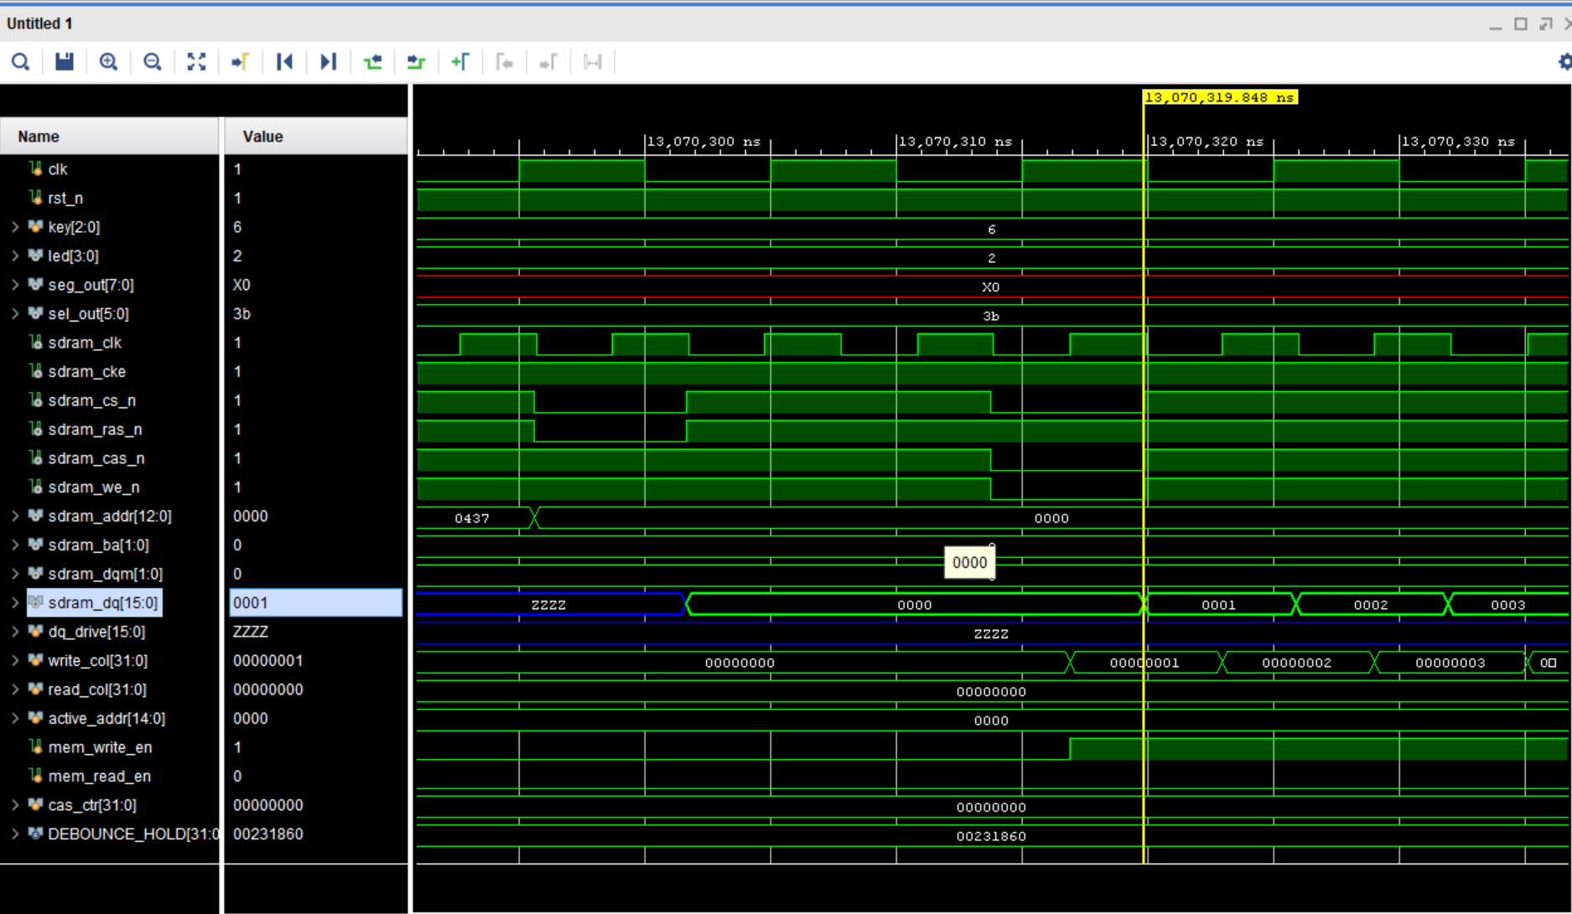
The waveform shows the beginning of burst data transfer. The sdram_dq line transitions from ZZZZ to valid data values such as 0000, 0001, 0002, and 0003. The write_col counter increments simultaneously, confirming sequential burst writes into SDRAM memory locations. The active address remains stable during the burst operation.

Figure 6: Precharge and bank transition operation.
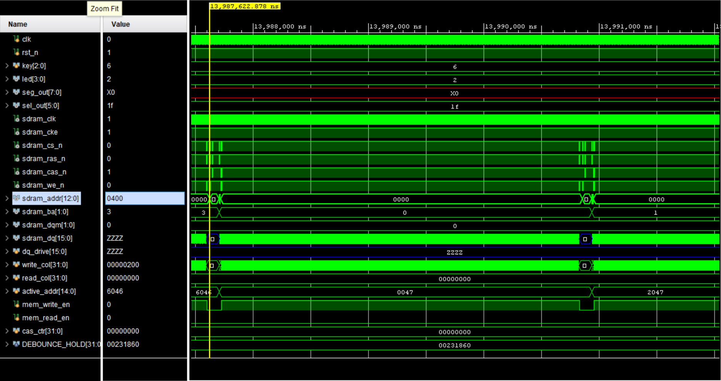
This waveform shows SDRAM precharge and bank transition behavior. The controller changes bank addresses while the active address updates accordingly. The SDRAM command lines toggle in patterns corresponding to ACTIVATE and PRECHARGE commands. During transitions, the data bus temporarily returns to high impedance state.

Figure 7: SDRAM command timing with row activation.
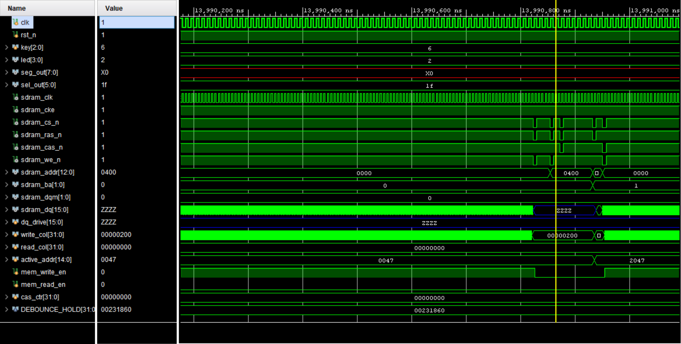
The waveform illustrates detailed SDRAM command timing. The command signals indicate activation and precharge cycles while the address bus switches to 0400. The controller follows proper SDRAM timing constraints before initiating the next memory access cycle.

Figure 8: Continuous burst data generation.
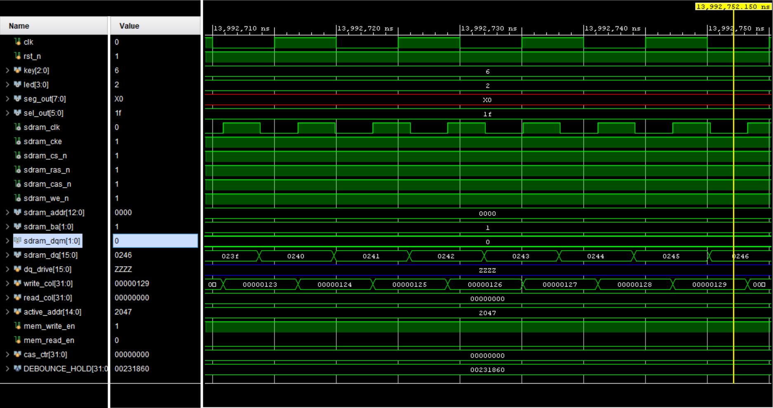
This waveform demonstrates continuous burst data generation. The sdram_dq values increment sequentially , while write_col also increments continuously. This confirms correct burst-write functionality and deterministic test-data generation.

Figure 9: SDRAM command execution with active memory row.
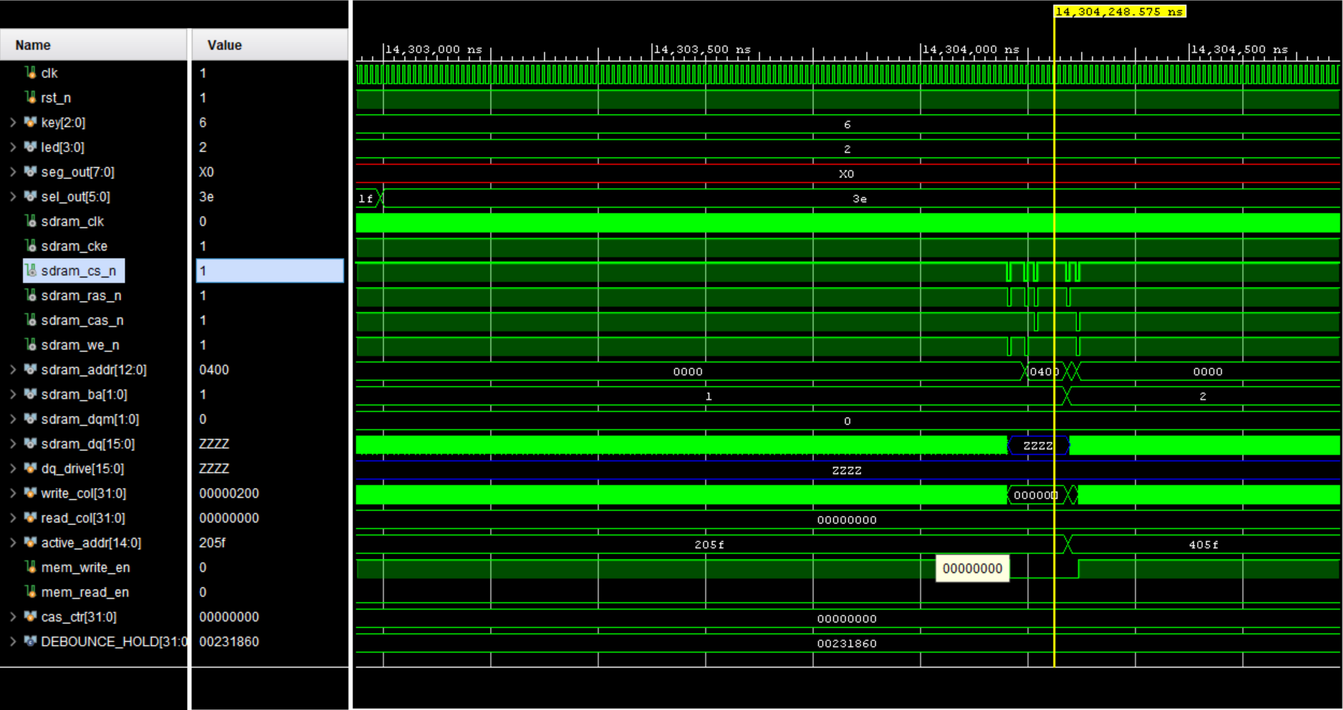
The waveform shows command execution for another active SDRAM row. The controller activates row address 205F and later transitions to another active row. The data bus remains in high impedance during command-only phases.

Figure 10: SDRAM address update during command cycle.
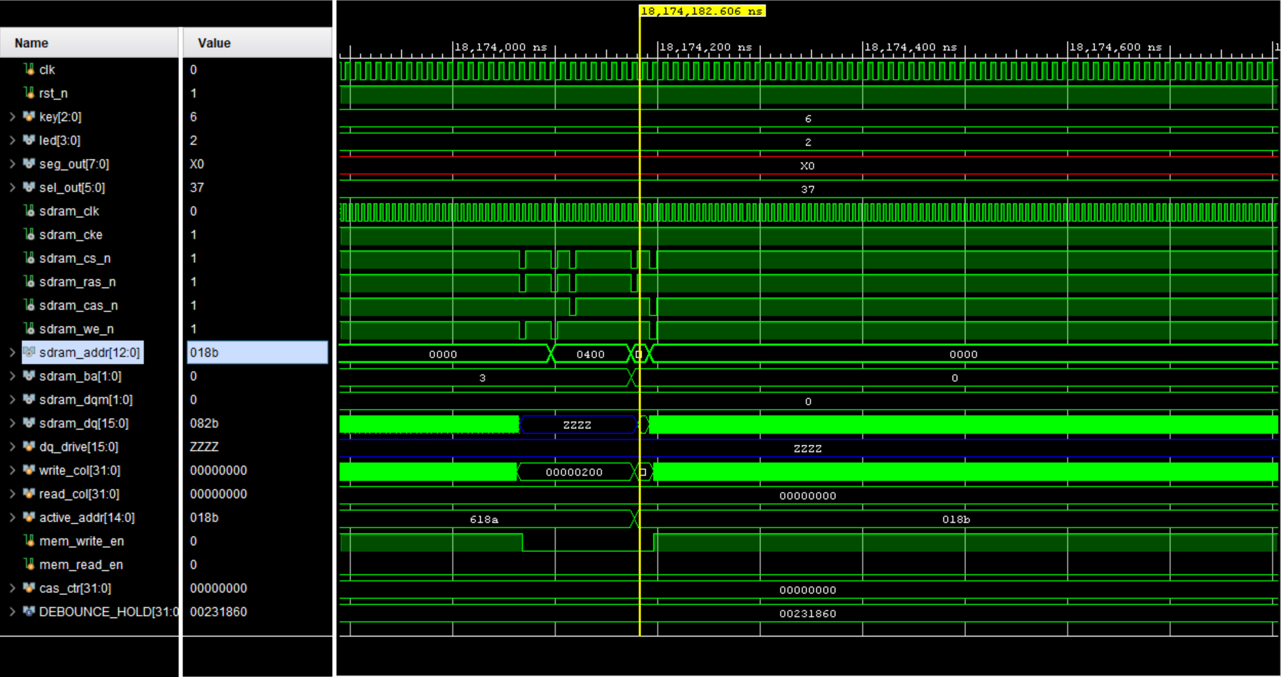
This waveform captures SDRAM address transitions during a command cycle. The active address changes while the SDRAM command signals toggle according to the FSM state transitions. The waveform confirms correct synchronization between address updates and SDRAM control signals.

Figure 11: SDRAM write burst with sequential address increment.
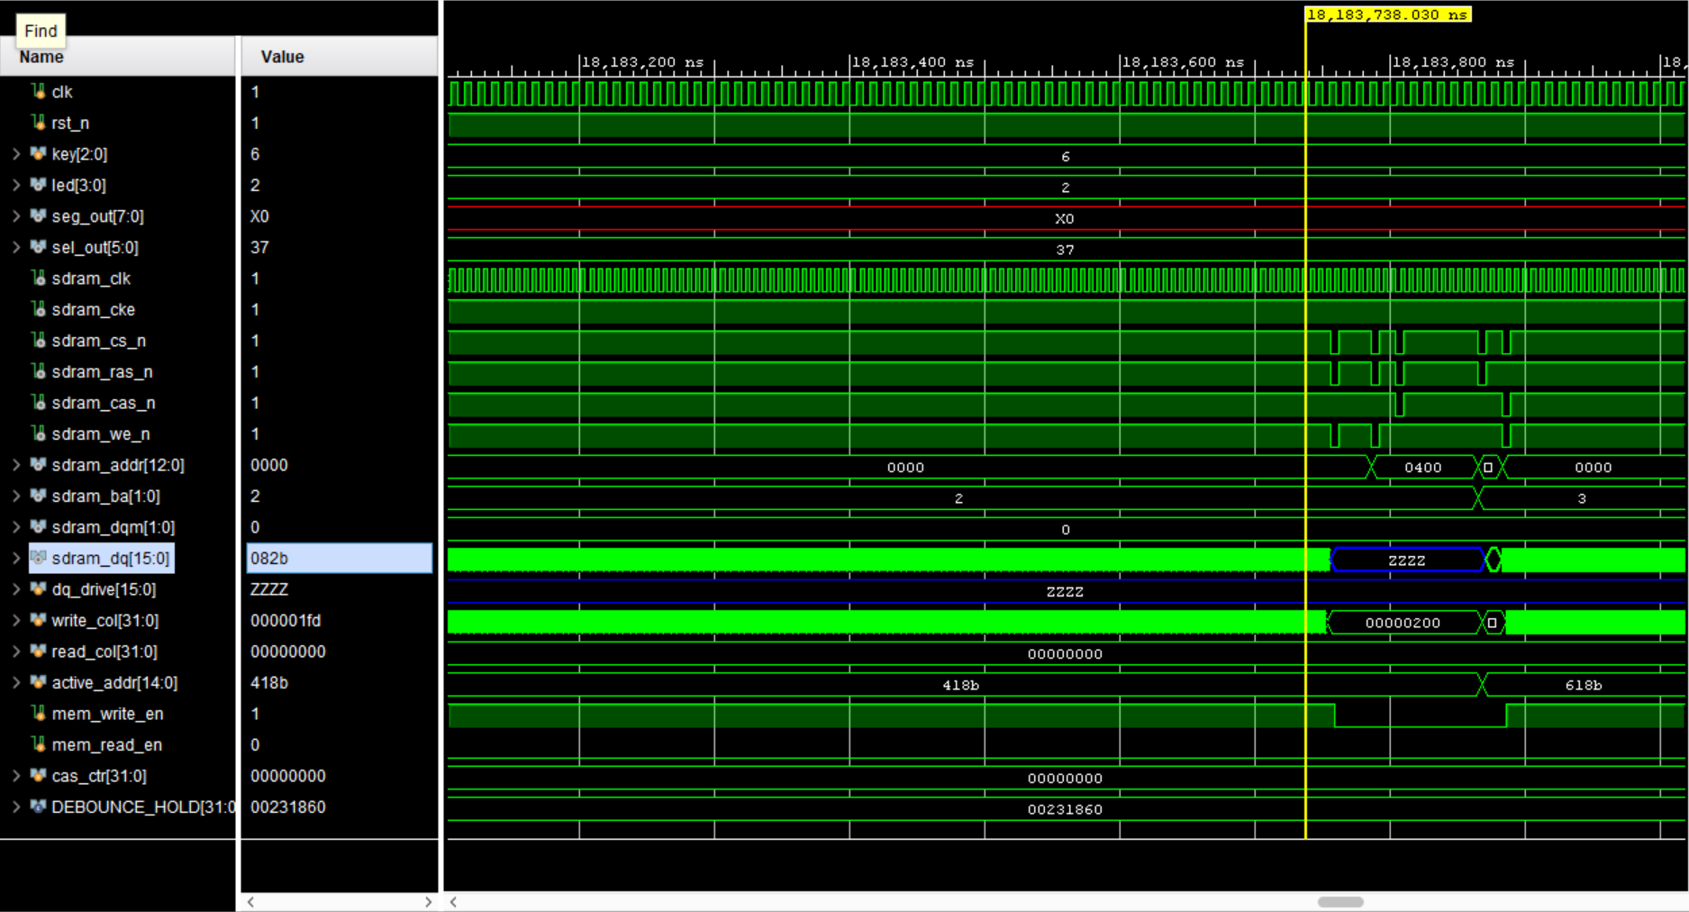
The waveform shows continuous write burst operation with incrementing SDRAM addresses and active row tracking. The controller cycles through banks while maintaining write enable operation. The deterministic data generation mechanism is visible through the incrementing data values.

Figure 12: Final burst-write verification waveform.
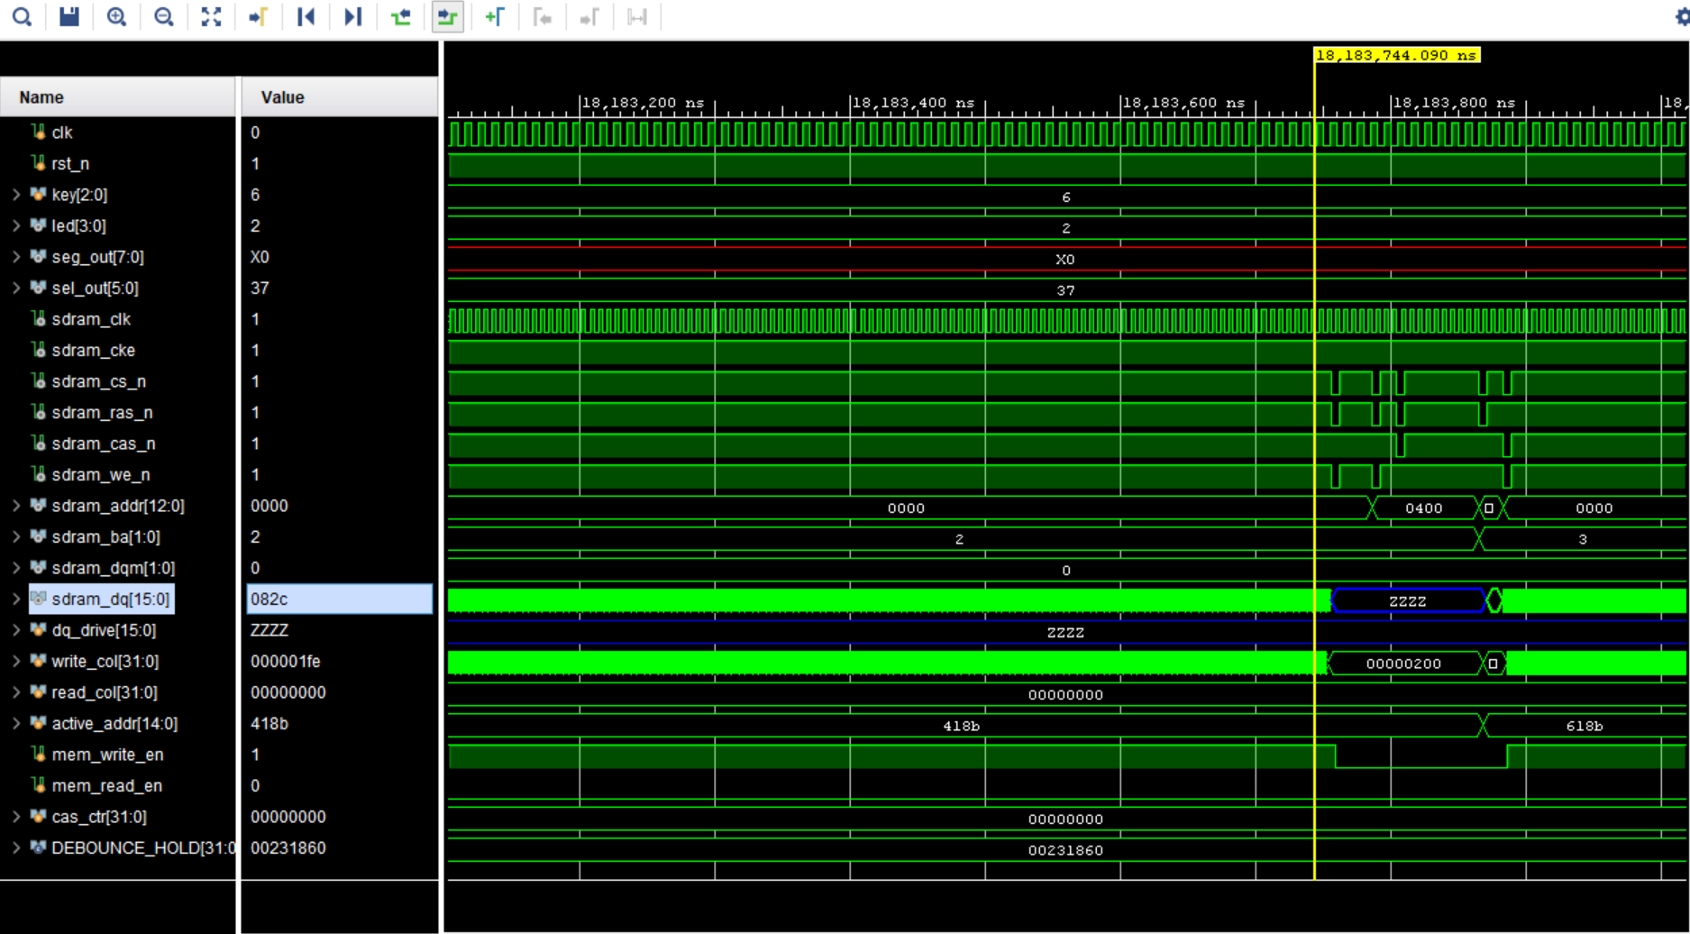
This waveform verifies stable burst-write operation toward the end of the simulation sequence. SDRAM command timing, bank switching, and address updates remain synchronized, confirming proper controller functionality throughout the burst transaction.

Important Relationships Observed in the Waveforms
- During burst write operation, the transmitted SDRAM data follows:
$$\text{sdram_dq}=\text{f_addr}+\text{burst_index}$$which causes continuously increasing write data values.
- The write_col counter increments together with burst_index, indicating sequential burst-column access.
- SDRAM commands are generated using the control signals:
$$\left\{cs_{n} , ras_{n} , cas_{n} , we_{n}\right\}$$
Different combinations correspond to ACTIVATE, WRITE, READ, and PRECHARGE operations.
During write operations, mem_write_en = 1 enables valid data on sdram_dq. Otherwise, the bus remains in high-impedance (ZZZZ) state.
- The value 0400 on sdram_addr corresponds to PRECHARGE ALL operation because address bit A10 becomes high.
- The stable value 0437 during initialization occurs because the controller remains in the delay state before starting normal SDRAM transactions.
Sequential changes in active_addr confirm proper bank switching and row activation during burst transfers.

