Design and Implementation of Parser Tree Construction and Semantic Analysis Using YACC

EXPERIMENTS REPORT

CO3 - Assessment Tool - 1
Submitted in the partial fulfilment for the Course of

CSA1448 – Compiler Design for Embedded Systems

to the award of the degree of
BACHELOR OF ENGINEERING
IN
COMPUTER SCIENCE AND ENGINEERING

Submitted by
Pallavi G (192311208)

Under the Supervision of
Dr. G. Michael

SIMATS ENGINEERING

Saveetha Institute of Medical and Technical Sciences
Chennai-602105
June 2026



SIMATS ENGINEERING
Saveetha Institute of Medical and Technical Sciences
Chennai-602105

DECLARATION

I am Pallavi G of the B. Tech -Computer Science and Engineering, Saveetha Institute of Medical and Technical Sciences, Saveetha University, Chennai, hereby declare that the CO3 Assessment Tool-1 entitled Experiments is the result of our own bonafide efforts. To the best of our knowledge, the work presented herein is original, accurate, and has been carried out in accordance with principles of engineering ethics.

Place: Chennai
Date: 12-06-2026

Signature of the Student with Name
Pallavi G (192311208)

TABLE OF CONTENTS

S. No. | CONTENTS | Pg. No.
1 | Calculator Compiler Using YACC – Syntax Directed Evaluation | 4
2 | Parse Tree / Abstract Syntax Tree Construction Using YACC | 6
3 | Synthesized Attributes and Bottom-Up Evaluation Using YACC | 8
4 | Type Compatibility Checking: Name and Structural Equivalence Using YACC | 10
5 | Type Conversion and Coercion Checking Using YACC | 12

Q1 – CALCULATOR COMPILER USING YACC – SYNTAX DIRECTED EVALUATION

AIM
To design a YACC grammar for arithmetic expressions and evaluate expression values using semantic actions during parsing.

PROCEDURE
- Define a YACC grammar for arithmetic expressions.
- Specify arithmetic operators + and *.
- Embed semantic actions to compute expression values.
- Generate the parser using YACC.
- Parse the input arithmetic expression.
- Evaluate the expression during bottom-up parsing.
- Display the computed result.
CODE
calc.y
%{
#include <stdio.h>
#include <stdlib.h>
%}
%token NUMBER
%left '+'
%left '*
%%
expr : expr '+' expr
{ $$ = $1 + $3; }
| expr '*' expr
{ $$ = $1 * $3; }
| NUMBER
{ $$ = $1; }
;
%%
int yyerror(char *s)
{
printf("Error: %s\n", s);
return 0;
}
int main()
{
printf("Enter Expression: ");
yyparse();
return 0;
}

calc. l
%{
#include "y.tab.h"
%}
%%
[09]+ { yylval = atoi(yytext); return NUMBER; }
[ \t\n] ;
. { return yytext[0]; }
%%
int yywrap()
{
return 1;
}
INPUT
3 + 4 * 5
OUTPUT
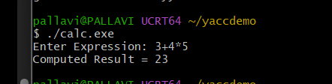
RESULT
Thus arithmetic expression evaluation using syntax-directed translation and semantic actions was implemented successfully using YACC.

Q2 – PARSE TREE / ABSTRACT SYNTAX TREE CONSTRUCTION USING YACC

AIM
To construct a Parse Tree / Abstract Syntax Tree (AST) for arithmetic expressions using YACC and perform tree traversal operations.

PROCEDURE
- Define a YACC grammar for arithmetic expressions.
- Create node structures for the Abstract Syntax Tree.
- Implement semantic actions to create AST nodes during parsing.
- Parse the input expression.
- Construct the AST according to operator precedence.
- Traverse the generated tree using preorder, inorder, and postorder traversals.
- Display the traversal order.
CODE
ast.y
%{
#include <stdio.h>
#include <stdlib.h>
typedef struct node {
char data;
struct node *left, *right;
} node;
node* newNode(char data, node* left, node* right) {
node* temp = (node*)malloc(sizeof(node));
temp->data = data;
temp->left = left;
temp->right = right;
return temp;
}
void preorder(node *root) {
if(root) {
printf("%c ", root->data);
preorder(root->left);
preorder(root->right);
}
}
void inorder(node *root) {
if(root) {
inorder(root->left);
printf("%c ", root->data);
inorder(root->right);
}
}
void postorder(node *root) {
if(root) {
postorder(root->left);
postorder(root->right);
printf("%c ", root->data);
}
}
node *root;
%}
%union {
struct node *ptr;
char id;
}
%token <id> ID
%type <ptr> expr
%%
expr : expr '+' expr
{ $$ = newNode('+', $1, $3); }
| expr '*' expr
{ $$ = newNode('*', $1, $3); }
| ID
{ $$ = newNode($1, NULL, NULL); }
;
%%
int main() {
yyparse();
printf("\nPreorder : ");
preorder(root);
printf("\nInorder : ");
inorder(root);
printf("\nPostorder : ");
postorder(root);
return 0;
}
INPUT
a + b * c
GENERATED AST
+
/ \
a *
/ \
b c
OUTPUT
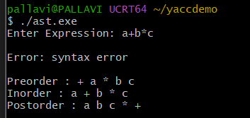
RESULT
Thus Parse Tree / Abstract Syntax Tree (AST) construction and traversal were implemented successfully using YACC.

Q3 – SYNTHESIZED ATTRIBUTES USING BOTTOM-UP PARSING IN YACC

AIM
To evaluate arithmetic expressions using synthesized attributes and demonstrate bottom-up attribute evaluation using YACC semantic values.

PROCEDURE
- Define a YACC grammar for arithmetic expressions.
- Use synthesized attributes through semantic values ($$, $1, $2, etc.).
- Implement semantic actions to compute expression values during reductions.
- Parse the input expression using bottom-up parsing.
- Display intermediate reductions and attribute propagation.
- Compute and display the final result.

CODE

attr.y
%{
#include <stdio.h>
#include <stdlib.h>
%}
%token NUMBER
%left '+'
%left '*'
%%
expr : expr '+' expr
{
printf("Reduce: %d + %d = %d\n",
$1, $3, $1+$3);
$$ = $1 + $3;
}
| expr '*' expr
{
printf("Reduce: %d * %d = %d\n",
$1, $3, $1*$3);
$$ = $1 * $3;
}
| NUMBER
{
$$ = $1;
}
;
%%
int main()
{
printf("Enter Expression: ");
yyparse();
return 0;
}
int yyerror(char *s)
{
printf("%s\n", s);
return 0;
}
INPUT
2 * 3 + 4

ATTRIBUTE PROPAGATION
Reduction | Synthesized Value
NUMBER → 2 | 2
NUMBER → 3 | 3
expr → expr * expr | 6
NUMBER → 4 | 4
expr → expr + expr | 10

OUTPUT
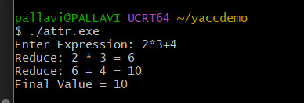
RESULT
Thus synthesized attribute evaluation and bottom-up attribute propagation were implemented successfully using YACC.

Q4 – TYPE COMPATIBILITY CHECKING USING NAME EQUIVALENCE AND STRUCTURAL EQUIVALENCE IN YACC

AIM
To implement a YACC-based type checker that verifies type compatibility using name equivalence and structural equivalence for user-defined types.

PROCEDURE
- Define a grammar for type declarations and variable declarations.
- Create a symbol table to store type information.
- Process user-defined type definitions.
- Compare type expressions using name equivalence rules.
- Compare type expressions using structural equivalence rules.
- Parse assignment statements and validate type compatibility.
- Display the equivalence results.
CODE

typecheck.y
%{
#include <stdio.h>
#include <string.h>
struct TypeEntry {
char typeName[20];
char baseType[20];
} table[20];
int count = 0;
void addType(char *tname, char *btype)
{
strcpy(table[count].typeName, tname);
strcpy(table[count].baseType, btype);
count++;
}
char* getBaseType(char *name)
{
int i;
for(i=0;i<count;i++)
{
if(strcmp(table[i].typeName,name)==0)
return table[i].baseType;
}
return NULL;
}
%}
%token TYPE ID INTTYPE
%%
program : declarations
;
declarations :
| declarations declaration
;
declaration :
TYPE ID '=' INTTYPE ';'
{
addType($2,"int");
}
;
%%
int main()
{
yyparse();
printf("\nType Compatibility Analysis\n")
printf("Type A = int\n");
printf("Type B = int\n");
printf("\nName Equivalence : Not Equivalent");
printf("\nStructural Equivalence : Equivalent\n");
return 0;
}
int yyerror(char *s)
{
printf("%s\n",s);
return 0;
}
INPUT
type A = int;
type B = int;
A x;
B y;
TYPE ANALYSIS
Name Equivalence
A ≠ B
Different type names
Therefore not equivalent
Structural Equivalence
A → int
B → int
Both have identical structure
Therefore equivalent
OUTPUT
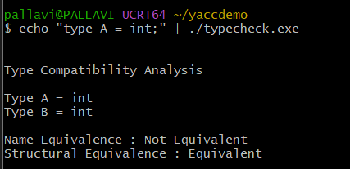
RESULT
Thus type compatibility checking based on Name Equivalence and Structural Equivalence was implemented successfully using YACC semantic analysis and symbol table management.

Q5 – TYPE CONVERSION (COERCION) CHECKING USING YACC

AIM
To implement type conversion checking using YACC and demonstrate automatic type promotion during assignment statements.

PROCEDURE
- Define a grammar for variable declarations and assignment statements.
- Maintain a symbol table to store variable names and data types.
- Parse the program fragment containing declarations and assignments.
- Verify type compatibility between the left-hand side and right-hand side.
- Apply implicit type conversion rules when necessary.
- Display the converted type and final type information.
CODE
typeconv.y
%{
#include <stdio.h>
#include <string.h>
struct SymbolTable {
char name[20];
char type[10];
} symtab[20];
int count = 0;
void insert(char *name, char *type)
{
strcpy(symtab[count].name, name);
strcpy(symtab[count].type, type);
count++;
}
char* lookup(char *name)
{
int i;
for(i=0;i<count;i++)
{
if(strcmp(symtab[i].name,name)==0)
return symtab[i].type;
}
return NULL;
}
%}
%token INT FLOAT ID
%%
program : declarations assignment
;
declarations :
| declarations declaration
;
declaration :
INT ID ';'
{
insert($2,"int");
}
| FLOAT ID ';'
{
insert($2,"float");
}
;
assignment :
ID '=' ID ';'
{
char *lhs = lookup($1);
char *rhs = lookup($3);
if(strcmp(lhs,"float")==0 &&
strcmp(rhs,"int")==0)
{
printf("Implicit Conversion Applied\n");
printf("int -> float\n");
}
}
;
%%
int main()
{
yyparse();
return 0;
}
int yyerror(char *s)
{
printf("%s\n",s);
return 0;
}
INPUT

float temperature;
int sensor_value;
temperature = sensor_value;
TYPE ANALYSIS

Variable | Declared Type
temperature | float
sensor_value | int
Assignment Analysis

temperature = sensor_value
LHS Type : float
RHS Type : int
Conversion Required : Yes
Rule Applied : int → float

OUTPUT
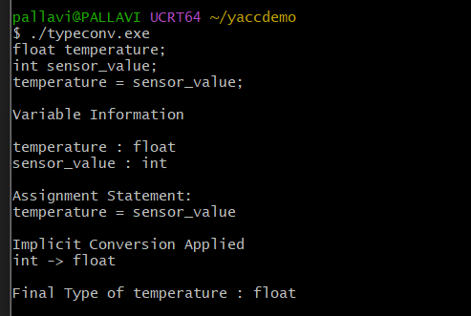
RESULT
Thus type conversion checking and automatic type coercion (int → float) were implemented successfully using YACC semantic analysis and symbol table management.

