Flexbox is a one-dimensional layout method for laying out items in rows or columns
It’s a better way to align items into a container
Flexbox = flexible + box

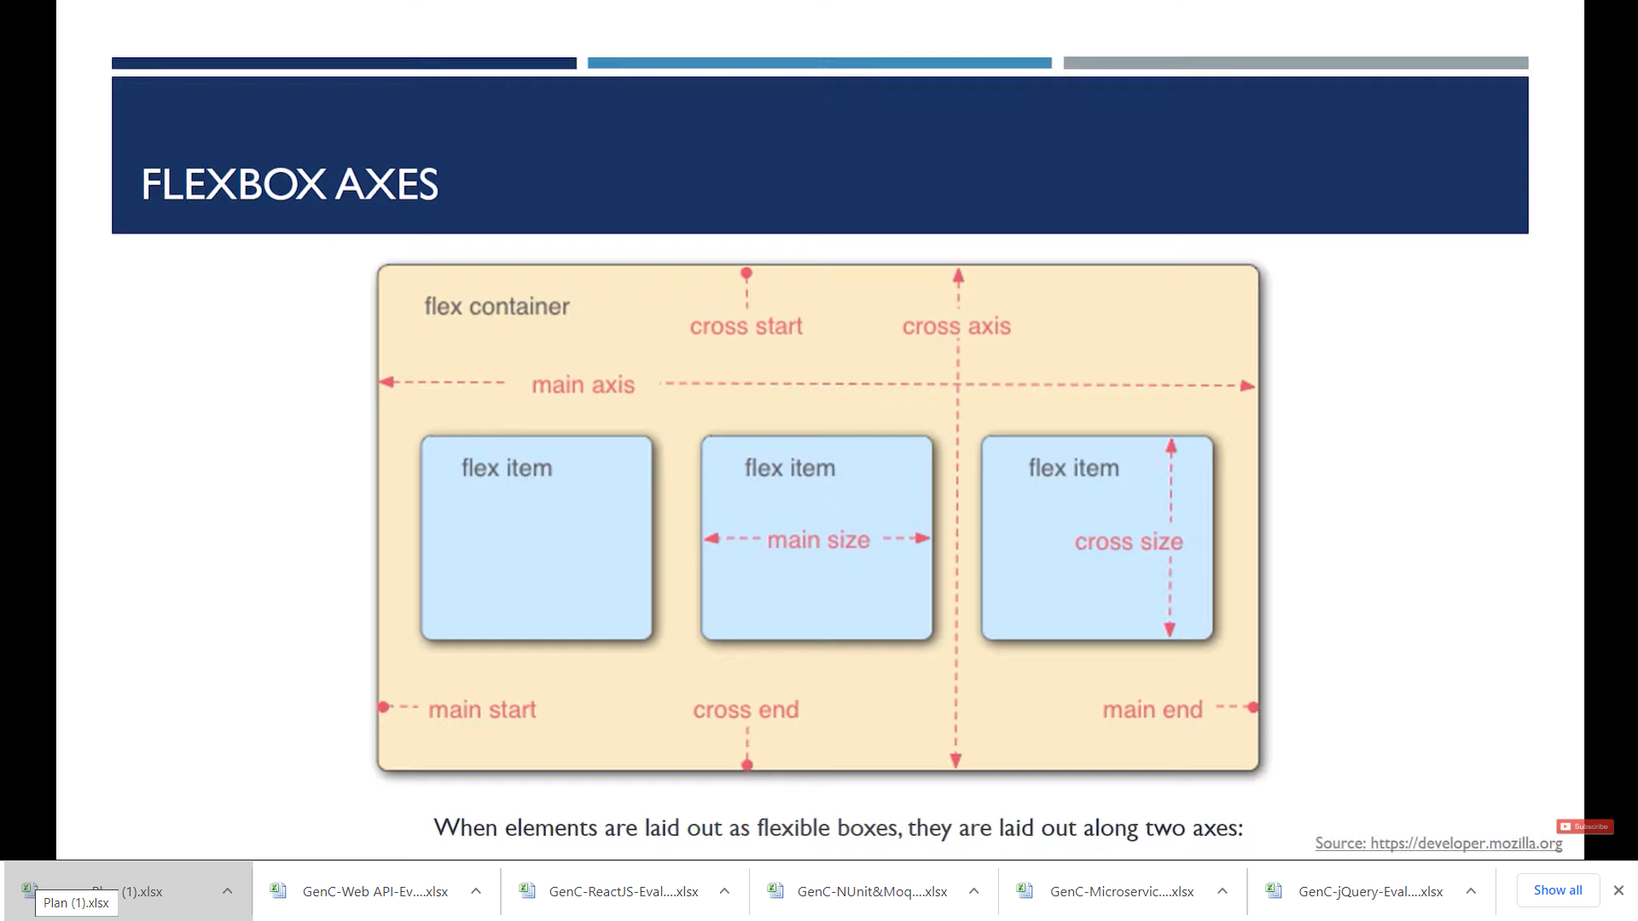

<!DOCTYPE html>
<html>
<head>
<meta charset="utf-8" />
<title>FlexBox Demo</title>
<style>
.container
{
height:544px;
width:100%;
border:2px solid black;
display:flex;
/* flex-direction:column;*/
/* flex-direction:row-reverse;
*/ /* flex-direction:column-reverse;*/
/* flex-wrap: wrap;*/
/* Flex-flow:row wrap; // direction & wrap together
justify-content:center;
justify-content:space-between;
justify-content:space-evenly;
justify-content:space-around;

align-items:center; // vertically center
}
#item-1 {
/* Flex properties for a flex item */
/* Higher the order, later it shows up in the container */
/* order: 2; */
/* flex-grow: 2;
flex-shrink: 2; */
}

#item-2 {
order:100;

flex-grow: 3;
/* flex-shrink: 3 ;
flex-basis: 160px;
/* when flex-direction is set to row flex-basis: will control width */
/* when flex-direction is set to column flex-basis: will control height */
}

#item-3 {
/* flex: 2 2 230px; */
align-self: flex-start;
align-self: flex-end;
align-self: center;
}

.item

{
height:100px;
width:100px;
background-color:tomato;
border:2px solid red;
margin:10px;
padding:10px;
}
</style>
</head>
<body>
<h1> Flex Demo </h1>
<div class="container">
<div class="item" id="item-1"> First Box</div>

<div class="item" id="item-2"> Second Box</div>
<div class="item" id="item-3">Third Box</div>
<div class="item" id="item-4">Fourth Box</div>
<div class="item" id="item-5">Fifth Box</div>

<div class="item" id="item-6">Sixth Box </div>

</div>

</body>
</html>

<!DOCTYPE html>
<html>
<head>
<meta charset="utf-8" />
<title>FlexBox Demo</title>
<style>
.container
{
height:544px;
width:100%;
border:2px solid black;
}
.item

{
background-color:tomato;
border:2px solid red;
margin:10px;
padding:10px;
}
</style>
</head>
<body>
<h1> Flex Demo </h1>
<div class="container">
<div class="item" id="item-1"> First Box</div>

<div class="item" id="item-2"> Second Box</div>
<div class="item" id="item-3">Third Box</div>
<div class="item" id="item-4">Fourth Box</div>
<div class="item" id="item-5">Fifth Box</div>

<div class="item" id="item-6">Sixth Box </div>

</div>

</body>
</html>

<!DOCTYPE html>
<html>
<head>
<meta charset="utf-8" />
<title>FlexBox Demo</title>
<style>
.container
{
height:544px;
width:100%;
border:2px solid black;
display:flex;
}
.item

{
height:200px;
width:200px;
background-color:tomato;
border:2px solid red;
margin:10px;
padding:10px;
}
</style>
</head>
<body>
<h1> Flex Demo </h1>
<div class="container">
<div class="item" id="item-1"> First Box</div>

<div class="item" id="item-2"> Second Box</div>
<div class="item" id="item-3">Third Box</div>
<div class="item" id="item-4">Fourth Box</div>
<div class="item" id="item-5">Fifth Box</div>

<div class="item" id="item-6">Sixth Box </div>

</div>

</body>
</html>
/* Initializes the container as flex box */
display:flex;
/* Default value of flex-direction is row

flex-direction:column;
flex-direction:row-reverse;
flex-direction:column-reverse;
flex-wrap: wrap;

COMBINATION OF DIRECTION AND WRAP IS
Flex-flow: row-reverse wrap;
justify-content:center;
justify-content:space-between;
excluding corners
justify-content:space-evenly;
including corners
justify-content:space-around;
Adds margins on both sides
align-items:center;
Aligns items center
align-items:flex-end;

<!DOCTYPE html>
<html lang="en">
<head>
<meta charset="UTF-8">
<meta name="viewport" content="width=device-width, initial-scale=1.0">
<meta http-equiv="X-UA-Compatible" content="ie=edge">
<title>Flexbox Tutorial</title>
<style>
.container{
height: 544px;
width: 100%;
border: 2px solid black;
display: flex; /* Initialize the container as a flex box */

/* Flex properties for a flex container */

/* flex-direction: row; (Default value of flex-direction is row) */
/* flex-direction: column;
flex-direction: row-reverse;
flex-direction: column-reverse; */

/* flex-wrap: wrap; (Default value of flex-wrap is no-wrap) */
/* flex-wrap: wrap-reverse; */

/* This is a shorthand for flex-direction: and flex-wrap: ;; */
/* flex-flow: row-reverse wrap; */

/* justify-content will justify the content in horizontal direction */
/* justify-content: center; */
/* justify-content: space-between; */
/* justify-content: space-evenly; */
/* justify-content: space-around; */

/* justify-content will justify the content in vertical direction */
/* align-items: center; */
/* align-items: flex-end; */
/* align-items: flex-start; */
/* align-items: stretch; */
}
.item{
width: 200px;
height: 200px;
background-color: tomato;
border: 2px solid green;
margin: 10px;
padding: 3px;
}

#item-1{
/* Flex properties for a flex item */
/* Higher the order, later it shows up in the container */
/* order: 2; */

/* flex-grow: 2;
flex-shrink: 2; */

}
#item-2{
/* flex-grow: 3;
flex-shrink: 3 ; */
flex-basis: 160px;
/* when flex-direction is set to row flex-basis: will control width */
/* when flex-direction is set to column flex-basis: will control height */
}
#item-3{
/* flex: 2 2 230px; */
/* grow shrink flex-basis
align-self: flex-start;
align-self: flex-end;
align-self: center;

}

</style>
</head>
<body>
<h1>This is Flexbox Tutorial</h1>
<div class="container">
<div class="item" id="item-1">First Box</div>
<div class="item" id="item-2">Second Box</div>
<div class="item" id="item-3">Third Box</div>
<!-- <div class="item" id="item-4">Fourth Box</div>
<div class="item" id="item-5">Fifth Box</div>
<div class="item" id="item-6">Sixth Box</div> -->
</div>
</body>
</html>

