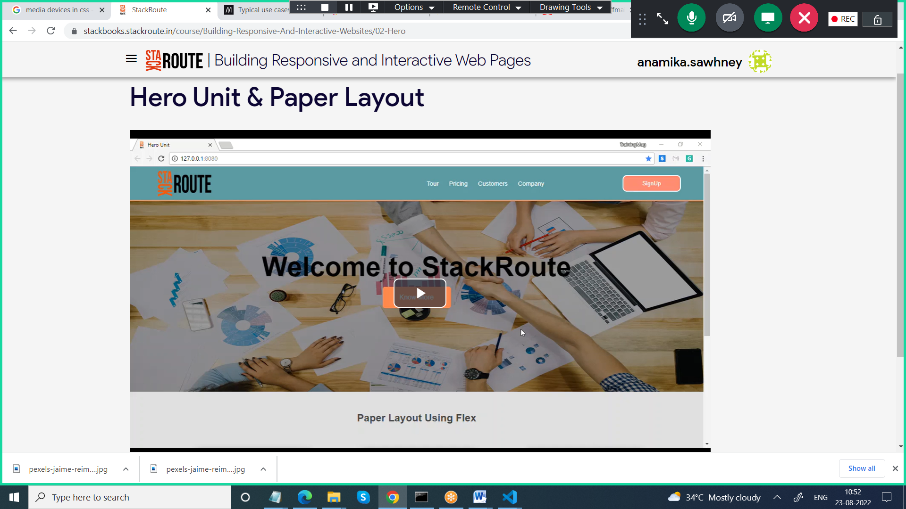

<!DOCTYPE html>
<html>
<head>
<title> Hero Unit Demo </title>
<link href="style3.css" rel="stylesheet">
</head>
<body>
<header class="header-container">
<div class="branding">
<img src="StackRoute.png" style="align-self: center;">

</div>
<nav class="nav-bar">
<ul>
<li> <a href=""> Tour</a></li>
<li> <a href=""> Pricing </a></li>
<li> <a href=""> Customers </a></li>
<li> <a href=""> Company</a></li>

</ul>
</nav>
<button class="signup"> Sign Up </button>
</header>
</body>
</html>

<!DOCTYPE html>
<html>
<head>
<title> Hero Unit Demo </title>
<link href="style3.css" rel="stylesheet">
</head>
<body>
<header class="header-container">
<div class="branding">
<img src="StackRoute.png" style="align-self: center;">

</div>
<nav class="nav-bar">
<ul>
<li> <a href=""> Tour</a></li>
<li> <a href=""> Pricing </a></li>
<li> <a href=""> Customers </a></li>
<li> <a href=""> Company</a></li>

</ul>
</nav>
<button class="signup"> Sign Up </button>
</header>

<section class="hero-unit-section">
<div class="hero-unit-mask">
<h1> Welcome to StackRoute </h1>
<a href="">Know More</a>
</div>
</section>
</body>
</html>

