Semantic HTML elements are those that clearly describe their meaning in a human- and machine-readable way. Elements such as <header> , <footer> and <article> are all considered semantic because they accurately describe the purpose of the element and the type of content that is inside them.

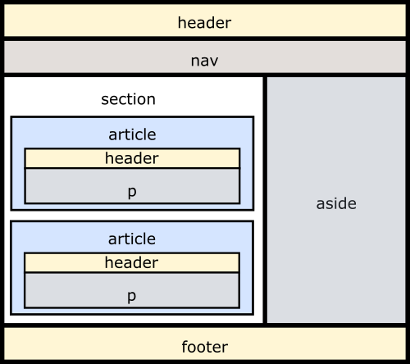

<!DOCTYPE html>
<html>
<head>
<!--<link href="style.css" rel="stylesheet" />-->
<meta charset="utf-8" />
<style>
* {
box-sizing: border-box;
}
div{
width : 300px;
height: 200px;
padding: 15px;
margin: 10px;
border : 5px solid red;

}
</style>
<title></title>
</head>
<body>

<div style="background-color:pink"> These are contents of Div 1 </div>
<div style="background-color:gray"> These are contents of Div 2 </div>

</body>
</html>
<DOCTYPE html>
<head>
<style>

input[type=text],[type=number] {
height:30px;
margin-left:200px;

}

input:required {
background-color: pink;
}

input:valid {
background-color: green;
}

input:invalid {
background-color: yellow;
}
input[type=submit] {
background-color: blue;
color: white;
width: 200px;
}
input {
background-color: red;
}

</style>

</head>
<body>

<form>
<fieldset>
<legend> Personal Info </legend>
<div>
<label for="name"> ENter Name </label>
<input type="text" id="name" maxlength="20" size="5" required/>
</div>

<div>
<label for="markseng"> Enter Marks of English </label>
<input type="number" id="markseng" min="0" max="100" />
</div>
<div>
<label for="markshindi"> Enter Marks of Hindi </label>
<input type="number" id="markshindi" min="0" max="100" />
</div>
</fieldset>
<br />
<fieldset>
<legend> Educational Info </legend>
<label for="name"> Enter Name </label>
<input type="text" id="name" name="name" required />
<br>
<label for="marks"> ENterMarksName </label>
<input type="number" id="marks" name="marks" min="0" max="100" />
<br>
<label for="marks"> ENterMarksName </label>
<input type="number" id="marks" name="marks" min="0" max="100" />
<br>
<br> <br> <br> <br>

Select Age : <input id="ageCategory" name="ageCategory" list="ageRanges" />
<datalist id="ageRanges">
<option value="Under Two's"></option>
<option value="2-7"> </option>
<option value="8-12"> </option>
<option value="13-17"> </option>
<option value="Adult"> </option>
</datalist>
<br>
<div id="carManufacturee">
<select id="carManufacturer">
<optgroup label="European">
<option value="volvo"> Volvo </option>
<option value="audi"> Audi </option>
</optgroup>
<optgroup label="American">
<option value="chrysler"> Chrysler </option>
<option value="ford"> Ford </option>
</optgroup>
</select>
</div>
<input id="orderRef" name="orderReference" type="text" pattern="[0-9]{2}[A-Z]{3}" title="2 digits and 3 uppercase letters" />
</fieldset>
<input type="submit" value="Submit" name="b1" id="b1"/>

</form>
</body>

<!DOCTYPE html>
<html>
<head>
<link href="main2.css" rel="stylesheet" />
<title></title>

</head>
<body>

<div>
<h1 class="header"> Welcome to LTI </h1>
</div>
<div class="topnav">
<ul>
<li> <a href="Htmlpage3.html"> Home </a></li>
<li> <a href="register1"> Register </a></li>
<li> <a href="login1"> Login </a></li>
<li> <img src="images/lti.jpg" style="float:right; height:80px; padding:20px; width:auto;" /> </li>
</ul>
</div>

<div class="main">
<div class="card">
<p>
Static Web Page : A page with no interaction
HTML : Hyper Text Markup Language
Which means it is made up of some tags
<h1> </h1>
Tags : Container Tags, Empty Tags
</p>
</div>
<div class="card">

<p>
Static Web Page : A page with no interaction
HTML : Hyper Text Markup Language
Which means it is made up of some tags
<h1> </h1>
Tags : Container Tags, Empty Tags
</p>
</div>

<div class="card">
<h1 style="text-align:center"> Our Bileifs </h1>

<div class="imagescr">
<img src="images/push-frontiers-of-innovation-237x300_robo.jpg" />
<p> Go to Extra Miles </p>
</div>
<div class="imagescr">
<img src="images/keep-learning-237x300.png" />
<p> Go to Extra Miles </p>
</div>

<div class="imagescr">
<img src="images/solve-for-society-237x300_new-237x300.png" />
<p> Go to Extra Miles </p>
</div>

<div class="imagescr">
<img src="images/extra-mile-237x300.png" />
<p> Go to Extra Miles </p>
</div>
<!--<div class="imagescr">
<img src="images/ceo.jpg" />
</div>-->
</div>

</div>

<div class="footer">
<p> 2020 LTI </p>

</div>
</body>
</html>

