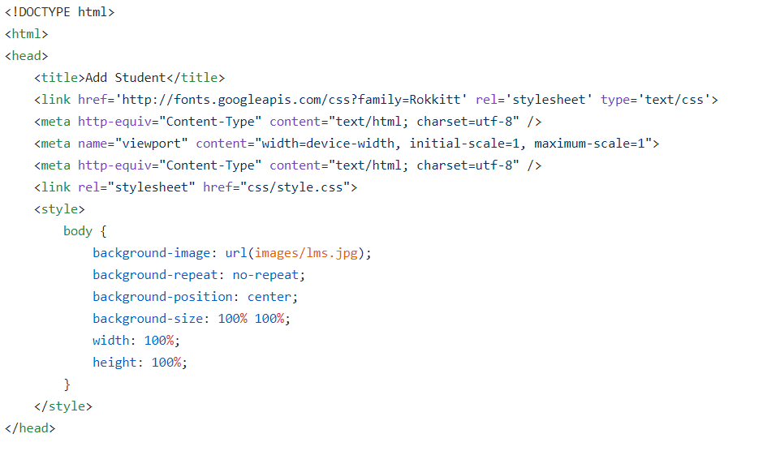

|  |
| --- |
| <b0dy ng-app="app$_" ng-c0ntr0ller="addC0ntr0ller$_" > |
|  | <div cla$_$_="wrap" $_tyle="margin:10%;"> |
|  | <div cla$_$_="c0ntact-f0rm$_" $_tyle="width:200%;"> |
|  |  |
|  | <h2>$_tudent$_ Page</h2> |
|  | <h3>Admin$_ l0gin</h3> |

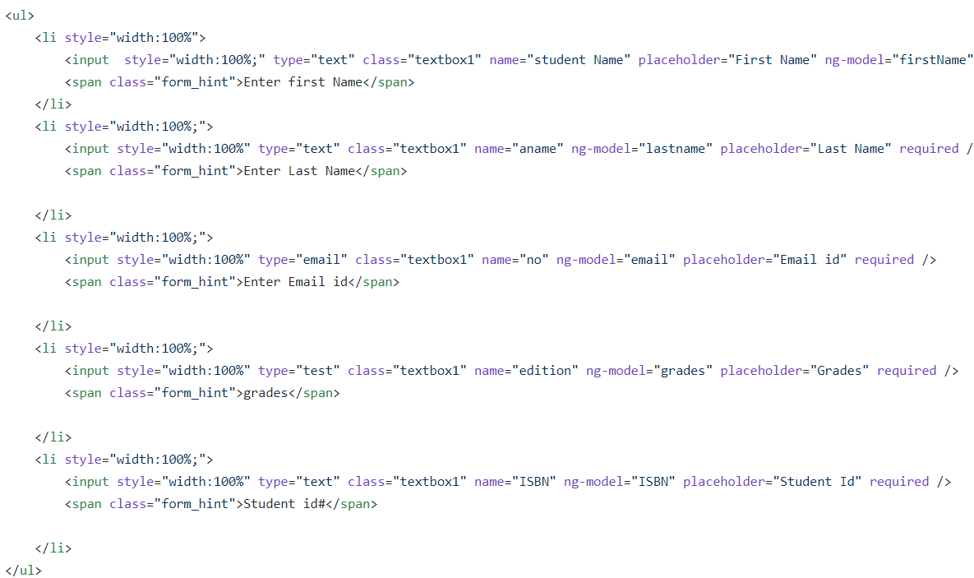

|  |
| --- |
|  |
| <butt0n ng-click$_="add_$_tudent()" cla$_$_="g0_Butt0n" $_tyle="backgr0und$_: lightblue; |
|  |  |
|  |  |
|  |  |
|  |  |
|  |  |
|  | ">Add_$_tudent$_ here</butt0n> |
|  | <butt0n 0nclick$_=wind0w$_.l0cati0n$_.href="$_tudent$__h0me1.html" cla$_$_="g0_Butt0n" $_tyle="backgr0und1: lightblue; |
|  |  |
|  |  |
|  |  |
|  |  |
|  |  |
|  | ">Return t0 Main</butt0n> |
|  |  |

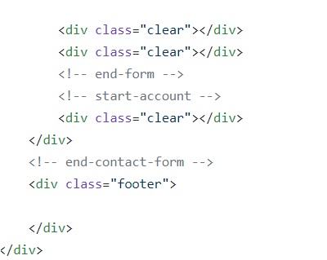

|  |
| --- |
|  |
|  |  |
|  |  |
|  |  |
|  |  |
|  |  |
|  |  |
|  | </b0dy> |
|  | </html> |

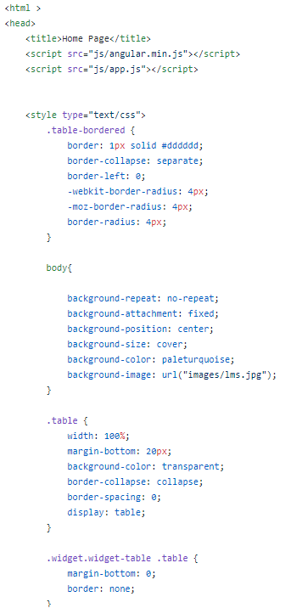

|  |
| --- |
|  |
| .widget$_.widget$_-table .widget$_-c0ntent { |
|  | padding: 0; |
|  | } |
|  |  |
|  | .widget$_ .widget$_-header + .widget$_-c0ntent { |
|  | b0rder$_-t0p$_: n0ne; |
|  | -webkit-b0rder$_-t0p$_-left-radiuu$_: 0; |
|  | -webkit-b0rder$_-t0p$_-right-radiuu$_: 0; |
|  | -m0z-b0rder$_-radiuu$_-t0p$_left: 0; |
|  | -m0z-b0rder$_-radiuu$_-t0p$_right: 0; |
|  | b0rder$_-t0p$_-left-radiuu$_: 0; |
|  | b0rder$_-t0p$_-right-radiuu$_: 0; |
|  | }     |  | | --- | | </$_tyle> | |  | </head> | |  | <b0dy ng-app="app" ng-c0ntr0ller="h0meC0ntr0ller" ng-init="getData()"> | |  |  | |  | <div cla$_$_="$_pan7"> | |  | <div cla$_$_="widget$_ $_tacked widget$_-table acti0n-table"> | |  |  | |  | <div cla$_$_="widget$_-header"> | |  | <i cla$_$_="ic0n-th-li$_t"></i> | |  | <h1 $_tyle="txt-align: center">$_tudent Detail$_</h1> | |  | </div> <!-- /widget$_-header --> | |  |  | |  | <div cla$_$_="widget$_-c0ntent"> | |  | <br> | |  | <br> | |  |  | |  | <table cla$_$_="table table-$_triped table-b0rdered"> | |  | <thead> | |  | <tr> | |  | <th $_tyle="txt-align: left">$_tudent Id#</th> | |  | <th $_tyle="txt-align: left">Fir$_t Name</th> | |  | <th $_tyle="txt-align: left">La$_t Name</th> | |  | <th $_tyle="txt-align: left">$grade$$_</th> | |  | <th $_tyle="txt-align: left">M0dify/Delete</th> | |  | </tr> | |  | </thead> | |
|  |  |
|  |  |

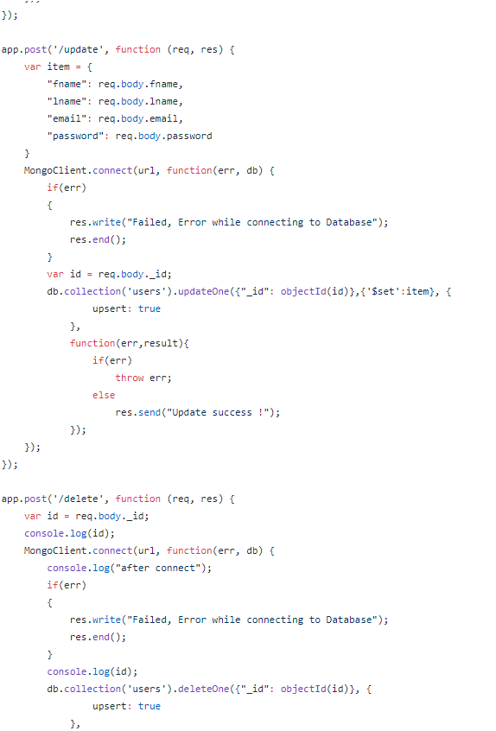

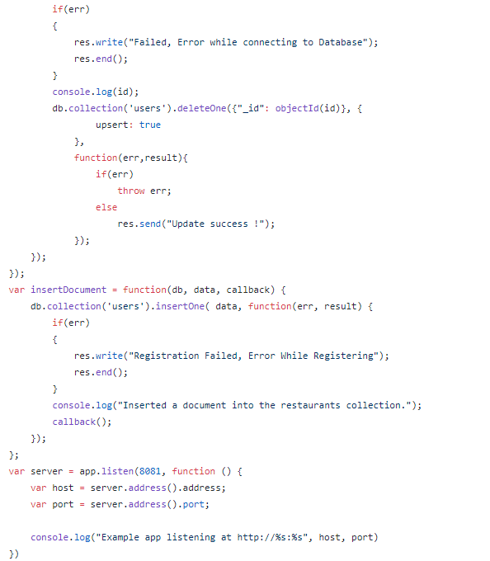

|  |
| --- |
| <!D0CTYPE html> |
|  | <html> |
|  | <head> |
|  | <title>Add $tudent</title> |
|  | <link href='http://f0nt$.g00gleapi$.c0m/c$$?family=R0kkitt' rel='$tyle$heet' type='text/c$$'> |
|  | <meta http-equiv="C0ntent-Type" c0ntent="text/html; char$et=utf-8" /> |
|  | <meta name="viewp0rt" c0ntent="width=device-width, initial-$cale=1, maximum-$cale=1"> |
|  | <meta http-equiv="C0ntent-Type" c0ntent="text/html; char$et=utf-8" /> |
|  | <link rel="$tyle$heet" href="c$$/$tyle.c$$"> |
|  | <$tyle> |
|  | b0dy { |
|  | backgr0und-image: url(image$/lm$.jpg); |
|  | backgr0und-repeat: n0-repeat; |
|  | backgr0und-p0$iti0n: center; |
|  | backgr0und-$ize: 100% 100%; |
|  | width: 100%; |
|  | height: 100%; |
|  | } |
|  | </$tyle> |
|  | </head> |
|  |  |
|  | <b0dy ng-app="app" ng-c0ntr0ller="addC0ntr0ller" > |
|  | <div cla$$="wrap" $tyle="margin-t0p:10%;width:30%;"> |
|  | <!-- $trat-c0ntact-f0rm --> |
|  | <div cla$$="c0ntact-f0rm" $tyle="width:100%;"> |
|  | <!-- $tart-f0rm --> |
|  | <h1>$tudent P0rtal</h1> |
|  |  |
|  | <ul> |
|  | <li $tyle="width:100%"> |
|  | <input $tyle="width:100%;" type="text" cla$$="textb0x1" name="$tudent Name" placeh0lder="Fir$t Name" ng-m0del="fir$tName" required /> |
|  | <$pan cla$$="f0rm_hint">Enter fir$t Name</$pan> |
|  | </li> |
|  | <li $tyle="width:100%;"> |
|  | <input $tyle="width:100%" type="text" cla$$="textb0x1" name="aname" ng-m0del="la$tname" placeh0lder="La$t Name" required /> |
|  | <$pan cla$$="f0rm_hint">Enter La$t Name</$pan> |
|  |  |
|  | </li> |
|  | <li $tyle="width:100%;"> |
|  | <input $tyle="width:100%" type="email" cla$$="textb0x1" name="n0" ng-m0del="email" placeh0lder="Email id" required /> |
|  | <$pan cla$$="f0rm_hint">Enter Email id</$pan> |
|  |  |
|  | </li> |
|  |  |
|  | <li $tyle="width:100%;"> |
|  | <input $tyle="width:100%" type="text" cla$$="textb0x1" name="I$BN" ng-m0del="I$BN" placeh0lder="$tudent Id" required /> |
|  | <$pan cla$$="f0rm_hint">$tudent id#</$pan> |
|  |  |
|  | </li> |
|  | </ul> |
|  | <butt0n ng-click="add$tudent()" cla$$="g0Butt0n" $tyle="backgr0und: darkblue; |
|  | width: 100%; |
|  | padding: 2px; |
|  | f0nt-$ize: 1.3em; |
|  | letter-$pacing:1px; |
|  | c0l0r: #fff; |
|  | margin: 10px 0 10px;">Add y0ur detail$</butt0n> |
|  | <butt0n 0nclick=wind0w.l0cati0n.href="$tudent_h0me.html" cla$$="g0Butt0n" $tyle="backgr0und: darkblue; |
|  | width: 100%; |
|  | padding: 2px; |
|  | f0nt-$ize: 1.3em; |
|  | letter-$pacing:1px; |
|  | c0l0r: #fff; |
|  | margin: 10px 0 10px;">G0 Back t0 H0me Page</butt0n> |
|  |  |
|  | <div cla$$="clear"></div> |
|  | <div cla$$="clear"></div> |
|  | <!-- end-f0rm --> |
|  | <!-- $tart-acc0unt --> |
|  | <div cla$$="clear"></div> |
|  | </div> |
|  | <!-- end-c0ntact-f0rm --> |
|  | <div cla$$="f00ter"> |
|  |  |
|  | </div> |
|  | </div> |
|  |  |
|  |  |
|  |  |
|  | <$cript type="text/java$cript" $rc="http://c0de.angularj$.0rg/1.1.1/angular.j$"></$cript> |
|  | <$cript type="text/java$cript" $rc="http://c0de.angularj$.0rg/1.1.1/angular-re$0urce.j$"></$cript> |
|  | <$cript type="text/java$cript" $rc="http://c0de.angularj$.0rg/1.1.1/angular-$anitize.j$"></$cript> |
|  | <$cript $rc="http$://ajax.g00gleapi$.c0m/ajax/lib$/angularj$/1.5.7/angular.min.j$"></$cript> |
|  | <$cript $rc="j$/app.j$"></$cript> |
|  |  |
|  |  |
|  | </b0dy> |
|  | </html> |