ASSIGNMENT-13

1. Create Azure Portal Free Account and windows Machine in Azure VM and Connect using RDP

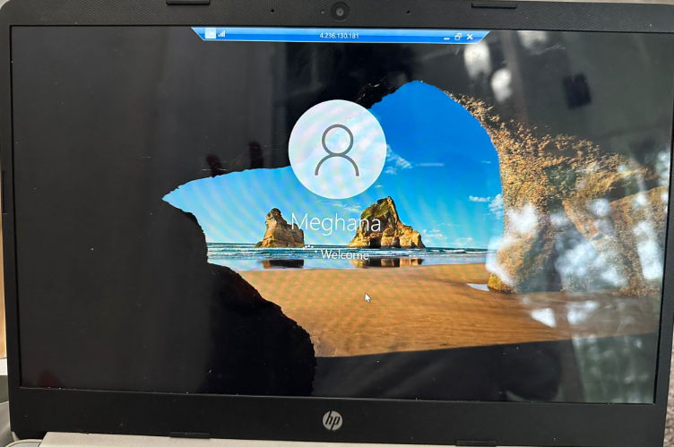

2. Create Full flow of ur Task using Feature Based in ur GitHub Repo (Provide ur Github Link in Tracker)

