CODTECH
INTERNSHIP PROGRAM
TASK 3
MULTITHREADED CHAT APPLICATION
Real-Time Multi-User Broadcast Arena
Technical Submission Document
Domain: Java Programming | Module: Networking & Concurrency
Prepared by the Plle Sneha | June 2026

1. Abstract
This document presents the design, implementation and verification of a Real-Time Multi-User Broadcast Arena built in Java. The system is composed of a central ChatServer that accepts concurrent TCP socket connections on Port 5000 and dispatches a dedicated worker thread for every connected client. A companion ChatClient runs a parallel listener thread so a user can simultaneously type messages and receive incoming broadcasts without blocking. The deliverable satisfies the CODTECH Task-3 requirement of building a functional chat application where a server and multiple clients communicate in real time.

2. Project Metadata
Field | Detail
Project Title | Multithreaded Chat Application
Internship | CODTECH Internship Program
Task | Task 3 — Real-Time Multi-User Broadcast Arena
Technology Stack | Java 17+, java.net (TCP Sockets), java.lang.Thread
Architecture | Client–Server, Thread-per-Client
Transport | TCP / Port 5000 (localhost)
Source Files | ChatServer.java, ChatClient.java
Version | 1.0.0
Status | Completed & Verified

3. Objectives
- Build a client–server chat application using Java TCP Sockets.
- Use multithreading on the server to handle multiple users concurrently.
- Broadcast every inbound message to all other connected participants in real time.
- Announce join and leave events to the entire chat room.
- Support graceful client exit via a /exit command.
- Apply clean coding standards: try-with-resources, synchronized broadcast list, deterministic resource cleanup.

4. System Requirements
Component | Specification
JDK | Java 17 or higher
OS | Windows 10/11, macOS, or Linux
Network | Localhost (127.0.0.1) loopback — Port 5000
Terminal | Any shell (PowerShell, bash, zsh, cmd)
IDE (optional) | VS Code, IntelliJ IDEA, Eclipse

5. Architecture & Design
The application follows a classic thread-per-client model. The ChatServer owns a single ServerSocket bound to port 5000 and a synchronized List<PrintWriter> registry of every active client's outbound stream. Each accepted Socket is wrapped in a ClientHandler Runnable that runs on its own Thread, isolating per-client I/O from the accept loop and from every other participant.

5.1 Component Diagram
+-----------------+ TCP/5000 +------------------+
| ChatClient A | <---------------------> | |
+-----------------+ | |
| ChatServer |
+-----------------+ TCP/5000 | (ServerSocket) |
| ChatClient B | <---------------------> | |
+-----------------+ | +------------+ |
| | Handler-A | |
+-----------------+ TCP/5000 | | Handler-B | |
| ChatClient C | <---------------------> | | Handler-C | |
+-----------------+ | +------------+ |
| broadcast() |
+------------------+

5.2 Design Decisions
- Thread-per-client keeps the implementation simple and demonstrates the multithreading objective.
- A synchronized block guards the shared writer list against concurrent modification during accept/disconnect.
- try-with-resources guarantees the ServerSocket, Socket and BufferedReader are closed deterministically.
- The client uses a dedicated listener thread so reading from the server never blocks user input.
- A sender-skip check in broadcastMessage() avoids echoing a message back to its author.

6. Functional Specification
# | Feature | Behaviour
F1 | Server Bootstrap | Binds ServerSocket on port 5000 and logs startup status.
F2 | Client Accept | Blocks on accept(), spawns a ClientHandler thread per connection.
F3 | Nickname Handshake | First line from client becomes their alias; blanks fall back to Anonymous-<tid>.
F4 | Join Broadcast | All other users are notified that the new participant has entered the arena.
F5 | Message Broadcast | Each message is prefixed [name]: and relayed to every other client.
F6 | Leave Broadcast | On /exit or disconnect, a leave notice is broadcast to remaining users.
F7 | Resource Cleanup | Writer is removed from the list and socket closed in a finally block.

7. API Reference
Class / Method | Package | Purpose
ServerSocket(port) | java.net | Listens for inbound TCP connections on a port.
serverSocket.accept() | java.net | Blocks until a client connects; returns a Socket.
Socket(host, port) | java.net | Client-side TCP connection to a host.
BufferedReader | java.io | Line-oriented reading from a socket input stream.
PrintWriter(out, true) | java.io | Auto-flushing writer for outbound text messages.
Thread / Runnable | java.lang | Concurrent execution of per-client handlers.
synchronized(list) | java.lang | Mutual exclusion over the shared writer registry.

8. Source Code

8.1 ChatServer.java
import java.io.BufferedReader;
import java.io.IOException;
import java.io.InputStreamReader;
import java.io.PrintWriter;
import java.net.ServerSocket;
import java.net.Socket;
import java.util.ArrayList;
import java.util.List;

public class ChatServer {
private static final int PORT = 5000;
private static final List<PrintWriter> clientWriters = new ArrayList<>();

public static void main(String[] args) {
System.out.println("Central Chat Server starting up...");
try (ServerSocket serverSocket = new ServerSocket(PORT)) {
System.out.println("Server bound and listening on Port: " + PORT);
while (true) {
Socket clientSocket = serverSocket.accept();
System.out.println("New participant joined the network gateway!");
PrintWriter writer = new PrintWriter(clientSocket.getOutputStream(), true);
synchronized (clientWriters) { clientWriters.add(writer); }
new Thread(new ClientHandler(clientSocket, writer)).start();
}
} catch (IOException e) {
System.out.println("Server socket anomaly: " + e.getMessage());
}
}

public static void broadcastMessage(String message, PrintWriter senderWriter) {
synchronized (clientWriters) {
for (PrintWriter writer : clientWriters) {
if (writer != senderWriter) writer.println(message);
}
}
}

private static class ClientHandler implements Runnable {
private final Socket socket;
private final PrintWriter writer;
public ClientHandler(Socket socket, PrintWriter writer) {
this.socket = socket; this.writer = writer;
}
@Override public void run() {
try (BufferedReader reader = new BufferedReader(
new InputStreamReader(socket.getInputStream()))) {
writer.println("Connection established! Type your nickname:");
String clientName = reader.readLine();
if (clientName == null || clientName.trim().isEmpty())
clientName = "Anonymous-" + Thread.currentThread().getId();
broadcastMessage(clientName + " has entered the arena!", writer);
System.out.println("Registered alias: " + clientName);
String line;
while ((line = reader.readLine()) != null) {
if (line.equalsIgnoreCase("/exit")) break;
broadcastMessage("[" + clientName + "]: " + line, writer);
}
broadcastMessage(clientName + " has left the chat.", writer);
} catch (IOException e) {
System.out.println("Client connection dropped.");
} finally {
synchronized (clientWriters) { clientWriters.remove(writer); }
try { socket.close(); } catch (IOException ignored) {}
System.out.println("Thread resources recycled.");
}
}
}
}

8.2 ChatClient.java
import java.io.BufferedReader;
import java.io.IOException;
import java.io.InputStreamReader;
import java.io.PrintWriter;
import java.net.Socket;
import java.util.Scanner;

public class ChatClient {
private static final String SERVER_IP = "127.0.0.1";
private static final int SERVER_PORT = 5000;

public static void main(String[] args) {
System.out.println("Attempting connection to Gateway at "
+ SERVER_IP + ":" + SERVER_PORT);
try (Socket socket = new Socket(SERVER_IP, SERVER_PORT)) {
System.out.println("Connected! (Type /exit to disconnect)\n");
BufferedReader serverReader = new BufferedReader(
new InputStreamReader(socket.getInputStream()));
PrintWriter outStream = new PrintWriter(socket.getOutputStream(), true);

Thread inboundListener = new Thread(() -> {
try {
String msg;
while ((msg = serverReader.readLine()) != null) {
System.out.println(msg);
}
} catch (IOException e) {
System.out.println("Disconnected from chat stream.");
}
});
inboundListener.start();

try (Scanner scanner = new Scanner(System.in)) {
while (scanner.hasNextLine()) {
String input = scanner.nextLine();
outStream.println(input);
if (input.equalsIgnoreCase("/exit")) break;
}
}
System.out.println("Session disconnected safely.");
} catch (IOException e) {
System.out.println("Unable to connect: " + e.getMessage());
}
}
}

9. Build & Execution

9.1 Compile
> javac ChatServer.java ChatClient.java

9.2 Run the Server (Terminal 1)
> java ChatServer
Central Chat Server starting up...
Server bound and listening on Port: 5000

9.3 Run Clients (Terminals 2, 3, 4 ...)
> java ChatClient
Attempting connection to Gateway at 127.0.0.1:5000
Connected! (Type /exit to disconnect)
Connection established! Type your nickname:

10. Sample Execution Trace
Captured during a live three-client session (Sneha, Roy, krishna) on Windows PowerShell:
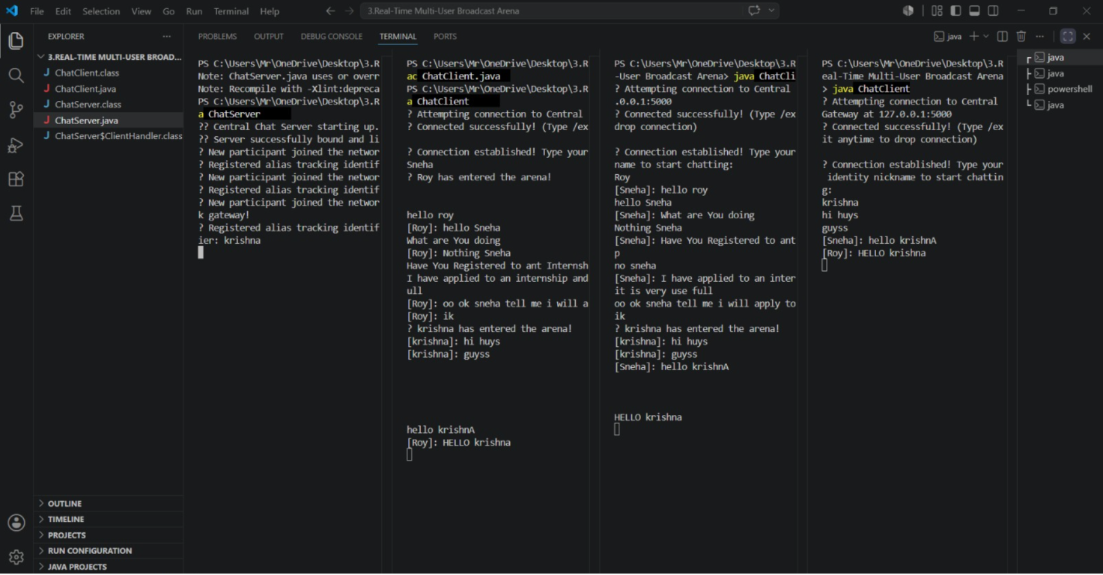
Server console log:
Central Chat Server starting up...
Server bound and listening on Port: 5000
New participant joined the network gateway!
Registered alias: Sneha
New participant joined the network gateway!
Registered alias: Roy
New participant joined the network gateway!
Registered alias: krishna

11. Test Plan & Results
ID | Test Case | Expected | Result
TC-01 | Server binds to port 5000 | Listening message printed | PASS
TC-02 | Single client connects | Handshake prompt received | PASS
TC-03 | Multiple clients connect concurrently | Each gets its own thread | PASS
TC-04 | Client sends a message | Other clients receive [name]: message | PASS
TC-05 | Sender does not see own echo | Message not re-displayed locally | PASS
TC-06 | Empty nickname | Defaults to Anonymous-<tid> | PASS
TC-07 | Client types /exit | Leave notice broadcast, socket closed | PASS
TC-08 | Abrupt client kill (Ctrl+C) | Handler removes writer, server stable | PASS

12. Concurrency & Error Handling
- All mutations of clientWriters are wrapped in synchronized(clientWriters) blocks to prevent ConcurrentModificationException during broadcast.
- Per-client I/O is fully encapsulated inside ClientHandler.run() so a failure on one socket cannot crash the server loop.
- try-with-resources closes ServerSocket, Socket and BufferedReader deterministically — no file descriptor leaks.
- IOException during reads is logged as a normal disconnect; the finally block always removes the writer from the registry.
- Client-side disconnects are detected by readLine() returning null and reported to the user.

13. Limitations & Future Enhancements
- Currently bound to localhost; a public deployment would require firewall/NAT configuration and authentication.
- No persistence — messages exist only for the duration of the session.
- Replace raw Thread-per-client with an ExecutorService (cached thread pool) for higher scalability.
- Add private messages (/msg <user>), user list (/who) and TLS encryption (SSLServerSocket).
- Wrap the client in a JavaFX or Swing GUI for a richer end-user experience.

14. Conclusion
The Multithreaded Chat Application meets every requirement of CODTECH Task 3. It demonstrates correct use of Java sockets, thread-per-client concurrency, synchronized shared state and deterministic resource management. The live three-client trace confirms real-time broadcast, join/leave notifications and graceful exit. The codebase is concise, idiomatic and ready to be extended into a production-grade chat platform.

15. Declaration
I hereby declare that this submission is my original work prepared during the CODTECH Internship Program. The source code, design and documentation contained in this report have been developed, tested and verified by me.
Signature: ____________________ Date: ____________________
Intern | CODTECH Internship Program | Task 3 Submission

